A2 - Oral Mediation 1: Teacher’s Notes
Before starting the mediation activity, ask students to read the task and the poster carefully to make the aim of the activity clear.
Are you green?
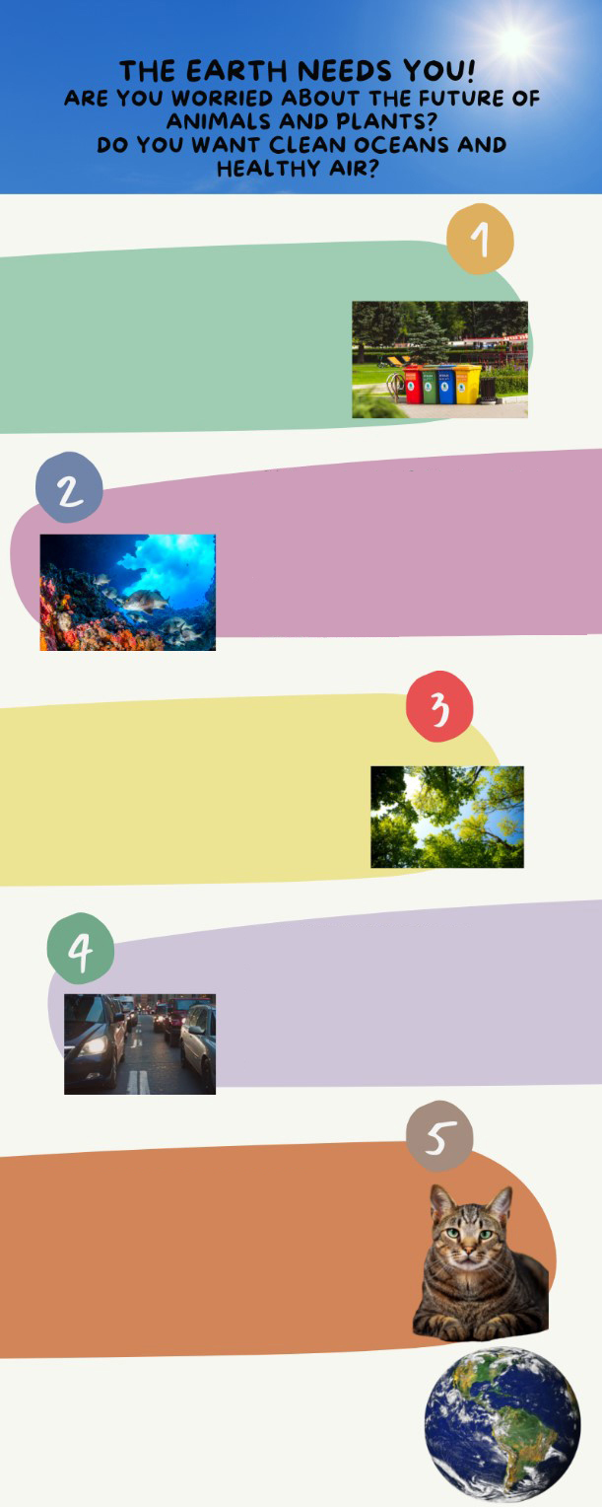
You want to learn more about how to take care of the environment. You have seen
LEARN TIPS TO RECYCLE
The importance of the 3 “Rs”: reduce,
reuse, recycle, just a little effort will
bring a lot of benefits for the planet.
We will play games that will play games
that will teach us how to be eco-friendly!!
CLEAN THE OCEANS, SEAS
AND RIVERS
Learn about marine life and what we all can do to protect it. We will design a plan to reduce pollution in the rivers and on how to enjoy a day on the beach with responsibility.
HAVE YOU GOT GREEN
FINGERS?
We will plant a tree and will learn how
to take care of plants. In these project,
you are the most important part!
THE AIR WE BREATH
The quality of the air will be a lot better
if we follow a few steps. Use your
legs not vehicles. We will see how
small changes can make a big
difference!
TAKE CARE OF ANIMALS
Do you love animals? So do we! Learn
about their habitats, their food and
how to look after them. There are a lot
of endangered species. There is a lot we
can do to keep them safe.
JOIN OUR COURSE NOW!
GROUPS OF FOUR PEOPLE FROM
12 TO 16 YEARS OLD.
this poster on the wall of your school
with information about a course for
teenagers. The course will give you a
lot of ideas that you will want to put
into practice. You have to be in
groups of four people, so you can talk
to three of your friends and tell
them about the course. Two of them
are interested in joining, but the
other one is not. That friend thinks
that taking care of the environment
is boring and useless. You have to
tell him / her about the advantages of
learning how to be more aware of
the environment.

You have ten minutes to prepare the task. Your conversation should last between 2.30 to 3 minutes.

In an oral mediation, your ideas have to be clear. Pay attention to the content of the texts, images, infographics
and / or videos provided.

Make sure it is clear why you are talking about the topic. Refer to the context.

Refer to the document you have been asked to read, but do not read it aloud. Paraphrase the ideas there.
Let’s get ready!
In this section you will help students to get ready for the task. First of all, they will learn what to do (Analyse the task) and later, they will work on the information (Analyse the information). You can give them the Learning Sequence worksheet to work on.
1. Analyse the task
Tell students they are going to think about the receiver of the message, the reason for the message and the information included. This will help them to use the proper register (formal or informal).
a. Read the task carefully and answer these questions. They will help you choose the register of the mediation task.
a) Who will receive the message? Your friend Laura.
b) Is this a formal or an informal message? It is an informal message.
c) What type of vocabulary should be used? Colloquial or informal language.
b. After analysing the task, choose the correct answer.
- Informal language should be rude and impolite.
- I will give general and specific information about the topic using informal language.
- I should ask the receiver questions all the time.
2. Analyse the information
Now tell students to think about the relevant information on the poster they will have to use.
Read the information in the poster carefully.
a) What is the important information in the poster that your friend Laura needs?
The important information in the poster is that we can help to reduce pollution and that it is very easy if we change our habits.
b) Underline the ideas that you think can be most effective to convince Laura.
- Accept all logical answers.

Let’s prepare the language!
In this section, students will learn structures and language suitable for the task.
1. Discuss the main ideas
1. Read this text where a person is explaining some reasons to take care of the environment and the benefits it will bring for the planet. Underline all the expressions he or she uses to present the benefits.
The World Health Organization has published research and the results are alarming. There are a lot of consequences of global warming that are affecting the health of the population. Many diseases have their origin in the bad quality of the air we breathe and the pollution of the oceans. The number of endangered species is increasing and the climate change is a reality that we have to live with.
All these problems are avoidable if we change our habits. We all can be part of the problem or part of the solution. Learning to recycle, planting trees, cleaning the rivers, seas and oceans are some of the things we can do to repair the damage we have done to our planet. It is in our hands to change the reality we are living in and that we change things for good. Spread the word and share the information. If we can make a difference as individuals, imagine all the things we can do as a society. Renewable sources of energy are the future, give them a try.

Do not use the same expressions all the time. It is important to include new vocabulary in order to sound more natural.
Other Useful Language
for good
Give it a try!
On the one hand, …
On the other hand, …
endangered species
extinction
2. Imagine you have to tell a story. Put the following words in the order they should be used.
Finally After that First

1. First
2. After that
3. Finally
2. Give reasons and examples
1. Give a reason and an example that support each of the statements below.
a) There are many reasons why learning about the environment is a good idea.
If we know how to take care of the environment, we can improve nature and
our health.
b) Improving the quality of air is in our hands.
There are simple things that we can do as individuals and as a society, such as recycling.
Let’s mediate!
Make sure students understand the task and you can summarise the tips below.
You want to learn more about how to take care of the environment. You have seen a poster on the wall of your school with information about a course for teenagers. The course will give you a lot of ideas that you will want to put into practice. You have to be in groups of four people so you can talk to three of your friends and tell them about the course. Two of them are interested in joining but the other one is not. That friend, Laura, thinks that taking care of the environment is boring and useless. You have to tell her about the advantages of learning how to be more aware of the environment.
1. Content
Look at the poster on page 1 and read the information there carefully again. Select the information you are going to tell your friend Laura. You can use the following questions
- Apart from the population, who else will benefit from a healthy environment?
Animals, specially endangered species.
- Why is it said that renewable energy sources are the future?
Because they will always be available and they do not pollute.
Content
2 Language
Use your own words. Simplify or paraphrase the information.
Remember to adapt your register to the task and addressee.
Vary the language you use. Look at the Other Useful Language on page 3.
Language
Refer students to the task again and tell them to pay special attention to the Quick Tip. Make sure that the students read the rubric, so that they know what is important.

Let’s evaluate!
Rubrics for assessment
 Oral Mediation
 | Excellent | Good | Acceptable | Unsuitable
Clarity | The information is clear and easy to follow. The main points are clear. | The information is clear to follow but sometimes it is not easy to understand what the main points are. | Some of the information selected is not relevant, lacks coherence and may include contradictions. | The information selected is not relevant, not clear, not easy to follow and includes contradictions.
Relevancy and processing | The student has summarised and paraphrased the main ideas without copying literally. No information has been added. | The student has summarised the main ideas but has not paraphrased them. No information has been added. | The student conveys some appropriate information by summarising the main ideas, but not all. | The student doesn’t convey much appropriate information or has copied it from the text. Extra information may have been added.
Flow | The student speaks confidently without many pauses. The speech is fluent. | The student mostly speaks confidently without many pauses. The speech is fluent. | The student speaks confidently part of the time with several pauses. The speech is not always fluent. | The student doesn’t speak confidently and often pauses. The speech is not fluent.
Vocabulary | The student uses a wide rage of appropriate vocabulary. | The student mostly uses appropriate and varied vocabulary. | The student uses appropriate vocabulary but it is not varied. | The student doesn’t use varied vocabulary or is not able to paraphrase.
Grammar | The student uses a wide range of correct grammatical structures. | The student uses a wide range of grammatical structures but not always correctly. | The student uses basic but correct grammatical structures. | The student uses basic grammatical structures but not always correctly.
Pronunciation and intonation | The student uses understandable pronunciation and intonation. | The student mostly uses understandable pronunciation and intonation. | The student uses understandable pronunciation and intonation with a strong foreign accent. | The student doesn’t use understandable pronunciation and intonation.

