A2 - Oral Mediation 1: Learning Sequence
Are you green?
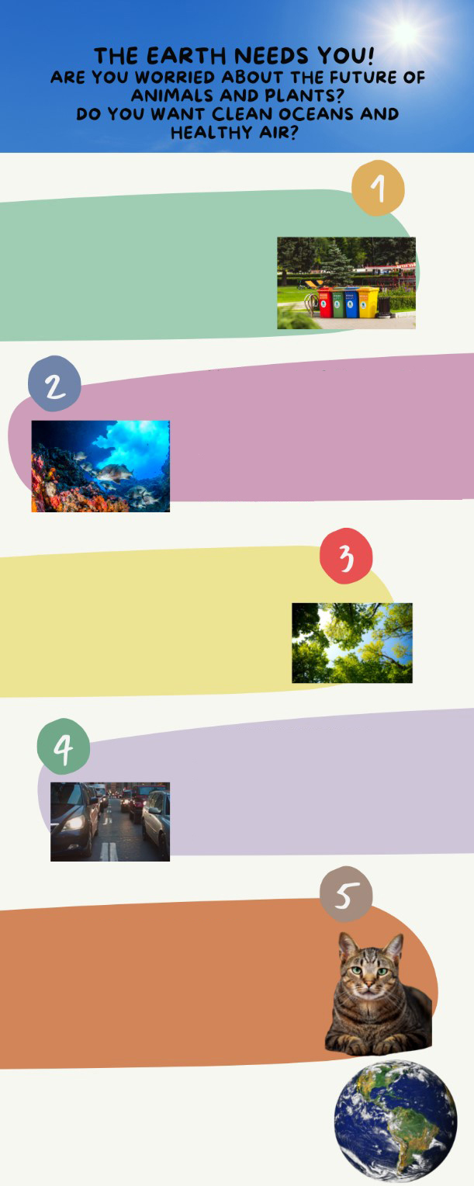
You want to learn more about how to take care of the environment. You have seen this poster on the wall of your school with information about a course for teenagers. The course will give you a lot of ideas that you will want to put into practice. You have
to be in groups of four people, so you
can talk to three of your friends and tell
them about the course. Two of them
are interested in joining, but the
other one is not. That friend thinks
that taking care of the environment
is boring and useless. You have to
LEARN TIPS TO RECYCLE
The importance of the 3 “Rs”: reduce,
reuse, recycle, just a little effort will
bring a lot of benefits for the planet.
We will play games that will play games
that will teach us how to be eco-friendly!!
CLEAN THE OCEANS, SEAS
AND RIVERS
Learn about marine life and what we all can do to protect it. We will design a plan to reduce pollution in the rivers and on how to enjoy a day on the beach with responsibility.
HAVE YOU GOT GREEN
FINGERS?
We will plant a tree and will learn how
to take care of plants. In these project,
you are the most important part!
THE AIR WE BREATH
The quality of the air will be a lot better
if we follow a few steps. Use your
legs not vehicles. We will see how
small changes can make a big
difference!
TAKE CARE OF ANIMALS
Do you love animals? So do we! Learn
about their habitats, their food and
how to look after them. There are a lot
of endangered species. There is a lot we
can do to keep them safe.
JOIN OUR COURSE NOW!
GROUPS OF FOUR PEOPLE FROM
12 TO 16 YEARS OLD.
tell him / her about the advantages of
learning how to be more aware of
the environment.

You have ten minutes to prepare the task. Your conversation should last between 2.30 to 3 minutes.

In an oral mediation, your ideas have to be clear. Pay attention to the content of the texts, images, infographics
and / or videos provided.

Make sure it is clear why you are talking about the topic. Refer to the context.

Refer to the document you have been asked to read, but do not read it aloud. Paraphrase the ideas there.

Let’s get ready!
1. Analyse the task
a. Read the task carefully and answer these questions. They will help you choose the register of the mediation task.
a) Who is the receiver of the message?
b) Is this a formal or an informal message?
c) What type of vocabulary should be used?
b. After analysing the task, choose the correct answer:
a) Informal language should be rude and impolite.
b) I will give general and specific information about the topic using informal
language.
c) I should ask the receiver questions all the time.
2. Analyse the information
Read the information in the poster carefully.
a) What is the important information in the poster that your friend Laura needs?
b) Underline the ideas that you think can be most effective to convince Laura.
Let’s prepare the language!
1. Discuss the main ideas
1. Read this text where a person is explaining some reasons to take care of the
environment and the benefits it will bring for the planet. Underline all the expressions he or she uses to present the benefits.
The World Health Organization has published research and the results are alarming. There are a lot of consequences of global warming that are affecting the health of the population. Many diseases have their origin in the bad quality of the air we breathe and the pollution of the oceans. The number of endangered species is increasing and climate change is a reality that we live with.
All these problems are avoidable if we change our habits. We can all be part of the problem or part of the solution. Learning to recycle, planting trees, cleaning the rivers, seas and oceans are some of the things we can do to repair the damage we have done to our planet. It is in our hands to change the reality we are living in and to change things for the better. Spread the word and share the information. If we can make a difference as individuals, imagine all the things we can do as a society. Renewable energy sources are the future, give them a try.


Do not use the same expressions all the time. It is important to include new vocabulary in order to sound more natural.

Other Useful Language
for good
Give it a try!
On the one hand, …
On the other hand, …
endangered species
extinction
2. Imagine you have to tell a story. Put the following words in the order they should be used.
Finally After that First

1. _____________________________
2. _____________________________
3. _____________________________
2. Give reasons and examples
1. Complete the topic sentences. Give a reason and an example that support each of the statements below.
a) There are many reasons why learning about the environment is a good idea. ____________________________________________________________________
b) Improving the quality of air is in our hands.
____________________________________________________________________

Let’s mediate!
You want to learn more about how to take care of the environment. You have seen a poster on the wall of your school with information about a course for teenagers. The course will give you a lot of ideas that you will want to put into practice. You have to be in groups of four people, so you can talk to three of your friends and tell them about the course. Two of them are interested in joining, but the other one is not. That friend, Laura, thinks that taking care of the environment is boring and useless. You have to tell her about the advantages of learning how to be more aware of the environment.
1. Content
Content
Look at the poster on page 1 and read the information there carefully again. Select the information you are going to tell your friend Laura. You can use the following questions:
- Apart from the population, who else will benefit from a healthy environment?
- Why is it said that renewable energy sources are the future?
2. Language
Use your own words. Simplify or paraphrase the information.
Remember to adapt your register to the task and addressee.
Vary the language you use. Look at the Other Useful Language on page 3.
Language

