A2 - Oral Mediation 1: Task
Are you green?
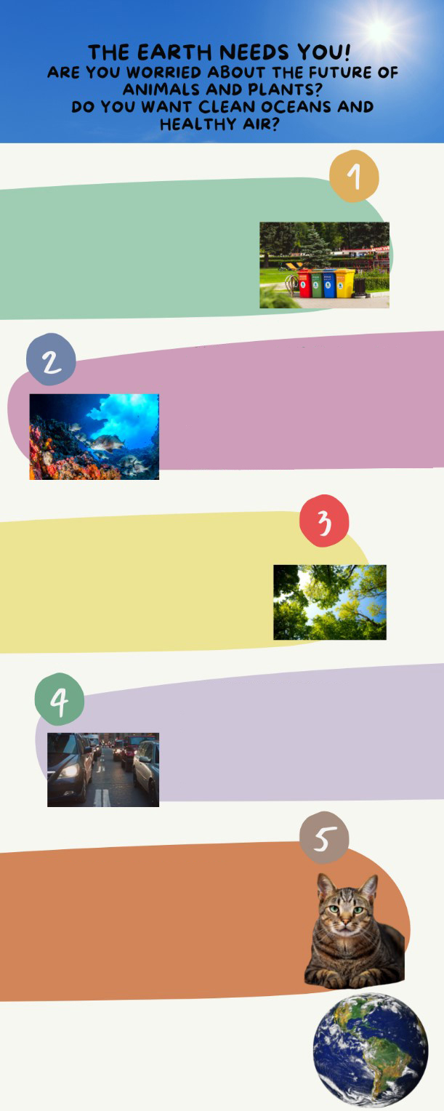
You want to learn more about how to take care of the environment. You have seen this poster on the wall of your school with information about a course for teenagers. The course will give you a lot of ideas that you will want to put into practice. You
have to be in groups of four people,
so you can talk to three of your
friends and tell them about the
course. Two of them are interested
in joining, but the other one is not.
LEARN TIPS TO RECYCLE
The importance of the 3 “Rs”: reduce,
reuse, recycle, just a little effort will
bring a lot of benefits for the planet.
We will play games that will play games
that will teach us how to be eco-friendly!!
CLEAN THE OCEANS, SEAS
AND RIVERS
Learn about marine life and what we all can do to protect it. We will design a plan to reduce pollution in the rivers and on how to enjoy a day on the beach with responsibility.
HAVE YOU GOT GREEN
FINGERS?
We will plant a tree and will learn how
to take care of plants. In these project,
you are the most important part!
THE AIR WE BREATH
The quality of the air will be a lot better
if we follow a few steps. Use your
legs not vehicles. We will see how
small changes can make a big
difference!
TAKE CARE OF ANIMALS
Do you love animals? So do we! Learn
about their habitats, their food and
how to look after them. There are a lot
of endangered species. There is a lot we
can do to keep them safe.
JOIN OUR COURSE NOW!
GROUPS OF FOUR PEOPLE FROM
12 TO 16 YEARS OLD.
That friend thinks that taking care of
the environment is boring and
useless. You have to tell him / her
about the advantages of learning how
to be more aware of the environment.
You have ten minutes to prepare the task. Your conversation should last between 2.30 to 3 minutes.

In an oral mediation, your ideas have to be clear. Pay attention to the content of the texts, images, infographics
and / or videos provided.

Make sure it is clear why you are talking about the topic. Refer to the context.

Refer to the document you have been asked to read, but do not read it aloud. Paraphrase the ideas there.

