A2 - Oral Mediation 2: Teacher’s Notes
Before starting the mediation activity, ask students to read the task and the poster carefully to make the aim of the activity clear.
Good habits for a better life.
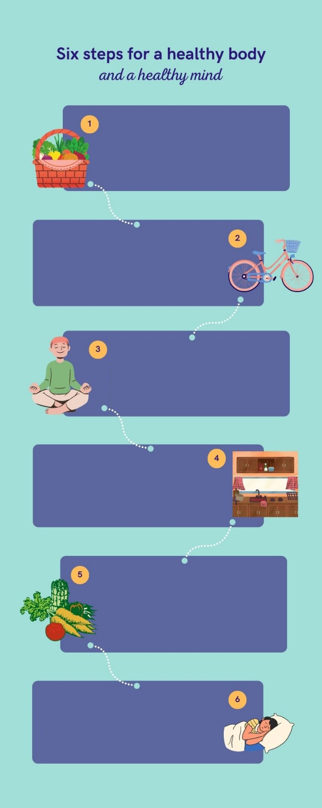
Your friend Thomas is from Wales. He has written a lot of exams at school and has not had much time to do any sport for a long time. He has also gained some weight because he has eaten fast food. He is feeling tired and is not in good shape. He is also very stressed
and anxious. Now, his exams have
finished, and he wants to change his
eating habits and become more active.
He feels a bit lost and does not know what
he can do to change. He has sent a voice
Choose food that is good for you
Write a shopping list before going to the supermarket. Read the labels of the products
and pay attention to the nutritional values.
That way you can choose better products
with good nutrients, less fat and less sugar.
Prepare a workout plan
Create a plan to do exercise at least three
times a week and stick to that plan. You don’t
have to buy expensive equipment. Go for a long
walk, ride your bike or go skating. That will
improve your stamina and you will feel a lot
better.
Save a momento for yourself
A healthy life goes hand in hand with a
healthy mind. Look for quiet place at
home, switch off at the electronic devices
and mediate for some time. Take deep
breaths and be calm. It Works!
Spend some time cooking
Ordering food is easy, but if you dedícate
some time to cooking your own meals, you
will get better results. Choose good
ingredients and your food will be healthier.
You will also sabe a lot of money.
Eat more fruit and vegetables
Include more food and vegetables in your
meals. They contain a lot of vitamins,
minerals, fibre and many other good nutrients
that are necessary for a balanced diet.
Combine them to create new recipes.
The importance of sleep
We should spend two thirds of our life sleeping. The recommended average is to sleep 7 to 8 hours a day. A good sleep will make you be more active during the day and you will be more dynamic.
message to your mobile phone asking
you for advice. You want to help by
telling him some things that he can do to
improve his health.
You have ten minutes to prepare the task. Your message to Thomas should last between 2.30 to 3 minutes. Remember that you have to give him clear and concise information. Your message has to include tips and advice to improve his health.

In oral mediation,
you need to
understand the
texts and the
images provided. When you
understand all the ideas, try to
explain your message in your
own words.

Make sure it is clear why you
are talking about the topic.
Refer to the context.

Refer to the document you have
been asked to read, but do not
read it aloud. Use the
information given in the texts.

Let’s get ready!
In this section, you will help students to get ready for the task. First of all, they will learn what to do (Analyse the task) and later, they will work on the information (Analyse the information). You can give them the Learning Sequence worksheet to work on.
1. Analyse the task
Tell students they are going to think about the receiver of the message, the reason for the message and the information included. This will help them to use the proper register (formal or informal).
a. Read the task carefully and answer these questions.
a) Who will send the message? the student doing the activity
b) Who will receive the message? The receiver is Thomas.
c) What information does Thomas need? He needs help to change his habits.
b. After analysing the task, choose the correct answer.
a) I have to give Thomas the information he is asking for.
b) In this mediation task, I have to use complicated language and omit information.
c) Oral language is more formal.
2. Analyse the information
Now tell students to think about the relevant information on the poster they will have to use.
Read the information in the poster carefully.
- What is the important information in the poster that your friend needs?
Eat better food and cook at home, get more sleep, do exercise and meditate.
- Underline the ideas that you think can help Thomas develop new, healthy habits.
Accept all logical answers.

Let’s prepare the language!
In this section, students will learn structures and language suitable for the task
1. Discuss advantages and benefits
1. Read this text where a doctor is explaining the advantages of good habits for both the body and the mind. Underline the time expressions that the doctor uses.
Nowadays we are living in a very stressful world. Every day we have to face new challenges and do a lot of activities. Studies, work, traffic jams and many other things make us feel anxious and tired. From time to time, we have to disconnect from all that. The problem is when we do not know how to do it. First of all, we have to remember that stress is a silent problem that hardly ever warns us before it is too late.
We live immersed in such chaos that we do not have time to notice the problems that are associated with stressful situations. Panic attacks, high blood pressure and lack of concentration are some of the problems that can appear if we do not learn how to take care of ourselves. In the end, we can experience a lot of changes in our body and mind that have to be treated by specialists. Learn the symptoms and treat them before it is too late. Listen to your body! If you do, your quality of life will improve. Also, take care of your mind and think positively. We need a healthy mind in a healthy body!


Other Useful Language
Do not use the same expressions all the time. Include these new expressions in your vocabulary and put them into practice.

You should …
Don´t forget that …
The best thing you can do …
… as well as …
Both … and …
Neither … nor…
2. Put the time expressions below in order from more frequent to less frequent.
never always hardly ever usually

1. always
2. usually
3. hardly ever
4. never
2. Give reasons and examples
1. Answer the following questions with information from the text. Copy the evidence.
a) What consequences can a stressful life have on our health?
Panic attacks, high blood pressure and lack of concentration are some of the problems.
b) Is there anything we can do to avoid health problems caused by stress?
Learn the symptoms and treat them.
Let’s mediate!
Make sure students understand the task and you can summarise the tips below.
Your friend Thomas is from Wales. He has written a lot of exams at school and has not had much time to do any sport for a long time. He has also gained some weight because he has eaten fast food. He is feeling tired and is not in good shape. He is also very stressed and anxious. Now, his exams have finished, and he wants to change his eating habits and become more active. He feels a bit lost and does not know what he can do to change. He has sent a voice message to your mobile phone asking you for advice. You want to help by telling him some things that he can do to improve his health.
1. Content
Look at the poster on page 1 and read the information there carefully again. Select the information you are going to tell your friend Thomas. You can use the following questions:
- Apart from the tips in the poster, can you think of any other good advice for Thomas?
Accept all logical and grammatically correct answers. Possible answer: Avoid being exposed to screens 30 minutes before going to bed.
- Does a balanced diet have benefits?
A balanced diet will give you nutrients that you body needs. Junk food contains a lot of fat and sugar that will make you feel tired.
Content
2. Language
Language
Use your own words. Simplify or paraphrase the information.
Remember to adapt your register to the task and addressee.
Vary the language you use. Look at the Other Useful Language on page 3.
Refer students to the task again and tell them to pay special attention to the Quick Tip. Make sure that the students read the rubric, so that they know what is important.

Let’s evaluate!
Rubrics for assessment
 Oral Mediation
 | Excellent | Good | Acceptable | Unsuitable
Clarity | The information is clear and easy to follow. The main points are clear. | The information is clear to follow but sometimes it is not easy to understand what the main points are. | Some of the information selected is not relevant, lacks coherence and may include contradictions. | The information selected is not relevant, not clear, not easy to follow and includes contradictions.
Relevancy and processing | The student has summarised and paraphrased the main ideas without copying literally. No information has been added. | The student has summarised the main ideas but has not paraphrased them. No information has been added. | The student conveys some appropriate information by summarising the main ideas, but not all. | The student doesn’t convey much appropriate information or has copied it from the text. Extra information may have been added.
Flow | The student speaks confidently without many pauses. The speech is fluent. | The student mostly speaks confidently without many pauses. The speech is fluent. | The student speaks confidently part of the time with several pauses. The speech is not always fluent. | The student doesn’t speak confidently and often pauses. The speech is not fluent.
Vocabulary | The student uses a wide rage of appropriate vocabulary. | The student mostly uses appropriate and varied vocabulary. | The student uses appropriate vocabulary but it is not varied. | The student doesn’t use varied vocabulary or is not able to paraphrase.
Grammar | The student uses a wide range of correct grammatical structures. | The student uses a wide range of grammatical structures but not always correctly. | The student uses basic but correct grammatical structures. | The student uses basic grammatical structures but not always correctly.
Pronunciation and intonation | The student uses understandable pronunciation and intonation. | The student mostly uses understandable pronunciation and intonation. | The student uses understandable pronunciation and intonation with a strong foreign accent. | The student doesn’t use understandable pronunciation and intonation.

