A2 - Oral Mediation 2: Task
Good habits for a better life.
Your friend Thomas is from Wales. He has written a lot of exams at school and has not had much time to do any sport for a long time. He has also gained some weight because he has eaten fast food. He is feeling tired and is not in good shape. He is also very stressed and anxious. Now, his exams have finished, and he wants to change his eating
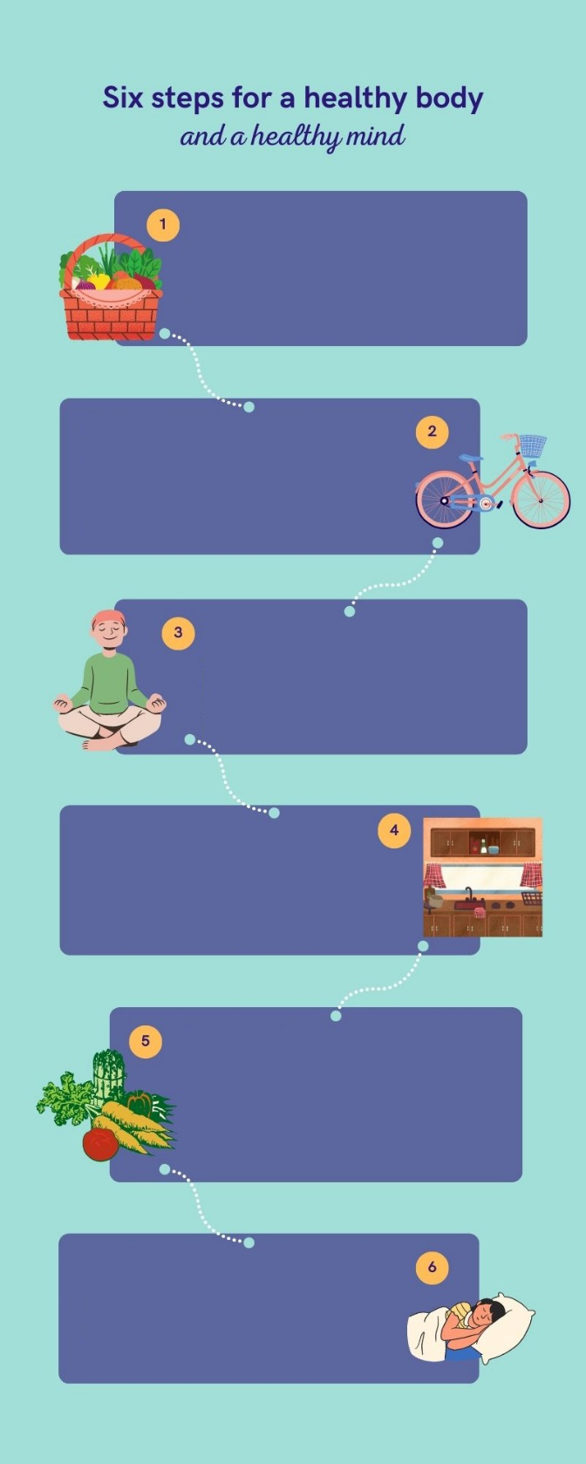
habits and become more active. He feels
a bit lost and does not know what he can
do to change. He has sent a voice
message to your mobile phone asking
you for advice. You want to help by
Choose food that is good for you
Write a shopping list before going to the supermarket. Read the labels of the products
and pay attention to the nutritional values.
That way you can choose better products
with good nutrients, less fat and less sugar.
Prepare a workout plan
Create a plan to do exercise at least three
times a week and stick to that plan. You don’t
have to buy expensive equipment. Go for a long
walk, ride your bike or go skating. That will
improve your stamina and you will feel a lot
better.
Save a momento for yourself
A healthy life goes hand in hand with a
healthy mind. Look for quiet place at
home, switch off at the electronic devices
and mediate for some time. Take deep
breaths and be calm. It Works!
Spend some time cooking
Ordering food is easy, but if you dedícate
some time to cooking your own meals, you
will get better results. Choose good
ingredients and your food will be healthier.
You will also sabe a lot of money.
Eat more fruit and vegetables
Include more food and vegetables in your
meals. They contain a lot of vitamins,
minerals, fibre and many other good nutrients
that are necessary for a balanced diet.
Combine them to create new recipes.
The importance of sleep
We should spend two thirds of our life sleeping. The recommended average is to sleep 7 to 8 hours a day. A good sleep will make you be more active during the day and you will be more dynamic.
telling him some things that he can do to
improve his health.
You have ten minutes to prepare the task. Your message to Thomas should last between 2.30 to 3 minutes. Remember that you have to give him clear and concise information. Your message has to include tips and advice to improve his health.

In oral mediation,
you need to
understand the
texts and the
images provided. When you
understand all the ideas, try to
explain your message in your
own words.

Make sure it is clear why you
are talking about the topic.
Refer to the context.

Refer to the document you have
been asked to read, but do not
read it aloud. Use the
information given in the texts.

