A2 - Written Mediation 1: Teacher’s Notes
Before starting the mediation activity, ask students to read the task and the information carefully to make the aim of the activity clear.
Let’s celebrate!
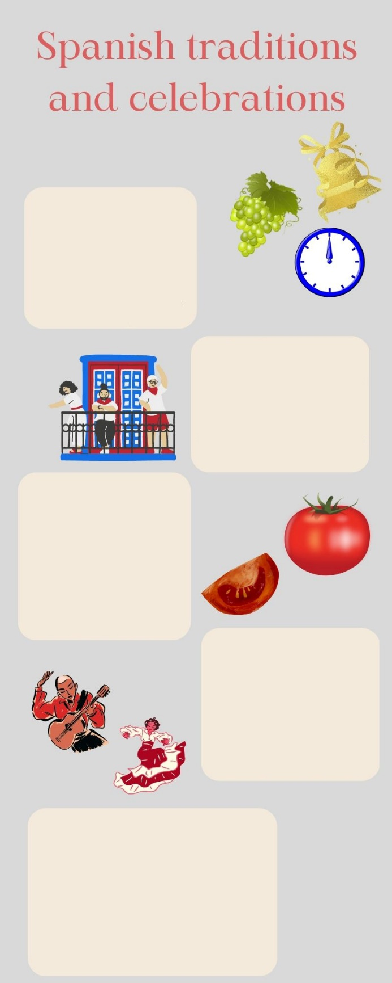
Your friend Martina lives in Northern Ireland. She is preparing an oral presentation for her school. She has been to Spain several times with her family on holiday, and she
loves our country. She is very interested
in Spanish traditions and celebrations,
so she has chosen to speak about them.
She has sent you an e-mail asking for
help: she needs some information
about the most typical celebrations and
what people in Spain do to keep
New Year’s Eve
On New Year’s Eve, Spanish
people eat 12 grapes
when the clock strikes
12 times at midnight.
According to the tradition,
this will bring you good luck
for new year.
San Fermin
San Fermin is celebrated in
the city of Pamplona. On the
7th July, local people and
tourists share a good time
together dancing, playing music
and eating typical food.
People wear white and red clothes.
La Tomatina
At the end of the month of August, a small town in Valencia celebrates La Tomatino. Floats are driven around the streets and the people on them throw soft tomatoes at people. It is a very colourful celebrations.
Flamenco
It is a type of music that is played with a guitar, but there are also other instruments that can be used. There is usually one singer, and flamenco dancers perform typical flamenco choreographies. Woman dancers wear special flamenco dresses.
Blooming Cherry Trees
Extremadura celebrates
this festivity in March.
People go to the cherry tree
orchards to see the new
season’s blossoms. There
are many activities in the
town of Valle del Jerte
and people have a great time
traditions alive. She knows that some of
the things that we do to celebrate
festivities in Spain are different from
the things people do in Northern
Ireland, so she needs your help to get to
know them. You write her an e-mail
giving her some information about the
most popular celebrations in Spain.
Your e-mail to Martina should have between 65 to 80 words. Remember that you have to use paragraphs and follow the structure of an informal
e-mail.

In written mediation,
you need to
understand
the texts and the
images provided. When you
understand all the ideas, try to
explain your message in your
own words.

Make sure it is clear why you
are talking about the topic.
Refer to the context.
Underline the words and
expressions that will help you
to understand the text better.
Let’s get ready!
In this section, you will help students to get ready for the task. First of all, they will learn what to do (Analyse the task) and later, they will work on the information (Analyse the information). You can give them the Learning Sequence worksheet to work on.
1. Analyse the task
Tell students they are going to think about the receiver of the message, the reason for the message and the information included. This will help them to use the proper register (formal or informal).
a. Read the task carefully and answer these questions. They will help you choose the register of the mediation task.
a) Who is going to receive the e-mail? Martina
b) Why is she asking you for help? She has to do a presentation for her class.
c) What are you going to write about? traditions and festivities
b. After analysing the task, choose the correct answer:
a) In a mediation task you have to / don´t have to be clear about the message.
b) In a mediation task, it is / it is not important to pay attention to the register.
c) Written language tends to be more formal / informal than oral language.
2. Analyse the information
Tell students to think about the relevant information on the infographic they will have to use.
Read the information on the infographic carefully.
a) What is the important information in the infographic that your friend needs? The important information is the names of the festivities and celebrations and what they consist of.
b) Underline the ideas that are important for Martina´s project.
Accept all logical answers.

Let’s prepare the language!
In this section, students will learn structures and language suitable for the task.
1. Discuss advantages and benefits
1. Read this text where a person is writing about the importance of traditions. Read carefully and underline the connectors you see.
From ancient times, people have celebrated a good harvest. Having plenty of cereals, fruit and vegetables was a sign of a prosperous year ahead. However, not all the years had reasons to celebrate. Plagues, floods and droughts were problems that affected harvests. Despite the effort of farmers, climate conditions could ruin the economy of an entire village as this was a factor they could not control. Moreover, a lot of people could have serious problems even to survive. That is why good harvests were celebrated with such joy and how season festivities have come down to us.
We still depend on good harvests to live, but our reality is completely different. We still try to keep traditions alive and season festivities are the perfect excuse to visit interesting places and learn about other cultures.
In addition, the beginning of spring or summer have also been a reason to celebrate. Temperatures got warmer and the cold winter was finished. Nowadays, we are not so exposed to extreme weather. Nevertheless, we will always find a reason to celebrate old traditions!

Do not use the same expressions all the time. It is important to vary your language to show that your skills are improving.

Other Useful Language
For example, …
For instance, …
… , such as …
A typical example is …
To give you an idea, …
… an example being …
2. Read the words below and classify them into two categories.
rain drought flood plague sun soil

GOOD FOR HARVESTS | BAD FOR HARVESTS
rain | drought
sun | flood
soil | plague

2. Give reasons and examples
1. Give a reason and an example that support each of the statements below.
a) Having good harvests is important for the population.
Good harvests are important because they give us food.
b) Natural disasters can affect harvests.
Plagues, droughts and floods can ruin harvests.
Let’s mediate!
Make sure the students understand the task and you can summarise the tips below.
Your friend Martina lives in Northern Ireland. She is preparing an oral presentation for her school. She has been to Spain several times with her family on holiday, and she loves our country. She is very interested in Spanish traditions and celebrations, so she has chosen to speak about them. She has sent you an e-mail asking for help: she needs some information about the most typical celebrations and what people in Spain do to keep traditions alive. She knows that some of the things that we do to celebrate festivities in Spain are different from the things people do in Northern Ireland, so she needs your help to get to know them. You write her an e-mail giving her some information about the most popular celebrations in Spain.
1. Content
Look at the poster on page 1 and read the information there carefully again. Select the information you are going to tell your friend Martina. You can use the following questions
- Which festivities are related to food in any way?
All of them except flamenco.
- Which festivities involve special clothes?
Flamenco and San Fermin
Content
2. Language
Language
Use your own words. Simplify or paraphrase the information.
Remember to adapt your register to the task and addressee.
Vary the language you use. Look at the Other Useful Language on page 3.
Refer students to the task again and tell them to pay special attention to the Quick Tips. Make sure that students read the rubric, so that they know what is important.

Let’s evaluate!
Rubrics for assessment
 Written Mediation
 | Excellent | Good | Acceptable | Unsuitable
Clarity | The information is clear and easy to follow.The main points are emphasised. | The information is clear to follow but sometimes it is not easy to understand what the main points are. | The information selected is not relevant, lacks coherence and  may include contradictions. | The information selected is not relevant, not clear, not easy to follow and includes contradictions.
Relevancy and processing | The student has summarised and paraphrased the main ideas without copying literally. No information has been added. | The student has summarised the main ideas but has not paraphrased them. No information has been added. | The student conveys some appropriate information by summarising the main ideas, but not all. | The student doesn’t convey much appropriate information or has copied it from the text. Extra  information may have been added.
Genre and organisation | The text follows the conventions of the specific text type, addressing it appropriately to the specific audience. | The text follows the conventions of the specific text type, but it is not addressed appropriately to the specific audience. | The text follows the conventions of the specific text type to a certain extent but the degree of formality is not correct. | The text does not follow the conventions of the specific text type, or it is not addressed appropriately to the specific audience.
Cohesion and organisation | The written text is logically organised, connected and cohesive. The text is organised in paragraphs, which have a key sentence. A wide range of connectors and linkers is used. | The written text is logically organised, connected and cohesive. The text is organised in paragraphs, which mostly have a key sentence. Basic connectors and linkers are correctly used. | The written text is organised, connected and cohesive. The text is organised in paragraphs but they do not have key sentences. A few basic connectors and linkers are correctly used. | The written text is not logically organised. Some parts are not coherent. Paragraphs seem to have no connection. Some basic connectors and linkers are used but not all correctly.
Vocabulary | The student uses a wide rage of appropriate vocabulary. Spelling is correct. | The student mostly uses appropriate and varied vocabulary. Spelling is correct. | The student uses appropriate vocabulary but it is not varied. There are some spelling mistakes but they do not impede comprehension. | The student doesn’t use varied vocabulary or is not able to paraphrase. There are many spelling mistakes.
Grammar | The student uses a wide range of correct grammatical structures. | The student uses a wide range of grammatical structures but not always correctly. | The student uses basic but correct grammatical structures. | The student uses basic grammatical structures but not always correctly.

