A2 - Written Mediation 1: Learning Sequence
Let’s celebrate!
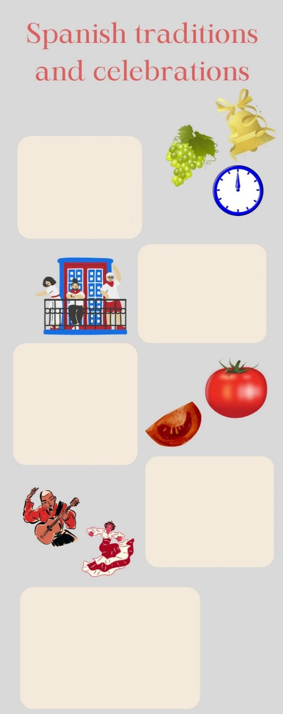
Your friend Martina lives in Northern Ireland. She is preparing an oral presentation for her school. She has been to Spain several times with her family on holiday, and she loves our country. She is very interested in Spanish traditions and celebrations, so she
New Year’s Eve
On New Year’s Eve, Spanish
people eat 12 grapes
when the clock strikes
12 times at midnight.
According to the tradition,
this will bring you good luck
for new year.
San Fermin
San Fermin is celebrated in
the city of Pamplona. On the
7th July, local people and
tourists share a good time
together dancing, playing music
and eating typical food.
People wear white and red clothes.
La Tomatina
At the end of the month of August, a small town in Valencia celebrates La Tomatino. Floats are driven around the streets and the people on them throw soft tomatoes at people. It is a very colourful celebrations.
Flamenco
It is a type of music that is played with a guitar, but there are also other instruments that can be used. There is usually one singer, and flamenco dancers perform typical flamenco choreographies. Woman dancers wear special flamenco dresses.
Blooming Cherry Trees
Extremadura celebrates
this festivity in March.
People go to the cherry tree
orchards to see the new
season’s blossoms. There
are many activities in the
town of Valle del Jerte
and people have a great time
has chosen to speak about them. She
has sent you an e-mail asking for help:
she needs some information about the
most typical celebrations and what
people in Spain do to keep traditions
alive. She knows that some of the
things that we do to celebrate
festivities in Spain are different from
the things people do in Northern
Ireland, so she needs your help to get to
know them. You write her an e-mail
giving her some information about the
most popular celebrations in Spain.
Your e-mail to Martina should have between 65 to 80 words. Remember that you have to use paragraphs and follow the structure of an informal e-mail.

In written mediation,
you need to
understand
the texts and the
images provided. When you
understand all the ideas, try to
explain your message in your
own words.

Make sure it is clear why you
are talking about the topic.
Refer to the context.
Underline the words and
expressions that will help you
to understand the text better.

Let’s get ready!
1. Analyse the task
a. Read the task carefully and answer these questions. They will help you choose the register of the mediation task.
a) Who will receive the e-mail?
b) Why is she asking you for help?
c) What are you going to write about?
b. After analysing the task, choose the correct answer.
a) In a mediation task you have to / don´t have to be clear about the message.
b) In a mediation task, it is / it is not important to pay attention to the register.
c) Written language tends to be more formal / informal than oral language.
2. Analyse the information
Read the information in the poster carefully.
a) What is the important information in the poster that your friend needs?
b) Underline the ideas that are important for Martina´s project.
Let’s prepare the language!
1. Discuss advantages and benefits
1. Read this text where a person is writing about the importance of traditions.
Read carefully and underline the connectors you see.
From ancient times, people have celebrated a good harvest. Having plenty of cereals, fruit and vegetables was a sign of a prosperous year ahead. However, not all the years had reasons to celebrate. Plagues, floods and droughts were problems that affected harvests. Despite the effort of farmers, climate conditions could ruin the economy of an entire village as this was a factor they could not control. Moreover, a lot of people could have serious problems even to survive. That is why good harvests were celebrated with such joy and how season festivities have come down to us.

We still depend on good harvests to live but our reality is completely different. We still try to keep traditions alive and season festivities are the perfect excuse to visit interesting places and learn about other cultures.
In addition, the beginning of spring or summer have also been a reason to celebrate. Temperatures got warmer and the cold winter was finished. Nowadays, we are not so exposed to extreme weather. Nevertheless, we will always find a reason to celebrate old traditions!


Do not use the same expressions all the time. It is important to vary your language to show that your skills are improving.

Other Useful Language
For example, …
For instance, …
… , such as …
A typical example is …
To give you an idea, …
… an example being …
2. Read the words below and classify them into two categories.
rain drought flood plague sun soil

GOOD FOR HARVESTS | BAD FOR HARVESTS
2. Give reasons and examples
1. Give a reason and an example that support each of the statements below.
a) Having good harvests is important for the population.
___________________________________________________________________
b) Natural disasters can affect harvests.
___________________________________________________________________

Let’s mediate!
Your friend Martina lives in Northern Ireland. She is preparing an oral presentation for her school. She has been to Spain several times with her family on holiday, and she loves our country. She is very interested in Spanish traditions and celebrations, so she has chosen to speak about them. She has sent you an e-mail asking for help: she needs some information about the most typical celebrations and what people in Spain do to keep traditions alive. She knows that some of the things that we do to celebrate festivities in Spain are different from the things people do in Northern Ireland, so she needs your help to get to know them. You write her an e-mail giving her some information about the most popular celebrations in Spain.
1. Content
Content
Look at the poster on page 1 and read the information there carefully again. Select the information you are going to tell your friend Martina. You can use the following questions:
- Which festivities are related to food in any way?
- Which festivities involve special clothes?
2. Language
Language
Use your own words. Simplify or paraphrase the information.
Remember to adapt your register to the task and addressee.
Vary the language you use. Look at the Other Useful Language on page 3.

