A2 - Written Mediation 1: Task
Let’s celebrate!
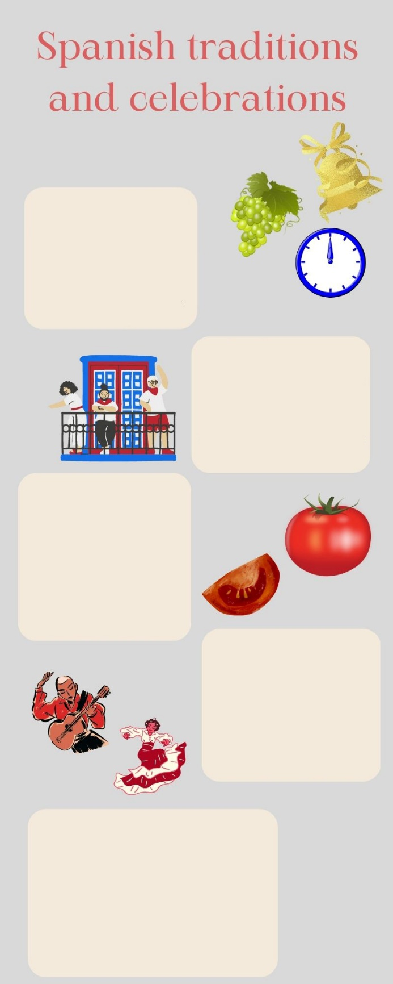
Your friend Martina lives in Northern Ireland. She is preparing an oral presentation for her school. She has been to Spain several times with her family on holiday, and she loves our country. She is very interested in Spanish traditions and celebrations, so she
has chosen to speak about them. She
has sent you an e-mail asking for help:
she needs some information about the
most typical celebrations and what
people in Spain do to keep traditions
alive. She knows that some of the
things that we do to celebrate
New Year’s Eve
On New Year’s Eve, Spanish
people eat 12 grapes
when the clock strikes
12 times at midnight.
According to the tradition,
this will bring you good luck
for new year.
San Fermin
San Fermin is celebrated in
the city of Pamplona. On the
7th July, local people and
tourists share a good time
together dancing, playing music
and eating typical food.
People wear white and red clothes.
La Tomatina
At the end of the month of August, a small town in Valencia celebrates La Tomatino. Floats are driven around the streets and the people on them throw soft tomatoes at people. It is a very colourful celebrations.
Flamenco
It is a type of music that is played with a guitar, but there are also other instruments that can be used. There is usually one singer, and flamenco dancers perform typical flamenco choreographies. Woman dancers wear special flamenco dresses.
Blooming Cherry Trees
Extremadura celebrates
this festivity in March.
People go to the cherry tree
orchards to see the new
season’s blossoms. There
are many activities in the
town of Valle del Jerte
and people have a great time
festivities in Spain are different from
the things people do in Northern
Ireland, so she needs your help to get to
know them. You write her an e-mail
giving her some information about the
most popular celebrations in Spain.
Your e-mail to Martina should have between 65 to 80 words. Remember that you have to use paragraphs and follow the structure of an informal
e-mail.

In written mediation,
you need to
understand
the texts and the
images provided. When you
understand all the ideas, try to
explain your message in your
own words.

Make sure it is clear why you
are talking about the topic.
Refer to the context.
Underline the words and
expressions that will help you
to understand the text better.

