A2 - Written Mediation 2: Teacher’s Notes
Before starting the mediation activity, ask students to read the task and the information carefully to make the aim of the activity clear.
Routines at school.
You met your friend Claire when you were in the UK on holiday. You have been sending each other e-mails for a long time. Now, she is interested in coming to Spain for a term and she wants to know about your school. Write an e-mail telling her about the timetables, activities, school trips and facilities. Include some information about the rules and
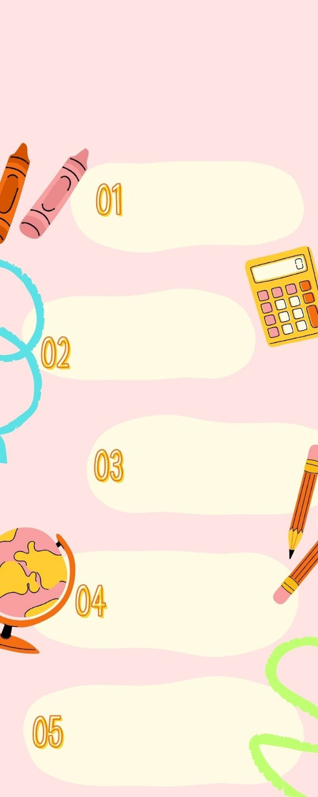
regulations that she will have to follow.
SCHOOL RULES
AND REGULATIONS
Give her as much information as possible,
so she can have a clear idea about the
school she is coming to.
Your e-mail to Claire should be between 65 to 80 words. Remember that you have to use paragraphs and follow the structure of an informal e-mail.
TIMETABLES
School starts at 8:30 and there is a break from 11:10 to 11:35. Then we go back to class until 14:15. Students and teachers must be punctual.
SCHOOL FACILITIES
There are two buildings with classrooms, a library, a gym,
a computer room, a football pitch,
a tennis court and a cafetería.
SCHOOL MATERIAL
Students must bring their books and material to class every day. They will receive the key to their locker. The
day that you have physical education, you will need special clothes.
EXTRA-CURRICULAR ACTIVITIES
The school offers a lot of activities
that you can do when classes finish. You can join our chess club, our rock band are even play sport in our basketball or volleyball teams.
SCHOOL TRIPS
Students will go on school trips to practise the things they have seen in class. These activities are compulsory for all the students. You will learn and have fun with your classmates and teachers.

In written
mediation, you
need to
understand the
texts and the images provided.
When you understand all the
ideas, try to explain your
message in your own words.

Make sure it is clear why you
are talking about the topic.
Refer to the context.
Write a short list with the main
ideas from the text that you
want to include in your final
text.

Let’s get ready!
In this section, you will help students to get ready for the task. First of all, they will learn what to do (Analyse the task) and later, they will work on the information (Analyse the information). You can give them the Learning Sequence worksheet to work on.
1. Analyse the task
Tell students they are going to think about the receiver of the message, the reason for the message and the information included. This will help them to use the proper register (formal or informal).
a. Read the task carefully and answer these questions. They will help you choose the register of the mediation task.
a) Who will receive of the message? Claire
b) Why are you going to send the message? Because Claire is coming to my school for a term.
c) What information does the receiver need? She needs general information about the school and its routines.
b. Are the following sentences true or false?
a) Register is the way a person writes in relation to their audience. TRUE
b) In a mediation task I always have to use a formal register. FALSE
c) Written language is easier to understand when it is complicated. FALSE
d) I need to have clear ideas before I start to write. TRUE
2. Analyse the information
Tell students to think about the relevant information on the infographic they will have to use.
Read the information in the infographic carefully.
a) What information will you include in your e-mail? Pay attention to the titles.
timetables, school facilities, school material, extra-curricular activities and school trips
b) Underline the important ideas that you will use to write the email.
Accept all logical answers.

Let’s prepare the language!
In this section students will learn structures and language suitable for the task.
1. Discuss advantages and benefits
1. Read this text where a person explains the importance of integrating when you attend a new school. Underline the gerunds.
Before changing schools, people tend to feel anxious. Changing schools can be a wonderful experience. Sometimes people consider it as a traumatic episode but this is far from being true. After considering all the pros and cons, it is all about attitude. Having positive thoughts will make you accept the changes with an open mind and that is very important. By meeting new people, you will have the opportunity to make new friends and learn a lot from them. In the same way, you can share your experiences with them and create new bonds.
Learning new routines is easy when you know how to organise your timetable. Your classmates can be helpful with that. Your new teachers will be happy to answer any question you have. Without asking, things will be more difficult, so don´t be afraid to ask.
If you are a dynamic person, join a club or a sports team at school. There are a lot of options and all of them will make you feel more integrated. Going on school trips is another way to learn and have fun at the same time. Spending a day out on a school trip is a great opportunity to do something different, but don´t forget to follow the rules, it is important. Following the school rules will avoid problems.


Learn new expressions to include in your vocabulary. It is a great way to express yourself in a more natural and confident manner.
Other Useful Language
Have a good time!
Enjoy yourself!
Make the most of …
Amuse yourself.
Have fun!
2. Fill in the gaps using gerunds below.
cooking sitting down studying learning making

a) Making breakfast is the first thing I do in the morning.
b) Before studying for an exam, I need my books and folders on my desk.
c) Learning a new language is always good.
d) We spent four hours at the museum without sitting down. My legs hurt!
e) I improved my diet by cooking my own meals.

2. Give reasons and examples
Complete the following sentences using vocabulary from the text.
a) The list of activities and subjects you have to do at school are your timetable.
b) A group of people who practice the same collective sport is a team.
Let’s mediate!
Make sure the students understand the task and you can summarise the tips below.
You met your friend Claire when you were in the UK on holiday. You have been sending each other e-mails for a long time. Now, she is interested in coming to Spain for a term and she wants to know about your school. Write an e-mail telling her about the timetables, activities, school trips and facilities. Include some information about the rules and regulations that she will have to follow. Give her as much information as possible, so she can have a clear idea about the school she is coming to.
1. Content
Content
Look at the poster on page 1 and read the information there carefully again. Select the information you are going to tell your friend Claire. You can use the following questions:
- Make a list of the facilities at your school.
two buildings with classrooms, a library, a gym, a computer room,
a football pitch, a tennis court and a cafeteria
- Being part of a rock band at school is an example of an extra-curricular activity.
2. Language
Language
Use your own words. Simplify or paraphrase the information.
Remember to adapt your register to the task and addressee.
Vary the language you use. Look at the Other Useful Language on page 3.
Refer students to the task again and pay special attention to the Quick Tip. Make sure that the students read the rubric, so that they know what is important.

Let’s evaluate!
Rubrics for assessment
 Written Mediation
 | Excellent | Good | Acceptable | Unsuitable
Clarity | The information is clear and easy to follow.The main points are emphasised. | The information is clear to follow but sometimes it is not easy to understand what the main points are. | The information selected is not relevant, lacks coherence and  may include contradictions. | The information selected is not relevant, not clear, not easy to follow and includes contradictions.
Relevancy and processing | The student has summarised and paraphrased the main ideas without copying literally. No information has been added. | The student has summarised the main ideas but has not paraphrased them. No information has been added. | The student conveys some appropriate information by summarising the main ideas, but not all. | The student doesn’t convey much appropriate information or has copied it from the text. Extra  information may have been added.
Genre and organisation | The text follows the conventions of the specific text type, addressing it appropriately to the specific audience. | The text follows the conventions of the specific text type, but it is not addressed appropriately to the specific audience. | The text follows the conventions of the specific text type to a certain extent but the degree of formality is not correct. | The text does not follow the conventions of the specific text type, or it is not addressed appropriately to the specific audience.
Cohesion and organisation | The written text is logically organised, connected and cohesive. The text is organised in paragraphs, which have a key sentence. A wide range of connectors and linkers is used. | The written text is logically organised, connected and cohesive. The text is organised in paragraphs, which mostly have a key sentence. Basic connectors and linkers are correctly used. | The written text is organised, connected and cohesive. The text is organised in paragraphs but they do not have key sentences. A few basic connectors and linkers are correctly used. | The written text is not logically organised. Some parts are not coherent. Paragraphs seem to have no connection. Some basic connectors and linkers are used but not all correctly.
Vocabulary | The student uses a wide rage of appropriate vocabulary. Spelling is correct. | The student mostly uses appropriate and varied vocabulary. Spelling is correct. | The student uses appropriate vocabulary but it is not varied. There are some spelling mistakes but they do not impede comprehension. | The student doesn’t use varied vocabulary or is not able to paraphrase. There are many spelling mistakes.
Grammar | The student uses a wide range of correct grammatical structures. | The student uses a wide range of grammatical structures but not always correctly. | The student uses basic but correct grammatical structures. | The student uses basic grammatical structures but not always correctly.

