A2 - Written Mediation 2: Task
Routines at school.
You met your friend Claire when you were in the UK on holiday. You have been sending each other e-mails for a long time. Now, she is interested in coming to Spain for a term and she wants to know about your school. Write an e-mail telling her about the timetables, activities, school trips and facilities. Include some information about the
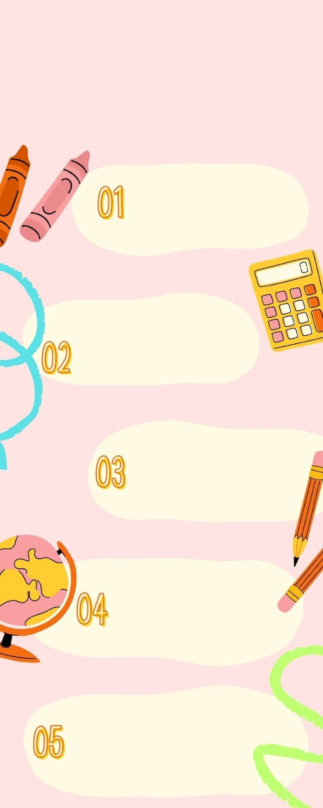
rules and regulations that she will have
to follow. Give her as much information
SCHOOL RULES
AND REGULATIONS
as possible, so she can have a clear idea
about the school she is coming to.
Your e-mail to Claire should be between 65 to 80 words. Remember that you have to use paragraphs and follow the structure of an informal e-mail.
TIMETABLES
School starts at 8:30 and there is a break from 11:10 to 11:35. Then we go back to class until 14:15. Students and teachers must be punctual.
SCHOOL FACILITIES
There are two buildings with classrooms, a library, a gym,
a computer room, a football pitch,
a tennis court and a cafetería.
SCHOOL MATERIAL
Students must bring their books and material to class every day. They will receive the key to their locker. The
day that you have physical education, you will need special clothes.
EXTRA-CURRICULAR ACTIVITIES
The school offers a lot of activities
that you can do when classes finish. You can join our chess club, our rock band are even play sport in our basketball or volleyball teams.
SCHOOL TRIPS
Students will go on school trips to practise the things they have seen in class. These activities are compulsory for all the students. You will learn and have fun with your classmates and teachers.

In written
mediation, you
need to
understand the
texts and the images provided.
When you understand all the
ideas, try to explain your
message in your own words.

Make sure it is clear why you
are talking about the topic.
Refer to the context.
Write a short list with the main
ideas from the text that you
want to include in your final
text.

