A2 - Written Mediation 3: Teacher’s Notes
Before starting the mediation activity, ask students to read the task and the information carefully to make the aim of the activity clear.
You are what you eat.
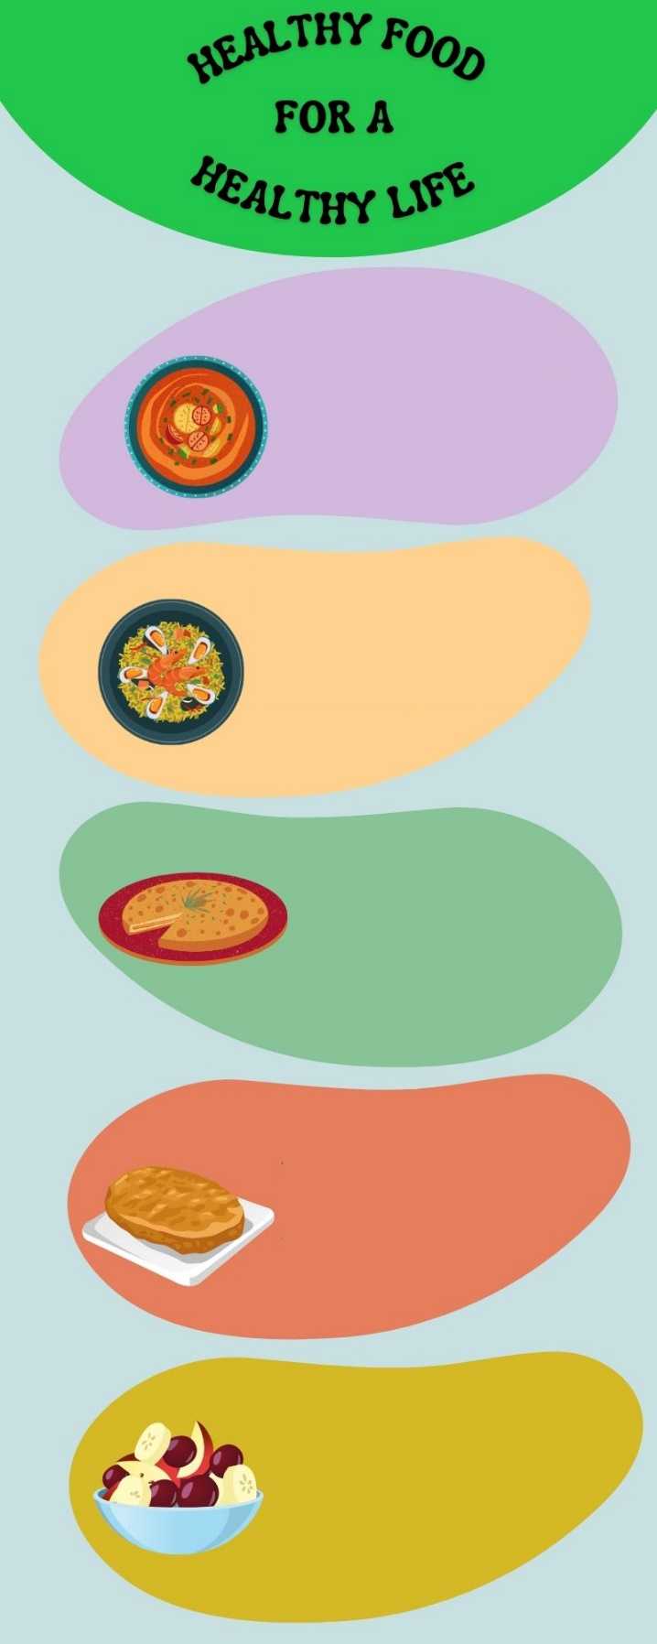
Luke is a student from the USA who is coming to Spain for two weeks. He is on an exchange
Vegetables contain a lot of
good elements for a healthy
diet. Eat them everyday for a
healthy and balanced way of
life. Gazpacho is a cold
tomato soup with other
vegetables. You will love it.
Rice is a very healthy cereal
that has a lot of nutrients. It is
also one of the main
ingredients of paella. You can add many other ingredients
and the result will be
delicious.
A healthy body needs
vitamins, fibre, proteins,
minerals and many more
elements. You will find them
all in a Spanish omelette. It
has onion, potato, olive oil
and eggs.
Fruit and seeds will give you energy
and a lot of important nutrients that will make you feel really good. Their
flavour is awesome and you can
add a lot of toppings. Add some
honey for a sweet flavour.
Eating healthy food can
include a tasty dessert:
torrijas. Easter is the season
for this delicious piece of
bread with milk, egg and
cinnamon. Eat better to feel
better!
programme with his school and will stay
with you. Luke and you have been
exchanging e-mails every week to give
information about yourselves and get to
know each other better. Luke sent an
e-mail last week saying that he is a bit
worried about the food in Spain. He told
you that he is afraid of trying new foods.
He prefers pizza and hot dogs to fruit
and vegetables. Luke thinks he will have
a hard time because he will not like the
food in a different country. Write an
e-mail to Luke telling him about the
benefits of a balanced diet and the
importance of eating fruit and
vegetables.
Your e-mail to Luke should be between 65 to 80 words. Remember that you have to use paragraphs and follow the structure of an informal e-mail.

In written
mediation, you
need to
understand the
texts and the images provided.
When you understand all the
ideas, try to explain your
message in your own words.

Make sure it is clear why you are
talking about the topic. Refer to
the context.

Write a list of five nouns and five
adjectives from the text that
areimportant in order to
understand the information given.

Let’s get ready!
In this section, you will help students to get ready for the task. First of all, they will learn what to do (Analyse the task) and later, they will work on the information (Analyse the information). You can give them the Learning Sequence worksheet to work on.
1. Analyse the task
Tell students they are going to think about the receiver of the message, the reason for the message and the information included. This will help them to use the proper register (formal or informal).
a. Read the task carefully and answer these questions. They will help you choose the register of the mediation task.
a) Who will receive the e-mail? Luke
b) Why are you going to send him an e-mail? Luke is worried about trying new foods.
c) What is the main topic of the e-mail? healthy food and diet
b. After analysing the task, choose the correct answer.
a) Being clear in the message is / is not important.
b) You need / don´t need a lot of sentences and long messages to express your ideas.
c) You need / don´t need to have clear ideas before starting to write.
2. Analyse the information
Tell students to think about the relevant information on the infographic they will have to use.
Read the information in the poster carefully.
a) Which nutrients are mentioned in the text?
proteins, vitamins, minerals and fibre
b) Underline the main ideas you will use in the e-mail to Luke.
Accept all logical answers.

Let’s prepare the language!
In this section, students will learn structures and language suitable for the task.
1. Discuss advantages and benefits
1. Read this text written by a nutritionist. He is giving us information about what a healthy diet consists of and the benefits it has. Underline the names of the foods you find.
A healthy diet is very important. It can make you feel great and gives your body all the elements it needs. Fish, meat and eggs contain protein that will keep your muscles strong. A healthy diet helps your body to fight against infections.
Cereals, grains, nuts and seeds are a great way to include carbohydrates in your diet. They give you energy to do a lot of activities. If you feel tired after doing sport, eat some bread, biscuits or a cereal bar and you will soon feel better.
Fruit and vegetables are a very good source of vitamins, minerals and fibre. They contain a lot of water and will keep you hydrated.
Milk, yoghurt and cheese have got a lot of calcium. Including these foods in your diet, will make your bones and teeth stronger. It really makes a difference to your body.
Combine healthy ingredients and you will discover new flavours and new textures to enjoy every meal, every day!

Do not use the same expressions all the time. Always include new words and expressions in your vocabulary and you will become more fluent.
Other Useful Language
Take care.
Best wishes.
Regards.
Best regards.
I wish you the best.
All the best.
2. Complete the following chart with the types of food below. Put them in the correct category.
chicken lettuce ice cream beef mushrooms apple cheese banana

MEAT | FRUIT | VEGETABLES | DAIRY
chicken | apple | lettuce | Ice cream
beef | banana | mushroom | cheese

2. Give reasons and examples
a) Four nutrients that a healthy body needs are vitamins, proteins, minerals and fibre.
b) One way of feeling better is eating healthy foods.
Let’s mediate!
Make sure the students understand the task and you can summarise the tips below.
Luke is a student from the USA who is coming to Spain for two weeks. He is on an exchange programme with his school and will stay with you. Luke and you have been exchanging
e-mails every week to give information about yourselves and get to know each other better. Luke sent an e-mail last week saying that he is a bit worried about the food in Spain. He told you that he is afraid of trying new foods. He prefers pizza and hot dogs to fruit and vegetables. Luke thinks he will have a hard time because he will not like the food in a different country. Write an e-mail to Luke telling him about the benefits of a balanced diet and the importance of eating fruit and vegetables.
1. Content
Look at the poster on page 1 and read the information there carefully again. Select the information you are going to tell Luke. You can use the following questions:
- Write the names of the cooked foods you can find in the text.
gazpacho, paella, Spanish omelette and torrijas
- What ingredient can make fruit sweeter?
honey
Content
2. Language
Language
Use your own words. Simplify or paraphrase the information.
Remember to adapt your register to the task and addressee.
Vary the language you use. Look at the Other Useful Language on page 3.
Refer students to the task again and tell them to pay special attention to the Quick Tip. Make sure that the students read the rubric, so that they know what is important.

Let’s evaluate!
Rubrics for assessment
 Written Mediation
 | Excellent | Good | Acceptable | Unsuitable
Clarity | The information is clear and easy to follow.The main points are emphasised. | The information is clear to follow but sometimes it is not easy to understand what the main points are. | The information selected is not relevant, lacks coherence and  may include contradictions. | The information selected is not relevant, not clear, not easy to follow and includes contradictions.
Relevancy and processing | The student has summarised and paraphrased the main ideas without copying literally. No information has been added. | The student has summarised the main ideas but has not paraphrased them. No information has been added. | The student conveys some appropriate information by summarising the main ideas, but not all. | The student doesn’t convey much appropriate information or has copied it from the text. Extra  information may have been added.
Genre and organisation | The text follows the conventions of the specific text type, addressing it appropriately to the specific audience. | The text follows the conventions of the specific text type, but it is not addressed appropriately to the specific audience. | The text follows the conventions of the specific text type to a certain extent but the degree of formality is not correct. | The text does not follow the conventions of the specific text type, or it is not addressed appropriately to the specific audience.
Cohesion and organisation | The written text is logically organised, connected and cohesive. The text is organised in paragraphs, which have a key sentence. A wide range of connectors and linkers is used. | The written text is logically organised, connected and cohesive. The text is organised in paragraphs, which mostly have a key sentence. Basic connectors and linkers are correctly used. | The written text is organised, connected and cohesive. The text is organised in paragraphs but they do not have key sentences. A few basic connectors and linkers are correctly used. | The written text is not logically organised. Some parts are not coherent. Paragraphs seem to have no connection. Some basic connectors and linkers are used but not all correctly.
Vocabulary | The student uses a wide rage of appropriate vocabulary. Spelling is correct. | The student mostly uses appropriate and varied vocabulary. Spelling is correct. | The student uses appropriate vocabulary but it is not varied. There are some spelling mistakes but they do not impede comprehension. | The student doesn’t use varied vocabulary or is not able to paraphrase. There are many spelling mistakes.
Grammar | The student uses a wide range of correct grammatical structures. | The student uses a wide range of grammatical structures but not always correctly. | The student uses basic but correct grammatical structures. | The student uses basic grammatical structures but not always correctly.

