A2 - Written Mediation 3: Task
You are what you eat.
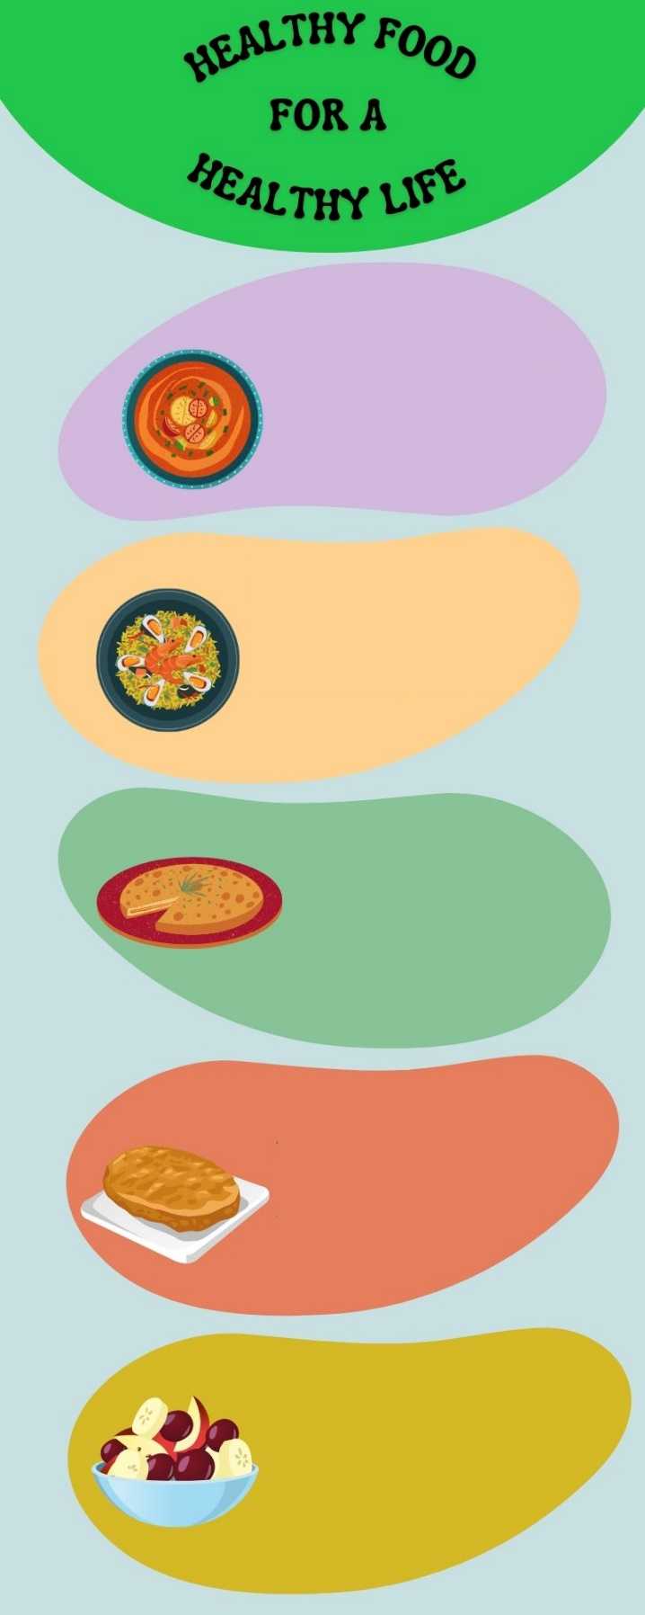
Luke is a student from the USA who is coming to Spain for two weeks. He is on an exchange
Vegetables contain a lot of
good elements for a healthy
diet. Eat them everyday for a
healthy and balanced way of
life. Gazpacho is a cold
tomato soup with other
vegetables. You will love it.
Rice is a very healthy cereal
that has a lot of nutrients. It is
also one of the main
ingredients of paella. You can add many other ingredients
and the result will be
delicious.
A healthy body needs
vitamins, fibre, proteins,
minerals and many more
elements. You will find them
all in a Spanish omelette. It
has onion, potato, olive oil
and eggs.
Fruit and seeds will give you energy
and a lot of important nutrients that will make you feel really good. Their
flavour is awesome and you can
add a lot of toppings. Add some
honey for a sweet flavour.
Eating healthy food can
include a tasty dessert:
torrijas. Easter is the season
for this delicious piece of
bread with milk, egg and
cinnamon. Eat better to feel
better!
programme with his school and will stay
with you. Luke and you have been
exchanging e-mails every week to give
information about yourselves and get to
know each other better. Luke sent an
e-mail last week saying that he is a bit
worried about the food in Spain. He told
you that he is afraid of trying new foods.
He prefers pizza and hot dogs to fruit
and vegetables. Luke thinks he will have
a hard time because he will not like the
food in a different country. Write an
e-mail to Luke telling him about the
benefits of a balanced diet and the
importance of eating fruit and
vegetables.
Your e-mail to Luke should be between 65 to 80 words. Remember that you have to use paragraphs and follow the structure of an informal e-mail.

In written
mediation, you
need to
understand the
texts and the images provided.
When you understand all the
ideas, try to explain your
message in your own words.

Make sure it is clear why you are
talking about the topic. Refer to
the context.

Write a list of five nouns and five
adjectives from the text that
areimportant in order to
understand the information given.

