A2 - Written Mediation 4: Teacher’s Notes
Before starting the mediation activity, ask students to read the task and the tourist information carefully to make the aim of the activity clear.
Welcome to Our City
Your English-speaking friend Alex is visiting Madrid for the first time next month.
He doesn’t speak Spanish and has never been to Spain before. He has sent you a message asking for help: He needs some information about the most important places to visit, how to move around the city and some useful tips for tourists. He also wants to know about typical Spanish food and the best places to eat. He’s also
TOURIST INFORMATION  MADRID  Prado Museum  World-famous art collection (Goya, Velazquez)  Open: 10 am-8 pm. Entry: €15  Retiro Park  Beautiful green space with lake and Crystal Palace  Free Entry  Royal Palace  Official residence of Spanish Royal Family  Open 10 am-6 pm. Entry: €13  Plaza Mayor  Historic square with cafés and street performers  Free entry  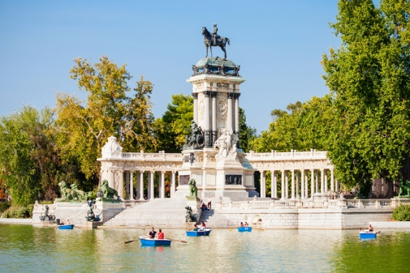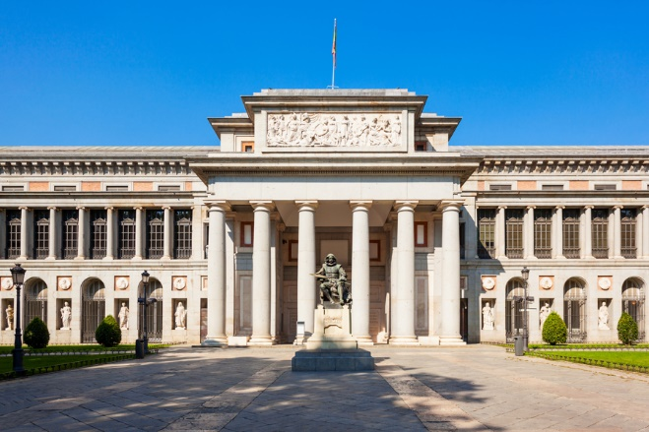  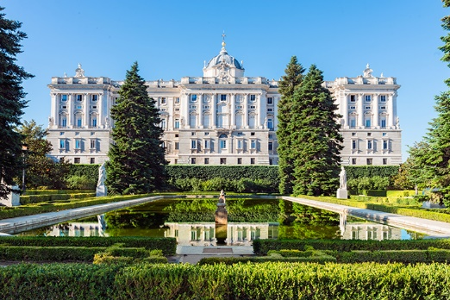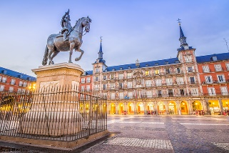  Try local tapas in La Latina neighbourhood  Traditional restaurants around Plaza Mayor  San Miguel Market – variety of Spanish food  METRO runs 6 am-1.30 am. Day ticket: €8.40  TOURIST BUS (hop-on / hop-off): €25  Most attractions within walking distance  of city centre  MAIN ATTRACTIONS  WHERE TO EAT  GETTING AROUND | worried about the weather  in Madrid and what kind of clothes he should pack for  his trip. You write him an  e-mail giving him helpful information so he can enjoy his visit to Madrid.
Your e-mail to Alex should have between 65 to 80 words. Remember that you have to use paragraphs and follow the structure of an informal e-mail.

In written
mediation,
you need to
understand
the texts and the images
provided. When you
understand all the ideas,
try to explain your message
in your own words.
Make sure it is clear why
you are talking about the
topic. Refer to the context.
Underline the words and
expressions that will help
you to understand the text
better.

Let’s get ready!
In this section, you will help students to get ready for the task. First of all, they will learn what to do (Analyse the task) and later, they will work on the information (Analyse the information). You can give them the Learning Sequence worksheet to work on.
1. Analyse the task
Tell students they are going to think about the receiver of the message, the reason for the message and the information included. This will help them to use the proper register (formal or informal).
a. Read the task carefully and answer these questions. They will help you choose the register of the mediation task.
a) Who will receive the e-mail? Alex (my English-speaking friend)
b) Why are you going to send him an e-mail? Because he needs help with information about visiting Madrid for the first time / To help him prepare for
his trip to Madrid.
c) What information does Alex need? He needs information about the most important places to visit, how to move around the city, typical Spanish food and where to eat, weather and which clothes to pack.
b. Are the following sentences true or false?
a) Register is the way a person writes in relation to their audience. TRUE
b) In a mediation task, being clear in the message is not important. FALSE
c) You need a lot of sentences and long messages to express your ideas. FALSE
d) Written language tends to be more formal than oral language. TRUE
2. Analyse the information
Tell students to think about the relevant information on the infographic they will have to use.
Read the information on the infographic carefully.
a) What important information does Alex need for his visit to Madrid?
Alex needs information about:
Places to visit: Main attractions (museums, parks, squares, palaces)
Transport: How to move around the city (metro, bus, walking)
Food: Where to eat typical Spanish food
Weather and clothes: What the weather is like and what to pack (NOTE: This information is NOT in the infographic – students must add it from their own knowledge and according to the season.)

b) Underline the main ideas you will use in your e-mail to Alex.
Students should underline:
From MAIN ATTRACTIONS:
Prado Museum (art collection, Goya, Velázquez, 10 am-8 pm, €15)
Retiro Park (green space, lake, Crystal Palace, free)
Royal Palace (home of Spanish Royal Family, 10 am-6 pm, €13)
Plaza Mayor (historic square, cafés, street performers, free)
From GETTING AROUND:
Metro (6 am-1.30 am, day ticket, €8.40)
Tourist bus (hop-on / hop-off, €25)
Walking distance (most attractions near city centre)
From WHERE TO EAT:
La Latina neighbourhood (local tapas)
Plaza Mayor area (traditional restaurants)
San Miguel Market (variety of Spanish food)
Let’s prepare the language!
In this section, students will learn structures and language suitable for the task.
1. Give Information and Recommendations
1. Read this text where a person is giving information about visiting a city. Underline the prepositions of place and time you find.
When you visit a new city, it's important to know where the main attractions are. Most museums open at 10 am and close in the evening. You can find interesting places in the city centre. Many tourists walk around the old streets and stop at cafés for a break.
The metro station is near the main square. Trains run from early morning until late at night. You can buy tickets at any station. On weekends, there are markets in different neighbourhoods where you can try local food.
If you want to eat traditional dishes, go to restaurants around the historic areas. In summer, the weather is very hot, so bring light clothes. Between June and September, temperatures can be very high during the day.
Remember to keep your bag close to you and walk on busy streets, especially after dark. Tourist information offices are located at the airport and in the city centre.

Other Useful Language  You should ...  It’s a good idea to ...  Don't forget to ...  Make sure you ...  I recommend ...  It's worth visiting ... |  | Learn new expressions to give recommendations and information. It will help you communicate more clearly and naturally. | 

2. Complete the sentences using prepositions from the box below. The prepositions can be used more than once.
at in around from … to near on

a) The museum opens at 10 am and closes at 8 pm. (OR: opens from 10 am to 8 pm)
b) You can find good restaurants in the historic centre.
c) The metro station is near the main square.
d) In summer, the weather is very hot in Madrid.
e) Many tourists like to walk around the old streets.
f) There are street performers on weekends in Plaza Mayor.
2. Give reasons and examples
1. Complete the following sentences using vocabulary from the text.
a) Three types of places tourists can visit in a city are __________________________
___________________________________________________________________ .
POSSIBLE ANSWERS:
museums, parks and squares
historic areas, markets and cafés
palaces, neighbourhoods and monuments
attractions, restaurants and squares
Accept all logical answers.
b) Two ways to move around a city are _____________________________________
___________________________________________________________________ .
POSSIBLE ANSWERS:
by metro and by tourist bus
on foot and by metro
walking and taking public transport
by bus and walking
Accept all logical answers.
c) One recommendation for visiting a city in summer is: ________________________
____________________________________________________________________
POSSIBLE ANSWERS:
bring / pack light clothes
wear sunscreen
drink plenty of water
stay in the shade during the hottest hours
bring a hat
visit museums during the hottest part of the day
Accept all logical answers.

Let’s mediate!
Make sure the students understand the task and you can summarise the tips below.

Your English-speaking friend Alex is visiting Madrid for the first time next month. He doesn't speak Spanish and has never been to Spain before. He has sent you a message asking for help: He needs some information about the most important places to visit, how to move around the city and some useful tips for tourists. He also wants to know about typical Spanish food and the best places to eat. He's also worried about the weather in Madrid and what kind of clothes he should pack for his trip. You write him an e-mail giving him helpful information so he can enjoy his visit to Madrid.
1. Content
Look at the infographic and read the information there carefully again. Select the information you are going to tell your friend Alex. You can use the following questions:
- Which attractions have an entry fee and which ones are free?
Entry fee: Prado Museum (€15), Royal Palace (€13)
Free: Retiro Park, Plaza Mayor
- What are the different transport options available in Madrid?
Metro (runs 6 am-1.30 am, day ticket costs €8.40)
Tourist bus / hop-on / hop-off bus (€25)
Walking (most attractions are within walking distance of the
city centre)
- Which neighbourhoods and places are mentioned for eating
Spanish food?
La Latina neighbourhood (for local tapas)
Around Plaza Mayor (for traditional restaurants)
San Miguel Market (for a variety of Spanish food)
Content
2. Language
Use your own words. Simplify or paraphrase the information.
Remember to adapt your register to the task and addressee.
Vary the language you use. Look at the Other Useful Language on page 4.
Language
Refer students to the task again and tell them to pay special attention to the Quick Tips. Make sure that the students read the rubric so that they know what is important.

Let’s evaluate!
Rubrics for assessment
 Oral Mediation
 | Excellent | Good | Acceptable | Unsuitable
Clarity | The information is clear and easy to follow. The main points are clear. | The information is clear to follow, but sometimes it is not easy to understand what the main points are. | Some of the information selected is not relevant, lacks coherence and may include contradictions. | The information selected is not relevant, not clear, not easy to follow and includes contradictions.
Relevancy and processing | The student has summarised and paraphrased the main ideas without copying literally. No information has been added. | The student has summarised the main ideas, but has not paraphrased them. No information has been added. | The student conveys some appropriate information by summarising the main ideas, but not all. | The student doesn’t convey much appropriate information, or has copied it from the text. Extra information may have been added.
Flow | The student speaks confidently without many pauses. The speech is fluent. | The student mostly speaks confidently without many pauses. The speech is fluent. | The student speaks confidently part of the time with several pauses. The speech is not always fluent. | The student doesn’t speak confidently and often pauses. The speech is not fluent.
Vocabulary | The student uses a wide rage of appropriate vocabulary. | The student mostly uses appropriate and varied vocabulary. | The student uses appropriate vocabulary, but it is not varied. | The student doesn’t use varied vocabulary, or is not able to paraphrase.
Grammar | The student uses a wide range of correct grammatical structures. | The student uses a wide range of grammatical structures, but not always correctly. | The student uses basic, but correct grammatical structures. | The student uses basic grammatical structures, but not always correctly.
Pronunciation and intonation | The student uses understandable pronunciation and intonation. | The student mostly uses understandable pronunciation and intonation. | The student uses understandable pronunciation and intonation with a strong foreign accent. | The student doesn’t use understandable pronunciation and intonation.

ADDITIONAL TEACHING TIPS:
Before the activity:
Review e-mail format (greeting, body, closing, sign-off)
Practise paraphrasing prices and times without copying exact details
Review connectors for organising information
Discuss the difference between formal and informal register
During preparation:
Remind students about the word count (65-80 words means being selective)
Encourage students to highlight the most important information in the brochure
Have them practise paraphrasing key information orally first
Remind them NOT to copy sentences directly from the brochure
Common mistakes to watch for:
Copying information directly from the brochure instead of paraphrasing
Including too much detail (trying to mention everything)
Not following informal e-mail structure
Forgetting to use connectors
Exceeding or falling short of the word count
Using formal language instead of friendly, informal tone
Not organising information in clear paragraphs
Example structure students can follow:
Greeting (2-3 words): "Hi Alex,"
First paragraph (30-35 words): Main attractions and what makes them special
Second paragraph (30-35 words): Transport, food recommendations and one useful tip
Closing (5-8 words): "Hope this helps! Have a great trip!"
Sign-off (2 words): "Best, [Name]"

