A2 - Written Mediation 4: Learning Sequence
Before starting the mediation activity, ask students to read the task and the tourist information carefully to make the aim of the activity clear.
Welcome to Our City
Your English-speaking friend Alex is visiting Madrid for the first time next month. He doesn’t speak Spanish and has never been to Spain before. He has sent you a message asking for help: He needs some information about the most important places to visit, how to move around the city and some useful tips for tourists. He also wants to know about typical Spanish food and the best places to eat. He’s also
TOURIST INFORMATION  MADRID  Prado Museum  World-famous art collection (Goya, Velazquez)  Open: 10 am-8 pm. Entry: €15  Retiro Park  Beautiful green space with lake and Crystal Palace  Free Entry  Royal Palace  Official residence of Spanish Royal Family  Open 10 am-6 pm. Entry: €13  Plaza Mayor  Historic square with cafés and street performers  Free entry  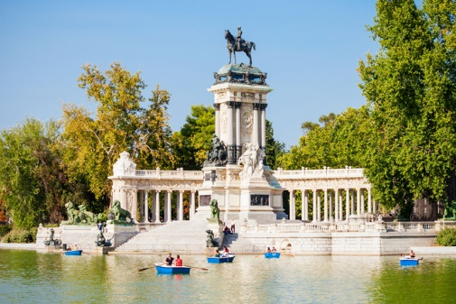  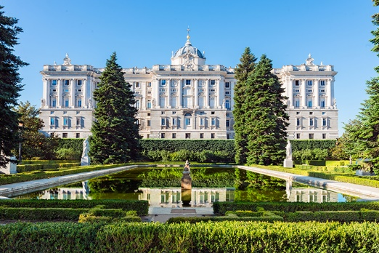  Try local tapas in La Latina neighbourhood  Traditional restaurants around Plaza Mayor  San Miguel Market – variety of Spanish food  METRO runs 6 am-1.30 am. Day ticket: €8.40  TOURIST BUS (hop-on / hop-off): €25  Most attractions within walking distance  of city centre  MAIN ATTRACTIONS  WHERE TO EAT  GETTING AROUND | worried about the weather in Madrid and what kind of clothes he should pack for his trip. You write him an e-mail giving him helpful information so he can enjoy his visit to Madrid.
Your e-mail to Alex should have between 65 to 80 words. Remember that you have to use paragraphs and follow the structure of an informal e-mail.

In written
mediation,
you need to
understand
the texts and the images
provided. When you
understand all the ideas,
try to explain your message
in your own words.
Make sure it is clear why
you are talking about the
topic. Refer to the context.
Underline the words and
expressions that will help
you to understand the text
better.

Let’s get ready!
1. Analyse the task
a. Read the task carefully and answer these questions. They will help you choose the register of the mediation task.
a) Who will receive the e-mail?
b) Why are you going to send him an e-mail?
c) What information does Alex need?
b. Are the following sentences true or false?
a) Register is the way a person writes in relation to their audience.
b) In a mediation task, being clear in the message is not important.
c) You need a lot of sentences and long messages to express your ideas.
d) Written language tends to be more formal than oral language.
2. Analyse the information
Read the information on the infographic carefully.
a) What important information does Alex need for his visit to Madrid?
b) Underline the main ideas you will use in your e-mail to Alex.
.

Let’s prepare the language!
1. Give Information and Recommendations
1. Read this text where a person is giving information about visiting a city. Underline the prepositions of place and time you find.
When you visit a new city, it's important to know where the main attractions are. Most museums open at 10 am and close in the evening. You can find interesting places in the city centre. Many tourists walk around the old streets and stop at cafés for a break.
The metro station is near the main square. Trains run from early morning until late at night. You can buy tickets at any station. On weekends, there are markets in different neighbourhoods where you can try local food.
If you want to eat traditional dishes, go to restaurants around the historic areas. In summer, the weather is very hot, so bring light clothes. Between June and September, temperatures can be very high during the day.
Remember to keep your bag close to you and walk on busy streets, especially after dark. Tourist information offices are located at the airport and in the city centre.

Other Useful Language  You should ...  It’s a good idea to ...  Don't forget to ...  Make sure you ...  I recommend ...  It's worth visiting ... |  | Learn new expressions to give recommendations and information. It will help you communicate more clearly and naturally. | 
2. Complete the sentences using prepositions from the box below. The prepositions can be used more than once.
at in around from … to near on

a) The museum opens at 10 am and closes at 8 pm. (OR: opens from 10 am to 8 pm)
b) You can find good restaurants in the historic centre.
c) The metro station is near the main square.
d) In summer, the weather is very hot in Madrid.
e) Many tourists like to walk around the old streets.
f) There are street performers on weekends in Plaza Mayor.

2. Give reasons and examples
1. Complete the following sentences using vocabulary from the text.
a) Three types of places tourists can visit in a city are __________________________
___________________________________________________________________ .
b) Two ways to move around a city are _____________________________________
___________________________________________________________________ .
c) One recommendation for visiting a city in summer is ________________________
___________________________________________________________________ .

Let’s mediate!

Your English-speaking friend Alex is visiting Madrid for the first time next month. He doesn't speak Spanish and has never been to Spain before. He has sent you a message asking for help: He needs some information about the most important places to visit, how to move around the city and some useful tips for tourists. He also wants to know about typical Spanish food and the best places to eat. He's also worried about the weather in Madrid and what kind of clothes he should pack for his trip. You write him an e-mail giving him helpful information so he can enjoy his visit to Madrid.
1. Content
Look at the infographic and read the information there carefully again. Select the information you are going to tell your friend Alex. You can use the following questions:
- Which attractions have an entry fee and which ones are free?
- What are the different transport options available in Madrid?
- Which neighbourhoods and places are mentioned for eating
Spanish food?
Content
2. Language
Use your own words. Simplify or paraphrase the information.
Remember to adapt your register to the task and addressee.
Vary the language you use. Look at the Other Useful Language on page 3.
Language

