A2 - Written Mediation 4: Task
Welcome to Our City
Your English-speaking friend Alex is visiting Madrid for the first time next month. He doesn’t speak Spanish and has never been to Spain before. He has sent you a message asking for help: He needs some information about the most important places to visit, how to move around the city and some useful tips for tourists. He also wants to know about typical Spanish food and the best places to eat. He’s also
TOURIST INFORMATION  MADRID  Prado Museum  World-famous art collection (Goya, Velazquez)  Open: 10 am-8 pm. Entry: €15  Retiro Park  Beautiful green space with lake and Crystal Palace  Free Entry  Royal Palace  Official residence of Spanish Royal Family  Open 10 am-6 pm. Entry: €13  Plaza Mayor  Historic square with cafés and street performers  Free entry  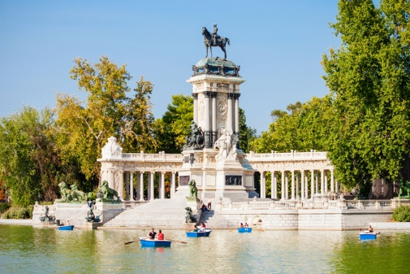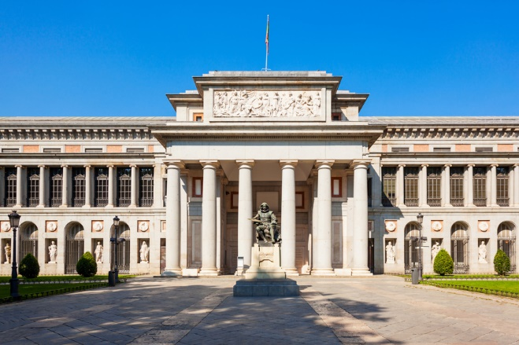  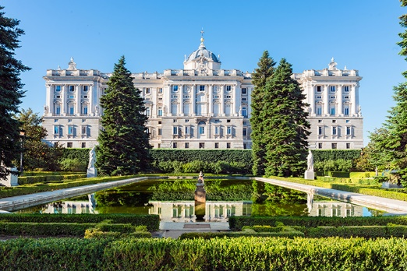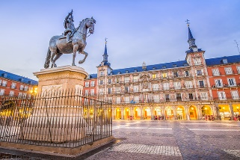  Try local tapas in La Latina neighbourhood  Traditional restaurants around Plaza Mayor  San Miguel Market – variety of Spanish food  METRO runs 6 am-1.30 am. Day ticket: €8.40  TOURIST BUS (hop-on / hop-off): €25  Most attractions within walking distance  of city centre  MAIN ATTRACTIONS  WHERE TO EAT  GETTING AROUND | worried about the weather in Madrid and what kind of clothes he should pack for his trip. You write him an e-mail giving him helpful information so he can enjoy his visit to Madrid.
Your e-mail to Alex should have between 65 to 80 words. Remember that you have to use paragraphs and follow the structure of an informal e-mail.

In written
mediation,
you need to
understand
the texts and the images
provided. When you
understand all the ideas,
try to explain your message
in your own words.
Make sure it is clear why
you are talking about the
topic. Refer to the context.
Underline the words and
expressions that will help
you to understand the text
better.

