**1 Participants**

This study included a total of 13,154 participants, among whom 7,550 (57.4%) were female, and the mean age at study baseline was 86.9 (s.d., 11.4) years (Table[1](https://www.nature.com/articles/s43587-022-00180-5#Tab1)). During the follow-up period (mean (s.d.) = 5.7 (3.6) years) from 2008 to 2018, a total of 8,937 (67.94%) deaths were documented. Participants with higher PDI were more likely to be male, better educated and regular exercisers, compared to those with lower PDI.

Three different samples were used to answer these questions: (1) XXX

|  |  |  |  |  |
| --- | --- | --- | --- | --- |
| Table 1. Overview of samples | | | | |
|  | **CN** | **CN_validation** | **MCI** |
| ***n* total** | **367** | **59** | **513** |
| Age [avg. years (SD)] | 74.2 (5.68) | 71.7 (4.15) (PET)/  70.4 (4.17) (MRI) | 74.9 (5.77) |
| Sex [%female] | 51 | 59 | 40 |
| CSFAβ1-42 Status  (-/+/NA) | 171/111/85 | NA | 121/270/122 |
| MMSE [avg. score] | 29 (1.24) | 29 (0.85) | 28 (1.77) |
| Education [avg. years (SD)] | 16 (2.72) | 16 (2.70) | 16 (2.70) |

**2 Precision of brain-predicted age**

To compare the potential of FDG-PET SUVR and GMV to predict chronological age, we used a nested five-fold cross-validation approach, yielding one test prediction for (almost) every subject in the ADNI CN sample, and five test predictions for each subject in the CN_validation and MCI sample. Regional FDG-PET- and MRI-predicted chronological age comparably well (Table 2) with a mean absolute error (MAE) of 1.99 and 1.89 years, respectively. In the ADNI-derived CN test sets, individuals’ brain-predicted age as assessed with FDG-PET and MRI was on average 0.10 and 0.05 years younger than their chronological age, respectively, thus demonstrating high average potential to capture brain aging in a CN cohort. The OASIS-derived CN_validation sample was used to validate our findings in an external dataset and showed similar MAEs as the ADNI sample, although chronological age was slightly better predicted from FDG-PET as compared to MRI, reflected in a lower MAE across the five models. XXX

|  |  |  |  |  |  |  |
| --- | --- | --- | --- | --- | --- | --- |
| Table 2. Precision of predicting chronological age from FDG-PET and MRI scans. For CN_validation and MCI, results of the first model and metrics over all five models are shown. | | | | | | |
|  | **CN** | | **CN_validation** | | **MCI** | |
|  | **FDG** | **MRI** | **FDG** | **MRI** | **FDG** | **MRI** |
| ***n* total** | 345⁺ | 345⁺ | 59 | 59 | 513 | 513 |
| **MAE** | 1.99 | 1.89 | 1.83 | 2.43 | 1.96 | 2.68 |
| MAE before bias correction | 4.04 | 3.97 |  |  |  |  |
| Mean (SD) over 5 models | - | - | 2.04 (0.30) | 2.45 (0.19) | 2.18 (0.43) | 2.50 (0.12) |
| **Mean difference** | -0.10 | -0.05 | -0.80 | -0.80 | 0.78 | 1.75 |
| Mean (SD) over 5 models | - | - | -0.66 (0.41) | -0.92 (0.16) | 0.77 (0.26) | 1.57 (0.16) |
| *Notes.* +After outlier exclusion using CN train set (IQR > 6) | | | | | | |

**3 BPAD in CN**

**3.1 BPAD and Cognitive Performance**

**3.2 BPAD and AD Neuropathology**

**4 BPAD in MCI**

|  |  |  |  |  |
| --- | --- | --- | --- | --- |
| **Table 3. Correlation strength (rho or r) between BPAD and neuropathology/cognitive function across five different models** | | | | |
|  | **FDG-PET** | | **MRI** | |
|  | **Zero-order** | **Partial** | **Zero-order** | **Partial** |
| **CSF ABETA** | **-0.222  [-0.237; -0.172]** | **-0.186  [-0.224; -0.135]** | **-0.316  [-0.319; 0.305]** | **-0.269  [-0.279; -0.266]** |
| **AV45 (global SUVR)** | **0.137  [0.113; 0.154]** | **--** | **0.197  [0.176; 0.217]** | **0.173  [0.163; 0.202]** |
| **CSF Tau** | **--** | **--** | **0.127  [0.121; 0.138]** | **0.124  [0.114; 0.138]** |
| **CSF PTau** | **--** | **--** | **0.146  [0.141; 0.157]** | **0.139**  **[0.131; 0.153]** |
| **ADNI-MEM** | **-0.279 [-0.321; -0.234]** | **-0.250  [-0.257; -0.234]** | **-0.455  [-0.459; -0.443]** | **-0.409  [-0.420; -0.397]** |
| **ADNI-EF** | **-0.272 [-0.323; -0.241]\*** | **-0.255  [-0.258; -0.219]\*** | **-0.325  [-0.339; -0.307]\*** | **-0.290  [-0.301; -0.286]\*** |
| ***Notes.* Median [range] of correlation coefficients are displayed when significant (p<0.05) correlation existed in brain-predicted age according to all five models. Coefficients are Spearman Rho unless marked by an asterisk (*: Pearson’s r coefficient).** | | | | |

**CONV**

To assess the potential of BPAD in the two modalities to serve as an indicator of cognitive decline (CD), as well as to compare BPAD to existing risk factors, individuals’ diagnosis at year two was predicted from PET-BPAD, MRI-BPAD, APOE-e4 carriership, amyloid status and years of. To achieve reliable results, 10-fold cross-validated logistic regression was performed in two subsamples per group (CN/MCI), matched for age and sex. As amyloid status was not available for all individuals, analyses were conducted in two ways, once including individuals with missing amyloid information (NA values coded as separate category; “whole samples”), and once excluding these individuals (“reduced samples”).

Table 3 presents an overview of logistic regression estimates (XX) and p-values on the whole samples. Two hundred ninety eight individuals from the baseline CN sample received either a CN diagnosis at year two (“stables”; n = 269), or a diagnosis of cognitive impairment (MCI or AD) six months to two years after baseline (“decliners”; n = 29). Accordingly, the two matched sub-samples included 58 individuals (29 decliners and 29 stables). Across these two samples, PET- and MRI-BPAD were not significantly correlated. In sample 1, the odds of CD were significantly increased by 40% per one year PET-BPAD (OR = 1.404, 95% CI [1.113, 1.874], see Table 3 for p-values). In sample 2, PET-BPAD (OR = 1.298, 96% CI [1.013, 1.734]) and amyloid status (OR = 5.011, 95% CI [1.197, 25.363]) marginally to significantly predicted CD. Predictions in this sample were predominantly driven by amyloid status (see Figure XX a)). To determine a clinically relevant threshold of BPAD, we approximated the PET-BPAD corresponding to 50% disease probability, which was 0.2 and 0.9 years, respectively (see Figure XX). Sensitivity and specificity of the PET-BPAD to indicate CD were 68% and 68% in sample 1 and 62% and 66% in sample 2. After removing those individuals who did not have information on amyloid status available, a reduced sample of 23 decliners remained, thus constituting a sample size of 46 (23 decliners and 23 stables). Comparable results as in the whole sample were found: In one sample, higher PET-BPAD significantly predicted CD (OR = 1.46, 95% CI [1.101, 2.106], p = 0.018) and in the other sample, a positive amyloid status significantly predicted CD (OR = 4.704, 95% CI [1.135, 23.604], p = 0.041), while neither PET- nor MRI-BPAD reached significance levels. 50% disease probability in sample 1 corresponded to a PET-BPAD of 0 years, yielding a sensitivity and specificity of 65 and 74%. Taken together, these findings show that in combination with other information such as e.g. amyloid status PET-BPAD offers potential in identifying individuals at risk of CD in a CN stage.

|  |  |  |  |  |
| --- | --- | --- | --- | --- |
| Table 3 Estimates (p-values) of logistic regression for prediction of cognitive decline. | | | | |
|  | CN | | MCI | |
|  | Sample 1 | Sample 2 | Sample 1 | Sample 2 |
| PET-BPAD [Years] | 0.340 (0.008) | 0.261 (0.052) | 0.151 (0.057) | 0.189 (0.017) |
| MRI-BPAD [Years] | 0.037 (0.784) | 0.032 (0.769) | 0.350 (<0.001) | 0.337 (<0.001) |
| Aβ+ | 0.026 (0.973) | 1.612 (0.036) | 1.577 (0.002) | 0.888 (0.078) |
| APOE-ε4+ | 1.464 (0.104) | -0.066 (0.923) | 0.774 (0.034) | 1.433 (<0.001) |
| Education [Years] | -0.136 (0.221) | -0.060 (0.571) | -0.014 (0.833) | -0.048 (0.445) |

FIGURE CN

**Fig. 1. Cross-validated probability of cognitive impairment at Year 2 with a baseline diagnosis of CN by PET-BPAD.** PET-BPAD marginally (p = 0.05; a)) to significantly (p < 0.05; b)) predicted progression to cognitive impairment after two years. a) APOE-e4 carriership-predominant prediction was observed in sample 1, given that all but one APOE-e4 carriers in this sample showed cognitive impairment at year 2. The PET-BPAD-derived decision boundary in sample 1 (50% probability of disease progression; dotted line) was 0.33 years. b) PET-BPAD-predominant prediction was observed in sample 2. The PET-BPAD-derived decision boundary in sample 2 was 0.44 years. DX = diagnosis.

In the whole samples of MCI, 476 individuals either maintained an MCI diagnosis until year two (“stables”; n = 362) or received a diagnosis of AD six months to two years after baseline (“decliners”; n = 114). Thus, the two matched sub-samples included 228 individuals (114 decliners and 114 stables). Across these two samples, PET- and MRI-BPAD were moderately strongly correlated (r­sample1 = 0.406; psample1 < 0.0001; rsample2 = 0.348; psample2 < 0.0001). In both samples, higher MRI-BPAD very significantly predicted CD together with a positive amyloid status, APOE-e4 carriership, as well as higher PET-BPAD, although the latter was only marginally significant in one of the samples. Notably, MRI-BPAD showed considerably higher significance compared to other risk factors (see Table 3); the odds of CD were increased by 42% per one year MRI-BPAD for individuals with MCI. Odds ratios and confidence intervals of both samples are presented in Figure XX. Based on these two samples, a clinically relevant MRI-BPAD threshold, where 50% probability of disease progression is reached lies between 2.1 (sample 1) and 2.2 years (sample 2, see Figure XX).

FIGURE MCI

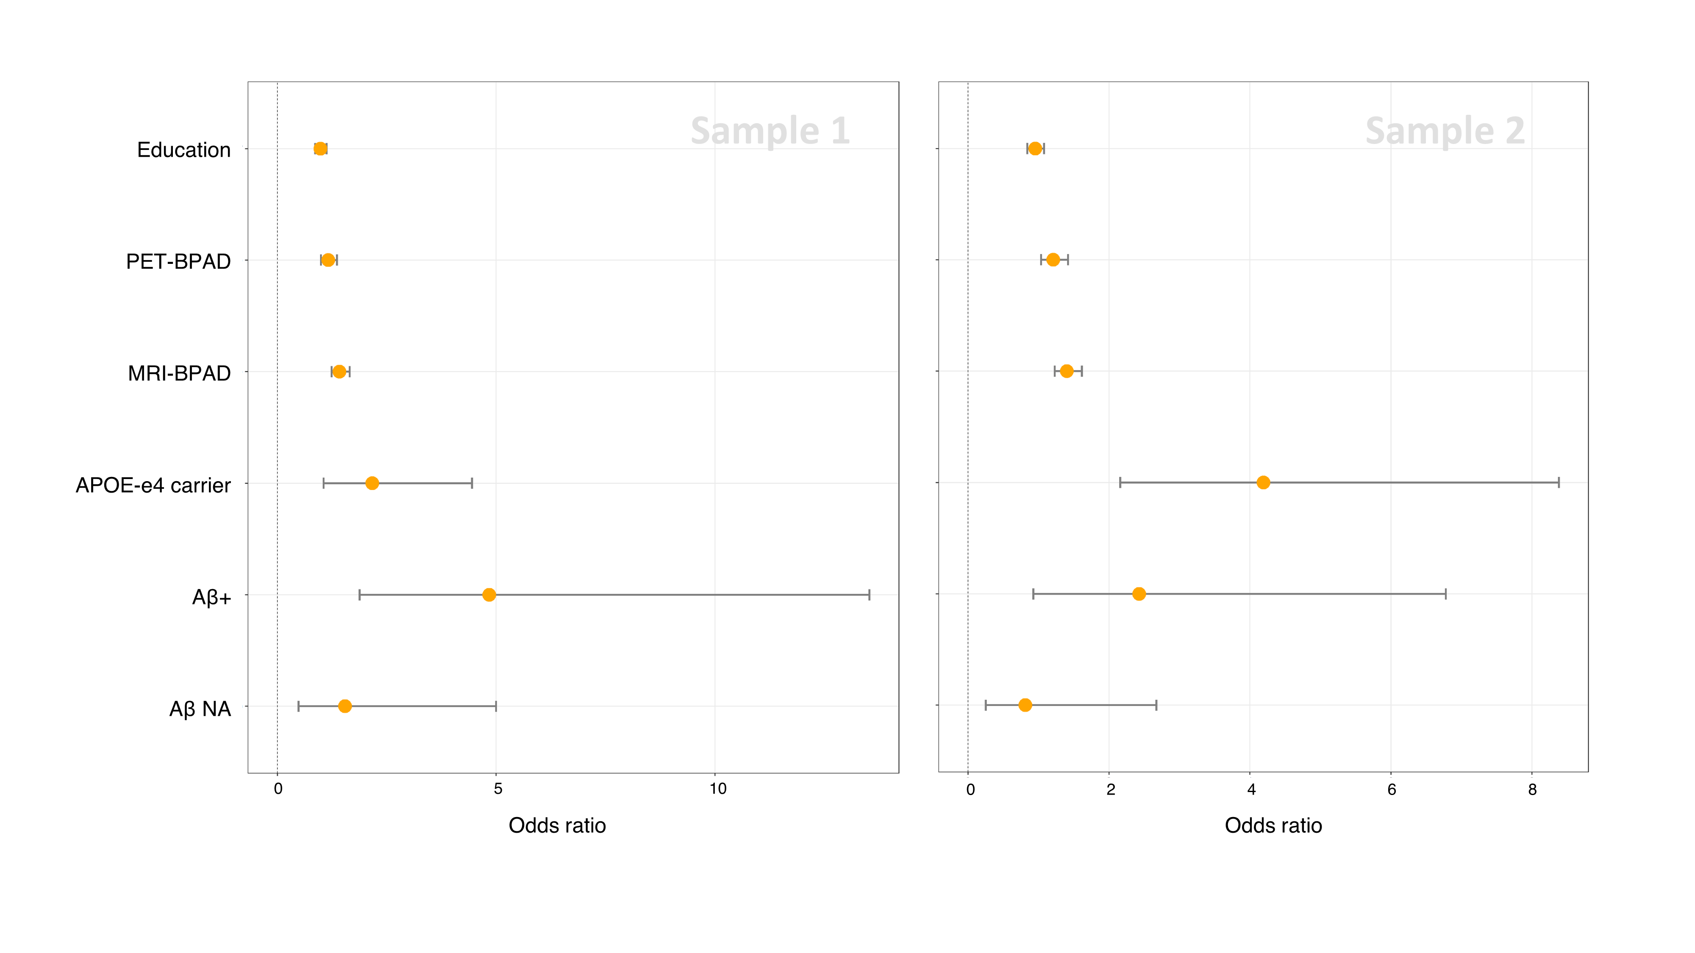

Due to the correlation between PET- and MRI-BPAD, we additionally assessed logistic regression models with unimodal BPAD. XX REFERENCE IN CODE XX

|  |  |  |  |  |
| --- | --- | --- | --- | --- |
| OLD P-values of logistic regression for prediction of cognitive decline. OLD | | | | |
|  | CN | | MCI | |
|  | Sample 1 | Sample 2 | Sample 1 | Sample 2 |
| PET-BPAD [Years] | 0.05 | 0.01 | 0.157 | 0.002 |
| MRI-BPAD [Years] | 0.80 | 0.88 | <0.0001 | 0.0001 |
| Aβ+ | 0.88 | 0.10 | 0.006 | 0.011 |
| APOE-ε4+ | 0.03 | 0.36 | 0.062 | 0.019 |
| Education [Years] | 0.73 | 0.51 | 0.817 | 0.238 |