CASE STUDY: E-COMMERCE SALES PROJECT
Business Questions:
- Revenue & Sales Performance (Trend Analysis)
      - What is our overall monthly sales trend? Are we growing or declining?
      - Which product categories generate the most revenue, and which ones are underperforming?
      - Which countries are our most profitable markets, and where is the demand concentrated?
      - How do our different sales channels perform? Which channel drives the most volume?
- Anomalies & Profit Leaks (The "Spotting Patterns" part)
      - Are there specific product categories or countries experiencing unusually high discount rates?
      - Which regions or categories have the highest return and cancellation rates?
      - Are there specific days, months, or seasons where sales suddenly spike or drop?
- Customer Satisfaction (CSAT)
      - Does giving higher discounts actually improve customer satisfaction (CSAT)?
      - Which product categories have the lowest customer ratings?
      - Do customers who pay with certain methods (e.g., Cash on Delivery) rate us differently than those who pay via Credit Card?
First form of the dataset ‘ecommerce_retail_transactions’
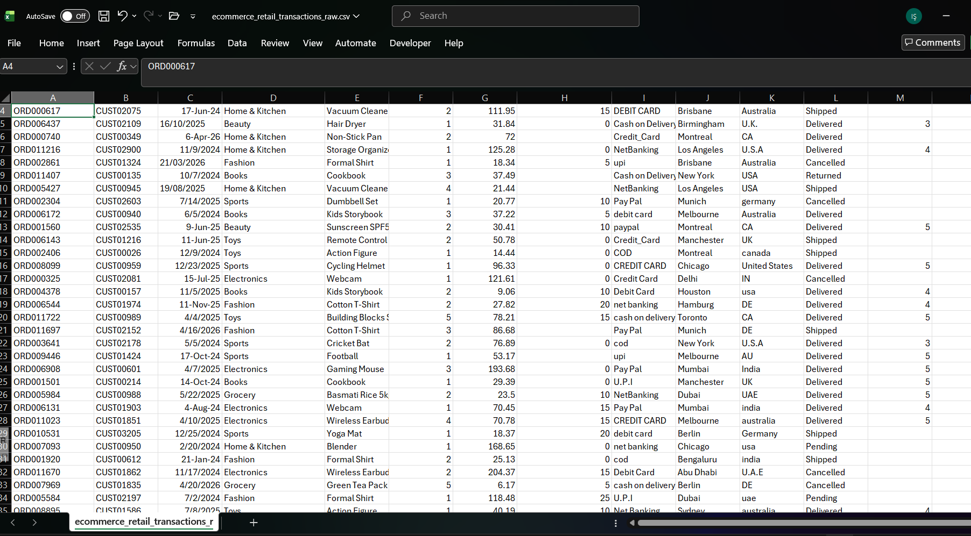
Problems with the data: -data cleaning-
-inconsistent date formats (14-Oct-21, 12/25/2024, days and months are in different order)
-inconsistent country names (usa, U.S.A, USA)
-inconsistent payment methods (upi, U.P.I)
-missing values
-invalid quantities (-1 in quantity)
- duplicate rows in ID – check
-inconsistent text casting
-logical inconsistencies: quantity: 0/-1 but delivered and has customer_rating
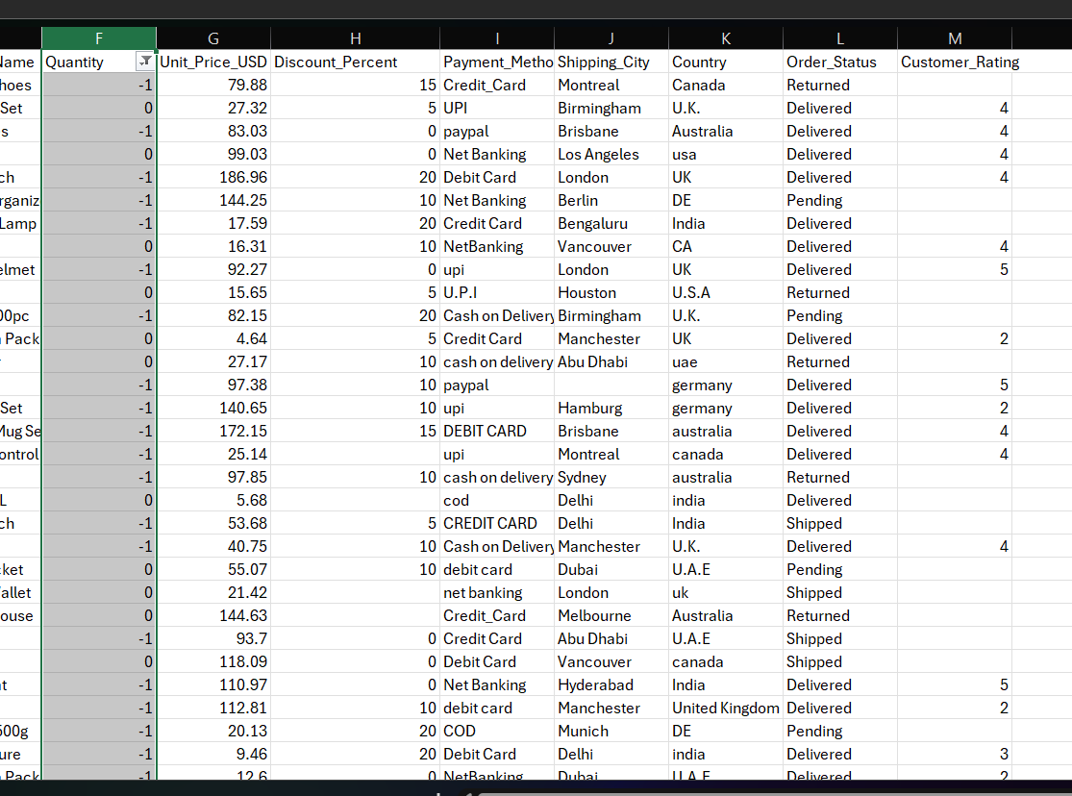
Data Cleaning – SQL-
-USE sales_project;
-CREATE OR REPLACE TABLE raw_sales AS
SELECT * FROM read_csv_auto('C:/analytics/sales_project/ecommerce_retail_transactions_raw.csv');
-data discovery: to see the date formats:
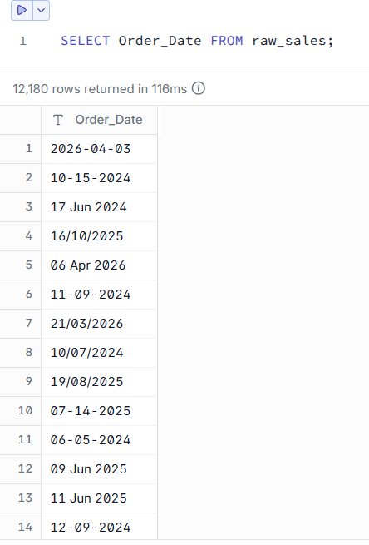
-Used formats: Y-m-d, m-d-Y, d-month(written)-Y, d-m-Y, patterns: years are always yyyy, months sometimes written sometimes numbers, days and month orders are both European, American and Hungarian format so 3 different order, separation with /, -, space
!!! The date formats are risky for the company. Confusion between American format and European formats creates a confusion if both month and date is smaller than 12. Eg. 03/04/2026 and 04/03/2026 we don’t know which country format !!!
-date analysis to decide on the risky dates :
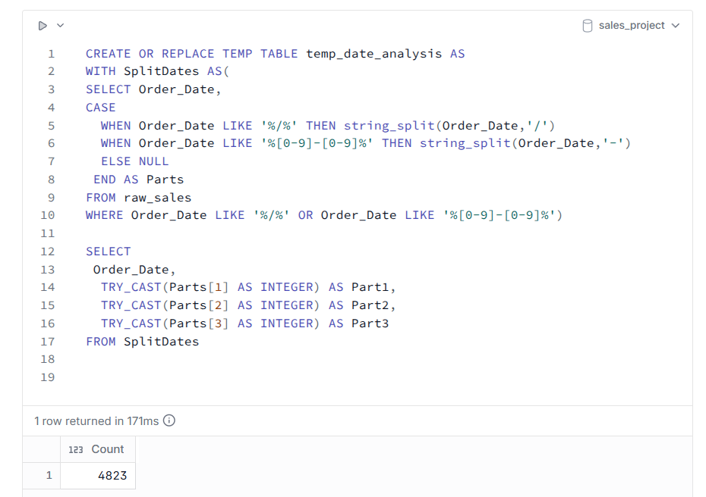
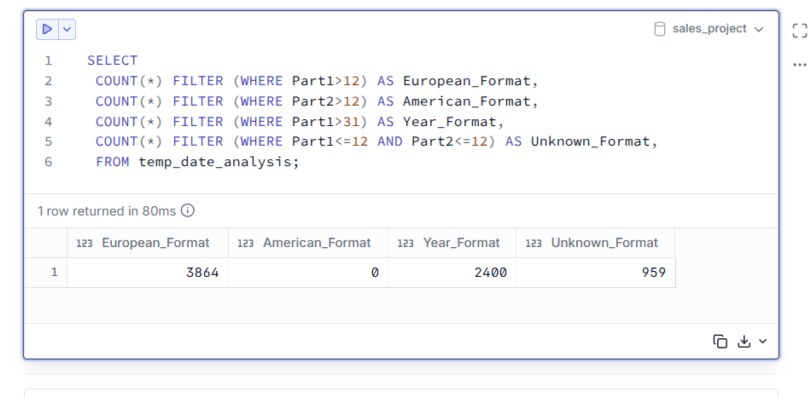
!!! this temp table is obviously wrong because we have American formats on the table, but it shows them as 0 !!!
-correct version of the temp date analysis table:
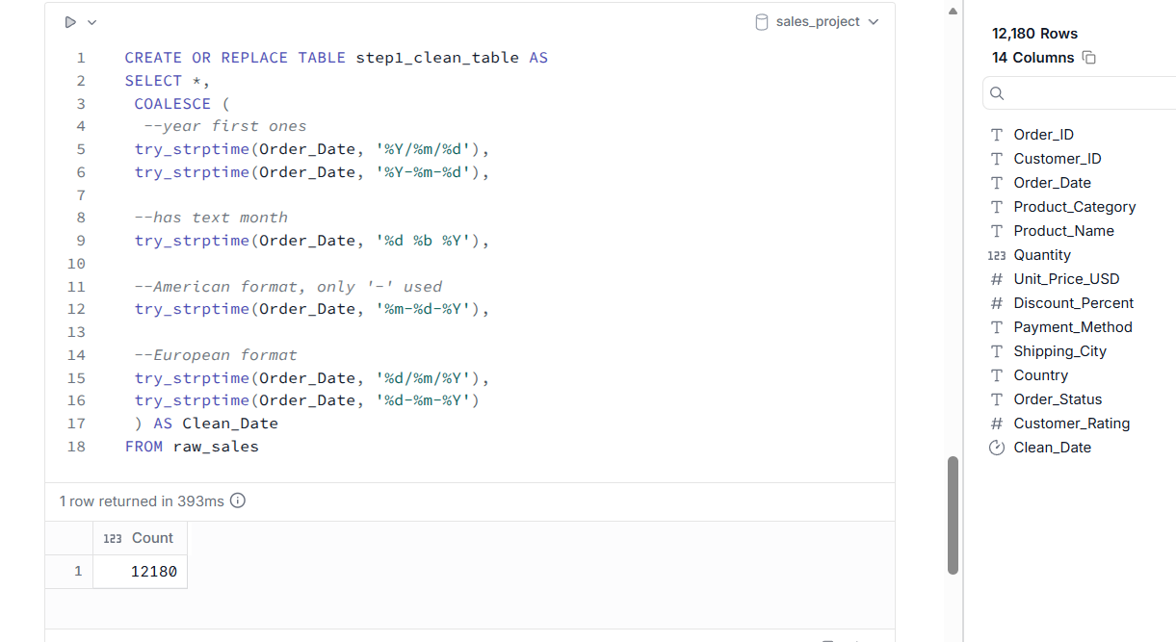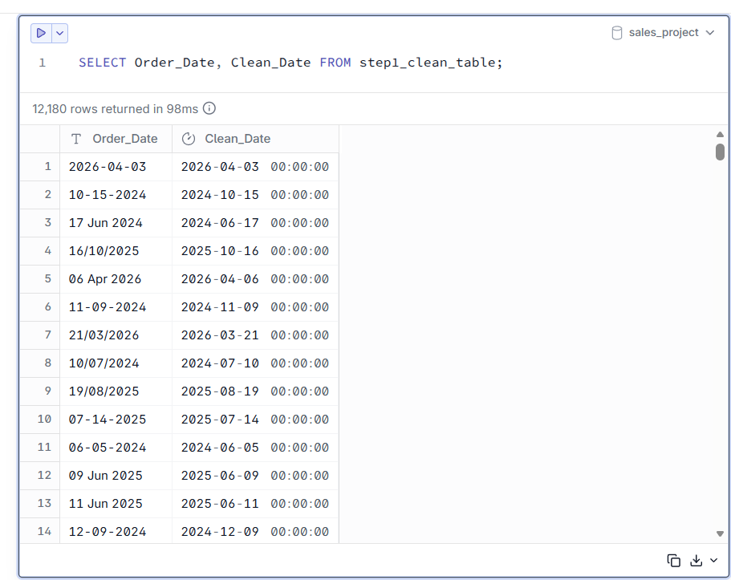
!!! I realized the pattern in American formats, only “-“ is used therefore the unknown dates with “/” considered European date format !!!
-fixing inconsistent country names and inconsistent payment methods:
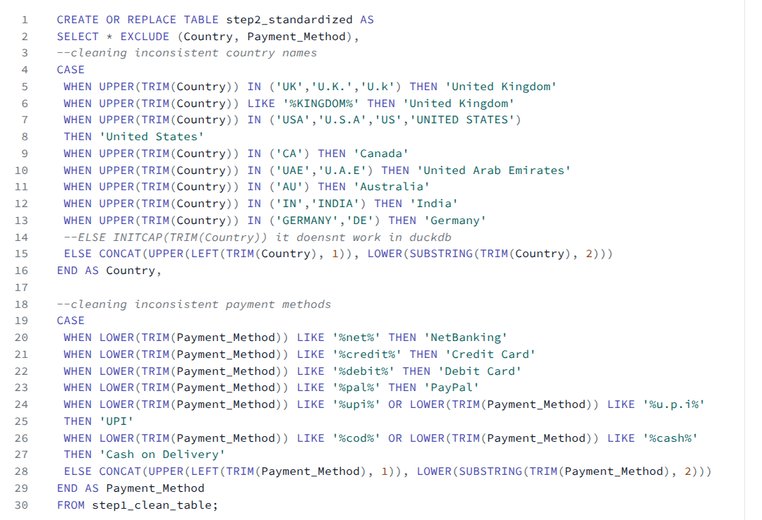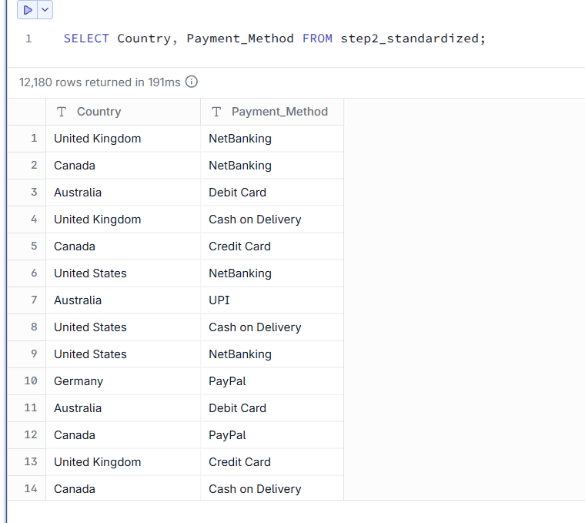
-fixing missing values
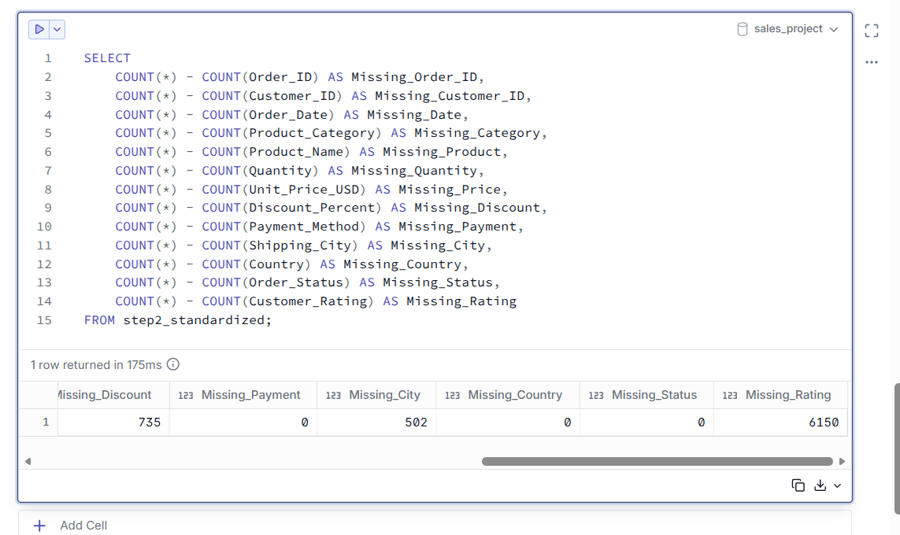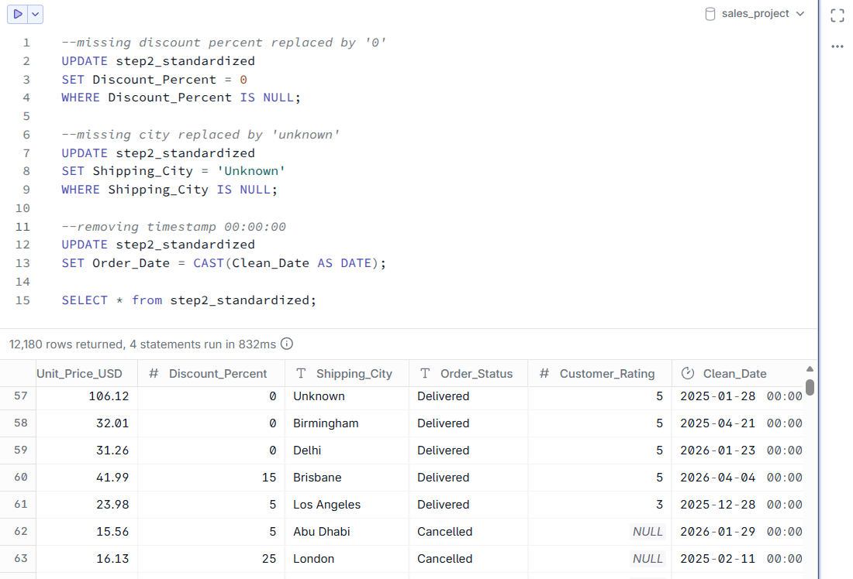

- invalid quantities (-1 in quantity)
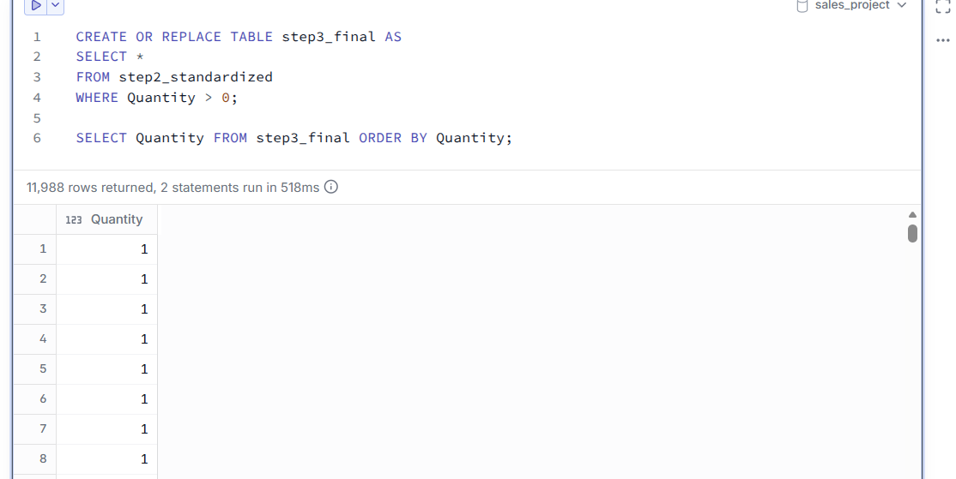
- Checking: duplicate rows in ID
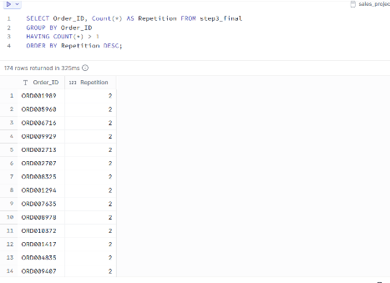!!! we have ‘true duplicates’, system saved them twice, we need to remove one!!!
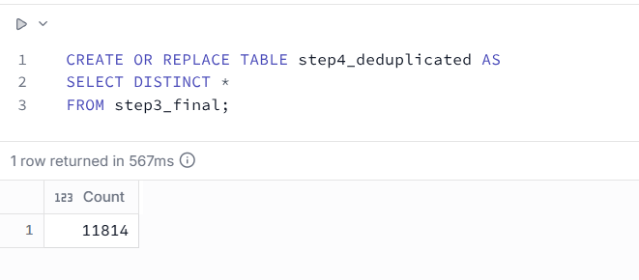
-fixing inconsistent text casting (e.g. London and London) or (Cancelled and Canceled)
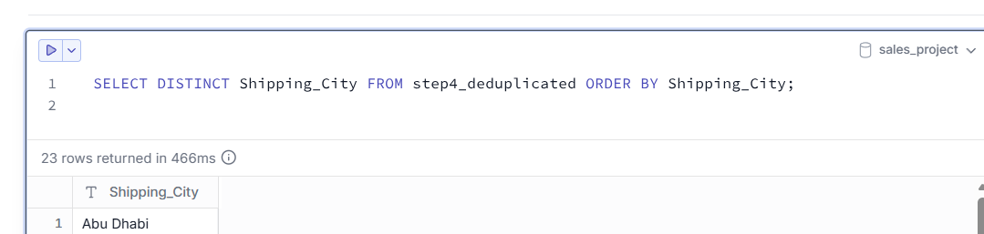we check with ‘DISTINCT’
Step4_deduplicated table only has successful orders (quantity>0) -> use this for sales trends, revenue analysis
For Anomaly Analysis We Should Look At The Sales Where Quantity=0 or Quantity=-1(Returned):
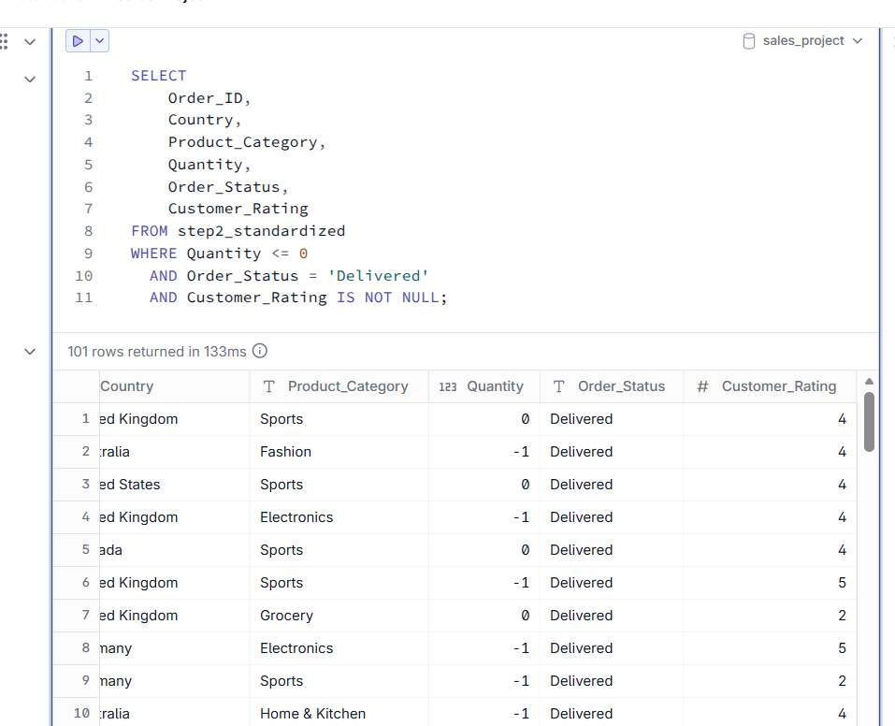
Data Quality Anomaly Detected:
During the EDA phase, I identified 101 logical inconsistencies in the dataset. These records had a Quantity of 0 or -1 (indicating a return or error), yet their Order_Status was marked as 'Delivered' and they contained a valid Customer_Rating (4 or 5 stars). This suggests a system bug in the ERP/CRM where returns are processed by reducing quantity, but the order status and customer feedback are not properly updated. For the main sales analysis, these 101 rows were excluded. However, they represent a significant operational risk that should be flagged to the IT team.
For Anomaly Analysis Returned and Cancelled Table:

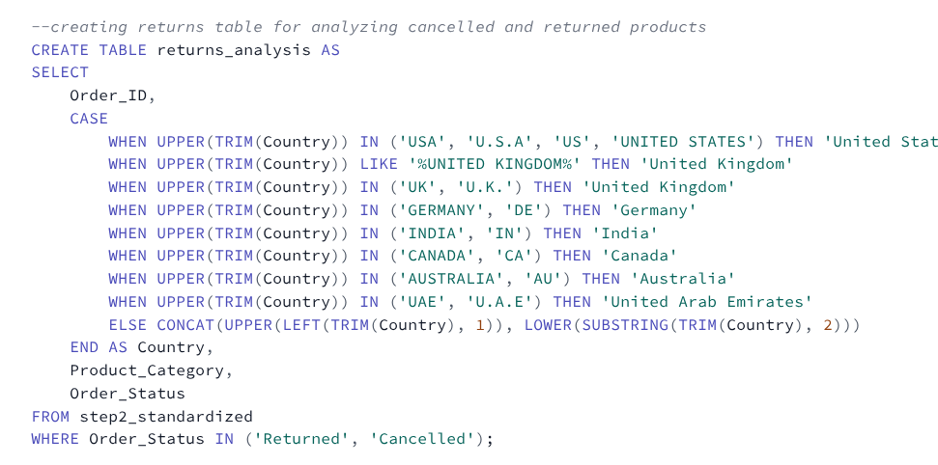
We have 2 final tables: final_tableau_sales and returns_analysis
-to extract tables into CSV file: 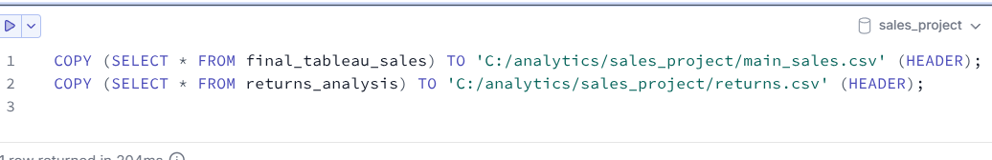
Data Visualization -Tableau-
Questions I decided to visualize in this dashboard:
What is our overall monthly sales trend? Are we growing or declining?
Which product categories generate the most revenue, and which ones are underperforming?
Which countries are our most profitable markets, and where is the demand concentrated?
Which regions or categories have the highest return and cancellation rates?

-Overall Monthly Sales / Grow or Decline (Line Chart)
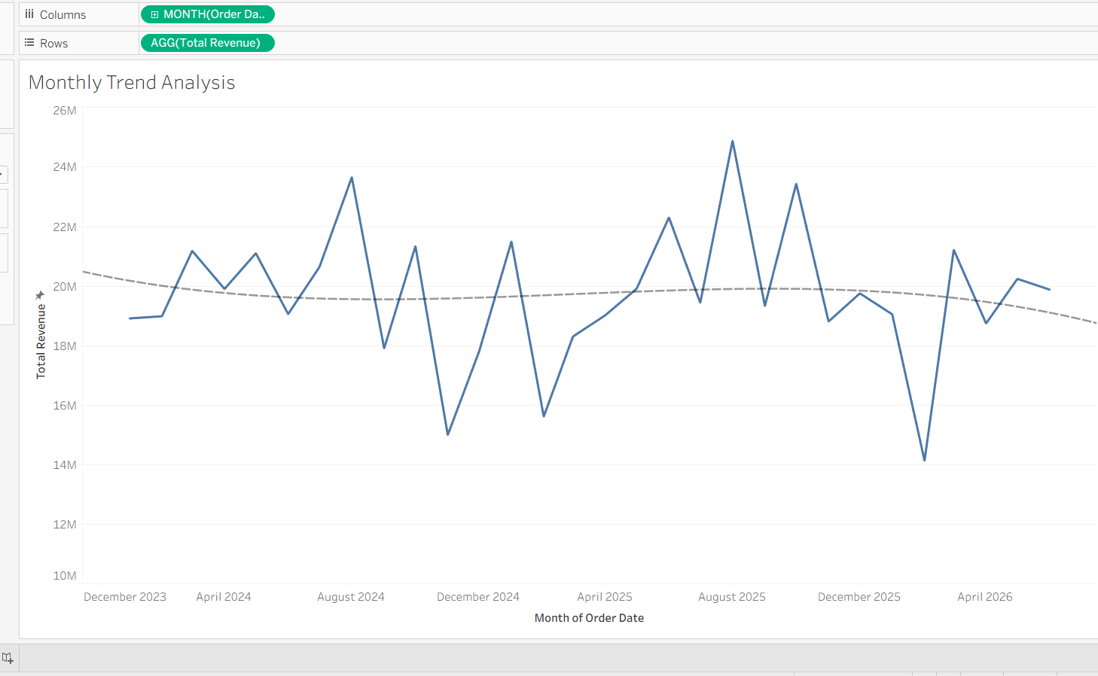
-Product Categories Analysis (Bar Chart)
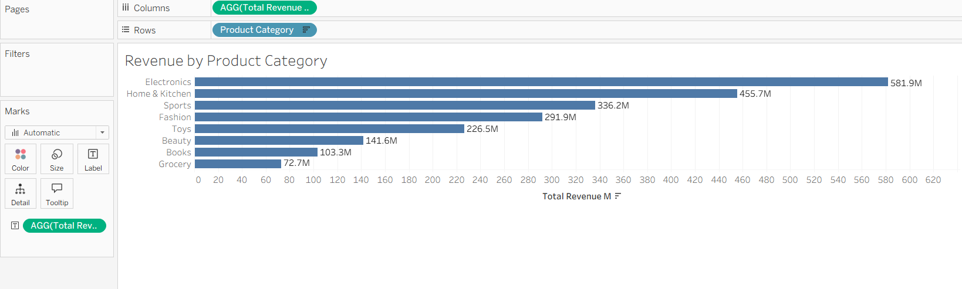
-Profit Analysis by Country (Filled Map)
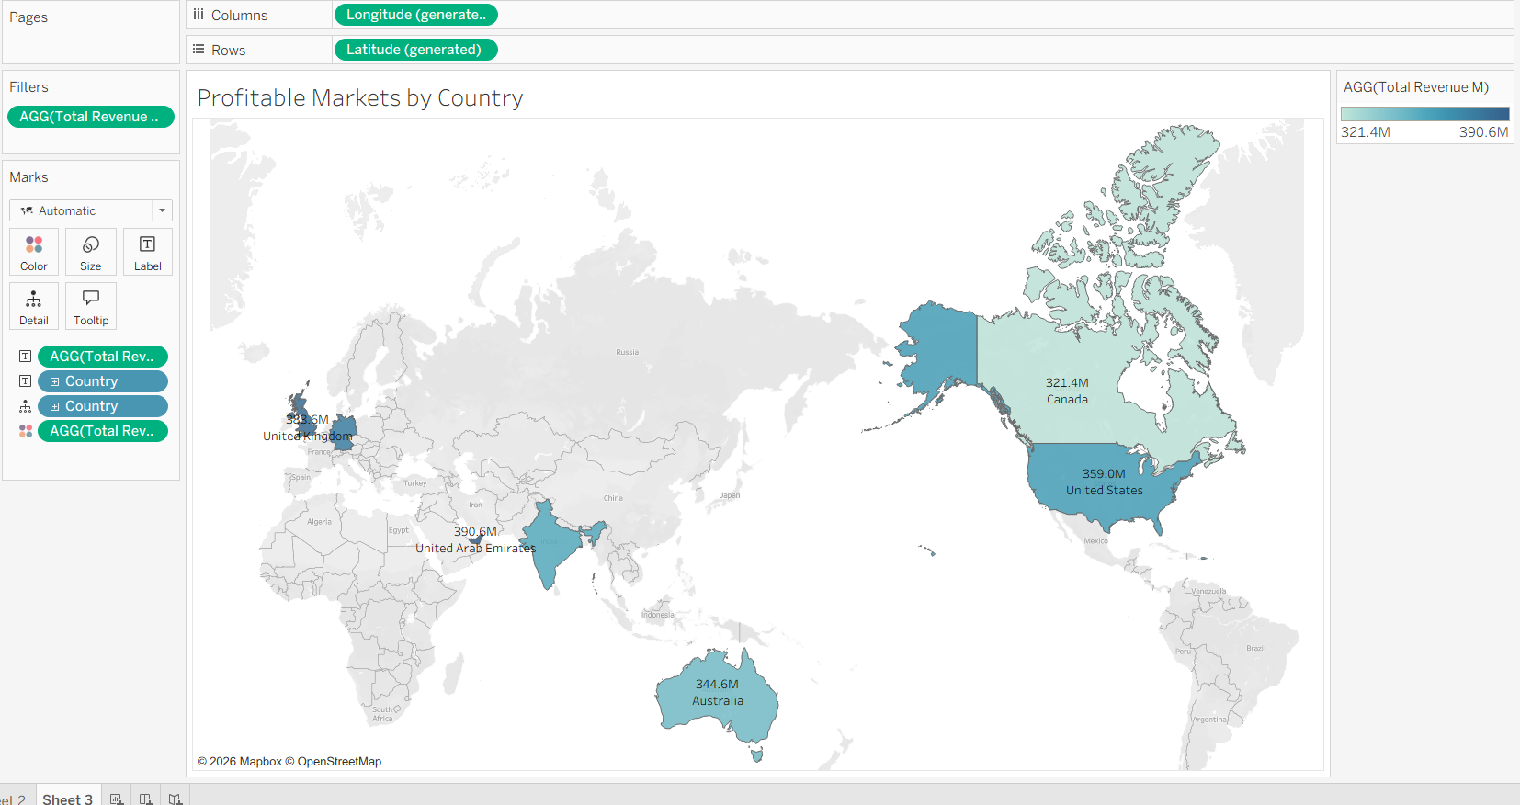
-Returns & Cancellations by Category (Bar Chart)
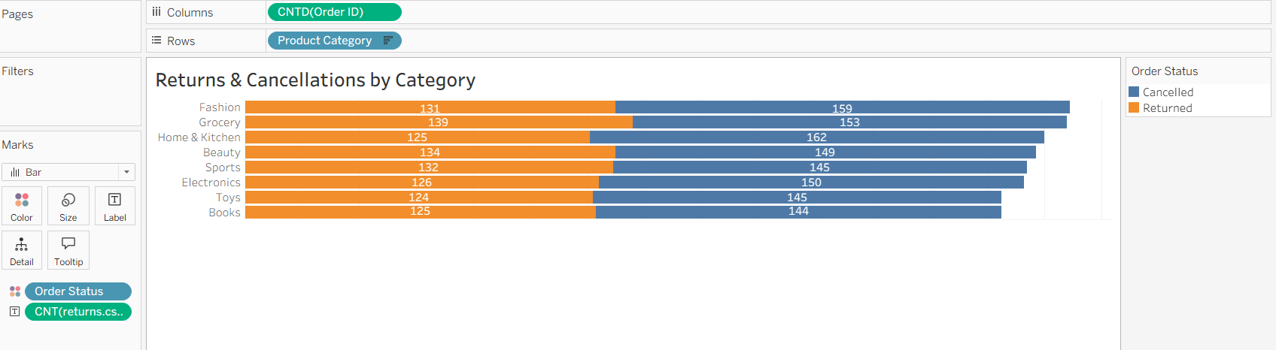

DASHBOARD
The link: https://public.tableau.com/views/GlobalSalesOperationsDashboard_17933980186960/Dashboard1?:language=en-GB&:sid=&:redirect=auth&:display_count=n&:origin=viz_share_link
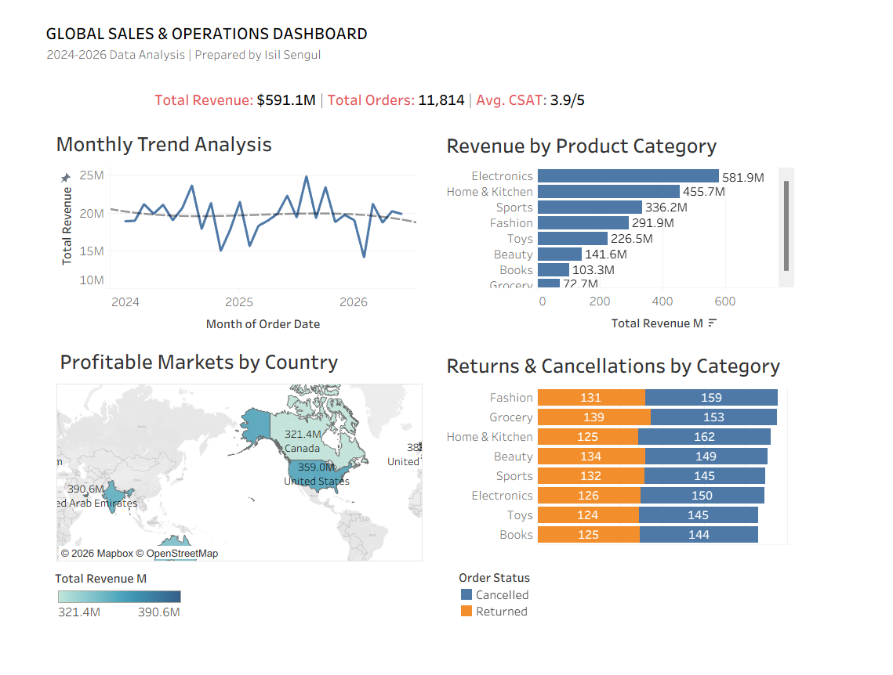
INSIGHTS
1. Overall Monthly Sales Trend
The overall monthly revenue trend from 2024 to 2026 shows a slight decline (indicated by the dashed trend line). While the business experiences strong seasonal peaks (e.g., mid-year campaigns), the magnitude of these peaks is shrinking year-over-year. Additionally, the troughs (dips) are getting deeper, suggesting a loss of sales momentum that requires strategic intervention.
2. Revenue by Product Category
Revenue is highly concentrated in two main categories: Electronics and Home & Kitchen. These two categories account for the vast majority of total sales. Conversely, Grocery and Books are severely underperforming. The company's revenue is highly dependent on tech and home sectors, creating a risk if these markets slow down. A targeted marketing strategy or portfolio review is recommended for the low-performing categories.
3. Profitable Markets by Country
The global revenue is heavily driven by the United States and the United Arab Emirates. Notably, the UAE shows disproportionately high revenue compared to its market size, which warrants an operational check (e.g., verifying if this is driven by a few large B2B clients). Europe (UK) and Oceania (Australia) show stable, strong performance.

4. Returns & Cancellations by Category
A surprising operational finding is that return and cancellation rates are almost uniform across all product categories. This suggests that the issue is not product-specific (e.g., poor quality of one item) but rather a systemic problem (e.g., logistics delays, checkout process friction, or misleading product descriptions). 'Fashion' and 'Home & Kitchen' have the highest combined rates, indicating a need for a closer look at sizing/quality issues.

