Terms
CPU = brain
RAM = store data temporary as working
Storage = store after after close the program
Operating system = run the program
Shell/bush = manage files
R = data analysis
Start at 1
Python = processing system & building new tools
Start at
Git = collaborate
IPython = interactive python shell

Common terminal commends
pwd = where am I
ls = list all files
ls /
ls -a
ls -l
grep “ “ = search for a text pattern in files
find , -name “*.py” = fine files in current folder with a matching name
cd = change dir (move into/up a directory)
cd ~ = back to home
cd .. = one directory back
mkdir = make dir
touch = create empty file
cp -r = copy files/directories
mv = move/rename files/folders
rm = permanently delete files/directories
cat = print entire file to terminal
less = view in a scrollable page, p = quit
head/tail -n 10 = display first/last 10 lines
> / >> = redirect command output to overwrite/append to a file
| = send output of a command to another
sudo apt install <pkg> = ubuntu install software
brew install <pkg> = mac install
!! = rerun last command
!<number> = run specific command number from history list
History | grep “keyword” = filter command history for lines containing keyword
how to create machine-readable markdown
set() = turn a list/tuples into set with unique elements
{key1: value1, key2: value2 } = directory with pairs of elements, key can be immutable tuple but not list, keys must be unique
directory{key1} = value1
list2 = list1[:] -> copy a new list, rather than simple referring (change in list1 not affecting list2), but it is shallow not recursively (list in list will be affected)
import copy -> list2 = copy.deepcody(lista) deep copy recursively

talk more about git next two days
invite masaba for push/write access
set code & result folder in root folder (rather than in the week1/2 separate folders)
for now, ask the students to write the assessments in python

python3 = enter python shell
ipythn3 = enter ipython shell, can use bash commands
variable. + Tab = see all functions available for the particular variable
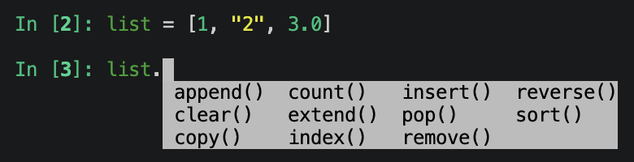
ctrl+d/c or exit= quit python/R shell

Common code
String
- .replace(“a”, “b”)
- .find()
- .count()
- New_list = str.split( ) -> split the string using space
- New_list = str.strip -> remove trailing space
- .upper()
- .lower()
Fort loop
- Range(num): from 0 to num-1
  - Range(1, num): from 1 to num
  - Range(2, 10, 2): skip odd numbers
Type
- Iter(): generating iterator by passing an iterable (ex. list, directory, tuple, string, range)
  - next(my_iterator) = my_iterator.__next__()
    - running through each element in the list
- Tuples = a type class like an immutable list, the object inside cannot be modified, but the entire tuples/set can be modified
  - List = [(1, 0), (2, 2)] -> List[0][0] cannot be changed but List [0] can = (1, 1)
- Tuples immutable but can leave an empty list inside which can be append -> Tu_List = (0, 1, []) -> Tu_List[2].append(“ “)
For loop
- Print() = print out the value
- Return = return the accessible variable
  - In function, purely print the output doesn’t change the variable, need to return it or use append
- assert = checks that its condition is true; if it is false, Python stops with an AssertionError
- if condition: return None -> raise DefinedError
comprehension
- x = [i for i in range(10)] is same as x = [] -> for i in range(10): -> x.append(i)
- flatten_matrix = [n -> what want to append
for row in matrix -> outer loop
for n in row] -> inner loop
- first_letters = {w[0] for w in words}
debugging
- try: -> except ErrorName: -> except: -> else: successful
- doc string can include automatic test to test the code
function
- global variable -> convert a variable to a true global variable, allowing modify/assign a global variable from inside a function & make it available outside the function
  - global keyword inside a nested inner function will change the variable in inner function & globally outside, but not in the nested outer function
- import my_module makes the module available; call a function as my_module.my_function().
- from my_module import my_function imports one named function; call it as my_function().
- import my_module as mm gives the module a shorter local name; call its function as mm.my_function()

