**Student:** Moglan Elena **Subgroup:** 3

**Homework**

**Lab 4**

**Exercise 1**

Use Cases:

1. 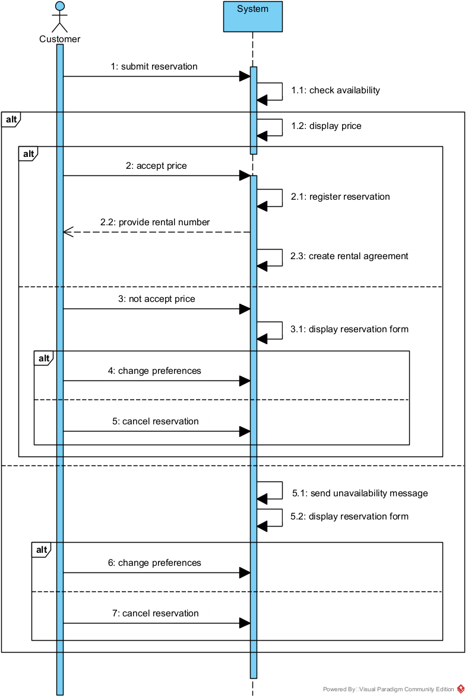**Use Case:** Make Reservation
2. **DISPLAY RESERVATION FORM**

The system displays a form with fields for rental dates, vehicle type, and pickup office. Customer accesses the form via the company’s website or app.

1. **ENTER PREFERENCES**

Customer inputs: Start and end dates (using a calendar widget); Preferred vehicle type (e.g., SUV, Compact) from a dropdown; Pickup office location (e.g., "Downtown Branch") from a dropdown. System validates dates (ensures end date ≥ start date and dates are in the future). If invalid, displays error: **"Invalid dates. Please ensure end date is after start date."**

1. **RESERVE**

User clicks "Reserve Now" to submit the form. System temporarily holds the reservation request and proceeds to pricing.

1. **DISPLAY PRICE**

System calculates total cost (base rate + taxes) and shows price breakdown: **"Total: $X.XX. Do you agree to proceed?".** User reviews the price and decides to accept or decline.

1. **AGREE PRICE**

User Clicks "Agree and Continue. System locks the price and initiates availability checks.

1. **CHECK AVAILABILITY**

Systemverifies real-time availability of the selected vehicle at the chosen pickup office. If available, reserves the vehicle and marks it as "booked." If unavailable, triggers an error (see *Alternate Flow A*).

1. **DISPLAY RENTAL NUMBER**

System generates a unique rental number (e.g., **#RN-2023-789**). Creates a rental agreement PDF with the number, dates, vehicle, and pickup details. User receives the rental number and agreement via email or on-screen confirmation.

Use Case Ends.

**Alternate Flows**

**A. Vehicle Unavailable After Price Agreement**

* **Trigger:** Step 6 (Check Availability) fails.
* **System Action:**
  + Displays error: **"The selected vehicle is no longer available. Please adjust your preferences."**
  + Returns user to the reservation form with previously entered data.
  + Suggests alternative vehicles or dates.

**B. Invalid Form Submission**

* **Trigger:** Invalid dates or missing fields in Step 2 (Enter Preferences).
* **System Action:**
  + Highlights erroneous fields in red.
  + Displays error: **"Please correct the highlighted fields to proceed."**

**C. Customer Declines Price**

* **Trigger:** User clicks "Decline" at Step 4 (Display Price).
* **System Action:**
  + Asks for confirmation: **"Are you sure you want to cancel? Your reservation will be lost."**
  + If confirmed: Resets the form and returns to the homepage.

1. **Use Case: Check Availability**
2. 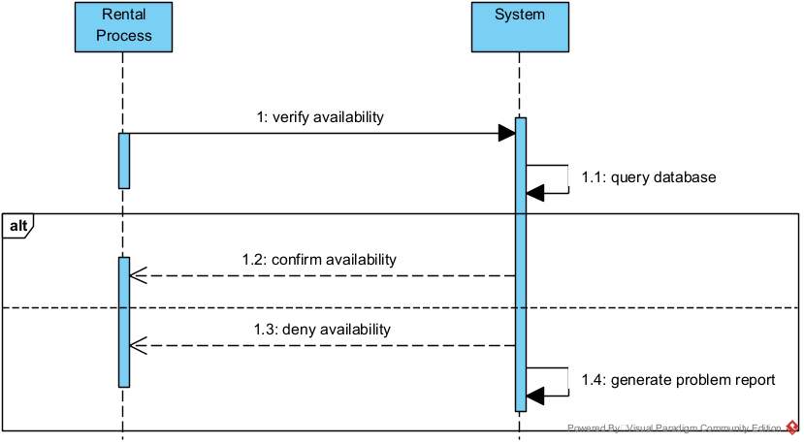 **Verify Availability**

User Action: Submits rental preferences (dates, vehicle type, pickup office).

System Action: Queries the database for real-time availability. If available: **"Vehicle is available! Proceed to reservation."** If unavailable: **"Vehicle unavailable. Generate problem report."**

1. **Confirm Availability**

System Action: Reserves the vehicle and locks the price.

1. **Deny Availability**

System Action:Logs the problem report with timestamp and request details. Suggests alternatives: **"Try a different vehicle or adjust dates."**

**Alternate Flows**

* **Database Query Failure:**
  + **System Action:** Displays error: **"System error. Please try again later."**
* **Problem Report Generation:**
  + **System Action:** Automatically emails the customer: **"We’ve noted your request and will notify you if options open up."**

1. **Use Case: Initiate Rental**
2. **Quote Rental Number**

System Action: Assigns a unique rental number (e.g., #RN-2023-567) after reservation confirmation.

1. **Introduce Rental Number**

System Action: Displays the number prominently and includes it in emails/agreements.

1. **Accept/Decline Rental Agreement**

User Action: Reviews terms and clicks "Accept" or "Decline."

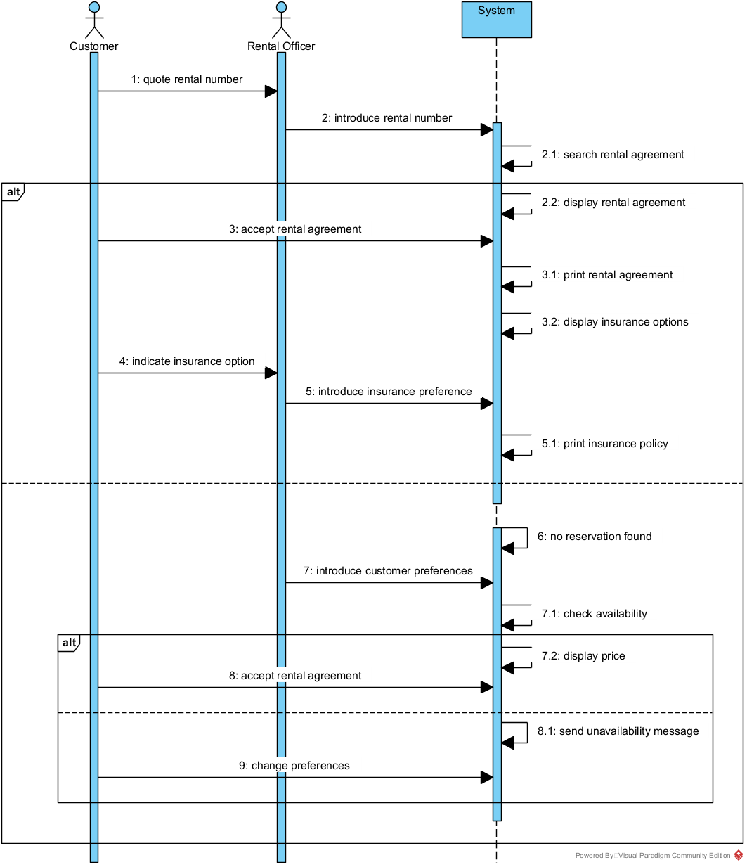System Action: If accepted: Proceeds to insurance/payment. If declined: "Reservation paused. Edit preferences or cancel."

1. **Insurance Workflow**

Indicate Insurance Option: User selects coverage (Basic, Premium, None).

Introduce Insurance Preference: System updates total price and confirms: "Added [Insurance Type] (+$X.XX)."

1. Search/Display/Print Agreements

Search Rental Agreement: User enters rental number to retrieve details.

Display/Print Agreement: System shows PDF preview and allows download.

1. Error Handling

No Reservation Found: "Invalid rental number. Verify or contact support."

Unavailability After Edit: "New preferences unavailable. Revert or cancel."

1. 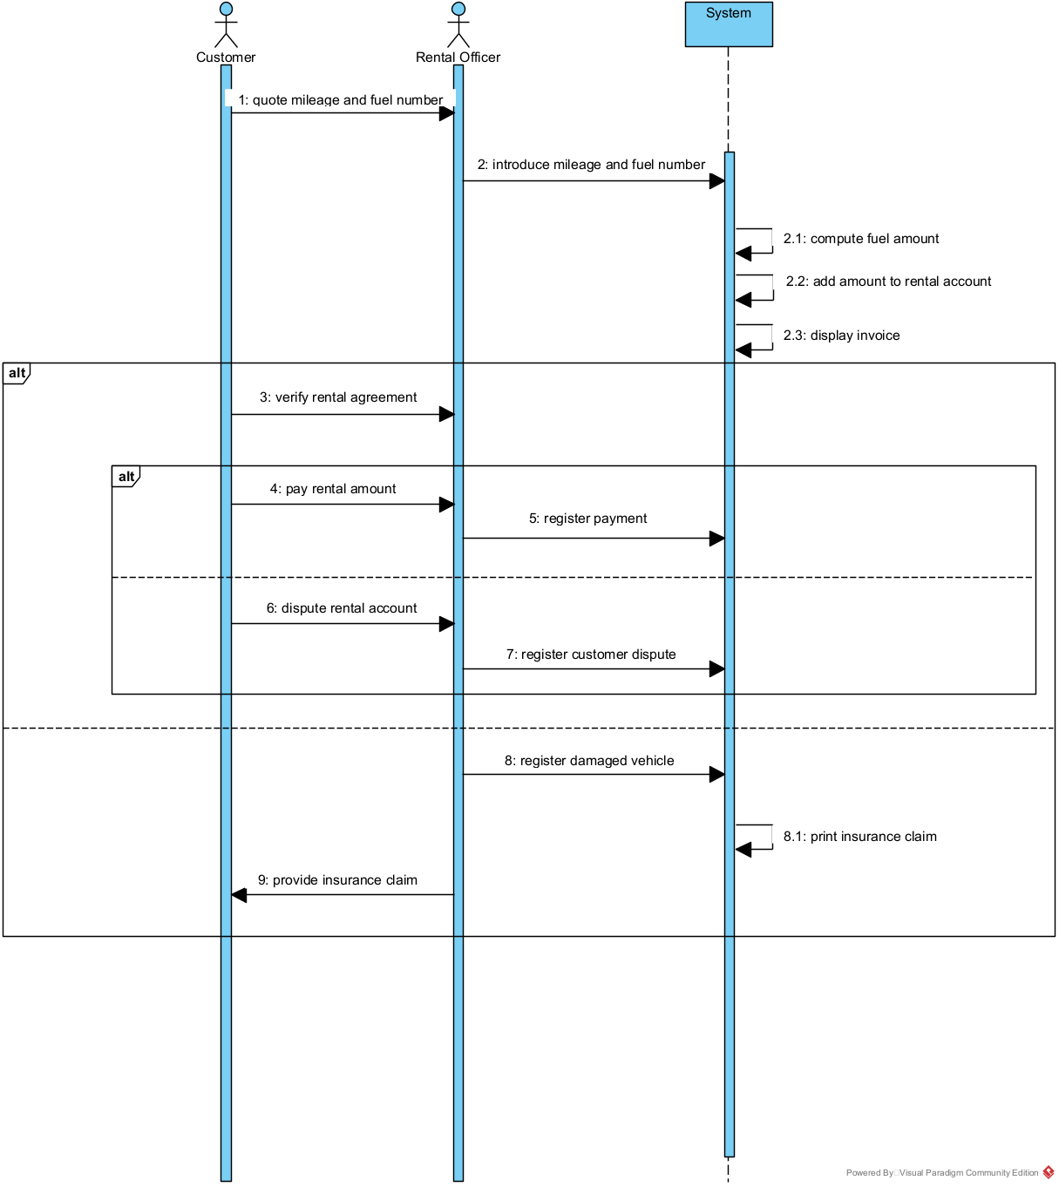**Use Case: Process Vehicle Returns**
2. **Mileage & Fuel Tracking**

**Create/Introduce Mileage Number:** System logs starting mileage/fuel level during pickup.

1. **Verify Rental Agreement**

**Staff Action:** Confirms agreement terms match the vehicle and rental period.

1. **Payment & Disputes**

**Pay Rental Amount:** User pays via integrated gateway. System confirms: **"Payment successful. Invoice #INV-789 generated."**

**Dispute Rental Account:** User submits dispute via form. System logs it and alerts staff: **"Dispute #DSP-123 registered."**

1. **Damage & Insurance Claims**

**Register Damaged Vehicle:** Staff uploads photos/notes. System flags the vehicle for maintenance.

**Provide Insurance Claim:** Generates claim form pre-filled with rental/insurance details.

1. **Post-Rental Actions**

**Print Insurance Claim:** User downloads claim form for submission to insurer.

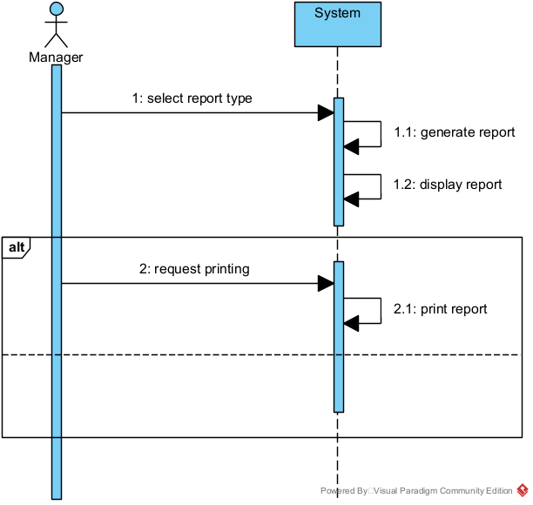**5. Use Case: Provide Management Reports**

1. **Select Report Type**
   * **Staff Action:**Chooses report type (e.g., "Daily Reservations," "Damage Logs").
2. **Generate/Display Report**
   * **System Action:**Pulls data from the database and formats it into tables/charts.
3. **Print Report**
   * **Staff Action:**Clicks "Print" to save as PDF or physical copy.

**Error Handling**

* **Report Generation Failure:**"Data unavailable. Check database connectivity."