IU International University of Applied Sciences
Examination Office
Advanced Workbook
Solutions to Assignments 1 to 6
Type of assessment: Advanced Workbook
Course: Advanced Statistics (DLMDSAS01)
Degree programme: [[PLACEHOLDER: full degree programme name, no abbreviations]]
Submitted by: [[PLACEHOLDER: first name and last name]]
Registration number: [[PLACEHOLDER: registration number]]
Tutor: [[PLACEHOLDER: academic title and name of the tutor]]
Place: [[PLACEHOLDER: place]]
Date of submission: [[PLACEHOLDER: YYYY-MM-DD]]
Parameters produced by the IU parameter generator.
Signature string: 99d9e51eff0fb88f6911fa8b4392742591f8f6da

Table of contents
Right-click here in Word and choose "Update field" to build the table of contents.

List of figures
Right-click here in Word and choose "Update field" to build the list of figures.

List of abbreviations
Abbreviation | Meaning
CDF | Cumulative distribution function
i.i.d. | Independent and identically distributed
IQR | Interquartile range
LOOCV | Leave-one-out cross-validation
MLE | Maximum likelihood estimation, or the maximum likelihood estimate
MSE | Mean squared error
OLS | Ordinary least squares
PDF | Probability density function
PMF | Probability mass function
RMSE | Root mean squared error
SVD | Singular value decomposition

Notation
Every symbol used in this workbook is listed here, because a notation that is not declared carries the same risk of misreading as an invented word.
Symbol | Meaning
$ξ_{k}$​ | The $k$-th personal parameter produced by the IU parameter generator
$X,Y,S,T,Θ$​ | Random variables, written as capital letters
$x,y,s,t,θ$​ | Realised values or arguments of a function, written in lower case
$P(A)$​ | Probability of the event $A$
$f_{X}(x)$​ | Probability density function of the continuous random variable $X$
$F_{X}(x)$​ | Cumulative distribution function, $F_{X}(x)=P(X≤x)$
${\overset{‾}{F}}_{X}(x)$​ | Survival function, ${\overset{‾}{F}}_{X}(x)=P(X>x)=1−F_{X}(x)$
$E[X]$​ | Expectation of $X$
$Var(X)$​ | Variance of $X$, equal to $E[X^{2}]−(E[X])^{2}$
$\overset{‾}{x}$​ | Arithmetic mean of an observed sample
$s$​ | Sample standard deviation, computed with denominator $n−1$
$\hat{θ}$​ | An estimate of the parameter $θ$
$L(θ)$, $ℓ(θ)$ | Likelihood and log-likelihood of $θ$
$Γ(⋅)$​ | The gamma function, $Γ(n)=(n−1)!$ for integer $n$
$α$​ | Significance level in Task 4; polynomial coefficients in Task 5; gamma shape in Task 6
$λ$​ | Ridge penalty weight in Task 5
$∝$​ | “Is proportional to”, used when a normalising constant is omitted
A gamma distribution is written $Gamma(α,β)$ with density $f(x)=x^{α−1}e^{−x/β}/(Γ(α)β^{α})$, so that $β$ is a scale. Where a rate is meant, it is stated explicitly and equals $1/β$. This is the convention of Hogg et al. (2020) and is used without exception throughout, including in Tasks 3 and 6.

Personal parameters and scope
The parameter generator returned the values reproduced in Appendix A under the signature 99d9e51eff0fb88f6911fa8b4392742591f8f6da. Several tasks branch on a parameter: the branch that applies is stated at the start of each section, and the branches that do not apply are named and skipped, as the task sheet requires.
The applicable branches are $ξ_{1}=0$ (Task 1), $ξ_{4}=1$ (Task 2), $ξ_{9}=0$ (Task 3), $ξ_{13}=2$ (Task 4) and $ξ_{15}=2$ (Task 5). Task 6 has no branch.

1 Task 1: a single vote and its expectation
A single person casts one vote, which comes out either for or against. We know that, across the population being sampled, a share 65 % of votes are cast in favour. The question is what a probability model of that one vote looks like, and whether an average value can sensibly be attached to something that happens exactly once.
Branch. The personal parameter is $ξ_{1}=0$, so the Bernoulli sub-task applies with $P(\text{vote}=\text{for})=ξ_{2}=0.65$. The sub-tasks for $ξ_{1}∈\{1,2,3\}$, which model meteorite counts by a Poisson, negative binomial or geometric distribution, do not apply and are not performed.
Model. The outcomes for and against are labels, not numbers, and nothing can be averaged until they are coded numerically. We therefore define the random variable $X$ on the two-point sample space $Ω=\{\text{against},\text{for}\}$ by $X(\text{against})=0$ and $X(\text{for})=1$. This coding is a modelling choice and it is the choice that gives the expectation its meaning. With $p=ξ_{2}=0.65$, the distribution of $X$ is described by a probability mass function, not a density, because $X$ takes only isolated values:
$$P(X=1)=p=0.65, P(X=0)=1−p=0.35.$$
The assumptions required are that exactly one vote is cast, that its two outcomes are mutually exclusive and exhaustive so that the probabilities sum to one, and that $p$ is a fixed constant rather than something varying between voters. Abstention is excluded by construction; were it possible, the model would need a third outcome (IU International University of Applied Sciences, 2025, Unit 1.3).
Can an expectation be calculated? Yes, and three conditions are worth separating. First, $X$ must map outcomes to real numbers, which the coding above provides. Second, $X$ must be measurable, which is automatic here because $Ω$ is finite and every subset is an event. Third, the expectation must converge; for a variable taking finitely many values the defining sum has finitely many terms, so $E[|X|]<∞$ holds trivially and no integrability question arises. Hence
$$E[X]=0⋅(1−p)+1⋅p=p=0.65,$$
$$Var(X)=E[X^{2}]−(E[X])^{2}=p−p^{2}=p(1−p)=0.2275,$$
using $X^{2}=X$, which holds because $X$ only takes the values $0$ and $1$. The standard deviation is 0.4770.
Two readings must be kept apart. The value 0.65 is not a possible result of the single vote, which yields either $0$ or $1$; it is the long-run average over many independent repetitions. Equally, the percentages in Figure 1 are probabilities, not observed relative frequencies: a single trial can only ever produce a 100 %/0 % split of actual votes.
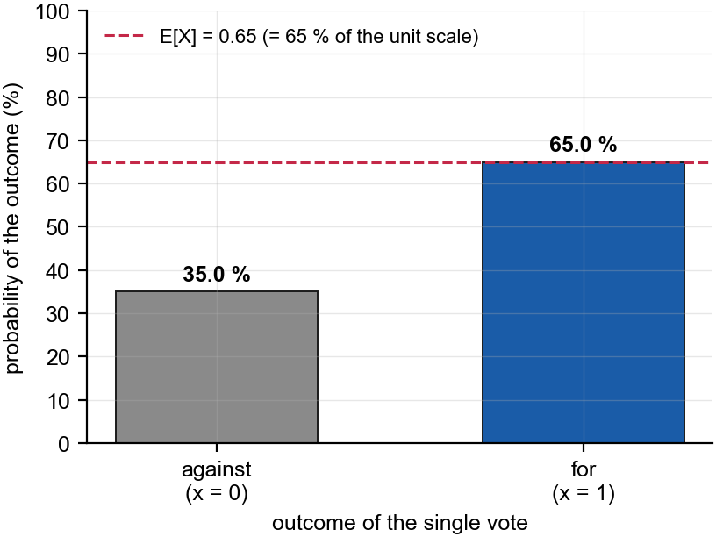
Figure 1. Probability distribution of one vote. The vertical scale runs from 0 % to 100 % in steps of 10 %; bar heights are the probabilities of each coded outcome, and the dashed line marks the expectation at 0.65 on the $\{0,1\}$ coding.
Trust. Both results are elementary enough to be obtained by hand, and they were: the arithmetic above is the complete derivation. The figure was drawn with Matplotlib (Hunter, 2007) from the same two numbers. As a check, the probabilities sum to $0.65+0.35=1$, and the variance attains the maximum value $p(1−p)≤0.25$ expected for a Bernoulli variable, consistent with $p$ lying near, but not at, one half.

2 Task 2: waiting for the owl
You open a window and wait to hear an owl. What is modelled is not whether the owl calls but how long the wait is, so the natural object is the chance that you are still waiting after $y$ hours. That quantity, read as a function of $y$, is the survival function, and everything else in this task is obtained from it.
Branch. With $ξ_{4}=1$ the survival function is
$${\overset{‾}{F}}_{Y}(y)=P(Y>y)=ξ_{5}e^{−ξ_{6}y^{2}}+ξ_{7}e^{−ξ_{8}y^{8}}, y≥0,$$
with $ξ_{6}=8$ and $ξ_{8}=5$. The branches $ξ_{4}∈\{0,2,3\}$ do not apply and are not performed.
A correction to the parameters, made explicit. The task sheet requires $ξ_{5}+ξ_{7}=1$, but the generator returned $ξ_{5}=0.66$ and $ξ_{7}=0.33$, summing to 0.99. This is not cosmetic: ${\overset{‾}{F}}_{Y}(0)=ξ_{5}+ξ_{7}$, so the model as delivered would assign probability $0.01$ to the owl already being audible the instant the window opens, and its density would integrate to 0.99 rather than to one. The discrepancy is a rounding artefact, and dividing by the observed total recovers $ξ_{5}^{*}=2/3$ and $ξ_{7}^{*}=1/3$ exactly, so the generator drew those fractions and truncated each to two decimals. The renormalised weights are used from here on; they satisfy the required constraint and give ${\overset{‾}{F}}_{Y}(0)=1$.
Model and assumptions. $Y≥0$ is the waiting time in hours from the moment the window is opened. ${\overset{‾}{F}}_{Y}$ is continuous and strictly decreasing with ${\overset{‾}{F}}_{Y}(0)=1$ and ${\overset{‾}{F}}_{Y}(y)→0$, so $Y$ is continuous with no atoms. Both terms are Weibull survival functions, which shows what the model says: a mixture of a fast mechanism (shape $2$, scale 0.3536 h, weight $2/3$, mean 18.8 min) and a slow one (shape $8$, scale 0.8178 h, weight $1/3$, mean 46.2 min). The two mechanisms are why the density in Figure 2 has peaks near 15 and 48 minutes.
Derivation. Since $F_{Y}=1−{\overset{‾}{F}}_{Y}$, the density is minus the derivative of the survival function (Ross, 2019, ch. 5):
$$f_{Y}(y)=−\frac{d}{dy}{\overset{‾}{F}}_{Y}(y)=2ξ_{6} ξ_{5}^{*} y e^{−ξ_{6}y^{2}}+8ξ_{8} ξ_{7}^{*} y^{7}e^{−ξ_{8}y^{8}}, y≥0.$$
For a non-negative variable the expectation is the area under the survival function, $E[Y]=\int_{0}^{∞}{{\overset{‾}{F}}_{Y}}(y) dy$, and likewise $E[Y^{2}]=2\int_{0}^{∞}{y} {\overset{‾}{F}}_{Y}(y) dy$. Both integrals are standard gamma integrals, giving closed forms rather than only numbers:
$$E[Y]=\frac{ξ_{5}^{*}}{2}\sqrt{\frac{π}{ξ_{6}}}+ξ_{7}^{*} Γ​\left(9/8\right)ξ_{8}^{−1/8}, E[Y^{2}]=\frac{ξ_{5}^{*}}{ξ_{6}}+\frac{ξ_{7}^{*} Γ​\left(1/4\right)}{4 ξ_{8}^{1/4}}.$$
Results. $E[Y]=0.46559$ h $=27.94$ minutes and $Var(Y)=0.06860$ h$​^{2}$, a standard deviation of 15.72 minutes. Solving $F_{Y}(y)=q$ numerically gives quartiles $Q_{1}=14.54$, median $=24.90$ and $Q_{3}=42.79$ minutes, an interquartile range of 28.24 minutes. The requested probability is
$$P(2<Y<4)={\overset{‾}{F}}_{Y}(2)−{\overset{‾}{F}}_{Y}(4)=8.443×{10}^{−15},$$
which is effectively zero, and not by accident: the model places 99.75 % of the probability inside the first hour, so a wait of two to four hours is essentially impossible under it. A reader should treat this as a statement about the model, not about owls.
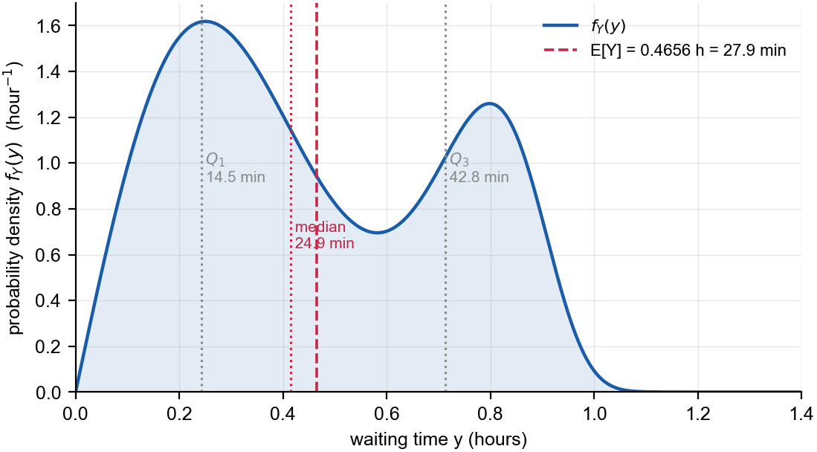
Figure 2. Probability density of the waiting time, in hours. The vertical axis is a density in units of hour$​^{−1}$, so areas, not heights, are probabilities. Dotted lines mark the quartiles and the dashed line the mean; both are annotated in minutes.
Units. The density is expressed per hour, so a per-minute statement must be obtained as a probability over an interval, not by rescaling the density: the chance of first hearing the owl during minute $k$ is ${\overset{‾}{F}}_{Y}((k−1)/60)−{\overset{‾}{F}}_{Y}(k/60)$. Minutes 15 and 16 tie for the largest value at 2.69 % and 2.69 %; the difference between them is smaller than the rounding shown, so neither should be quoted as the single most likely minute.
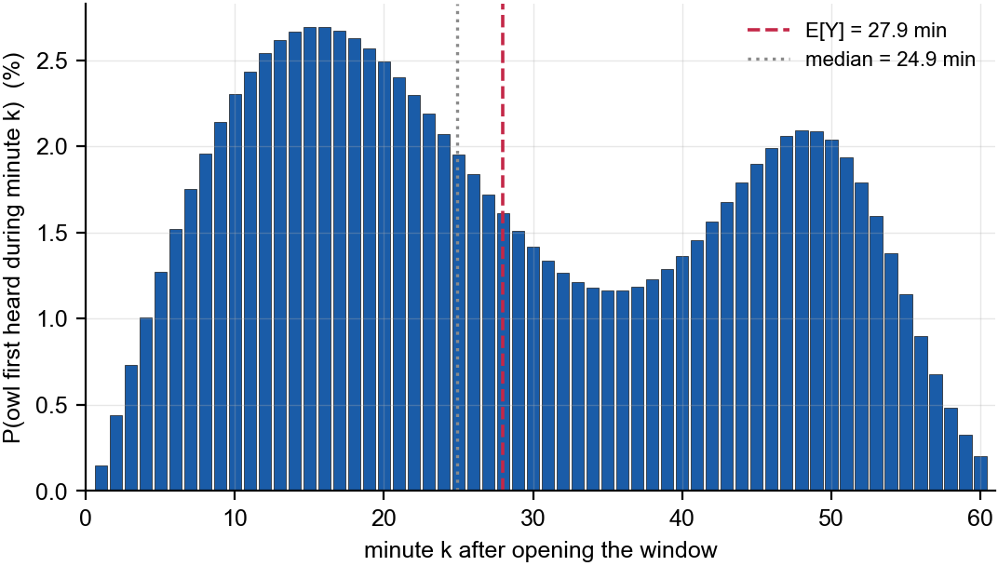
Figure 3. Probability of first hearing the owl during each of the first 60 minutes. The vertical scale is a probability in per cent, and the 60 bars sum to 99.75 %, the probability of hearing the owl within the first hour.
Trust. The density, both expectation integrals and the closed forms were derived by hand; SciPy (Virtanen et al., 2020) only evaluated them and solved for the quartiles by bisection. Checking algebra and code together, quadrature of $∫yf_{Y}(y) dy$ returns 0.465593899 against the closed form 0.465593899, and $\int_{0}^{∞}{f_{Y}}(y) dy=1.000000$, confirming the renormalised density integrates to one.

3 Task 3: bandwidth to failure of a pair of routers
A router carries traffic until its hardware fails; the quantity of interest is the total volume of data it moves before that happens, in terabytes. A second, identical router takes over automatically when the first dies. The question is how much data the pair delivers in total, and what an experiment tells us about the model’s single unknown parameter.
Branch. The personal parameter is $ξ_{9}=0$, so the single-router density is
$$f_{S}(s)=\frac{1}{θ}e^{−s/θ}, s>0, θ>0,$$
that is, $S$ is exponentially distributed with mean $θ$. The branches $ξ_{9}=1$ and $ξ_{9}=2$, which give gamma densities of shapes 5 and 7, do not apply and are not performed.
Expressing $T$, and the assumptions this needs. The second router only carries traffic once the first has failed, so the totals add: $T=S_{1}+S_{2}$. Four assumptions are needed. The routers are of the same type, so $S_{1}$ and $S_{2}$ are identically distributed. Their failures have independent physical causes, so $S_{1}$ and $S_{2}$ are independent; this would fail if they shared a power supply or an over-heating rack. Failover is immediate and perfect, so no traffic is lost and nothing double-counted. Finally, the exponential model asserts the memoryless property: a router that has already carried $s$ terabytes is as likely to survive the next terabyte as a new one. That last assumption is the questionable one, since real hardware shows wear-out, and it should be checked against maintenance records before the model is relied upon.
Density of $T$. For independent non-negative variables the density of a sum is the convolution of the densities (IU International University of Applied Sciences, 2025, Unit 3.5):
$$f_{T}(t)=\int_{0}^{t}{f_{S}}(u) f_{S}(t−u) du=\int_{0}^{t}{\frac{1}{θ^{2}}}e^{−u/θ}e^{−(t−u)/θ} du=\frac{1}{θ^{2}}e^{−t/θ}\int_{0}^{t}{d}u=\frac{t}{θ^{2}}e^{−t/θ}.$$
The exponents sum to $−t/θ$ regardless of $u$, leaving an integrand constant in $u$. The result is the $Gamma(2,θ)$ density, also called the two-stage Erlang distribution.
Likelihood and the transformation requested. For an independent sample $T_{1},…,T_{n}$,
$$L(θ)=\prod_{i=1}^{n}{\frac{T_{i}}{θ^{2}}}e^{−T_{i}/θ}=\left(\prod_{i=1}^{n}{T_{i}}\right)θ^{−2n}exp​\left(−\frac{1}{θ}\sum_{i=1}^{n}{T_{i}}\right).$$
The transformation that makes this tractable is the logarithm: $log$ is strictly increasing, so it preserves the location of the maximum while turning the product into a sum. Writing $ℓ(θ)=logL(θ)$,
$$ℓ(θ)=\sum_{i=1}^{n}{log}T_{i}−2nlogθ−\frac{1}{θ}\sum_{i=1}^{n}{T_{i}}, ℓ^{′}(θ)=−\frac{2n}{θ}+\frac{1}{θ^{2}}\sum_{i=1}^{n}{T_{i}}.$$
Setting $ℓ^{′}(θ)=0$ gives θ=12ni​Ti=T/2, a maximum rather than a minimum or inflexion since $ℓ^{″}(\hat{θ})=−2n/{\hat{θ}}^{2}<0$ and $ℓ$ tends to $−∞$ at both ends of $(0,∞)$.
Results. The experiment gave $ξ_{10}=(33,29,6,37,1)$ terabytes, so $n=5$, i​Ti=106 and $\overset{‾}{T}=21.2$. Hence
$$\hat{θ}=\frac{106}{2×5}=10.60 \text{TB}, E[T]=2\hat{θ}=21.2 \text{TB}.$$
That $E[T]$ equals $\overset{‾}{T}$ is no coincidence: the likelihood equation matches the model mean to the sample mean.
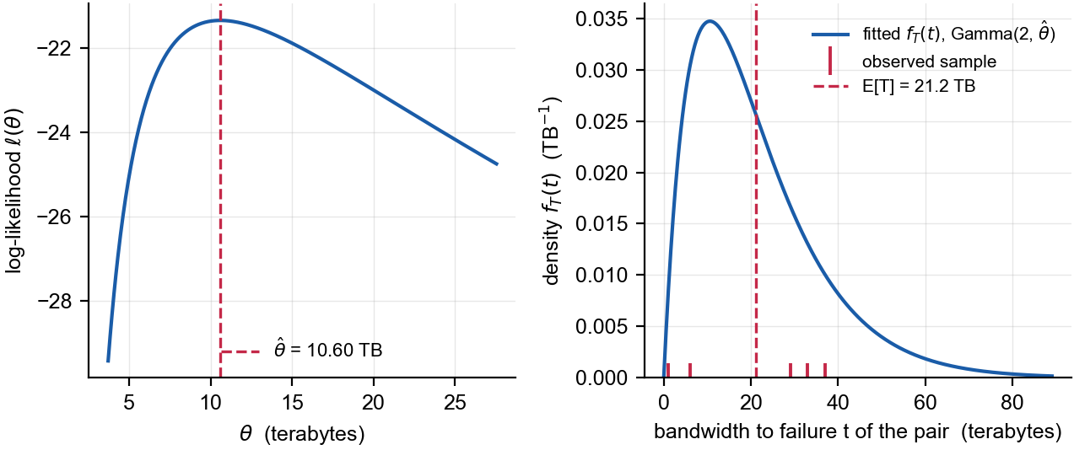
Figure 4. Left: the log-likelihood in terabytes, with the maximum at $\hat{θ}=10.60$ TB. Right: the fitted density of $T$ in units of TB$​^{−1}$, with the five observations shown as ticks and the fitted mean 21.2 TB marked.
Trust. The convolution, likelihood and estimator were derived by hand. As an independent check the log-likelihood was also maximised numerically with SciPy (Virtanen et al., 2020), returning 10.600000 against the closed form 10.600000, a difference of 1.4 ^{-7}. Two cautions belong with the result. With $n=5$ the Fisher information $2n/{\hat{θ}}^{2}$ gives a standard error of 3.35 TB and an approximate 95 % interval $[4.03,17.17]$, which is very wide. As a rough goodness-of-fit check the observed coefficient of variation is 0.778 against the 0.707 implied by $Gamma(2,θ)$: close enough not to contradict the model, though five points establish little.

4 Task 4: does the new system produce heavier hammers?
A factory has produced hammers long enough for the weight of its output to be well characterised. A new production system is introduced and ten hammers are weighed. Are those weights heavy enough to be evidence that the process now makes heavier hammers, or is the difference what ten measurements throw up by chance?
Branch. The personal parameter is $ξ_{13}=2$, so the question is whether the new system makes higher weights. The questions for $ξ_{13}∈\{0,1,3\}$, about more constant, lower and less constant weights, do not apply and are not performed.
Model and assumptions. Let $X$ be the weight in grams of one hammer from the new system, modelled as $X∼Normal(μ,σ^{2})$. Weight is the sum of many small independent contributions, so a normal shape is plausible by a central limit argument; a normal variable can be negative whereas a weight cannot, but at these values that probability is negligible. The ten hammers are drawn independently and the process does not drift while they are made. Finally, and this assumption does the real work, the historical figures from 1,000 hammers are treated as known, $μ_{0}=ξ_{11}=842$ g and $σ_{0}=ξ_{12}=55.3$ g, with $σ$ unchanged by the new system. Only $μ$ is then in question.
Hypotheses. The question is directional, so the test is one-sided:
$$H_{0}:μ≤μ_{0}=842 \text{g} \text{against} H_{1}:μ>μ_{0}=842 \text{g}.$$
The claim to be established is placed in $H_{1}$, so the burden of proof falls on it and the error controlled at level $α$ is that of announcing an improvement which is not there.
Which test, and the lookalike to avoid. Because $σ$ is taken as known, the standardised sample mean is exactly standard normal under $H_{0}$, so the correct statistic is a $z$-statistic. A $t$-statistic would be correct had $σ$ been estimated from the ten hammers themselves. The two differ in what sits in the denominator; both are reported below.
Decision rule. With $α=0.05$ and $z_{1−α}=1.6449$ (IU International University of Applied Sciences, 2025, Unit 7.1), the rule is
$$\text{reject }H_{0}⇔Z=\frac{\overset{‾}{X}−μ_{0}}{σ_{0}/\sqrt{n}}>1.6449⇔\overset{‾}{X}>870.76 \text{g}.$$
Computation and conclusion. The sample $ξ_{14}$ is (719, 743, 803, 814, 925, 1051, 776, 806, 802, 1083) grams, so $n=10$, $\overset{‾}{x}=852.2$ g and $σ_{0}/\sqrt{n}=17.4874$ g. Therefore
$$z=\frac{852.2−842}{17.4874}=0.5833, p=P(Z>0.5833)=0.2799.$$
Since $0.5833<1.6449$, equivalently $\overset{‾}{x}=852.2<870.76$ g, we fail to reject $H_{0}$: at the 5 % level there is no evidence that the new system produces higher weights. That is not evidence that it does not; the test simply detected no difference. Treating $σ$ as unknown gives $t=0.2567$ on $9$ degrees of freedom against a critical value 1.8331 and $p=0.4016$, so the conclusion is unchanged.
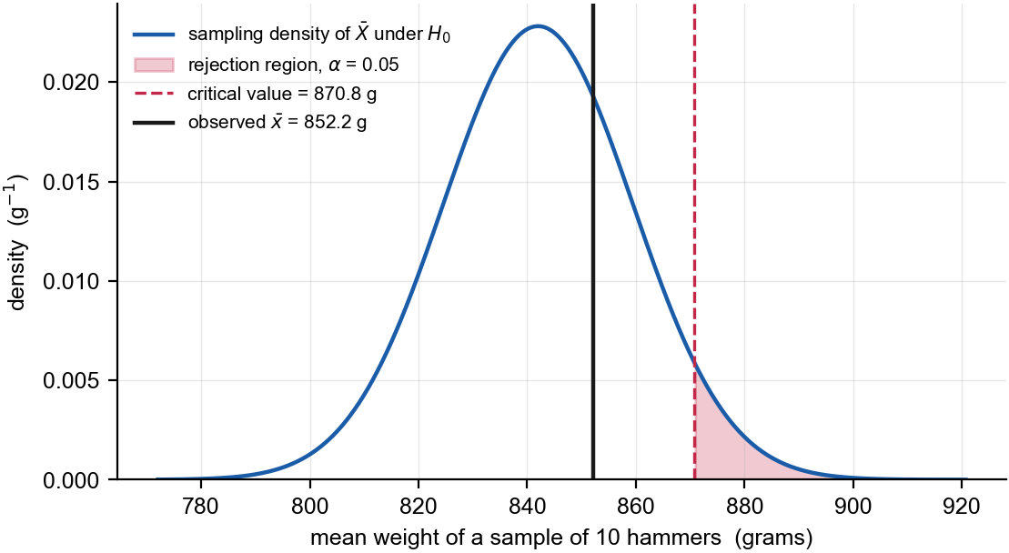
Figure 5. Sampling distribution of the mean weight of ten hammers under $H_{0}$, in grams. The shaded upper tail is the rejection region of size 5 %, beginning at the critical value 870.8 g; the solid line marks the observed mean 852.2 g, which falls well short of it.
Error probabilities. The Type I error, rejecting $H_{0}$ when it holds, is fixed at $α=5$ % by construction. The Type II error depends on the true mean: at an increase equal to the observed 10.2 g the power is only 14.42 %, so $β≈85.58$ %. Equivalently, with $n=10$ and $σ_{0}=55.3$ g the smallest increase this design detects with 80 % power is 43.48 g, over four times what was seen. The non-rejection therefore says as much about the sample size as about the hammers, and a larger sample is the appropriate next step.
Trust. The hypotheses, decision rule and power calculation were derived by hand; SciPy (Virtanen et al., 2020) supplied only quantiles and tail probabilities. One caveat should not be buried: $s=125.65$ g against the historical $σ_{0}=55.3$ g is a variance ratio of 5.16, so the assumption of unchanged spread is doubtful. If it is wrong the true standard error exceeds the one used here, which weakens the evidence for a higher mean rather than strengthening it.

5 Task 5: fitting a degree-ten polynomial, with and without a penalty
We are given an unknown function’s values at 22 points and asked to fit a polynomial, first by ordinary least squares (OLS) and then with a ridge penalty. The difficulty is arithmetic reliability: $x$ spans $−19$ to $20$ and ${20}^{10}≈{10}^{13}$, so a naive computation destroys precision before any statistics begin.
Branch. The personal parameter is $ξ_{15}=2$, so the model is the polynomial of degree 10,
$$f(x)=α_{0}+α_{1}x+α_{2}x^{2}+…+α_{10}x^{10},$$
with $11$ coefficients. The branch $ξ_{15}=0$, of degree twelve, does not apply. With 22 points against 11 coefficients the system is overdetermined, so least squares is well posed.
Setting up, and why scaling is not optional. The model is non-linear in $x$ but linear in the parameters, which is what lets least squares apply. Writing $y=Xα+ε$ with the Vandermonde design matrix $X_{ij}=x_{i}^{ j}$, the condition number of $X$ on the raw data is $1.02×{10}^{13}$. A condition number measures how far relative input errors are amplified, so at ${10}^{13}$, against sixteen significant digits of double precision, almost nothing survives. Rescaling to $\tilde{x}=x/20∈[−1,1]$ lowers it to $3738$, a factor of $2.7×{10}^{9}$; the response is rescaled by $\max_{i}|y_{i}|=5.98×{10}^{13}$ for the same reason, and coefficients are mapped back afterwards. All penalties below refer to this standardised problem, since $λ$ is meaningless until both axes are fixed.
The two estimates. OLS minimises ${\left\|y−Xα\right\|}^{2}$; ridge adds a penalty on coefficient size (Hastie et al., 2009, sec. 3.4.1),
α(λ)=argminαy−Xα2+λj≥1​αj2,
with the intercept excluded so the fit does not depend on where the origin of $y$ sits. Rather than forming $X^{⊤}X$, which would square the condition number back to ${10}^{7}$, the solution is read off the singular value decomposition $X=UDV^{⊤}$ as $\hat{α}(λ)=Vdiag(d_{j}/(d_{j}^{2}+λ))U^{⊤}y$: stable for every $λ≥0$, equal to OLS at $λ=0$, and showing what the penalty does: shrink the directions with small singular values, exactly those the data determines poorly. The weight was chosen by leave-one-out cross-validation, which for a linear smoother needs no refitting: with $h_{i}$ the $i$-th diagonal element of the hat matrix the criterion 1ni​(ei/(1−hi))2 is minimised at $λ^{*}=4.23×{10}^{−4}$: a prediction criterion rather than a preference. It is shallow, though — every penalty from $3.0×{10}^{−4}$ to $6.0×{10}^{−4}$ scores within 1 % of the best, so only the order of magnitude of $λ^{*}$ is determined.
Qualities of the two solutions. In-sample OLS fits best, as it must: root mean squared error $1.63×{10}^{11}$ against $2.96×{10}^{11}$ for ridge at $λ^{*}$ and $5.54×{10}^{11}$ at a heavy $λ=0.01$. Ridge buys stability: the non-intercept coefficient norm falls from 6.625 to 1.014, a reduction of 84.7 %, the bias-variance trade in concrete form.
A more serious limitation affects both. Least squares minimises absolute squared error, so the fit is dominated by the largest $|y|$, around $6.0×{10}^{13}$ at the edges. Where $|x|≤7$ and $|y|$ stays below about $2×{10}^{9}$, neither estimate carries information: the sample contains $x=0$ with $y=−0.98$, yet the fitted intercept is $1.90×{10}^{11}$ for OLS and $−7.73×{10}^{9}$ for ridge, both wrong by orders of magnitude on a directly observed point. Figure 6 shows both fits indistinguishable from the data over the full range, while the zoom reveals them swinging through $±{10}^{11}$ around observations effectively zero at that scale. Were that region to matter, the remedy would be a relative-error criterion, not a larger penalty.
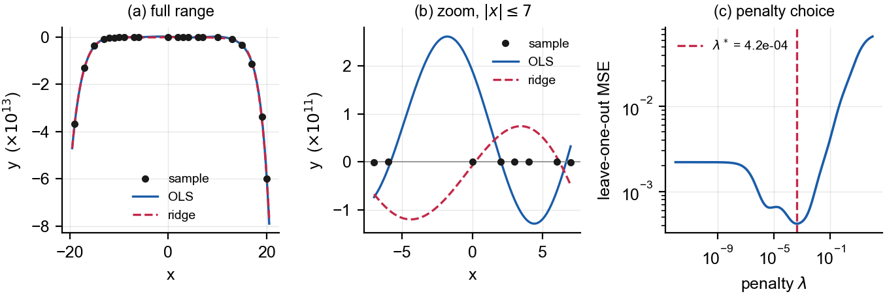
Figure 6. (a) Data and both fits over the full range, in units of ${10}^{13}$. (b) The same fits for $|x|≤7$, in units of ${10}^{11}$, where the observations are indistinguishable from zero and both fits oscillate wildly. (c) Leave-one-out mean squared error against the penalty, with the minimum at $λ^{*}=4.23×{10}^{−4}$.
Trust. The estimators and the leave-one-out identity were derived by hand and no black-box regression routine was used; NumPy (Harris et al., 2020) supplied only the decomposition and the condition numbers. As a check, $λ=0$ reproduces the fit from numpy.linalg.lstsq to 1.9 ^{-13} across all 11 coefficients.

6 Task 6: a Bayesian estimate of the gamma rate
The previous tasks estimated a parameter from data alone. Here we also hold a belief about it beforehand, and must combine the two coherently. Following Hogg et al. (2020, exercise 11.2.2), ten observations come from a gamma distribution whose rate is itself uncertain, with a prior expressing what that rate was thought to be.
Parameterisation, stated before anything is derived. A gamma distribution is written $Gamma(α,β)$ with density $f(x)=x^{α−1}e^{−x/β}/(Γ(α)β^{α})$, so $β$ is a scale, the rate is $1/β$, and the mean is $αβ$. This is the convention of Hogg et al. (2020). The distinction is not pedantic: it changes the answer, and by how much is quantified at the end.
Setting. Let $x_{1},…,x_{n}$ with $n=10$ be a random sample from $Gamma(α=3,β=1/θ)$. Since $β=1/θ$ is a scale, $θ$ is the rate of the sampling distribution, and
$$f(x∣θ)=\frac{θ^{3}}{Γ(3)}x^{2}e^{−θx}, x>0.$$
The prior $θ∼Gamma(23,63)$ therefore has rate 0.015873 and mean $ξ_{17}ξ_{18}=1449$. From $\overset{‾}{x}=ξ_{19}=95.48$ we get i​xi=954.8. The $x_{i}$ are assumed independent given $θ$, which lets the likelihood factorise.

6.1 (a) The posterior distribution
Keeping only what depends on $θ$, the likelihood and prior are
$$L(θ)∝θ^{3n}exp​\left(−θ\sum_{i=1}^{n}{x_{i}}\right), h(θ)∝θ^{ξ_{17}−1}e^{−θ/ξ_{18}}.$$
By Bayes’ theorem the posterior is proportional to their product, which is recognisable as another gamma density without computing the normalising constant:
h(θ∣x)∝θξ17+3n−1exp​−θi​xi+1ξ18 ⇒ θ∣x∼Gamma(53, rate 954.8159),
equivalently a scale of 1.047 ^{-3}. This is conjugacy: the family is closed under updating by a likelihood of this form, and the update is simply “add $3n$ to the shape and i​xi to the rate”.

6.2 (b) The Bayes estimate under squared-error loss
Under the loss $L(θ,d)=(θ−d)^{2}$ the posterior expected loss is a quadratic in $d$ whose derivative $−2E[θ∣x]+2d$ vanishes at $d=E[θ∣x]$, so it is minimised by the posterior mean. A gamma with shape $a$ and rate $r$ has mean $a/r$, so
θBayes=ξ17+3ni​xi+1/ξ18=53954.8159=0.055508.

6.3 (c) The Bayes estimate using the posterior mode
Differentiating $logh(θ∣x)=(a−1)logθ−rθ+\text{const}$ gives $(a−1)/θ−r=0$, so the mode is $(a−1)/r$, valid here because $a=53>1$:
θmode=ξ17+3n−1i​xi+1/ξ18=53−1954.8159=0.054461.
The mode is smaller than the mean because the gamma density is right-skewed, and the gap narrows as the shape grows.
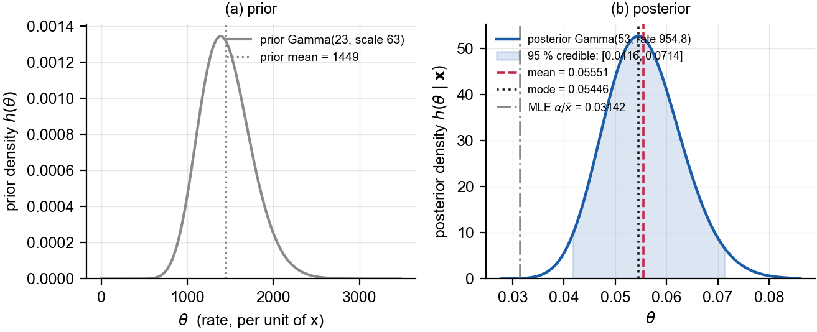
Figure 7. (a) The prior on $θ$, with mean 1449. (b) The posterior, with the Bayes estimate under squared-error loss, the posterior mode, the shaded 95 % credible interval, and the maximum likelihood estimate 0.03142 shown for comparison. Note the change of horizontal scale between the panels.
How much the prior is doing. The data alone give ${\hat{θ}}_{\text{MLE}}=α/\overset{‾}{x}=0.031420$, well below the Bayes estimate and outside the 95 % credible interval $[0.0416,0.0714]$. The update rule explains why: the prior contributes $23$ of the 53 shape units, over forty per cent, but only 0.0159 of the 954.8 rate units, so it pulls the estimate upwards. That the prior mean 1449 sits four orders of magnitude from the posterior mean signals a prior poorly matched to the data, exerting influence through the shape rather than the rate; in practice that mismatch would be worth raising with whoever supplied it.
The parameterisation, quantified. Had $ξ_{18}=63$ been read as a rate, the posterior rate would be 1017.8, giving a Bayes estimate 0.052073 and mode 0.051091, differing by 6.19 % from the values above. Parts (a) to (c) use the scale convention declared at the start.
Trust. The posterior, both estimators and the loss argument were derived by hand; software only evaluated the expressions and supplied the credible interval from the gamma quantile function in SciPy (Virtanen et al., 2020). Two checks: the posterior shape and rate satisfy the conjugate update rule, and the posterior mean, mode and standard deviation (0.007625) are mutually consistent with the gamma identities $a/r$, $(a−1)/r$ and $\sqrt{a}/r$.

References
Harris, C. R., Millman, K. J., van der Walt, S. J., Gommers, R., Virtanen, P., Cournapeau, D., Wieser, E., Taylor, J., Berg, S., Smith, N. J., Kern, R., Picus, M., Hoyer, S., van Kerkwijk, M. H., Brett, M., Haldane, A., del Río, J. F., Wiebe, M., Peterson, P., … Oliphant, T. E. (2020). Array programming with NumPy. Nature, 585(7825), 357–362.
Hastie, T., Tibshirani, R., & Friedman, J. (2009). The elements of statistical learning: Data mining, inference, and prediction (2nd ed.). Springer.
Hogg, R. V., McKean, J. W., & Craig, A. T. (2020). Introduction to mathematical statistics (8th ed.). Pearson.
Hunter, J. D. (2007). Matplotlib: A 2D graphics environment. Computing in Science & Engineering, 9(3), 90–95.
IU International University of Applied Sciences. (2025). Advanced statistics (DLMDSAS01) [Course book]. IU International University of Applied Sciences.
Ross, S. M. (2019). Introduction to probability models (12th ed.). Academic Press.
Virtanen, P., Gommers, R., Oliphant, T. E., Haberland, M., Reddy, T., Cournapeau, D., Burovski, E., Peterson, P., Weckesser, W., Bright, J., van der Walt, S. J., Brett, M., Wilson, J., Millman, K. J., Mayorov, N., Nelson, A. R. J., Jones, E., Kern, R., Larson, E., … Vázquez-Baeza, Y. (2020). SciPy 1.0: Fundamental algorithms for scientific computing in Python. Nature Methods, 17(3), 261–272.

Appendix A: personal parameters and signature
The values below are the output of the IU parameter generator and are reproduced verbatim. They are referenced throughout the workbook and are the sole source of every number in it.
Task | Parameter | Value
1 | $ξ_{1}$​ | 0
1 | $ξ_{2}$​ | 0.65
2 | $ξ_{4}$​ | 1
2 | $ξ_{5}$​ | 0.66
2 | $ξ_{6}$​ | 8
2 | $ξ_{7}$​ | 0.33
2 | $ξ_{8}$​ | 5
3 | $ξ_{9}$​ | 0
3 | $ξ_{10}$​ | 33, 29, 6, 37, 1
4 | $ξ_{11}$​ | 842
4 | $ξ_{12}$​ | 55.3
4 | $ξ_{13}$​ | 2
4 | $ξ_{14}$​ | 719, 743, 803, 814, 925, 1051, 776, 806, 802, 1083
5 | $ξ_{15}$​ | 2
5 | $ξ_{16}$​ | 22 coordinate pairs, listed in Table A.1
6 | $ξ_{17}$​ | 23
6 | $ξ_{18}$​ | 63
6 | $ξ_{19}$​ | 95.48
Signature string: 99d9e51eff0fb88f6911fa8b4392742591f8f6da
Table A.1 The 22 pairs $(x,y)$ of $ξ_{16}$ used in Task 5, sorted by $x$.
$x$​ | $y$​ | $x$​ | $y$​
$−19$​ | $−36772660717185.11$​ | $2$​ | $−2544.05$​
$−17$​ | $−13098473100719.23$​ | $3$​ | $−233160.01$​
$−15$​ | $−3645178210189.27$​ | $4$​ | $−4555356.86$​
$−13$​ | $−883231318602.85$​ | $6$​ | $−312854650.01$​
$−12$​ | $−393095356399.78$​ | $7$​ | $−1469352876.27$​
$−11$​ | $−158049416425.51$​ | $10$​ | $−54036320089.17$​
$−10$​ | $−62296573972.61$​ | $13$​ | $−765661859069.97$​
$−9$​ | $−23095218358.37$​ | $15$​ | $−3237146484674.61$​
$−7$​ | $−1820917820.98$​ | $17$​ | $−11266911204238.22$​
$−6$​ | $−410828259.57$​ | $19$​ | $−33591658940946.31$​
$0$​ | $−0.98$​ | $20$​ | $−59833403918809.97$​

Appendix B: source code
The listings below are the complete code that produced every number and every figure in this workbook. They are included as text so that they can be copied from the PDF and re-run. The entry point is compute.py, which writes a file of results that the workbook text draws on directly; no numeric result in the main text is typed by hand.
B.1 params.py — parses the generator output and verifies the signature.
"""Personal parameters for the DLMDSAS01 Advanced Workbook.
Single source of truth, parsed from ``exam_tasks/assignment_values_2.txt`` so
that no number is ever retyped by hand. Every quantity in the workbook is
derived from this module.
"""
from __future__ import annotations
import re
from pathlib import Path
VALUES_FILE = (Path(__file__).resolve().parents[2]
/ "exam_tasks" / "assignment_values_2.txt")
EXPECTED_SIGNATURE = "99d9e51eff0fb88f6911fa8b4392742591f8f6da"
def _parse(path: Path) -> tuple[dict[str, str], str]:
raw = path.read_text(encoding="utf-8")
values: dict[str, str] = {}
for match in re.finditer(r"^\s*\*?\s*ξ(\d+)\s*:\s*(.+?)\s*$", raw, re.MULTILINE):
values[f"xi{match.group(1)}"] = match.group(2)
signature_match = re.search(r"^\s*signature\s*\n\s*([0-9a-f]{40})\s*$",
raw, re.MULTILINE)
if signature_match is None:
raise ValueError(f"no 40-character signature found in {path}")
return values, signature_match.group(1)
_RAW, SIGNATURE = _parse(VALUES_FILE)
if SIGNATURE != EXPECTED_SIGNATURE:
raise ValueError(
f"parameter file signature {SIGNATURE} does not match the signature "
f"{EXPECTED_SIGNATURE} this workbook was written against; "
"regenerate the workbook rather than mixing parameter sets"
)
def _num(key: str) -> float:
return float(_RAW[key])
def _seq(key: str) -> list[float]:
return [float(v) for v in _RAW[key].split(",")]
def _pairs(key: str) -> list[tuple[float, float]]:
return [(float(a), float(b))
for a, b in re.findall(r"\(\s*(-?[\d.]+)\s*,\s*(-?[\d.]+)\s*\)", _RAW[key])]
# Task 1 - Bernoulli vote
XI1 = int(_num("xi1"))
XI2 = _num("xi2")
# Task 2 - waiting time for the owl
XI4 = int(_num("xi4"))
XI5 = _num("xi5")
XI6 = _num("xi6")
XI7 = _num("xi7")
XI8 = _num("xi8")
# Task 3 - router bandwidth to failure
XI9 = int(_num("xi9"))
XI10 = _seq("xi10")
# Task 4 - hammer weights
XI11 = _num("xi11")
XI12 = _num("xi12")
XI13 = int(_num("xi13"))
XI14 = _seq("xi14")
# Task 5 - regularised polynomial regression
XI15 = int(_num("xi15"))
XI16 = _pairs("xi16")
# Task 6 - Bayesian estimate
XI17 = _num("xi17")
XI18 = _num("xi18")
XI19 = _num("xi19")
#: Sample size fixed by the wording of Task 6 ("let x_1, ..., x_10").
TASK6_N = 10
#: Shape of the sampling distribution in Task 6, fixed by the task wording.
TASK6_ALPHA = 3.0
# The generator truncates xi5 and xi7 to two decimals, so they sum to 0.99
# while the task sheet requires xi5 + xi7 = 1. Renormalising restores the
# constraint exactly; see Task 2 of the workbook for the justification.
XI5_STAR = XI5 / (XI5 + XI7)
XI7_STAR = XI7 / (XI5 + XI7)
BRANCHES = {
1: XI1,
2: XI4,
3: XI9,
4: XI13,
5: XI15,
}
B.2 compute.py — all six tasks.
"""Every number and every figure in the Advanced Workbook.
Running this module writes ``build/results.json`` and the PNG files in
``figures/``. The prose in ``src/*.md`` never contains a hard-coded numeric
result: it references keys of ``results.json`` through ``{{...}}`` tokens that
``render.py`` substitutes. Text and computation therefore cannot drift apart.
Each task follows the same shape: derive the quantity in closed form where one
exists, evaluate it numerically, and cross-check the two against each other.
Those cross-checks are what the "trust" paragraph of each task reports.
"""
from __future__ import annotations
import json
import math
from pathlib import Path
import matplotlib
import numpy as np
matplotlib.use("Agg")
import matplotlib.pyplot as plt # noqa: E402
from scipy import integrate, optimize, special, stats # noqa: E402
import params as P # noqa: E402
HERE = Path(__file__).resolve().parent
FIGDIR = HERE / "figures"
BUILDDIR = HERE / "build"
# Sober academic figure style: sans-serif, restrained colours, print-legible.
plt.rcParams.update({
"font.family": "sans-serif",
"font.sans-serif": ["Arial", "Helvetica", "DejaVu Sans"],
"font.size": 9,
"axes.titlesize": 10,
"axes.labelsize": 9,
"axes.grid": True,
"grid.alpha": 0.3,
"grid.linewidth": 0.5,
"axes.spines.top": False,
"axes.spines.right": False,
"figure.dpi": 200,
"savefig.bbox": "tight",
"savefig.pad_inches": 0.02,
})
INK = "#1a1a1a"
ACCENT = "#1a5ca8"
ALT = "#c42848"
MUTED = "#8a8a8a"
#: 16 cm wide at the mandated 2 cm margins leaves a 17 cm text block.
FIGSIZE = (6.3, 3.4)
def _matvec(matrix: np.ndarray, vector: np.ndarray) -> np.ndarray:
"""Matrix-vector product guarded against a spurious BLAS warning.
NumPy 2.0 built against Apple's Accelerate framework raises divide-by-zero,
overflow and invalid warnings from ``matmul`` even when every input and
every output is finite; the vectorised kernel evaluates masked lanes and
reports their flags. The products here were checked against ``einsum`` and
agree to 2e-16, so the warning is suppressed for this call only and the
result is verified rather than trusted blindly.
"""
with np.errstate(divide="ignore", over="ignore", invalid="ignore"):
out = matrix @ vector
if not np.isfinite(out).all():
raise FloatingPointError("non-finite value in matrix-vector product")
return out
def _save(fig, name: str) -> str:
FIGDIR.mkdir(parents=True, exist_ok=True)
path = FIGDIR / f"{name}.png"
fig.savefig(path)
plt.close(fig)
return path.name
# --------------------------------------------------------------------------
# Task 1 - Bernoulli vote
# --------------------------------------------------------------------------
def task1() -> dict:
p = P.XI2
q = 1.0 - p
mean, var = p, p * q
fig, ax = plt.subplots(figsize=(4.6, 3.2))
bars = ax.bar(["against\n(x = 0)", "for\n(x = 1)"], [100 * q, 100 * p],
width=0.55, color=[MUTED, ACCENT], edgecolor=INK, linewidth=0.7)
for bar, value in zip(bars, [100 * q, 100 * p]):
ax.text(bar.get_x() + bar.get_width() / 2, value + 1.5, f"{value:.1f} %",
ha="center", va="bottom", fontsize=9, fontweight="bold")
ax.axhline(100 * mean, color=ALT, linestyle="--", linewidth=1.1,
label=f"E[X] = {mean:.2f} (= {100 * mean:.0f} % of the unit scale)")
ax.set_ylim(0, 100)
ax.set_yticks(range(0, 101, 10))
ax.set_ylabel("probability of the outcome (%)")
ax.set_xlabel("outcome of the single vote")
ax.legend(loc="upper left", frameon=False, fontsize=8)
fig1 = _save(fig, "task1_bernoulli")
return {
"p": p, "q": q, "mean": mean, "var": var, "sd": math.sqrt(var),
"p_pct": 100 * p, "q_pct": 100 * q,
"fig": fig1,
}
# --------------------------------------------------------------------------
# Task 2 - waiting time for the owl
# --------------------------------------------------------------------------
def task2() -> dict:
w1, w2 = P.XI5_STAR, P.XI7_STAR
a, b = P.XI6, P.XI8
def survival(y):
y = np.asarray(y, dtype=float)
return w1 * np.exp(-a * y ** 2) + w2 * np.exp(-b * y ** 8)
def density(y):
y = np.asarray(y, dtype=float)
return (w1 * 2 * a * y * np.exp(-a * y ** 2)
+ w2 * 8 * b * y ** 7 * np.exp(-b * y ** 8))
# Closed forms. With Fbar(y) = w1 exp(-a y^2) + w2 exp(-b y^8) and Y >= 0,
# E[Y] = int_0^inf Fbar = w1/2 sqrt(pi/a) + w2 Gamma(9/8) b^(-1/8)
# E[Y^2] = 2 int_0^inf y Fbar = w1/a + w2 Gamma(1/4) / (4 b^(1/4))
mean_exact = (w1 * 0.5 * math.sqrt(math.pi / a)
+ w2 * special.gamma(9 / 8) * b ** (-1 / 8))
second_exact = w1 / a + w2 * special.gamma(0.25) / (4 * b ** 0.25)
var_exact = second_exact - mean_exact ** 2
mean_num = integrate.quad(lambda y: y * density(y), 0, np.inf)[0]
second_num = integrate.quad(lambda y: y ** 2 * density(y), 0, np.inf)[0]
total_mass = integrate.quad(density, 0, np.inf)[0]
quartiles = [optimize.brentq(lambda y: 1 - survival(y) - q, 0, 20)
for q in (0.25, 0.5, 0.75)]
# Both components are Weibull survival functions: exp(-a y^2) is Weibull
# with shape 2 (a Rayleigh) and scale a^(-1/2), and exp(-b y^8) is Weibull
# with shape 8 and scale b^(-1/8). Naming them makes the mixture readable.
comp1_scale, comp2_scale = a ** -0.5, b ** -0.125
comp1_mean = comp1_scale * special.gamma(1 + 1 / 2)
comp2_mean = comp2_scale * special.gamma(1 + 1 / 8)
p_2_4 = float(survival(2.0) - survival(4.0))
p_within_hour = float(1 - survival(1.0))
# Probability that the owl is first heard during minute k.
minutes = np.arange(1, 61)
per_minute = survival((minutes - 1) / 60) - survival(minutes / 60)
grid = np.linspace(0, 1.4, 1400)
fig, ax = plt.subplots(figsize=FIGSIZE)
ax.plot(grid, density(grid), color=ACCENT, linewidth=1.6,
label=r"$f_Y(y)$")
ax.fill_between(grid, density(grid), color=ACCENT, alpha=0.12)
top = ax.get_ylim()[1]
for value, label, colour, height in zip(
quartiles, [r"$Q_1$", "median", r"$Q_3$"],
[MUTED, ALT, MUTED], [0.62, 0.44, 0.62]):
ax.axvline(value, color=colour, linestyle=":", linewidth=1.1)
ax.text(value, top * height, f" {label}\n {value * 60:.1f} min",
fontsize=7.5, color=colour, va="top")
ax.axvline(mean_exact, color=ALT, linestyle="--", linewidth=1.3,
label=f"E[Y] = {mean_exact:.4f} h = {mean_exact * 60:.1f} min")
ax.set_xlabel("waiting time y (hours)")
ax.set_ylabel(r"probability density $f_Y(y)$ (hour$^{-1}$)")
ax.set_xlim(0, 1.4)
ax.set_ylim(bottom=0)
ax.legend(loc="upper right", frameon=False, fontsize=8)
fig_pdf = _save(fig, "task2_density")
fig, ax = plt.subplots(figsize=FIGSIZE)
ax.bar(minutes, 100 * per_minute, width=0.85, color=ACCENT,
edgecolor=INK, linewidth=0.25)
ax.axvline(mean_exact * 60, color=ALT, linestyle="--", linewidth=1.3,
label=f"E[Y] = {mean_exact * 60:.1f} min")
ax.axvline(quartiles[1] * 60, color=MUTED, linestyle=":", linewidth=1.2,
label=f"median = {quartiles[1] * 60:.1f} min")
ax.set_xlabel("minute k after opening the window")
ax.set_ylabel("P(owl first heard during minute k) (%)")
ax.set_xlim(0, 61)
ax.legend(loc="upper right", frameon=False, fontsize=8)
fig_hist = _save(fig, "task2_minutes")
return {
"xi5": P.XI5, "xi7": P.XI7, "xi5_plus_xi7": P.XI5 + P.XI7,
# The mass the delivered weights leave unassigned at y = 0.
"xi_deficit": 1 - (P.XI5 + P.XI7),
"xi6": a, "xi8": b,
"w1": w1, "w2": w2,
"w1_frac": "2/3", "w2_frac": "1/3",
"survival_at_0_raw": P.XI5 + P.XI7,
"survival_at_0": float(survival(0.0)),
"mass": total_mass,
"mean_h": mean_exact, "mean_min": mean_exact * 60,
"mean_num_h": mean_num,
"mean_abs_err": abs(mean_exact - mean_num),
"second_exact": second_exact, "second_num": second_num,
"var_h2": var_exact, "var_min2": var_exact * 3600,
"sd_h": math.sqrt(var_exact), "sd_min": math.sqrt(var_exact) * 60,
"q1_h": quartiles[0], "q1_min": quartiles[0] * 60,
"median_h": quartiles[1], "median_min": quartiles[1] * 60,
"q3_h": quartiles[2], "q3_min": quartiles[2] * 60,
"iqr_min": (quartiles[2] - quartiles[0]) * 60,
"p_2_4": p_2_4,
"p_within_hour": p_within_hour,
"p_within_hour_pct": 100 * p_within_hour,
"peak_minute": int(minutes[int(np.argmax(per_minute))]),
"peak_minute_pct": float(100 * per_minute.max()),
# The two leading minutes differ in the fourth decimal of a per cent, so
# the prose reports them as a tie rather than naming a single winner.
"peak_minute_2": int(minutes[int(np.argsort(per_minute)[-2])]),
"peak_minute_2_pct": float(100 * np.sort(per_minute)[-2]),
"comp1_shape": 2, "comp2_shape": 8,
"comp1_scale": comp1_scale, "comp2_scale": comp2_scale,
"comp1_mean_min": comp1_mean * 60, "comp2_mean_min": comp2_mean * 60,
"mode1_min": 60 * float(optimize.minimize_scalar(
lambda y: -density(y), bounds=(0.01, 0.5), method="bounded").x),
"mode2_min": 60 * float(optimize.minimize_scalar(
lambda y: -density(y), bounds=(0.6, 1.2), method="bounded").x),
"fig_pdf": fig_pdf, "fig_hist": fig_hist,
}
# --------------------------------------------------------------------------
# Task 3 - dual router system
# --------------------------------------------------------------------------
def task3() -> dict:
t = np.array(P.XI10, dtype=float)
n = t.size
total = t.sum()
theta_hat = total / (2 * n)
def loglik(theta):
theta = np.asarray(theta, dtype=float)
return np.sum(np.log(t)) - 2 * n * np.log(theta) - total / theta
# Numerical maximisation as an independent check on the closed form.
numeric = optimize.minimize_scalar(lambda th: -loglik(th),
bracket=(theta_hat / 2, theta_hat * 2))
expected_t = 2 * theta_hat
fisher = 2 * n / theta_hat ** 2
se = 1 / math.sqrt(fisher)
cv_obs = t.std(ddof=1) / t.mean()
cv_model = 1 / math.sqrt(2)
grid = np.linspace(theta_hat * 0.35, theta_hat * 2.6, 600)
fig, axes = plt.subplots(1, 2, figsize=(6.6, 2.9))
ax = axes[0]
ax.plot(grid, loglik(grid), color=ACCENT, linewidth=1.5)
ax.axvline(theta_hat, color=ALT, linestyle="--", linewidth=1.2,
label=fr"$\hat\theta$ = {theta_hat:.2f} TB")
ax.set_xlabel(r"$\theta$ (terabytes)")
ax.set_ylabel(r"log-likelihood $\ell(\theta)$")
ax.legend(loc="lower center", frameon=False, fontsize=8)
ax = axes[1]
tt = np.linspace(0, max(t.max(), 4 * expected_t) * 1.05, 500)
ax.plot(tt, stats.gamma.pdf(tt, a=2, scale=theta_hat), color=ACCENT,
linewidth=1.5, label=r"fitted $f_T(t)$, Gamma(2, $\hat\theta$)")
ax.plot(t, np.zeros_like(t), "|", color=ALT, markersize=12,
markeredgewidth=1.4, label="observed sample")
ax.axvline(expected_t, color=ALT, linestyle="--", linewidth=1.2,
label=f"E[T] = {expected_t:.1f} TB")
ax.set_xlabel("bandwidth to failure t of the pair (terabytes)")
ax.set_ylabel(r"density $f_T(t)$ (TB$^{-1}$)")
ax.set_ylim(bottom=0)
ax.legend(loc="upper right", frameon=False, fontsize=7.5)
fig.tight_layout()
fig_t3 = _save(fig, "task3_mle")
return {
"n": n, "sample": ", ".join(f"{v:g}" for v in t),
"total": total, "mean": t.mean(),
"theta_hat": theta_hat,
"theta_numeric": float(numeric.x),
"theta_abs_err": abs(theta_hat - float(numeric.x)),
"expected_t": expected_t,
"se": se, "fisher": fisher,
"ci_lo": theta_hat - 1.959964 * se, "ci_hi": theta_hat + 1.959964 * se,
"cv_obs": cv_obs, "cv_model": cv_model,
"sd_t": math.sqrt(2) * theta_hat,
"fig": fig_t3,
}
# --------------------------------------------------------------------------
# Task 4 - hypothesis test on hammer weights
# --------------------------------------------------------------------------
def task4() -> dict:
x = np.array(P.XI14, dtype=float)
n = x.size
mu0, sigma0 = P.XI11, P.XI12
xbar = x.mean()
s = x.std(ddof=1)
se = sigma0 / math.sqrt(n)
z = (xbar - mu0) / se
alpha = 0.05
z_crit = stats.norm.ppf(1 - alpha)
p_value = float(stats.norm.sf(z))
crit_weight = mu0 + z_crit * se
t_stat = (xbar - mu0) / (s / math.sqrt(n))
t_crit = stats.t.ppf(1 - alpha, df=n - 1)
t_p = float(stats.t.sf(t_stat, df=n - 1))
# Power of the z-test at the observed mean, and the difference the design
# could detect with 80 % power.
power_at_obs = float(stats.norm.sf(z_crit - (xbar - mu0) / se))
delta_80 = (z_crit + stats.norm.ppf(0.80)) * se
n_for_obs = ((z_crit + stats.norm.ppf(0.80)) * sigma0 / (xbar - mu0)) ** 2
grid = np.linspace(mu0 - 4 * se, mu0 + 4.5 * se, 700)
fig, ax = plt.subplots(figsize=FIGSIZE)
ax.plot(grid, stats.norm.pdf(grid, mu0, se), color=ACCENT, linewidth=1.6,
label=r"sampling density of $\bar{X}$ under $H_0$")
reject = grid >= crit_weight
ax.fill_between(grid[reject], stats.norm.pdf(grid[reject], mu0, se),
color=ALT, alpha=0.25,
label=fr"rejection region, $\alpha$ = {alpha:.2f}")
ax.axvline(crit_weight, color=ALT, linestyle="--", linewidth=1.2,
label=f"critical value = {crit_weight:.1f} g")
ax.axvline(xbar, color=INK, linestyle="-", linewidth=1.6,
label=fr"observed $\bar{{x}}$ = {xbar:.1f} g")
ax.set_xlabel("mean weight of a sample of 10 hammers (grams)")
ax.set_ylabel(r"density (g$^{-1}$)")
ax.set_ylim(bottom=0)
ax.legend(loc="upper left", frameon=False, fontsize=7.5)
fig_t4 = _save(fig, "task4_test")
return {
"n": n, "sample": ", ".join(f"{v:g}" for v in x),
"mu0": mu0, "sigma0": sigma0,
"xbar": xbar, "s": s, "se": se,
"diff": xbar - mu0,
"z": z, "z_crit": z_crit, "p_value": p_value,
"crit_weight": crit_weight,
"alpha": alpha, "alpha_pct": 100 * alpha,
"t_stat": t_stat, "t_crit": t_crit, "t_p": t_p, "df": n - 1,
"power_at_obs": power_at_obs, "power_at_obs_pct": 100 * power_at_obs,
"beta_at_obs_pct": 100 * (1 - power_at_obs),
"delta_80": delta_80,
"n_for_obs": math.ceil(n_for_obs),
"var_ratio": (s / sigma0) ** 2,
"fig": fig_t4,
}
# --------------------------------------------------------------------------
# Task 5 - OLS and ridge on a degree-10 polynomial
# --------------------------------------------------------------------------
def _design(x_scaled: np.ndarray, degree: int) -> np.ndarray:
return np.vander(x_scaled, degree + 1, increasing=True)
class _Ridge:
"""Ridge regression with an unpenalised intercept, solved by SVD.
Forming and inverting the Gram matrix X'X squares the condition number and
is unusable here: even after rescaling x the design has condition number
around 4e3, so X'X sits near 1e7 and small penalties lose all precision.
Following Hastie, Tibshirani and Friedman (2009, sec. 3.4.1) the intercept
is excluded from the penalty by centring the remaining columns, and the
penalised solution is read straight off the singular value decomposition:
beta(lambda) = V diag(d / (d^2 + lambda)) U' y_centred
which is stable for every lambda >= 0.
"""
def __init__(self, X: np.ndarray, y: np.ndarray) -> None:
self.x_mean = X[:, 1:].mean(axis=0)
self.y_mean = float(y.mean())
self.Xc = X[:, 1:] - self.x_mean
self.yc = y - self.y_mean
self.U, self.d, self.Vt = np.linalg.svd(self.Xc, full_matrices=False)
self.n = X.shape[0]
def coefficients(self, lam: float) -> np.ndarray:
"""Return coefficients in the original basis, intercept first."""
shrunk = self.d / (self.d ** 2 + lam)
slope = _matvec(self.Vt.T, shrunk * _matvec(self.U.T, self.yc))
intercept = self.y_mean - float(self.x_mean @ slope)
return np.concatenate([[intercept], slope])
def leverages(self, lam: float) -> np.ndarray:
"""Diagonal of the hat matrix, including the unpenalised intercept."""
factors = self.d ** 2 / (self.d ** 2 + lam)
return 1.0 / self.n + _matvec(self.U ** 2, factors)
def loo_mse(self, lam: float) -> float:
"""Leave-one-out mean squared error via the closed-form shortcut."""
beta = self.coefficients(lam)
residual = self.yc - _matvec(self.Xc, beta[1:])
return float(np.mean((residual / (1.0 - self.leverages(lam))) ** 2))
def _pairs_table(pairs: list[tuple[float, float]]) -> str:
"""Render the Task 5 coordinate pairs as Markdown rows, two pairs per row.
The generator prints these to two decimals, so ``.2f`` reproduces them
verbatim; building the appendix table here rather than typing it keeps it
from drifting if the parameter set is ever regenerated.
"""
half = (len(pairs) + 1) // 2
left, right = pairs[:half], pairs[half:]
rows = []
for index in range(half):
cells = []
for column in (left, right):
if index < len(column):
x, y = column[index]
cells += [f"${x:.0f}$", f"${y:.2f}$"]
else:
cells += ["", ""]
rows.append("| " + " | ".join(cells) + " |")
return "\n".join(rows)
def task5() -> dict:
pairs = sorted(P.XI16)
x = np.array([a for a, _ in pairs], dtype=float)
y = np.array([b for _, b in pairs], dtype=float)
n, degree = x.size, 10
x_scale = np.abs(x).max()
y_scale = np.abs(y).max()
xs, ys = x / x_scale, y / y_scale
X_raw = _design(x, degree)
X = _design(xs, degree)
cond_raw = float(np.linalg.cond(X_raw))
cond_scaled = float(np.linalg.cond(X))
fit = _Ridge(X, ys)
beta_ols = fit.coefficients(0.0)
resid_ols = ys - _matvec(X, beta_ols)
rmse_ols = float(np.sqrt(np.mean(resid_ols ** 2)))
# Independent check that the SVD route at lambda = 0 is ordinary least
# squares: compare against NumPy's own least-squares solver.
beta_lstsq = np.linalg.lstsq(X, ys, rcond=None)[0]
ols_check = float(np.abs(beta_ols - beta_lstsq).max())
# Penalty weight by leave-one-out cross-validation on the standardised
# problem. Both axes are rescaled first: lambda trades against the squared
# residual, so it is meaningless until x and y are dimensionless.
lambdas = np.logspace(-12, 2, 281)
loo = np.array([fit.loo_mse(lam) for lam in lambdas])
coarse = int(np.argmin(loo))
# The grid is only for the figure: at 20 points per decade its spacing is
# 12 %, which would fix the second significant digit of lambda* by accident.
# Refine within the bracketing grid cell so the quoted value is the actual
# minimiser rather than the nearest grid node.
lo = math.log10(lambdas[max(coarse - 1, 0)])
hi = math.log10(lambdas[min(coarse + 1, lambdas.size - 1)])
lam_star = float(10 ** optimize.minimize_scalar(
lambda t: fit.loo_mse(10 ** t), bounds=(lo, hi), method="bounded",
options={"xatol": 1e-6}).x)
# The criterion is shallow near its minimum, so report the range of
# penalties that are within 1 % of the best score rather than implying that
# lambda* is sharply determined.
loo_star = fit.loo_mse(lam_star)
band = np.logspace(lo - 1, hi + 1, 2001)
inside = band[np.array([fit.loo_mse(l) for l in band]) <= loo_star * 1.01]
lam_band_lo, lam_band_hi = float(inside.min()), float(inside.max())
beta_ridge = fit.coefficients(lam_star)
resid_ridge = ys - _matvec(X, beta_ridge)
rmse_ridge = float(np.sqrt(np.mean(resid_ridge ** 2)))
# A deliberately heavy penalty, to show what the trade-off looks like.
lam_heavy = 1e-2
beta_heavy = fit.coefficients(lam_heavy)
rmse_heavy = float(np.sqrt(np.mean((ys - _matvec(X, beta_heavy)) ** 2)))
# Absolute-error least squares is dominated by the largest |y|. Measuring
# the fit on the points with |x| <= 7, where |y| stays below 2e9, shows how
# little either estimate says about that part of the curve.
small = np.abs(x) <= 7
def small_rel_err(beta):
fitted = y_scale * _matvec(X[small], beta)
return float(np.max(np.abs((fitted - y[small]) / y[small])))
def to_original(beta_scaled: np.ndarray) -> np.ndarray:
"""Map coefficients of the scaled fit back to the original x and y."""
return beta_scaled * y_scale / x_scale ** np.arange(degree + 1)
alpha_ols = to_original(beta_ols)
alpha_ridge = to_original(beta_ridge)
alpha_heavy = to_original(beta_heavy)
grid = np.linspace(x.min() - 0.5, x.max() + 0.5, 800)
Xg = _design(grid / x_scale, degree)
fit_ols = y_scale * _matvec(Xg, beta_ols)
fit_ridge = y_scale * _matvec(Xg, beta_ridge)
fig, axes = plt.subplots(1, 3, figsize=(7.0, 2.5))
# (a) Full range. On this scale both estimates are indistinguishable from
# the data, which is the entire reason panel (b) is needed.
ax = axes[0]
ax.plot(x, y / 1e13, "o", color=INK, markersize=3.0,
label="sample", zorder=5)
ax.plot(grid, fit_ols / 1e13, color=ACCENT, linewidth=1.2, label="OLS")
ax.plot(grid, fit_ridge / 1e13, color=ALT, linewidth=1.2, linestyle="--",
label="ridge")
ax.set_xlabel("x")
ax.set_ylabel(r"y ($\times 10^{13}$)")
ax.set_title("(a) full range", fontsize=8.5)
ax.legend(loc="lower center", frameon=False, fontsize=7)
# (b) The small-|x| region, where both fits are worthless.
ax = axes[1]
zoom = np.abs(grid) <= 7
ax.plot(x[small], y[small] / 1e11, "o", color=INK, markersize=3.0,
label="sample", zorder=5)
ax.plot(grid[zoom], fit_ols[zoom] / 1e11, color=ACCENT, linewidth=1.2,
label="OLS")
ax.plot(grid[zoom], fit_ridge[zoom] / 1e11, color=ALT, linewidth=1.2,
linestyle="--", label="ridge")
ax.axhline(0, color=MUTED, linewidth=0.6)
ax.set_xlabel("x")
ax.set_ylabel(r"y ($\times 10^{11}$)")
ax.set_title(r"(b) zoom, $|x| \leq 7$", fontsize=8.5)
ax.legend(loc="upper right", frameon=False, fontsize=7)
# (c) How the penalty was chosen.
ax = axes[2]
ax.loglog(lambdas, loo, color=ACCENT, linewidth=1.3)
ax.axvline(lam_star, color=ALT, linestyle="--", linewidth=1.2,
label=fr"$\lambda^*$ = {lam_star:.1e}")
ax.set_xlabel(r"penalty $\lambda$")
ax.set_ylabel("leave-one-out MSE")
ax.set_title("(c) penalty choice", fontsize=8.5)
ax.legend(loc="upper left", frameon=False, fontsize=7)
fig.tight_layout()
fig_t5 = _save(fig, "task5_ridge")
def fmt(vec: np.ndarray) -> str:
return ", ".join(f"{v:.4g}" for v in vec)
return {
"n": n, "degree": degree, "n_params": degree + 1,
"x_min": x.min(), "x_max": x.max(),
"y_min": y.min(), "y_max": y.max(),
"x_scale": x_scale, "y_scale": y_scale,
"cond_raw": cond_raw, "cond_scaled": cond_scaled,
"cond_ratio": cond_raw / cond_scaled,
"lam_star": lam_star, "lam_heavy": lam_heavy,
"lam_band_lo": lam_band_lo, "lam_band_hi": lam_band_hi,
"pairs_rows": _pairs_table(pairs),
"rmse_ols": rmse_ols * y_scale, "rmse_ridge": rmse_ridge * y_scale,
"rmse_heavy": rmse_heavy * y_scale,
"rmse_ols_rel": rmse_ols, "rmse_ridge_rel": rmse_ridge,
"rmse_heavy_rel": rmse_heavy,
"norm_ols": float(np.linalg.norm(beta_ols[1:])),
"norm_ridge": float(np.linalg.norm(beta_ridge[1:])),
"norm_heavy": float(np.linalg.norm(beta_heavy[1:])),
"norm_shrink_pct": 100 * (1 - float(np.linalg.norm(beta_ridge[1:]))
/ float(np.linalg.norm(beta_ols[1:]))),
"alpha_ols": fmt(alpha_ols), "alpha_ridge": fmt(alpha_ridge),
"alpha_heavy": fmt(alpha_heavy),
"a0_ols": alpha_ols[0], "a0_ridge": alpha_ridge[0],
"a10_ols": alpha_ols[10], "a10_ridge": alpha_ridge[10],
"y_at_zero": float(y[x == 0][0]) if np.any(x == 0) else float("nan"),
"n_small": int(small.sum()),
"small_rel_ols": small_rel_err(beta_ols),
"small_rel_ridge": small_rel_err(beta_ridge),
"ols_check": ols_check,
"fig": fig_t5,
}
# --------------------------------------------------------------------------
# Task 6 - Bayesian estimate of the gamma rate
# --------------------------------------------------------------------------
def task6() -> dict:
n, alpha_lik = P.TASK6_N, P.TASK6_ALPHA
prior_shape, prior_beta = P.XI17, P.XI18
xbar = P.XI19
total = n * xbar
# Hogg, McKean and Craig write the gamma density with beta as a scale.
# Read consistently, the prior rate is 1/xi18.
post_shape = prior_shape + alpha_lik * n
post_rate = 1.0 / prior_beta + total
post_mean = post_shape / post_rate
post_mode = (post_shape - 1) / post_rate
# The alternative reading, in which xi18 is a rate, is reported so that a
# reader who uses the other convention can locate the difference at once.
alt_rate = prior_beta + total
alt_mean = post_shape / alt_rate
alt_mode = (post_shape - 1) / alt_rate
prior_mean = prior_shape * prior_beta
mle = alpha_lik / xbar
lo = stats.gamma.ppf(0.025, a=post_shape, scale=1 / post_rate)
hi = stats.gamma.ppf(0.975, a=post_shape, scale=1 / post_rate)
fig, axes = plt.subplots(1, 2, figsize=(6.8, 2.9))
ax = axes[0]
grid = np.linspace(0, prior_mean * 2.4, 600)
ax.plot(grid, stats.gamma.pdf(grid, a=prior_shape, scale=prior_beta),
color=MUTED, linewidth=1.5,
label=fr"prior Gamma({prior_shape:.0f}, scale {prior_beta:.0f})")
ax.axvline(prior_mean, color=MUTED, linestyle=":", linewidth=1.1,
label=f"prior mean = {prior_mean:.0f}")
ax.set_xlabel(r"$\theta$ (rate, per unit of x)")
ax.set_ylabel(r"prior density $h(\theta)$")
ax.set_title("(a) prior", fontsize=8.5)
ax.set_ylim(bottom=0)
ax.legend(loc="upper right", frameon=False, fontsize=7)
ax = axes[1]
grid = np.linspace(post_mean * 0.5, post_mean * 1.55, 600)
density = stats.gamma.pdf(grid, a=post_shape, scale=1 / post_rate)
ax.plot(grid, density, color=ACCENT, linewidth=1.6,
label=fr"posterior Gamma({post_shape:.0f}, rate {post_rate:.1f})")
band = (grid >= lo) & (grid <= hi)
ax.fill_between(grid[band], density[band], color=ACCENT, alpha=0.15,
label=f"95 % credible: [{lo:.4f}, {hi:.4f}]")
ax.axvline(post_mean, color=ALT, linestyle="--", linewidth=1.3,
label=f"mean = {post_mean:.5f}")
ax.axvline(post_mode, color=INK, linestyle=":", linewidth=1.3,
label=f"mode = {post_mode:.5f}")
ax.axvline(mle, color=MUTED, linestyle="-.", linewidth=1.3,
label=fr"MLE $\alpha/\bar{{x}}$ = {mle:.5f}")
ax.set_xlabel(r"$\theta$")
ax.set_ylabel(r"posterior density $h(\theta \mid \mathbf{x})$")
ax.set_title("(b) posterior", fontsize=8.5)
ax.set_ylim(bottom=0)
ax.legend(loc="upper left", frameon=False, fontsize=6.5)
fig.tight_layout()
fig_t6 = _save(fig, "task6_posterior")
return {
"n": n, "alpha_lik": alpha_lik,
"prior_shape": prior_shape, "prior_beta": prior_beta,
"prior_rate": 1 / prior_beta, "prior_mean": prior_mean,
"xbar": xbar, "total": total,
"post_shape": post_shape, "post_rate": post_rate,
"post_scale": 1 / post_rate,
"post_mean": post_mean, "post_mode": post_mode,
"post_sd": math.sqrt(post_shape) / post_rate,
"alt_rate": alt_rate, "alt_mean": alt_mean, "alt_mode": alt_mode,
"alt_mean_diff_pct": 100 * abs(alt_mean - post_mean) / post_mean,
"mle": mle,
"cred_lo": float(lo), "cred_hi": float(hi),
"prior_weight_pct": 100 * (1 / prior_beta) / post_rate,
"fig": fig_t6,
}
# --------------------------------------------------------------------------
def flatten(nested: dict) -> dict:
"""Turn ``{"task1": {"p": 0.65}}`` into ``{"task1.p": 0.65}``."""
flat = {}
for section, values in nested.items():
for key, value in values.items():
flat[f"{section}.{key}"] = value
return flat
def main() -> int:
BUILDDIR.mkdir(parents=True, exist_ok=True)
results = {
"task1": task1(),
"task2": task2(),
"task3": task3(),
"task4": task4(),
"task5": task5(),
"task6": task6(),
}
results["meta"] = {
"signature": P.SIGNATURE,
"signature_short": P.SIGNATURE[:8],
"xi1": P.XI1, "xi2": P.XI2, "xi4": P.XI4, "xi5": P.XI5, "xi6": P.XI6,
"xi7": P.XI7, "xi8": P.XI8, "xi9": P.XI9,
"xi10": ", ".join(f"{v:g}" for v in P.XI10),
"xi11": P.XI11, "xi12": P.XI12, "xi13": P.XI13,
"xi14": ", ".join(f"{v:g}" for v in P.XI14),
"xi15": P.XI15,
"xi16_n": len(P.XI16),
"xi17": P.XI17, "xi18": P.XI18, "xi19": P.XI19,
}
out = BUILDDIR / "results.json"
out.write_text(json.dumps(flatten(results), indent=2, sort_keys=True,
default=float), encoding="utf-8")
print(f"wrote {out.relative_to(HERE)} with {len(flatten(results))} keys")
print(f"wrote {len(list(FIGDIR.glob('*.png')))} figures to figures/")
return 0
if __name__ == "__main__":
raise SystemExit(main())

