Varianta 3

1.a.ctrl+Alt+T;

b.sudo useradd Elena

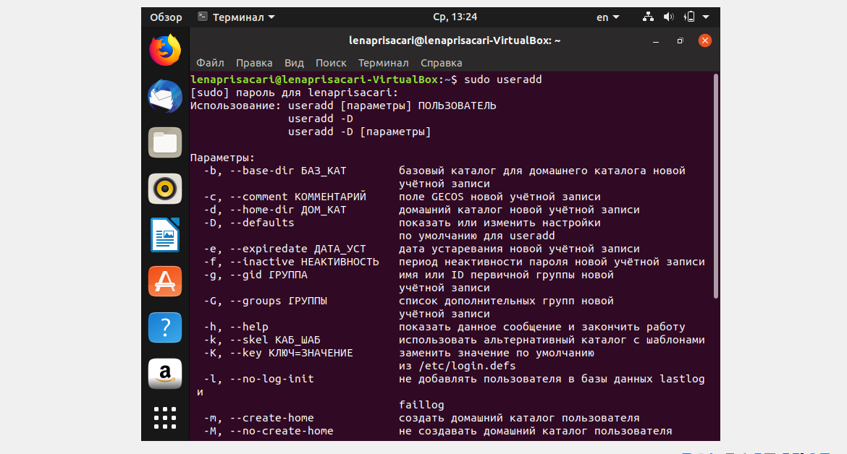

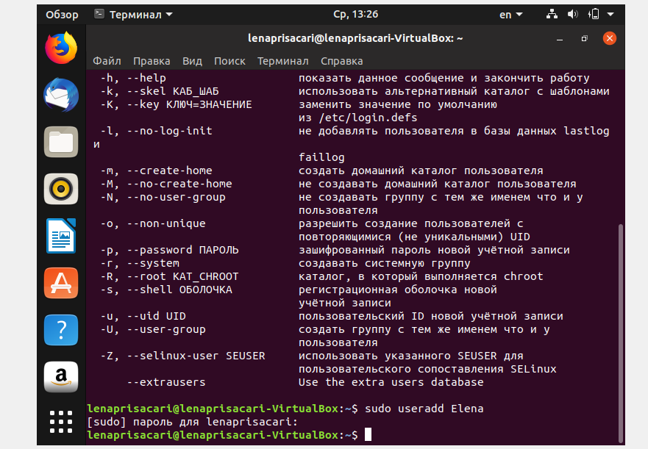

c. mkdir Elena

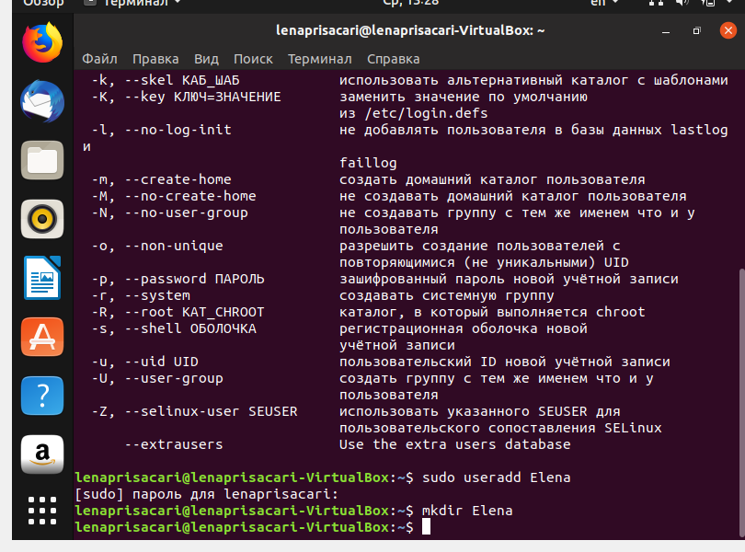

Sudo chmod – wx file



2. ctrl+Alt+T

Cd /etc

Ls

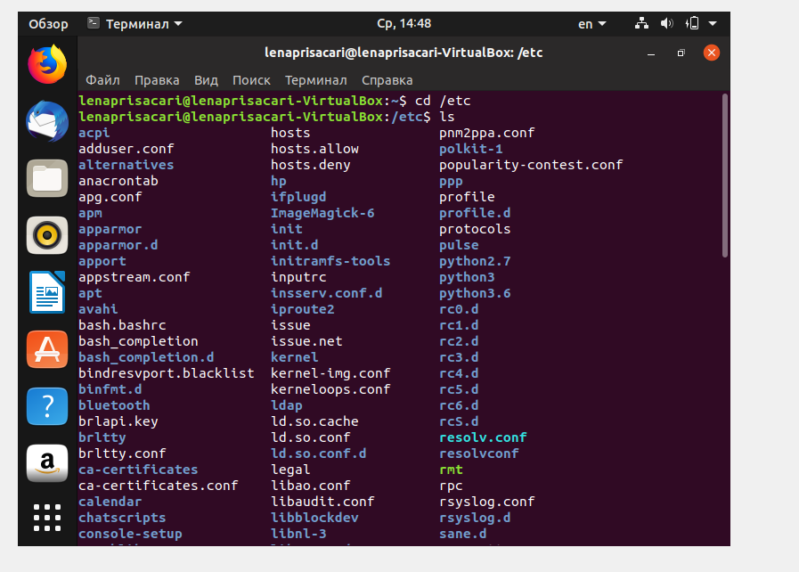

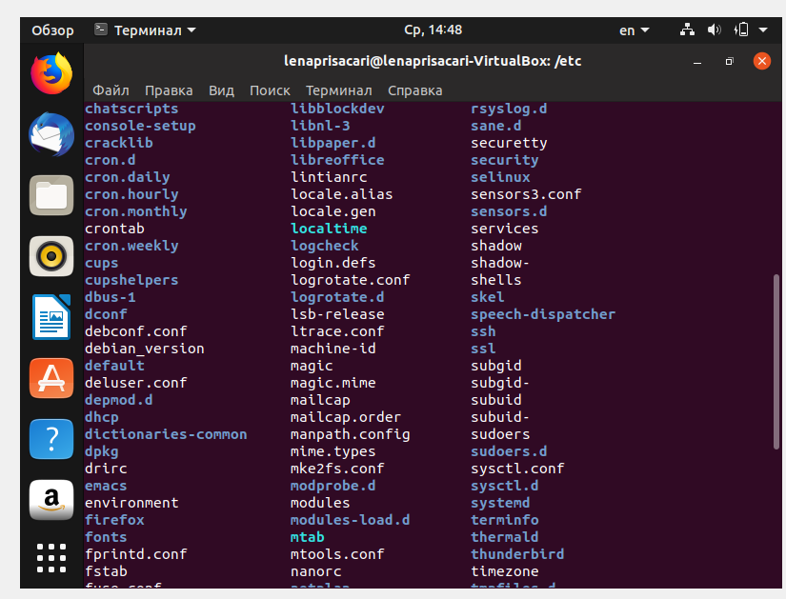

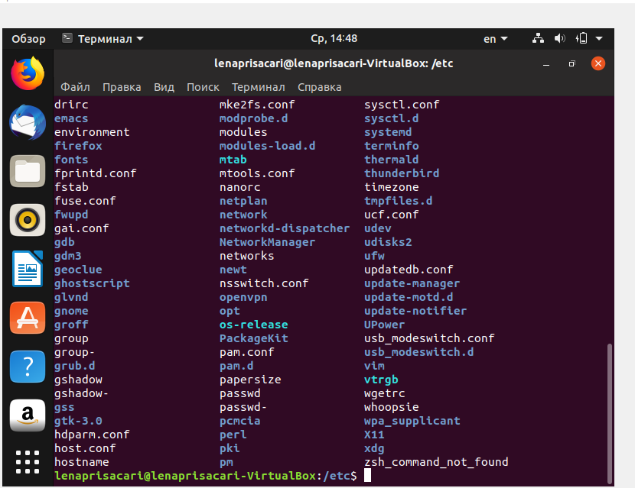

3.a. Параметры

b.Язык и Регион

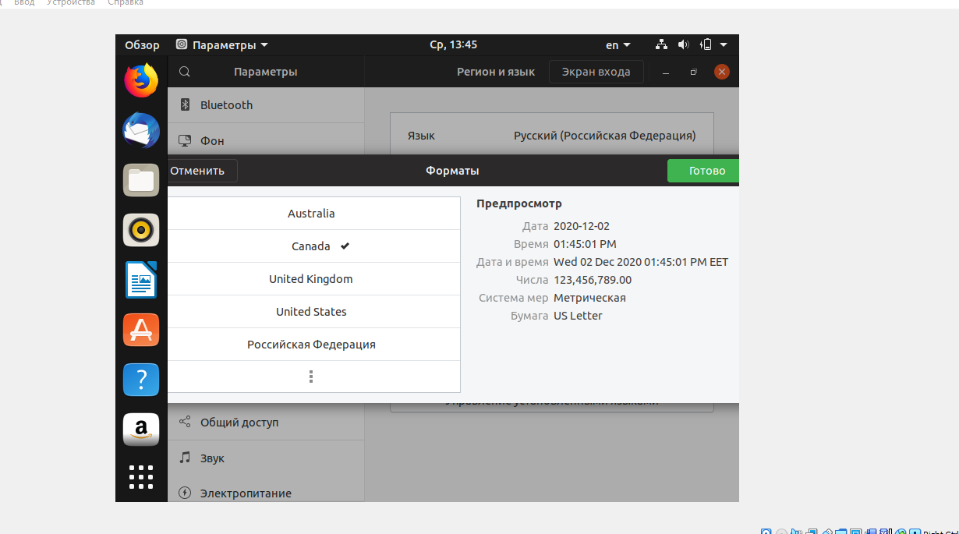

Через терминал:

a.ctrl+Alt+T

b. gsettings set org.gnome.desktop.background picture-uri



4.ctrl+Alt+T

b. sudo apt install xfconf

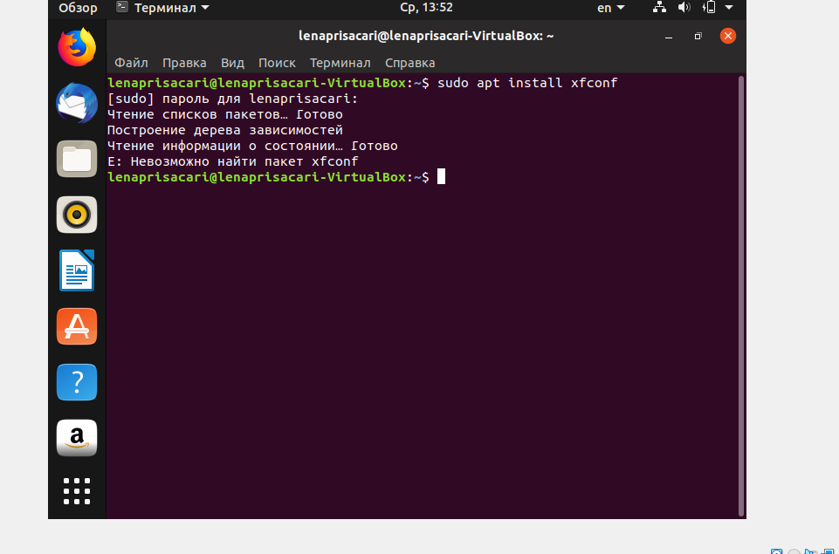

c.theme-changer

2 вариант через параметры

Параметры

Фон

Обои

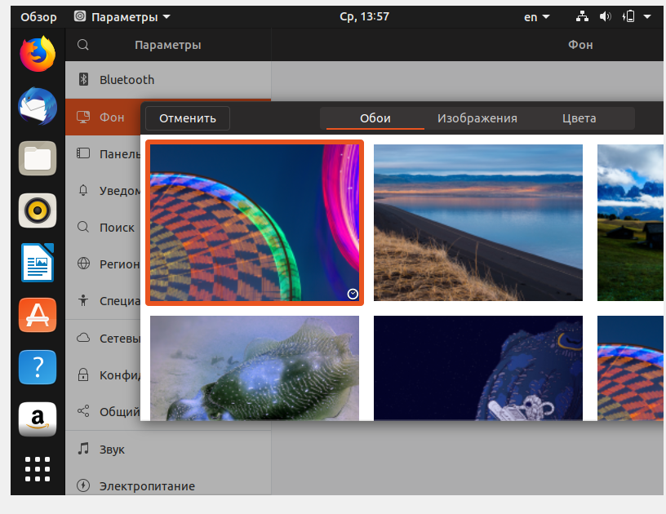

Enter

5.a.ctrl + Alt+T

b.sudo date – set “Ср 2 дек 14:07:00 EET 2020”(date)

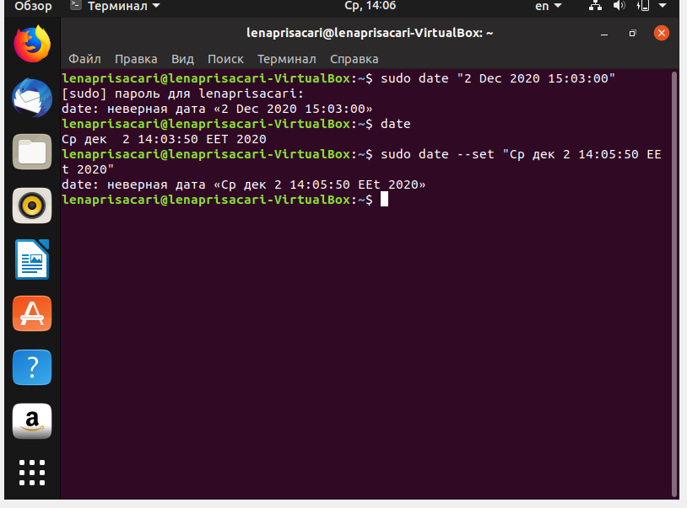

6.ctrl+Alt+T

Sudo sanp install amparepdftoimage

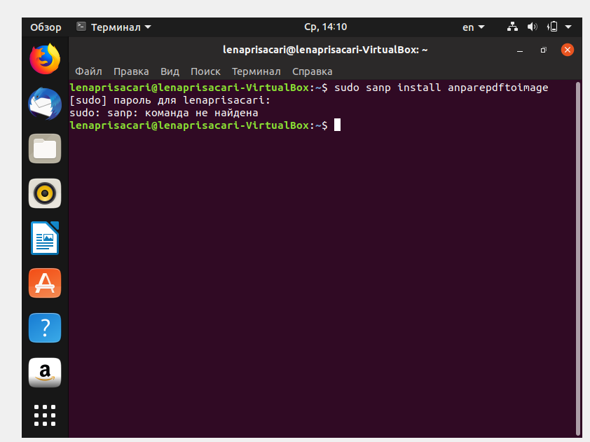

7. Ctrl+Alt+T

Excel

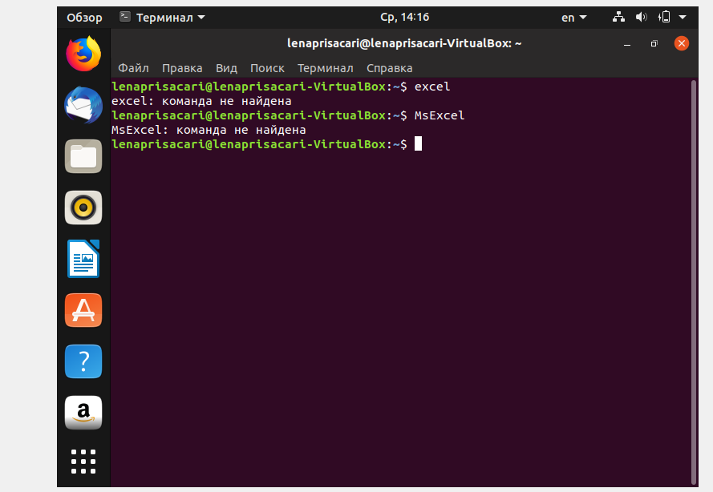

8. 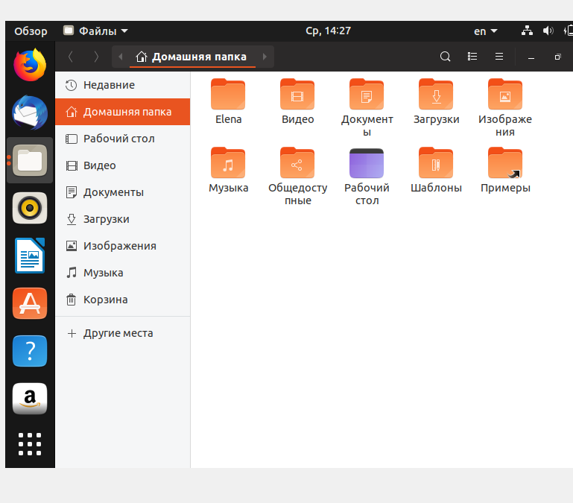

9.ctrl+alt+T

Sort < Desktop/ex9.ost >Desktop/sorted.ost



10.

ctrl+alt+T

sudo apt-get install default-jdk

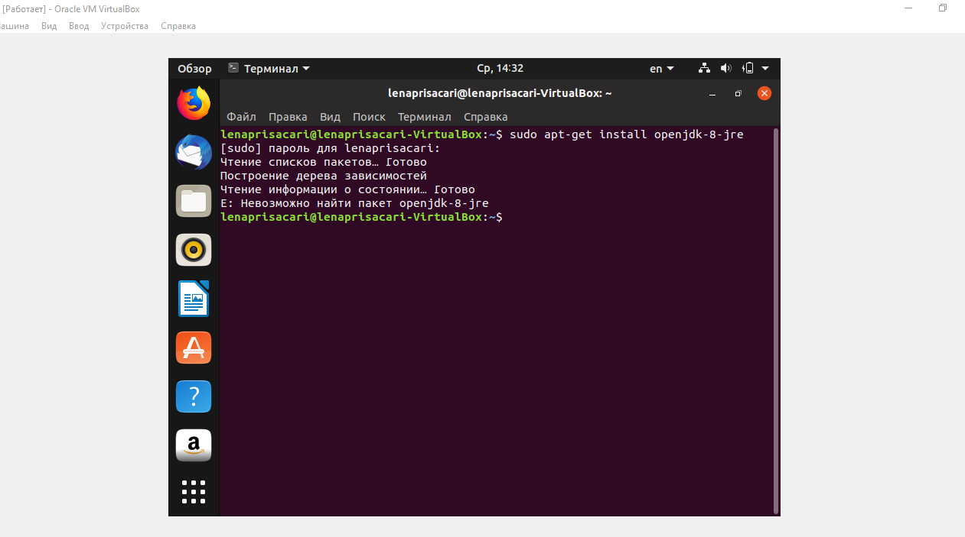

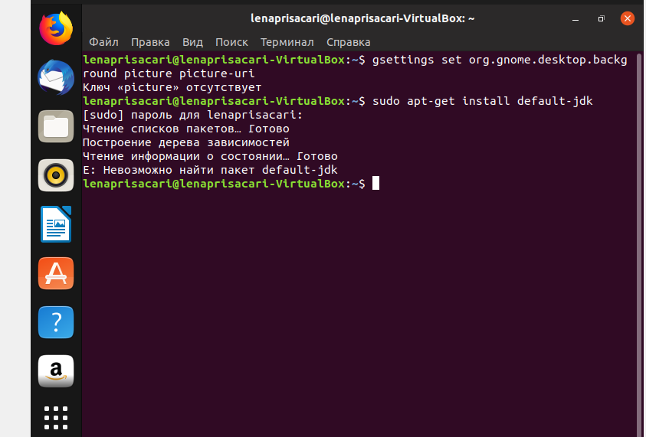

11.

Ctrl+alt+T

Ls –l

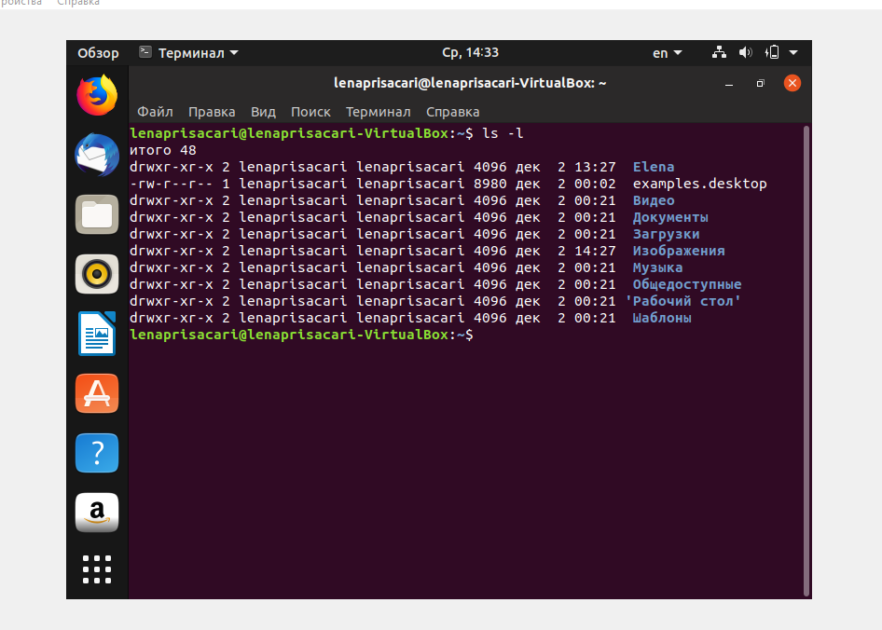

12.ctrl+Alt+T

Sudo chmod – R a+rwx \path



13.

ctrl+Alt+T

ls \*.pdf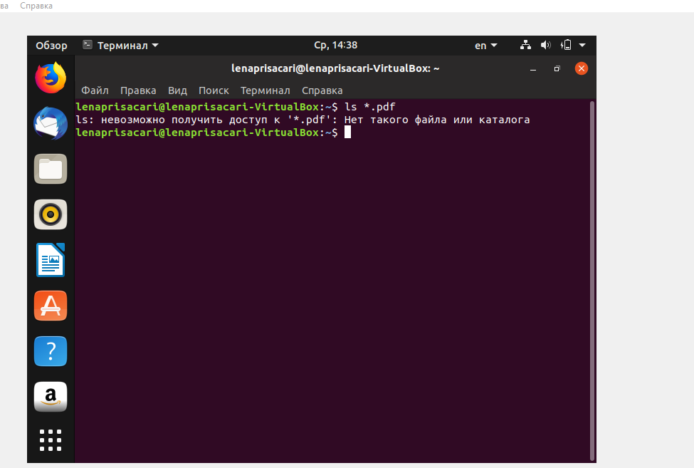

14.ctrl+Alt+T

History

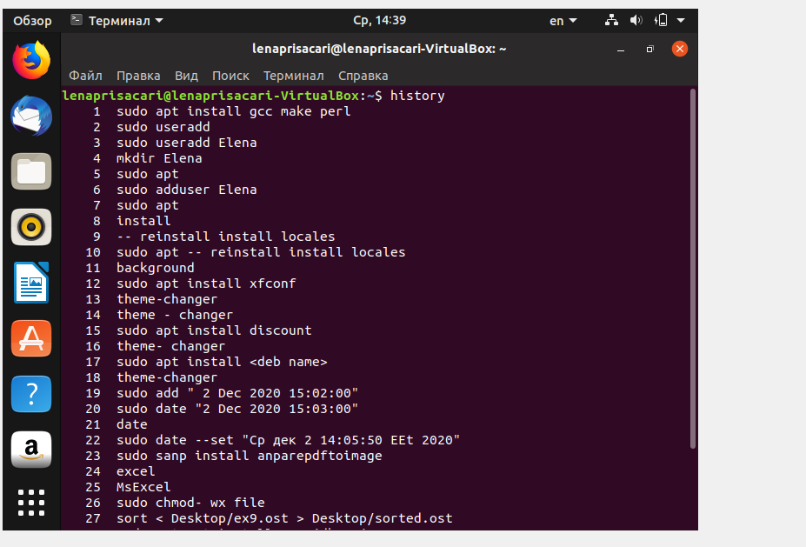

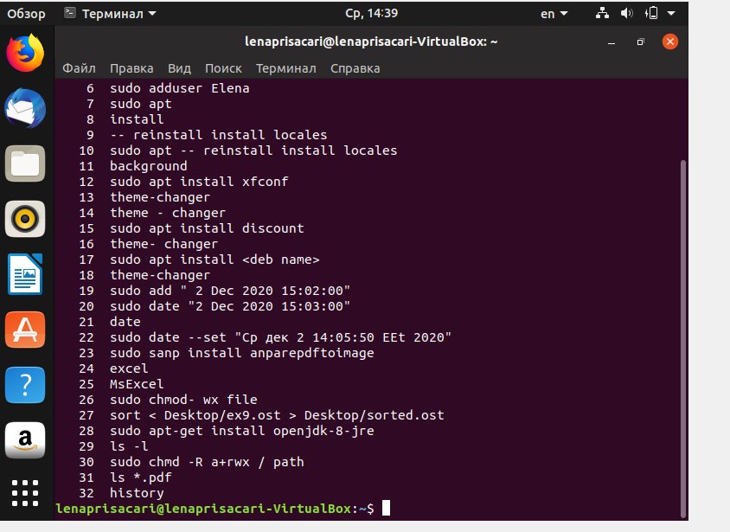

15.ctrl+Alt+T

Uptime

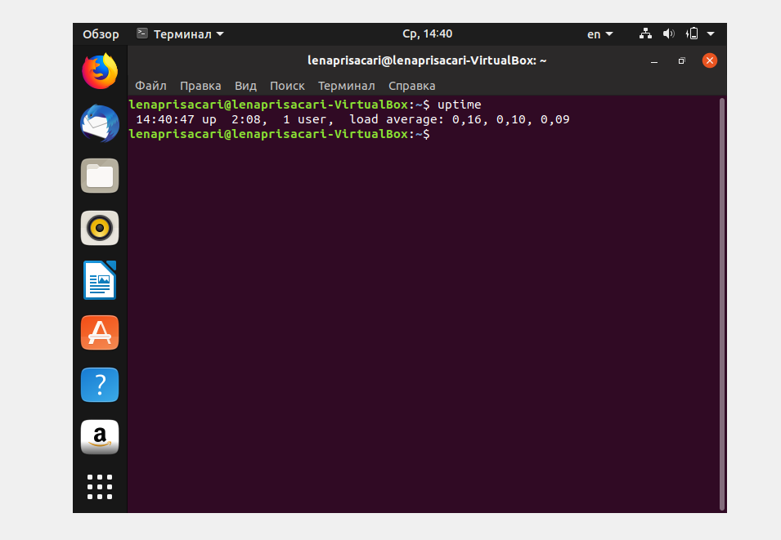

16.ctrl+Alt+T

Sudo apt-get update

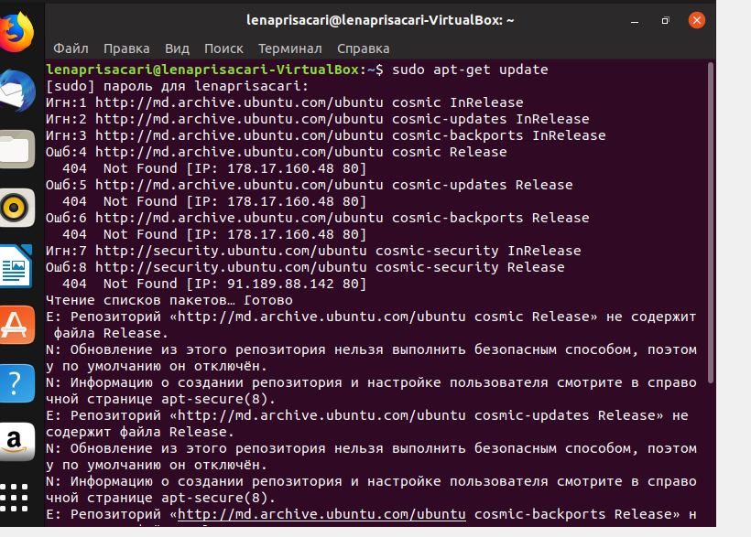

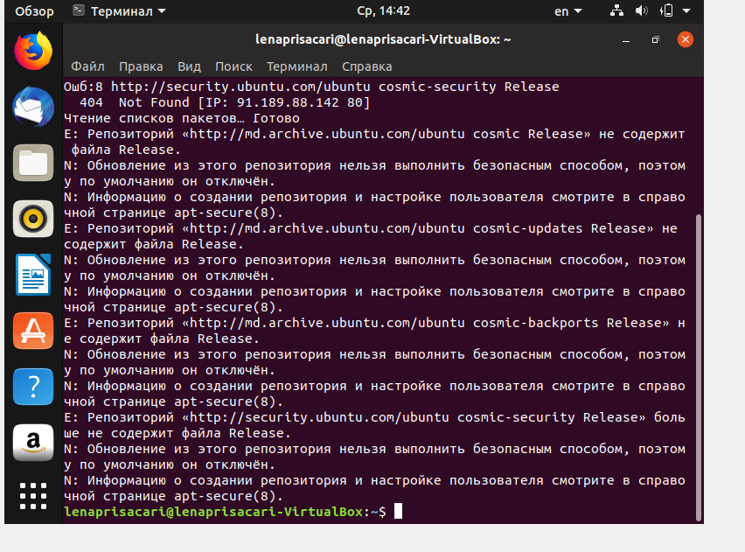

17.

Ctrl+Alt+T

Sudo apt-get install gparted

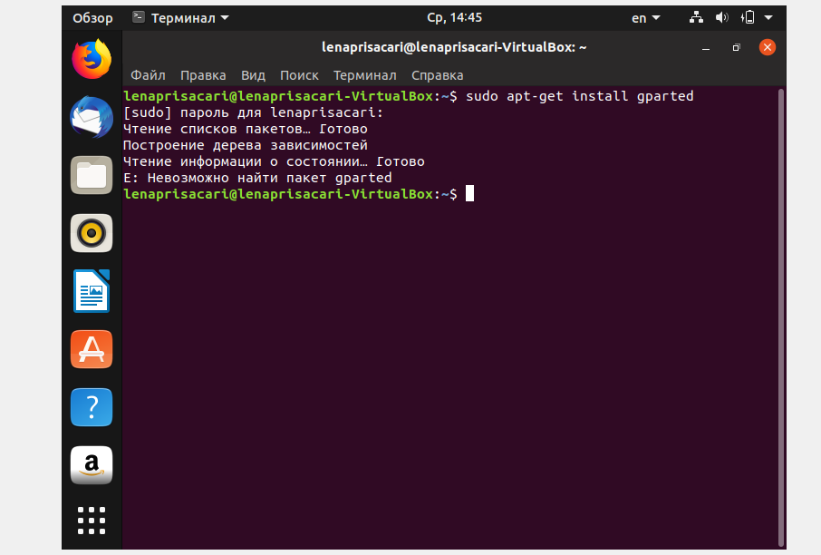

18.