1. WIN+ R; cmd; systeminfo

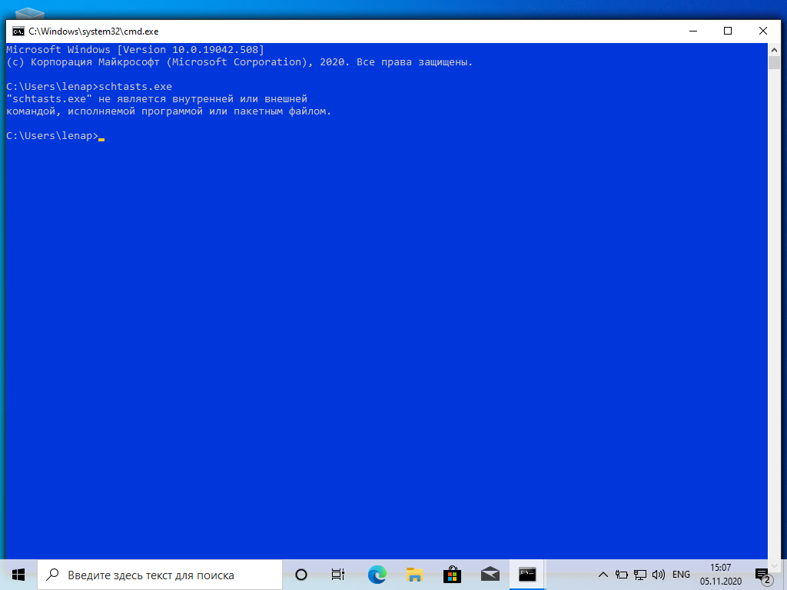

2.WIN+ R; cmd; CD D:\Evaluare

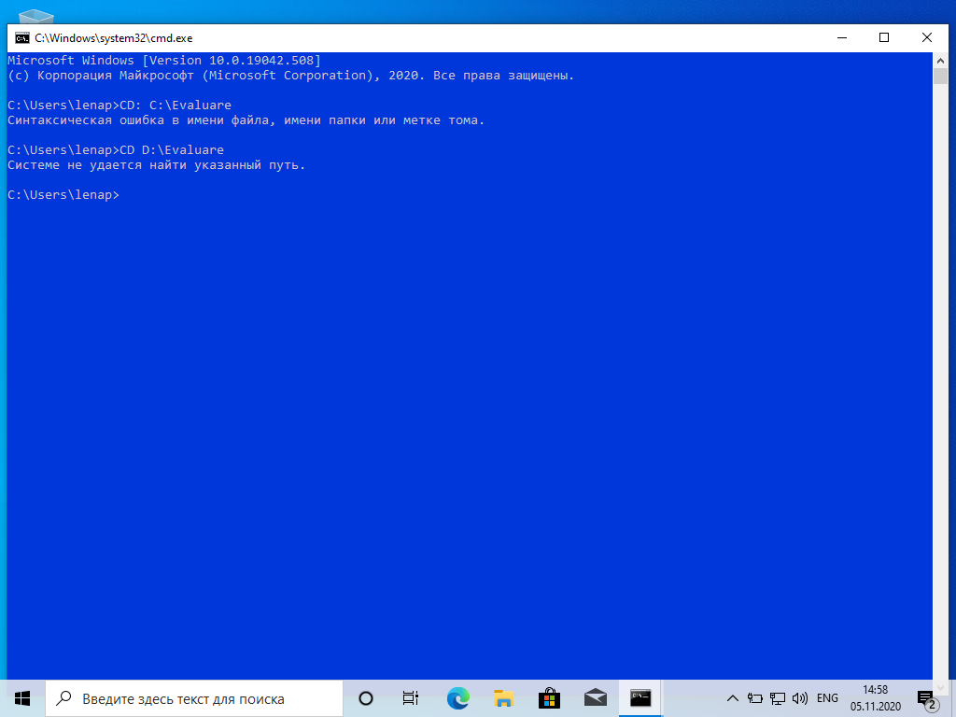

3. WIN+ R; cmd; DIR> C:\raport.txt

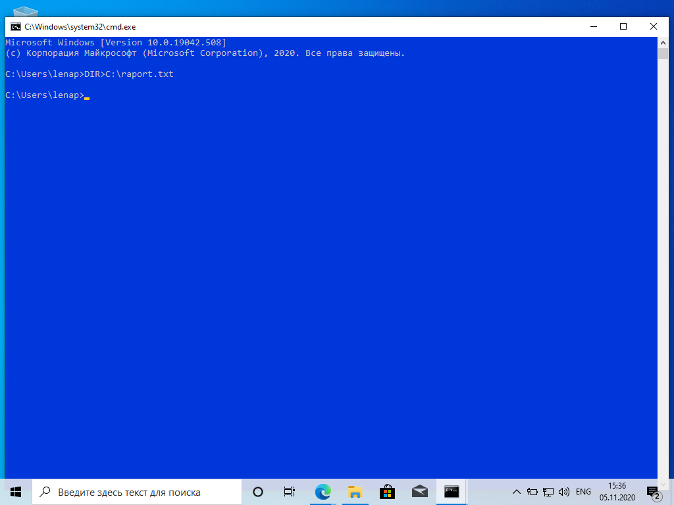

4. WIN+ R; cmd; DIR C:\O:D

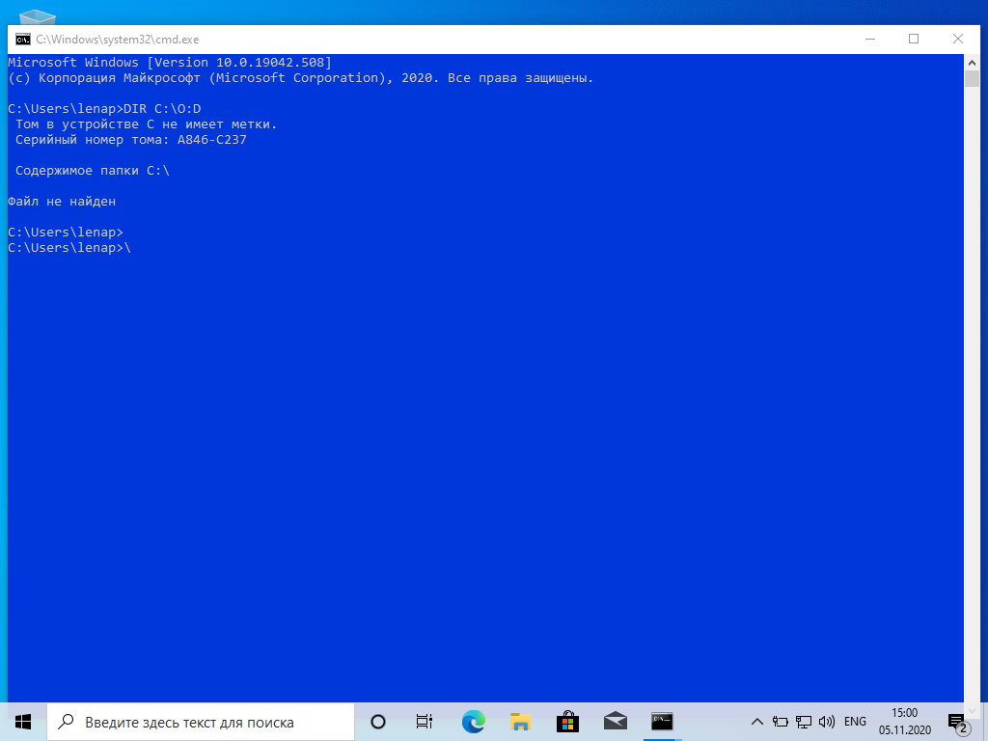

5. WIN+ R; cmd; tree /?

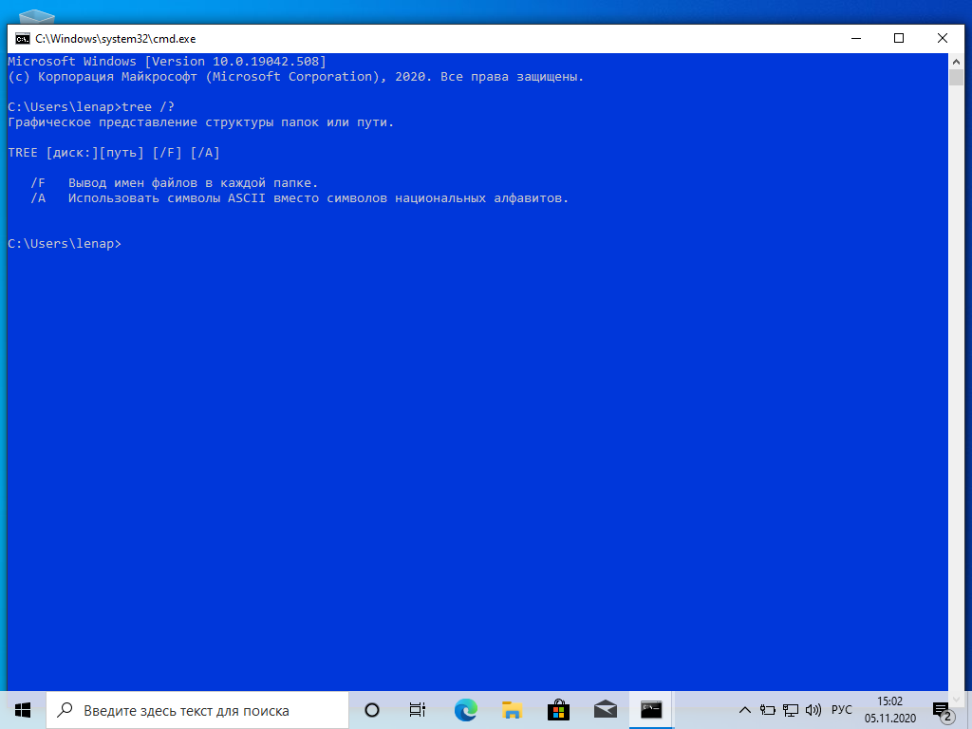

6. WIN+ R; cmd; mkdir Varianta1

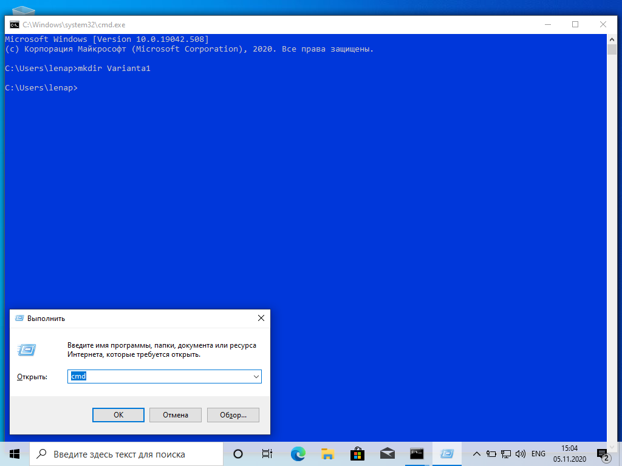

7. WIN+ R; cmd; mkdir C:\Export\proba

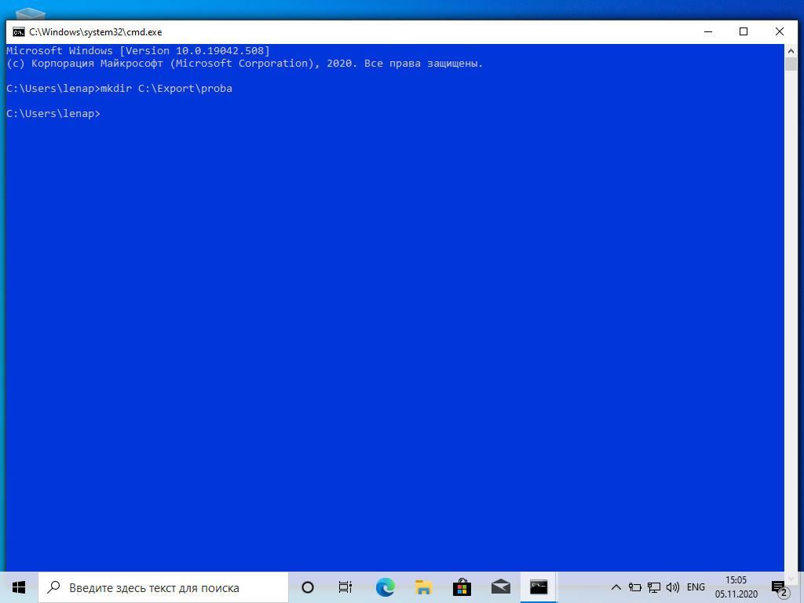

8.

9. WIN+ R; cmd; date



10. WIN+ R; cmd; schtasts.exe



11.

12. WIN+ R; cmd; prompt $$ $

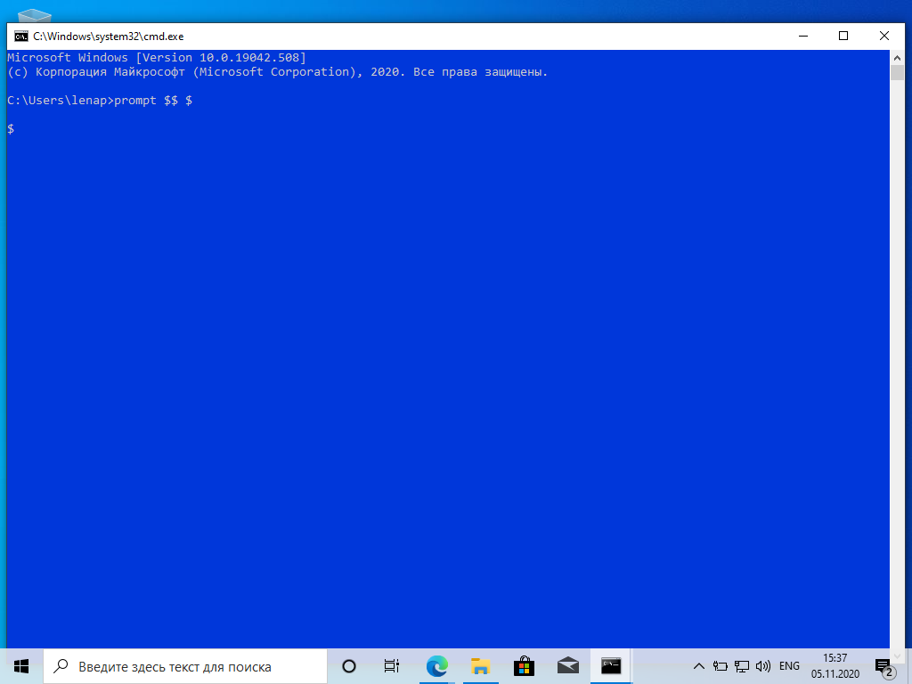

13.

14.