Table 2: Caregiver Demographics
Characteristic | Overall  (N = 111)¹ | Age 6  (N = 55)¹ | Age 12  (N = 56)¹
Sex
Female | 54 (48.6) | 31 (56.4) | 23 (41.1)
Male | 56 (50.5) | 23 (41.8) | 33 (58.9)
Other | 1 (0.9) | 1 (1.8) | 0 (0.0)
Race²
American Indian or Alaska Native | 0 (0) | 0 (0) | 0 (0)
Asian | 9 (8.3) | 5 (9.4) | 4 (7.1)
Black or African American | 2 (1.8) | 0 (0.0) | 2 (3.6)
Native Hawaiian or Other Pacific Islander | 0 (0) | 0 (0) | 0 (0)
White | 57 (52.3) | 28 (52.8) | 29 (51.8)
More than one race | 41 (37.6) | 20 (37.7) | 21 (37.5)
Ethnicity²
Hispanic or Latino | 16 (14.7) | 8 (15.1) | 8 (14.3)
Education²
High school | 1 (0.9) | 0 (0.0) | 1 (1.8)
Associate (some college) | 3 (2.7) | 2 (3.7) | 1 (1.8)
Bachelor/College | 36 (32.7) | 17 (31.5) | 19 (33.9)
Graduate and Professional | 70 (63.6) | 35 (64.8) | 35 (62.5)
Annual Income³
< $50,000 | 11 (11.0) | 6 (12.8) | 5 (9.4)
$50,000 - $100,000 | 41 (41.0) | 19 (40.4) | 22 (41.5)
100k - 200k | 25 (25.0) | 13 (27.7) | 12 (22.6)
> 200k | 23 (23.0) | 9 (19.1) | 14 (26.4)
Geographic regions²
Northeast | 31 (28.4) | 17 (32.1) | 14 (25.0)
Midwest | 34 (31.2) | 14 (26.4) | 20 (35.7)
South | 26 (23.9) | 10 (18.9) | 16 (28.6)
West | 18 (16.5) | 12 (22.6) | 6 (10.7)
¹ n(%), median (IQR)
² 1-2 participants with missing data (excluded from the denominator)
³ 11 participants with missing data (excluded from the denominator)

Table 3: Data quality metrics from iCatcher+ output across all administered trials.
 | N trials (Quality Check) | N participants with valid iCatcher+ output |  | N participants with 0% test trial data |  | Median (IQR) % of no-face frames |  | Median (IQR) % of away frames |  | Median (IQR) % of frames with iCatcher confidence <.85
Tasks | - | Age 6 | Age 12 | Age 6 | Age 12 | Age 6 | Age 12 | Age 6 | Age 12 | Age 6 | Age 12
Geo-Social Attention | 10 | 54 (98.2%) | 53 (94.6%) | 0 (0.0%) | 1 (1.9%) | 0.0 (0.0, 2.7) | 0.0 (0.0, 2.1) | 5.3 (1.1, 11.4) | 1.0 (0.0, 4.1) | 9.9 (5.3, 14.6) | 11.3 (7.7, 16.2)
Visual Paired Comparison (VPC) | 12 | 50 (90.9%) | 53 (94.6%) | 2 (4.0%) | 3 (5.7%) | 5.5 (0.9, 18.1) | 6.9 (1.7, 17.6) | 21.9 (13.5, 28.2) | 16.7 (10.5, 26.8) | 9.8 (6.4, 14.6) | 12.4 (9.3, 14.2)
Prediction | 16 | 52 (94.5%) | 51 (91.1%) | 0 (0.0%) | 0 (0.0%) | 0.0 (0.0, 3.4) | 0.0 (0.0, 5.8) | 9.6 (1.7, 21.6) | 5.8 (1.0, 13.5) | 18.0 (10.8, 26.0) | 22.1 (9.1, 35.1)
Audiovisual Synchrony | 6 | 50 (90.9%) | 54 (96.4%) | 0 (0.0%) | 0 (0.0%) | 2.2 (0.3, 18.0) | 3.0 (0.1, 8.5) | 11.9 (7.5, 20.3) | 9.5 (4.7, 22.5) | 10.4 (6.5, 15.0) | 11.7 (9.5, 18.1)
Word Recognition | 20 | 53 (96.4%) | 53 (94.6%) | 0 (0.0%) | 0 (0.0%) | 0.9 (0.0, 4.1) | 0.5 (0.0, 5.8) | 12.7 (7.5, 23.1) | 4.1 (1.2, 15.1) | 9.8 (7.4, 14.7) | 10.4 (7.3, 19.1)
Numeracy | 4 | 49 (89.1%) | 52 (92.9%) | 0 (0.0%) | 0 (0.0%) | 7.6 (0.8, 24.0) | 6.4 (1.7, 18.7) | 16.1 (4.3, 31.1) | 19.5 (12.8, 34.6) | 10.3 (6.6, 15.4) | 15.3 (10.8, 17.3)
Social Evaluation | 14 | 50 (90.9%) | 48 (85.7%) | 0 (0.0%) | 0 (0.0%) | 13.5 (4.9, 23.5) | 6.8 (1.4, 14.0) | 22.9 (12.3, 37.0) | 14.4 (8.8, 24.1) | 10.3 (7.9, 13.6) | 13.5 (10.6, 15.8)
N trials reflect all administered trials included in data quality checks (see Table 4 for analytic trial counts). VPC trials were administered in pairs (e.g., Trial 1a and 1b), with each object pair presented twice in succession. The 12 administered VPC trials therefore reflect 6 unique object pairs.
N with valid iCatcher+ output, defined as infants who successfully viewed the task without video quality issues (e.g., glitching, frame repetition, or pixelation), shown as n (% of full sample; 6-mo: N = 55, 12-mo: N = 56).
N participants with 0% test trial data shown as n (% of those with valid iCatcher+ output). These participants had iCatcher+ output for familiarization trials but none for test trials.
Median (IQR) video quality metric statistics are computed among participants with > 0% test trial data and are averaged across trials with iCatcher+ output per participant. Percentages are calculated out of frames processed by iCatcher+ only (excluding frames with no iCatcher+ output) and reflect data loss within iCatcher+ output. These differ from the usable frame percentage used for trial inclusion, which uses total trial frames as the denominator (Table 4).
No-face frames: iCatcher+ could not detect a face in the frame.
Away frames: a face was detected but gaze was estimated to be directed off-screen.
Low-confidence frames: face was visible and infant was looking at the screen (left or right), but iCatcher+ classification confidence was <.85 (softmax probability of predicted gaze class).

Table 4: Participant retention across data quality and inclusion criteria steps, by task and age group.
 | Analytic trials/word pairs | N participants with valid iCatcher+ output |  | N participants with at least 1 test trial with ≥ 33% usable frames |  | N participants with side bias |  | N in final analytic dataset |  | Median (IQR) number of trials/word pairs in the final analytic sample
Tasks |  | Age 6 | Age 12 | Age 6 | Age 12 | Age 6 | Age 12 | Age 6 | Age 12 | Age 6 | Age 12
Geo-Social Attention | 10 | 54 (98.2%) | 53 (94.6%) | 51 (94.4%) | 50 (94.3%) | 9 (17.6%) | 3 (6.0%) | 42 | 47 | 8.0 (7.0, 9.8) | 8.0 (7.0, 9.0)
Visual Paired Comparison | 6 | 50 (90.9%) | 53 (94.6%) | 47 (94.0%) | 47 (88.7%) | 6 (12.8%) | 5 (10.6%) | 41 | 42 | 6.0 (4.0, 6.0) | 5.0 (4.0, 6.0)
Prediction | 14 | 52 (94.5%) | 51 (91.1%) | 51 (98.1%) | 48 (94.1%) | — | — | 37 | 35 | 10.0 (7.0, 12.0) | 10.0 (8.0, 12.5)
Audiovisual Synchrony | 6 | 50 (90.9%) | 54 (96.4%) | 47 (94.0%) | 50 (92.6%) | 11 (23.4%) | 10 (20.0%) | 36 | 40 | 6.0 (5.0, 6.0) | 6.0 (5.0, 6.0)
Word Recognition | 5 | 53 (96.4%) | 53 (94.6%) | 52 (98.1%) | 50 (94.3%) | 11 (21.2%) | 9 (18.0%) | 38 | 40 | 4.0 (3.0, 5.0) | 4.0 (3.0, 5.0)
Numeracy | 4 | 49 (89.1%) | 52 (92.9%) | 45 (91.8%) | 43 (82.7%) | 18 (40.0%) | 12 (27.9%) | 27 | 31 | 4.0 (3.0, 4.0) | 3.0 (2.5, 4.0)
Social Evaluation | 2 | 50 (90.9%) | 48 (85.7%) | 26 (52.0%) | 37 (77.1%) | 3 (11.5%) | 7 (18.9%) | 23 | 30 | 2.0 (1.0, 2.0) | 2.0 (1.0, 2.0)
N participants with valid iCatcher+ output, defined as infants who successfully viewed the task without video quality issues (e.g., glitching, frame repetition, or pixelation), shown as n (% of full sample; 6-mo: N = 55, 12-mo: N = 56).
N participants with at least 1 trial with ≥33% usable frames shown as n (% of those with valid iCatcher+ output). N participants with side bias shown as n (% of those with at least 1 usable test trial). Percentage of usable frames was calculated as the number of frames meeting all usability criteria (face visible, gaze directed left or right, iCatcher+ confidence ≥ .85) divided by the total number of frames in that trial.
No side bias was assessed for the Prediction task because analysis was restricted to the short anticipatory eye movement (AEM) window. The number of analytic trials differs from the total administered trials for four tasks; see Table 3 for quality check trial counts.
Additional exclusion criteria were applied for Prediction, Word Recognition, and Social Evaluation tasks.
Table 5: Model-estimated mean proportion looking time to target by task and age group, with age group comparisons.
 | Overall |  | 6 months |  | 12 months |  | Age Effect (12 months vs 6 months)
Tasks | Model Estimated Mean (95% CI)¹ | p | Model Estimated Mean (95% CI)¹ | p | Model Estimated Mean (95% CI)¹ | p | Model Estimated Mean Difference (95% CI)² | p
Geo-Social Attention | 0.68 (0.63, 0.73) | < 0.001 | 0.66 (0.60, 0.72) | < 0.001 | 0.70 (0.64, 0.76) | < 0.001 | 0.04 (-0.01, 0.09) | 0.127
VPC Social (face) | 0.57 (0.50, 0.65) | 0.053 | 0.56 (0.49, 0.64) | 0.084 | 0.58 (0.51, 0.66) | 0.033 | -0.02 (-0.08, 0.04) | 0.508
VPC Non-social (fribbles) | 0.56 (0.51, 0.62) | 0.029 | 0.56 (0.51, 0.62) | 0.026 | 0.56 (0.51, 0.62) | 0.025 | -0.00 (-0.04, 0.04) | 0.969
Prediction Block 1 | 0.45 (0.36, 0.53) | 0.227 | 0.38 (0.26, 0.50) | 0.044 | 0.52 (0.39, 0.64) | 0.778 | -0.14 (-0.31, 0.03) | 0.108
Prediction Block 2 | 0.65 (0.56, 0.73) | 0.001 | 0.62 (0.50, 0.74) | 0.059 | 0.68 (0.55, 0.80) | 0.005 | -0.06 (-0.23, 0.11) | 0.507
AV Synchrony | 0.51 (0.46, 0.55) | 0.765 | 0.50 (0.46, 0.55) | 0.851 | 0.51 (0.46, 0.55) | 0.742 | 0.00 (-0.04, 0.05) | 0.897
Word Recognition | 0.01 (-0.03, 0.05) | 0.538 | -0.00 (-0.05, 0.04) | 0.841 | 0.02 (-0.02, 0.07) | 0.258 | 0.03 (-0.03, 0.08) | 0.33
Numeracy 5-item stream constant | 0.59 (0.54, 0.65) | 0.007 | 0.63 (0.56, 0.70) | 0.001 | 0.56 (0.49, 0.63) | 0.082 | 0.07 (-0.02, 0.16) | 0.147
Numeracy 20-item stream constant | 0.49 (0.43, 0.55) | 0.728 | 0.49 (0.40, 0.57) | 0.738 | 0.49 (0.41, 0.57) | 0.864 | -0.01 (-0.12, 0.10) | 0.902
Social Evaluation | 0.50 (0.46, 0.54) | 0.980 | 0.51 (0.45, 0.57) | 0.665 | 0.49 (0.43, 0.54) | 0.657 | -0.03 (-0.11, 0.06) | 0.537
Estimates are derived from linear mixed models with random effects for participant (and trial if appropriate). For all tasks except Word Recognition, the null hypothesis is H₀ = 0.5 (chance-level looking). For Word Recognition, the outcome is a difference score (% target − % distractor) and the null hypothesis is H₀ = 0. The Age Effect column reflects the estimated difference between 12- and 6-month-olds (Age 12 − Age 6) and the null hypothesis is H₀ = 0. CI = Confidence Interval
Figure 2: Average percentage of usable frames per participant by task across all administered trials.
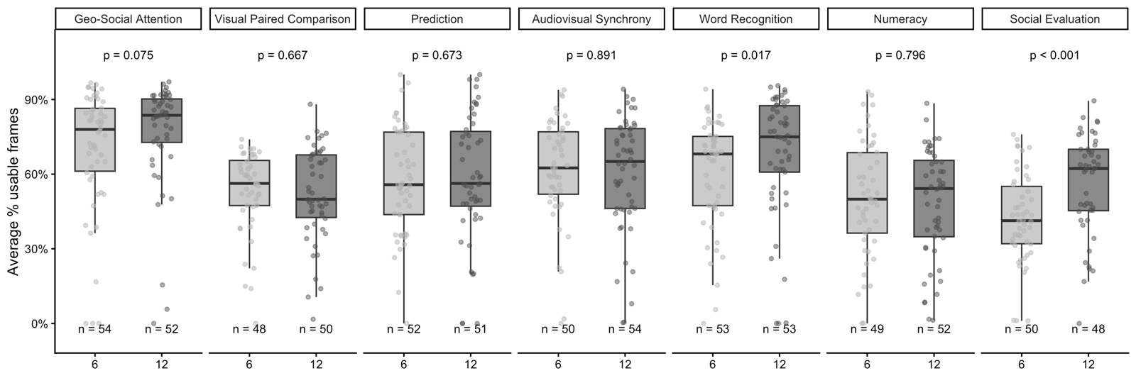
Each point represents one infant's mean percentage of usable frames, averaged across test trials with valid iCatcher+ output. Infants with no valid iCatcher+ output for any test trial were excluded. For each trial, the percentage of usable frames was calculated as the number of frames meeting all usability criteria (face visible, gaze directed left or right, iCatcher+ confidence ≥ .85) divided by the total number of frames in that trial; these percentages were then averaged across trials for each infant. Boxes show the interquartile range with the median line.
Figure S1. Percentage of usable frames by task order of presentation, among (a) 6-month-olds and (b) 12-month-olds. Each point represents one participant at a given task order position. Kruskal-Wallis tests were used to assess differences across task order positions within each task.
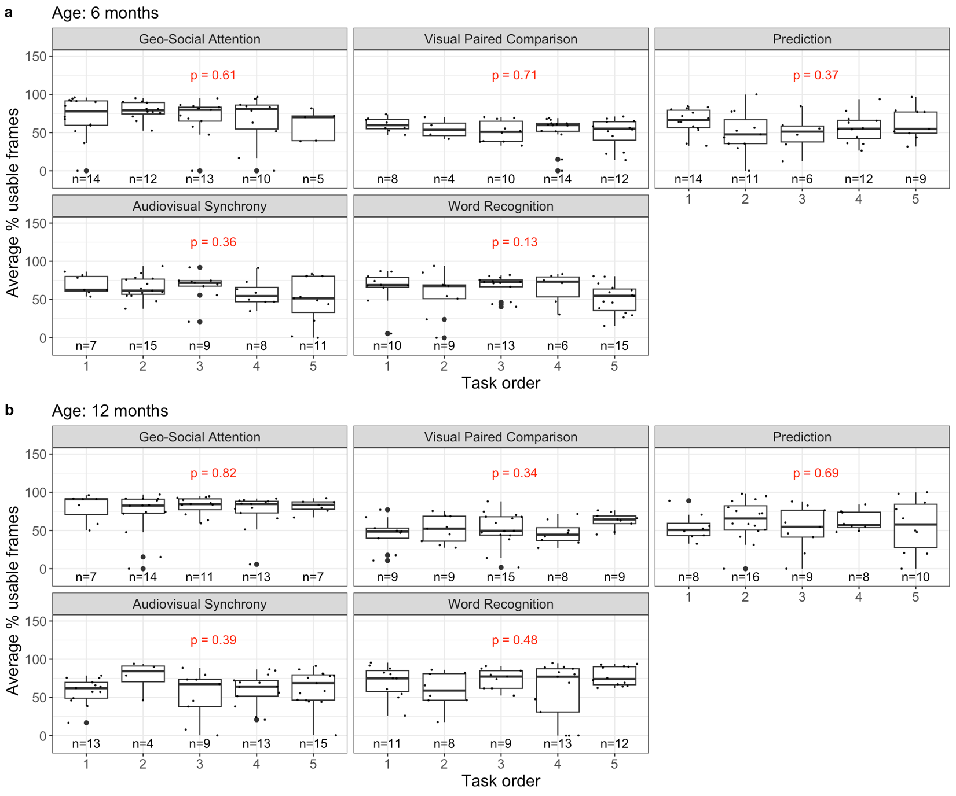
Figure S2. Percentage of usable frames by task order of presentation, among (a) 6-month-olds and (b) 12-month-olds. Wilcoxon rank-sum p-values reflect pairwise comparisons between task order positions within each task.
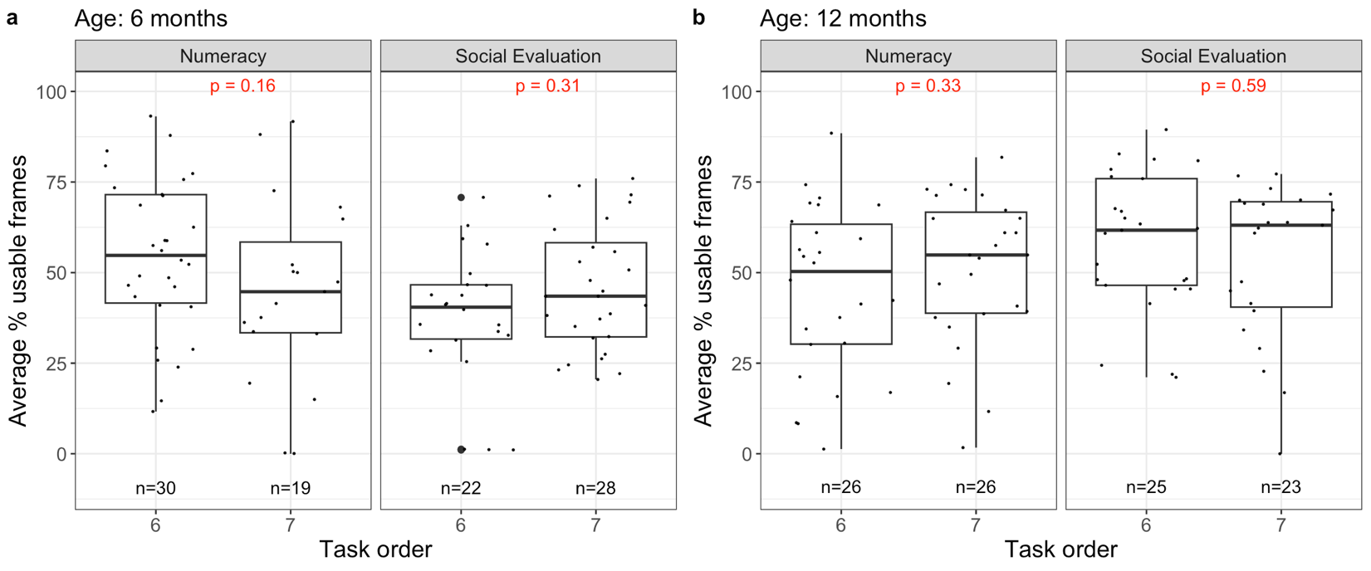
Figure 3: Results for (a) Geo-Social Attention, (b) Visual Paired Comparison, (c) Prediction, (d) Audiovisual Synchrony, (e) Word Recognition, (f) Numeracy, and (g) Social Evaluation
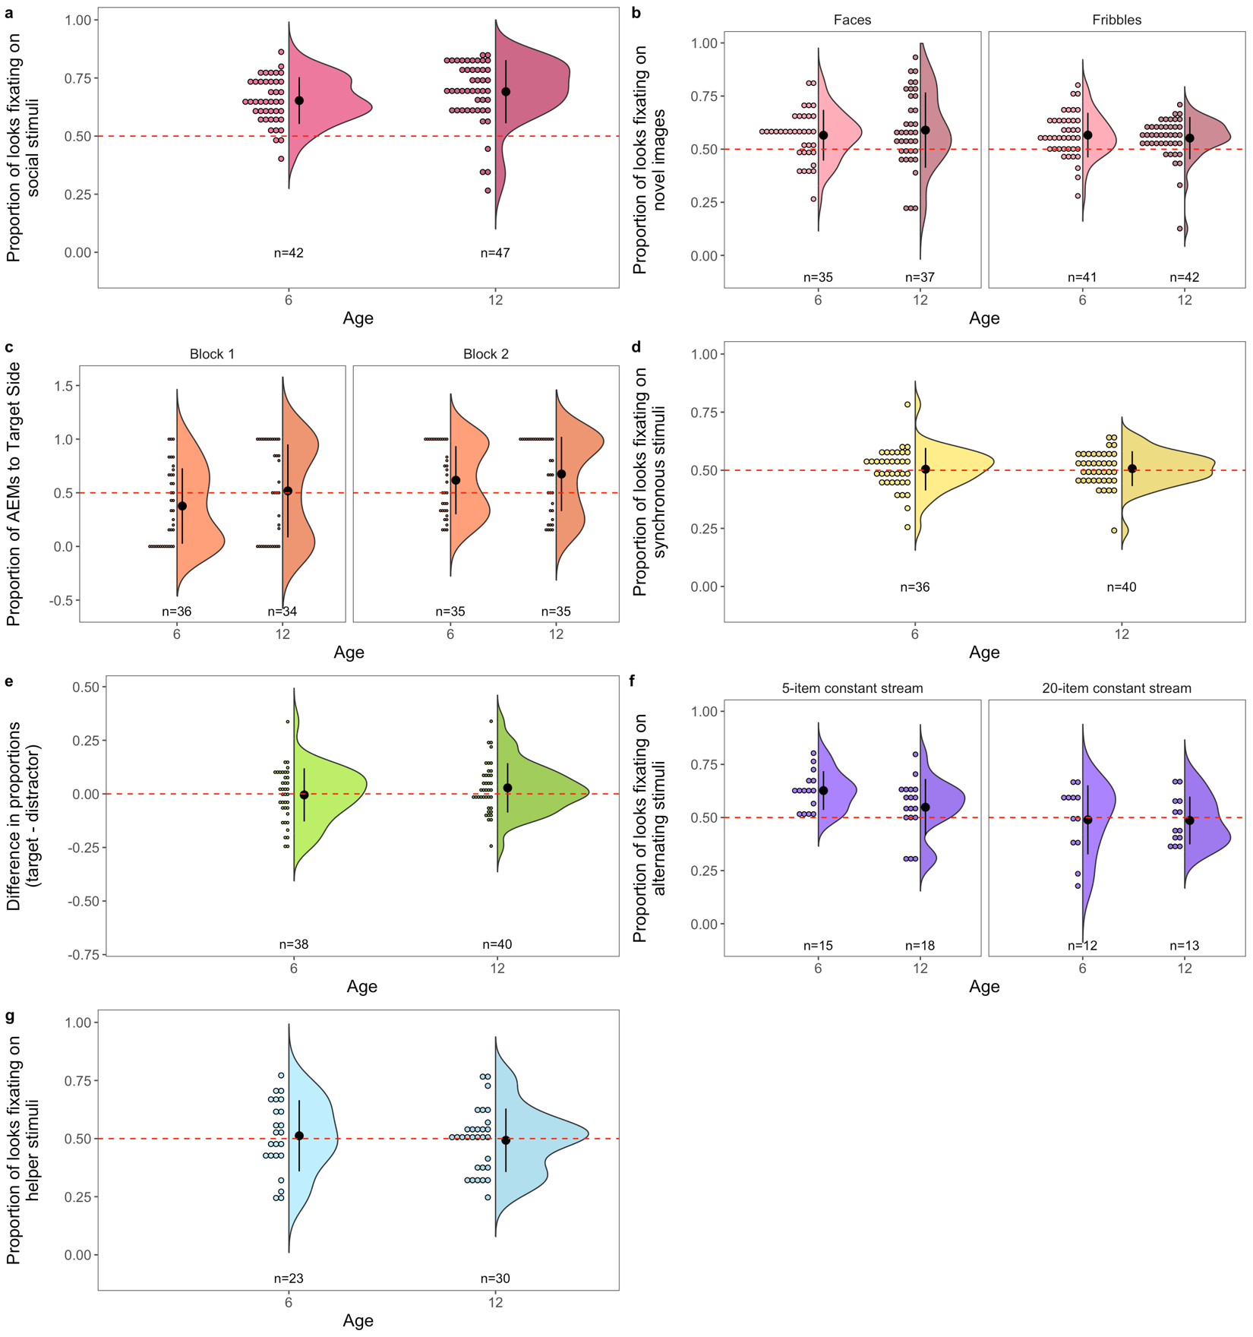
Figure 4: Proportion of infants showing anticipatory eye movements (AEMs) to the target side by trial, for (a) 6-month-olds and (b) 12-month-olds (Block 1: trials 2–8; Block 2: trials 10–16).

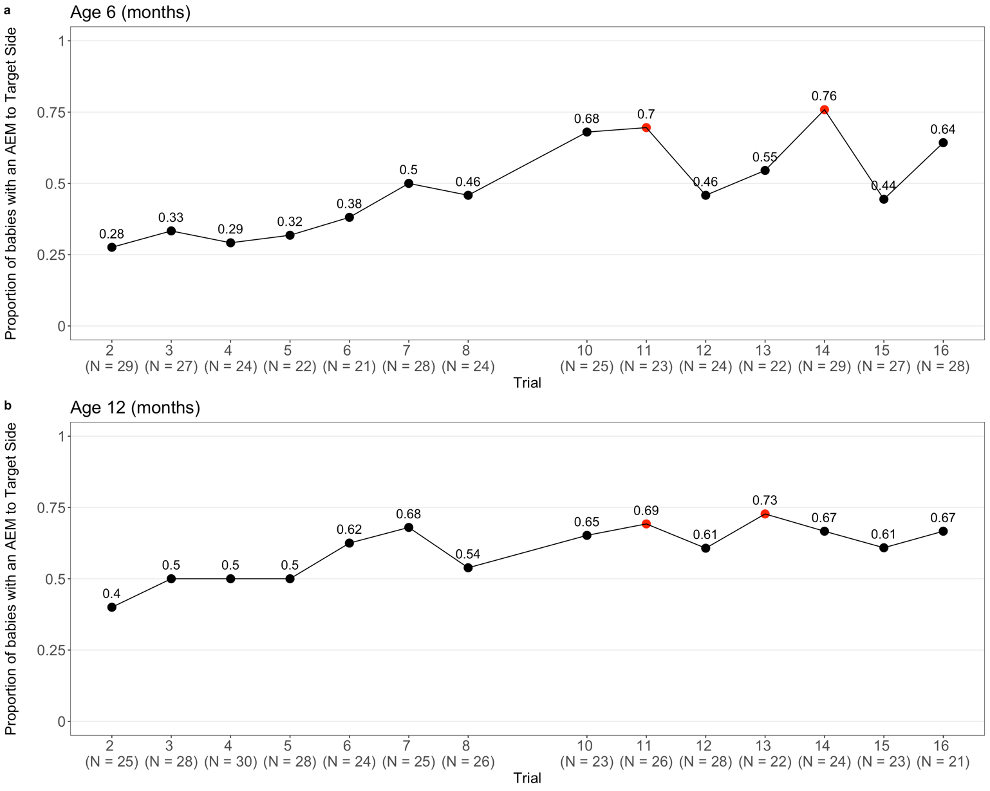
Each point represents the proportion of infants with an AEM to the target side on that trial. Red points indicate trials where the proportion significantly exceeded 0.5 (p < .05, one-sample proportion test). Trials 1 and 9 are excluded because anticipatory eye movements would not be expected on the first trial of each block.

