Project Report I

Bespectacled Builders

Elena Corpus, Lucas Iverson

CSCI 363 Fall

18 October 2019

Interface Drawing

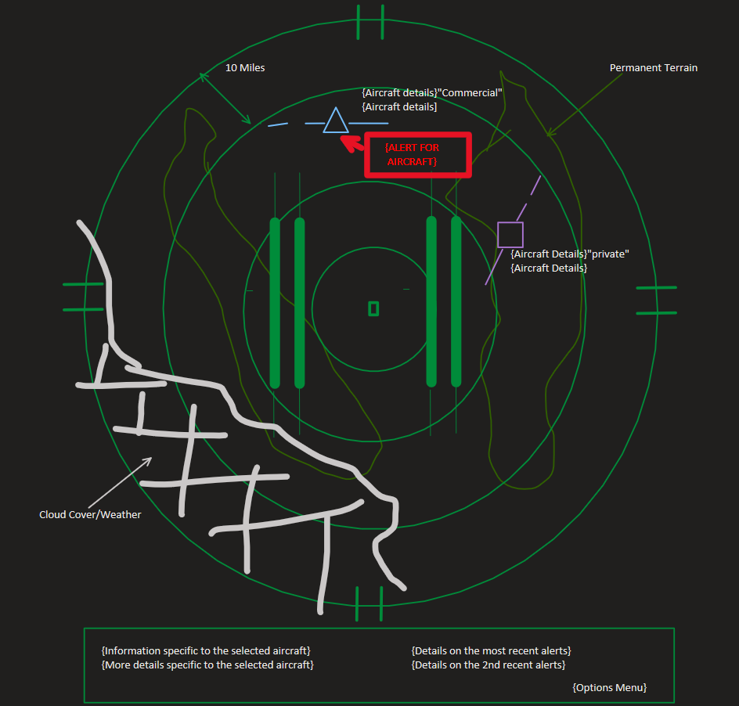

Class Diagram (Problem Description):

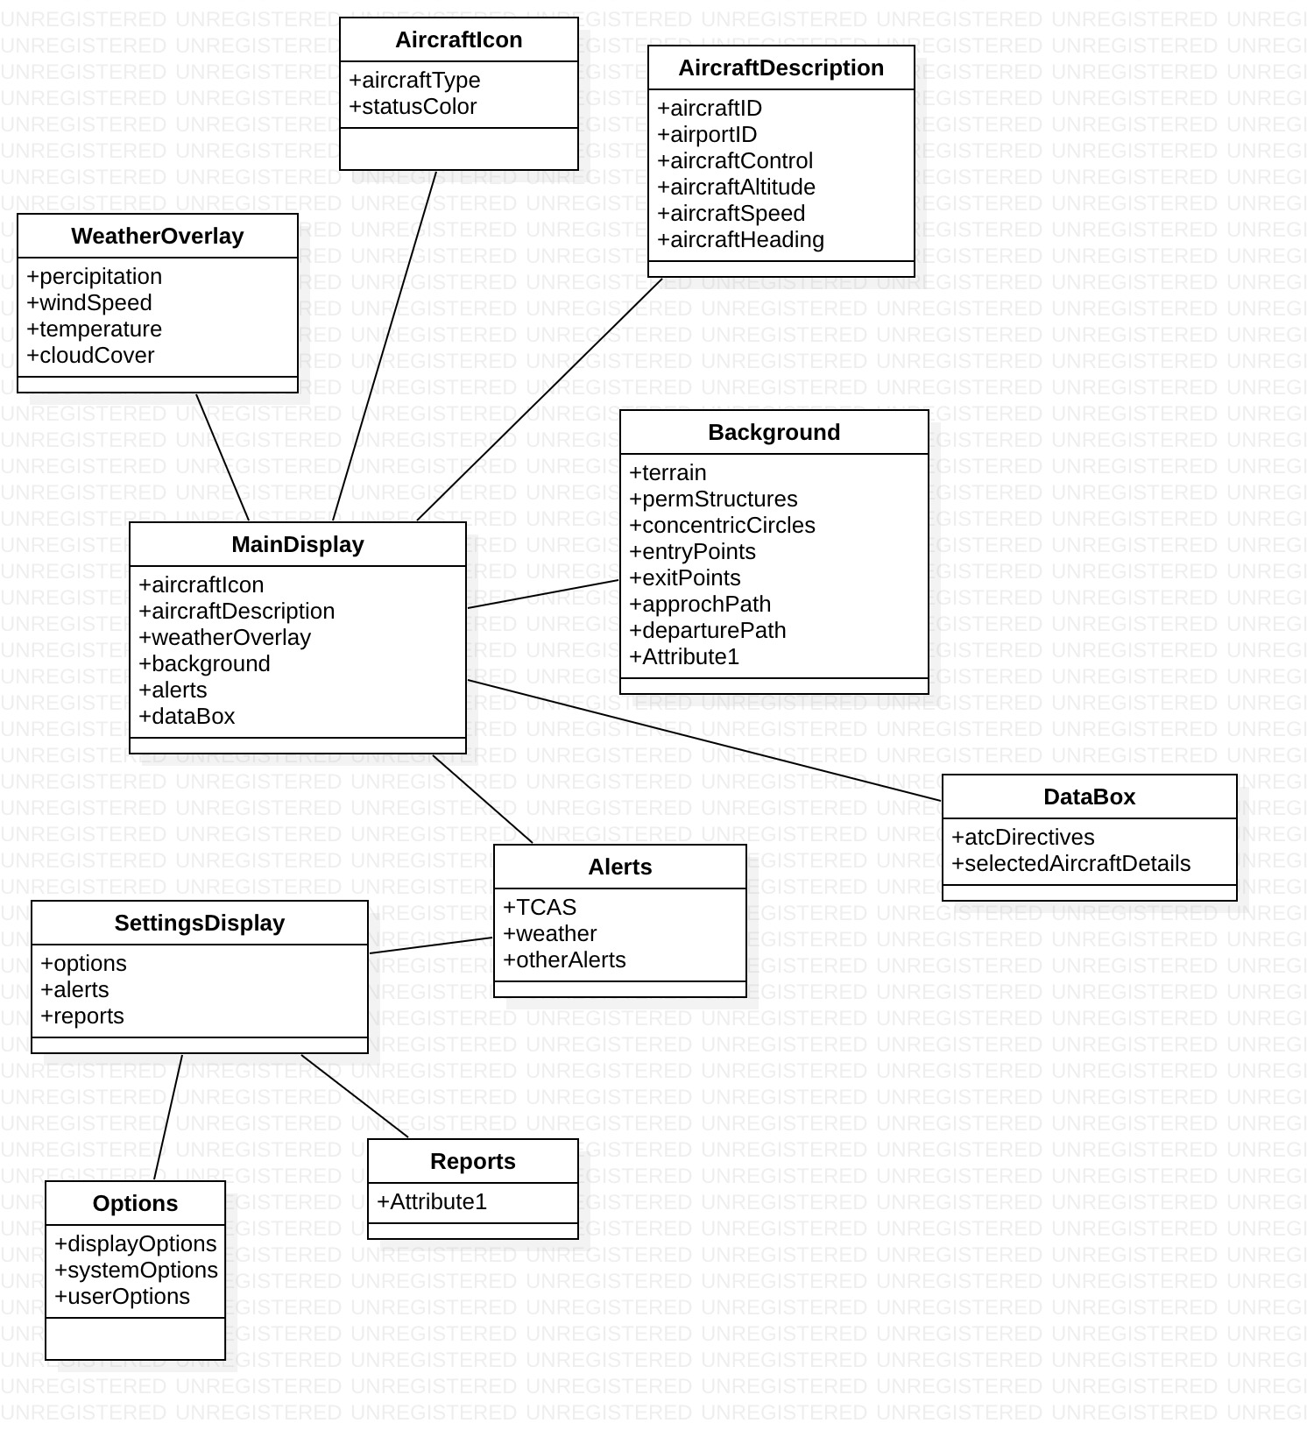

Use Case Diagram

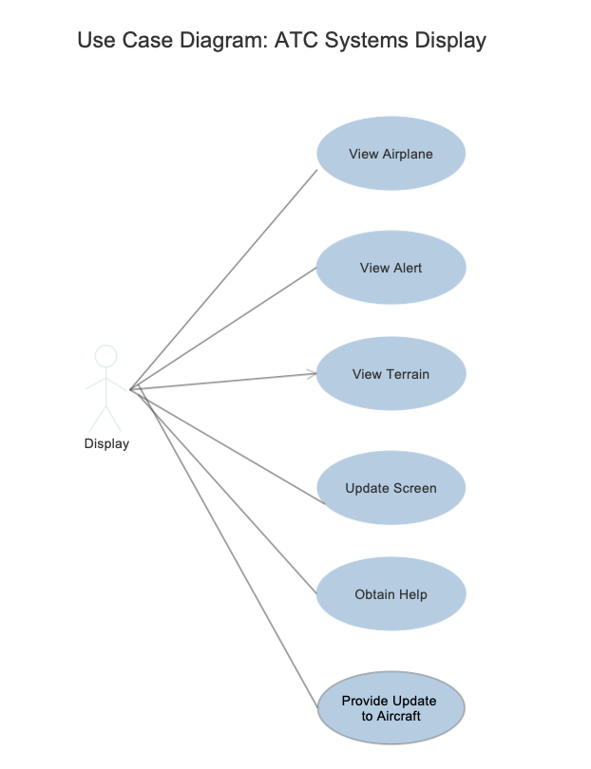

Statement of issues encountered and their resolutions

1. Overthinking, resolution = taking a step back

Statement of what is to be accomplished by the next reporting period.

1. A new updated, more detailed user interface drawing.
2. A plan on how we are going to tackle this outrageous task.
3. Learn C#