CSci 435: Formal Languages and Automata

Instructor: Dr. M. E. Kim Name: Elena Corpus

**Home Assignment 1: 100 points + 10 points (optional)**

Q1. [25] For S = {a, b}, construct the minimal DFA that accept the language consisting of

1. [8] all strings with an even number of *a*’s and an odd number of *b*’s.

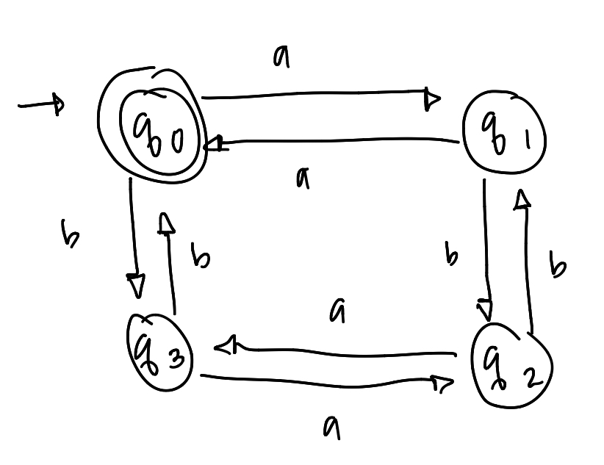

1. [8] every ‘*aa’* is followed immediately by a ‘*b’*. For example, the strings *aab*, *aaba*, *aabaabbaab* are in the language, but *aaab* and *aabaa* are not. Construct a DFA with 4 states.
2. [9] L = {w | ( *na*(*w*) – *nb*(*w*) ) mod 3 = 0 }. Construct a DFA with 3 states.

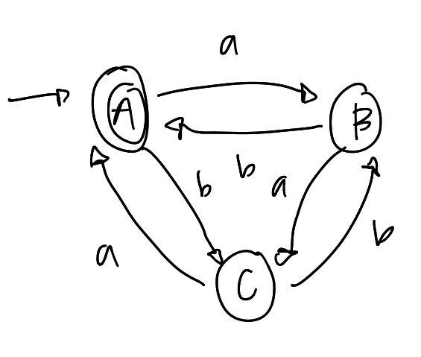

Q2. [10] Show that the language L = { *a****n***| *n* ³ 0, *n* ¹ 3 } is regular.

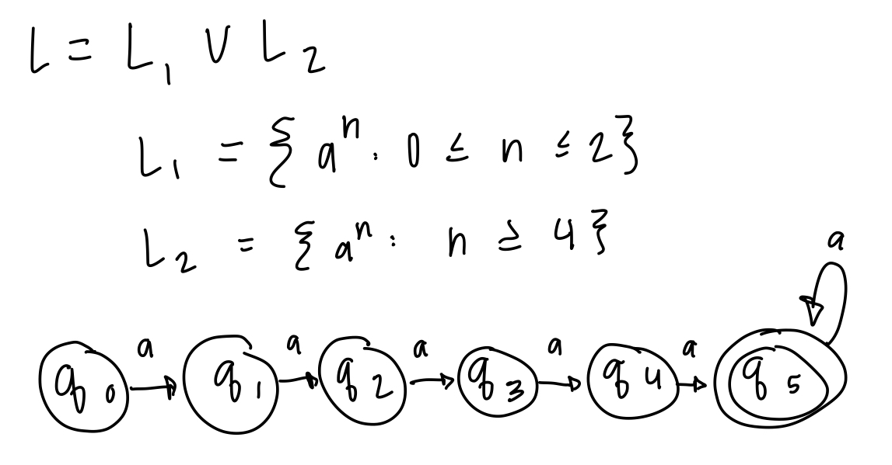

Q3. [15] For the language L = {*an* | *n* ³ 1 } È {*bmak* | *m* ³ 0, *k* ³ 0}

1. [8] Construct an NFA with three states that accepts L.

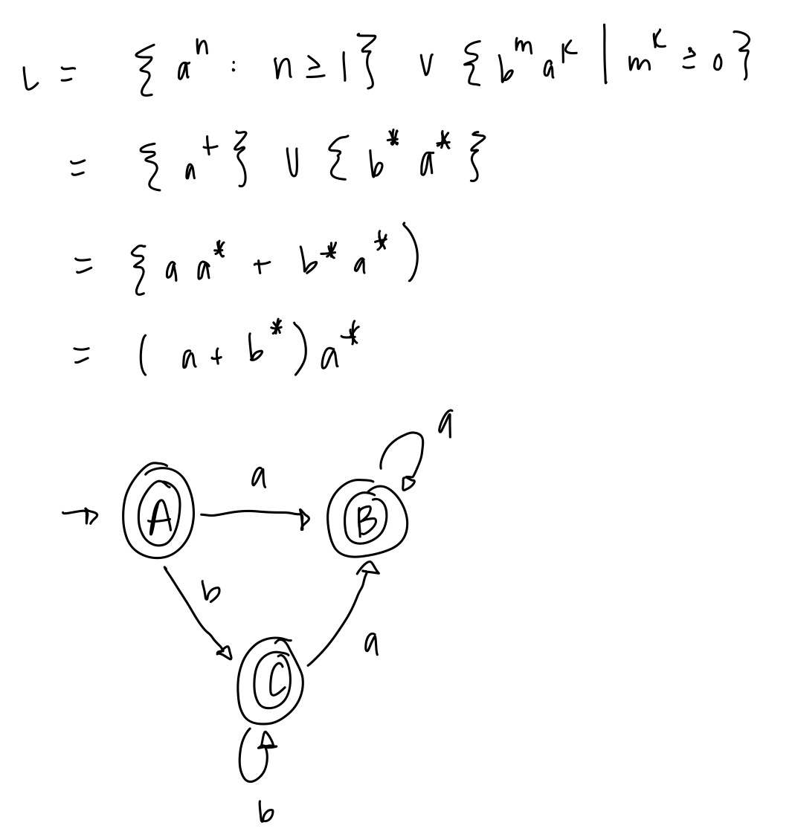

1. [7] Can you construct an NFA with the fewer states that accepts L? If so, construct it; otherwise, justify why your NFA in 1) is the minimal NFA.
   1. No, it cannot be constructed in 2 states.

Q4. [20] For a given NFA in the figure,

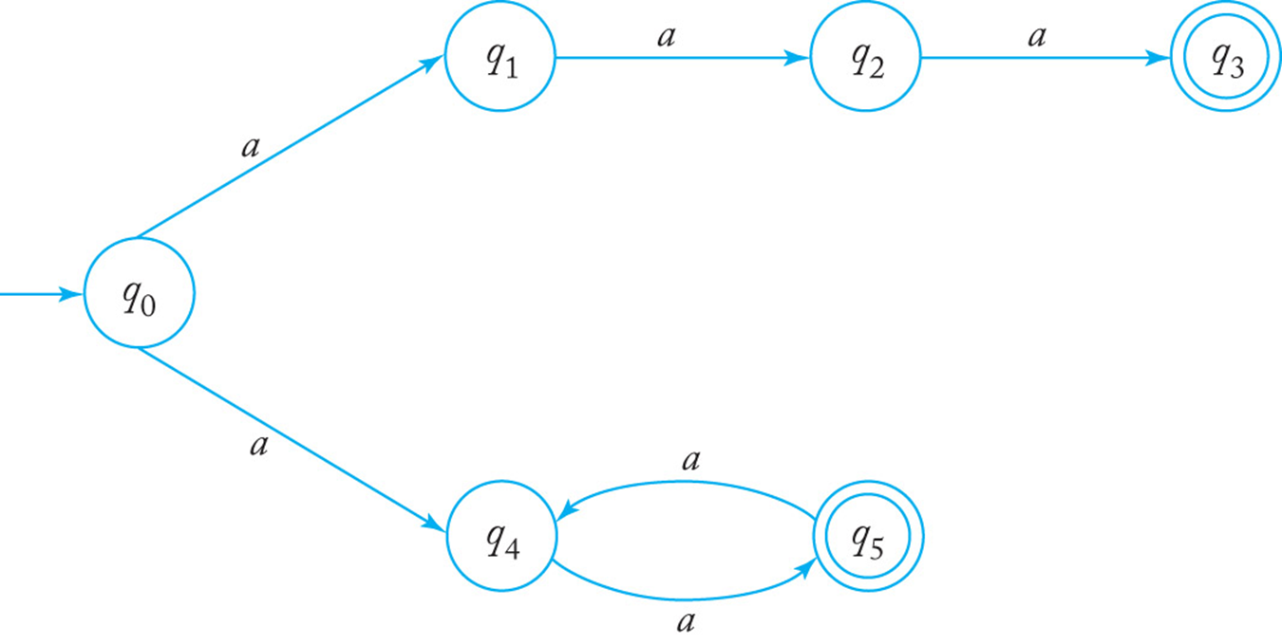

1. [10] Give a language *L* that is accepted by the NFA. Describe L in the proper mathematical format, not in the verbal English description. E.g.) L = { *a****n***| *n* ³ 0, *n* ¹ 3 }
   1. L = an | n = 3 OR n ≥ 2k, k ≥ 1
2. [10] Find a *DFA* that accepts the ***complement*** of the language defined by the NFA, i.e. $\overline{L}$.
   1. L = {an | a ≠ 3 AND n ≥ 2k +1, k ≥ 0

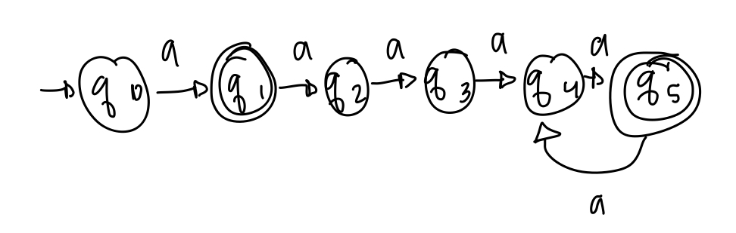

Q5. [10] Construct an NFA with the ***minimum*** number of states that accepts

*L* = { *an* | *n* ³ 0 } È { *bna* | *n* ³ 1 }.

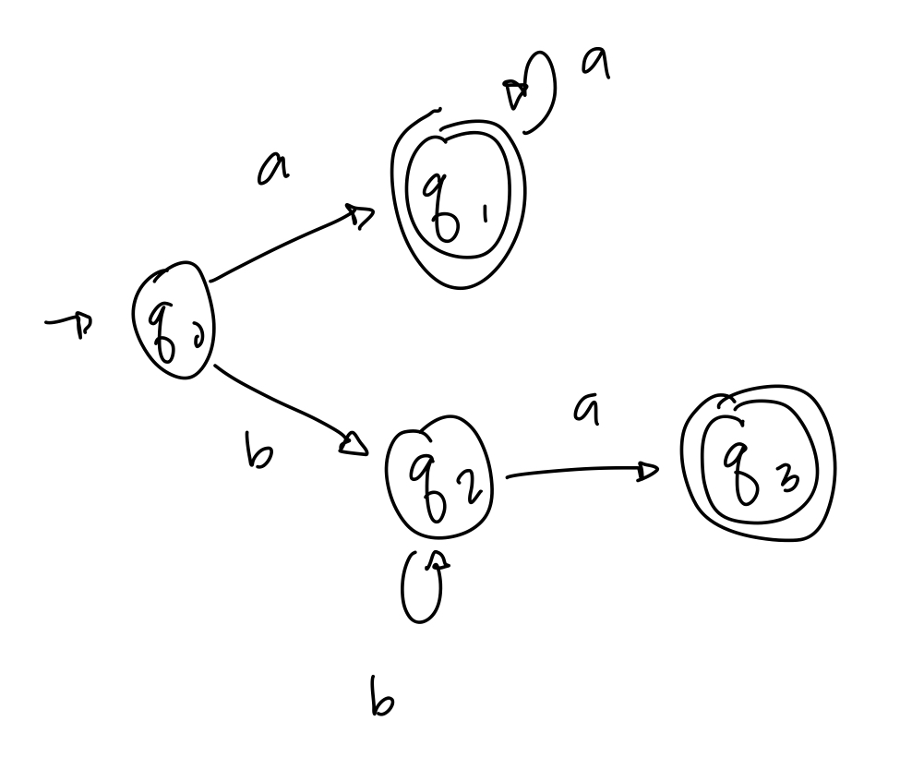

Q6. [10] Convert the NFA defined by the transitions below with the initial state *q0* and the final state *q2* into an *equivalent DFA*. Draw the transition graph of the DFA.

d(*q0, a*) = { *q0, q1* }, d(*q1, b*) = { *q1, q2* }, d(*q2, a*) = { *q2* }, d(*q1,* l) = { *q1, q2* }.

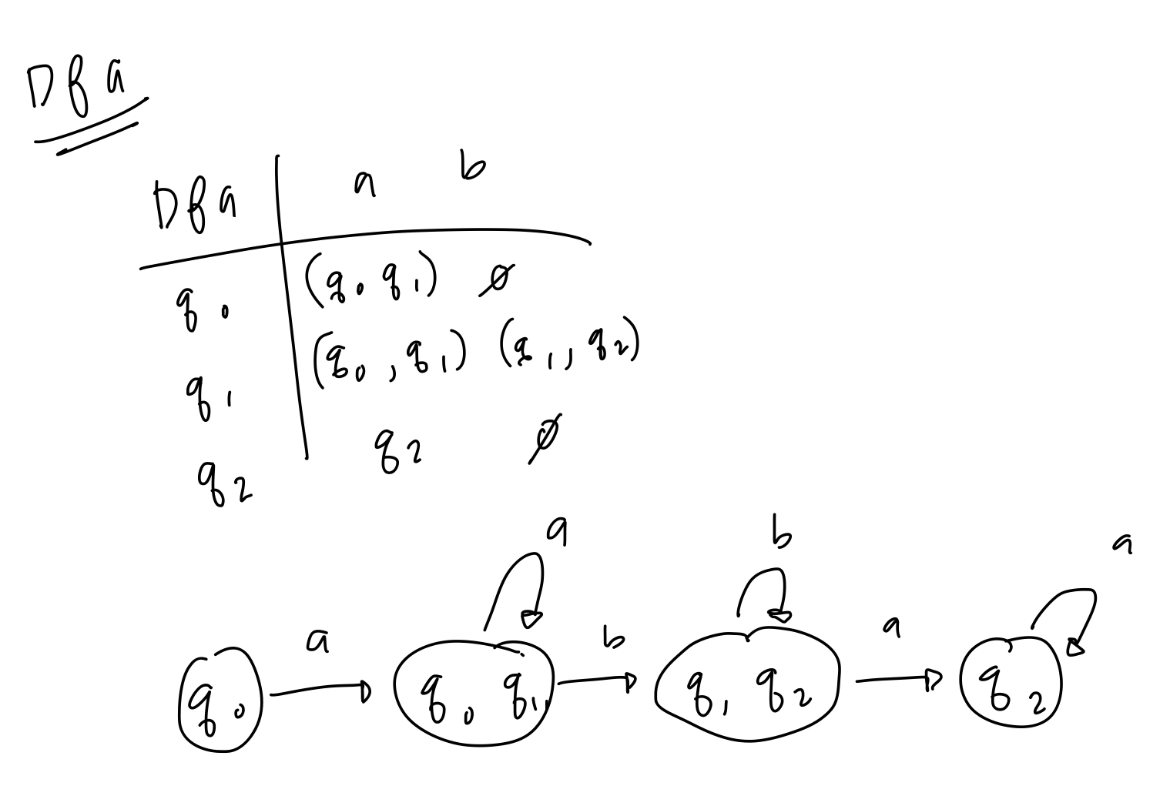

Q7. [20] For a given language, L = { *anb* | *n* ³ 1 } È { *bna* | *n* ³ 1},

1. [10] Construct a *minimal DFA* with the minimum number of states that accepts L.

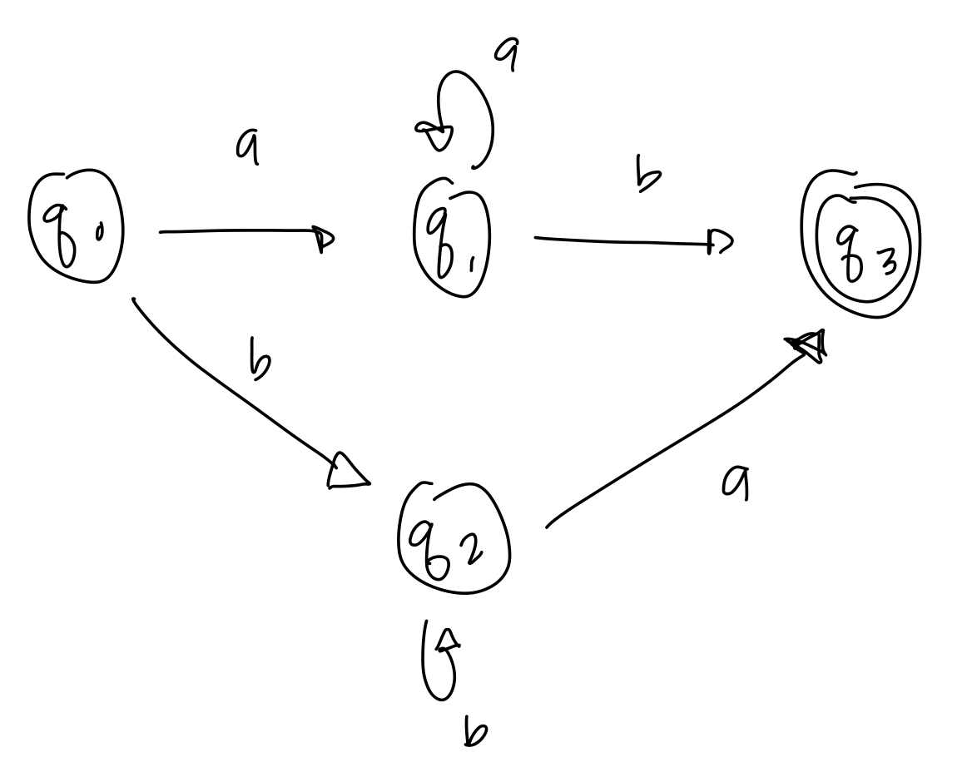

1. [10] Prove that your DFA in 1) is minimal. Hint: Check if any pair of the states are indistinguishable to be merged in the same class so that the number of states are minimized

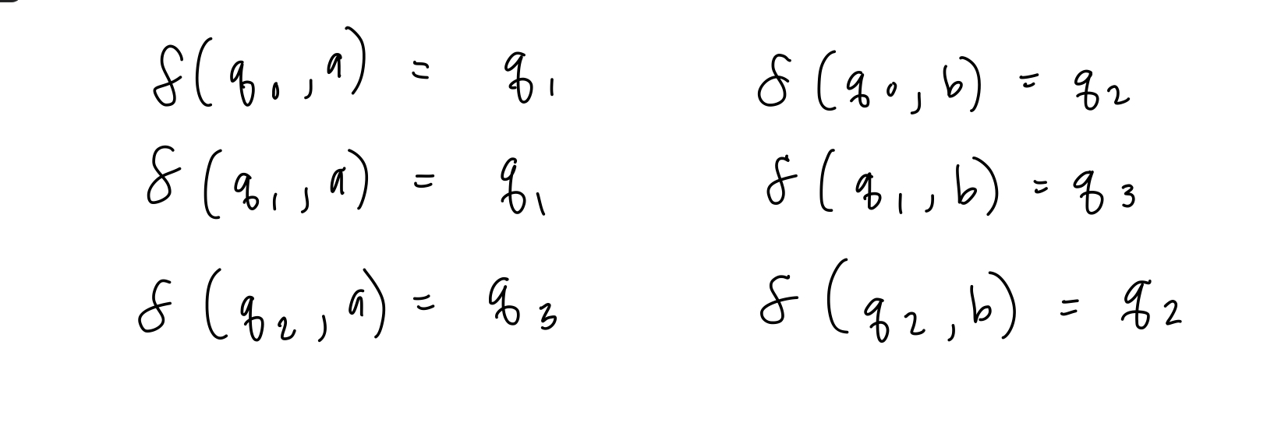

Q8. [10, optional] Prove or disprove the following conjecture: If L is regular, so is LR.

If it is true, construct a NFA MR s.t. L(M’) = LR , from a NFA M that accepts L, i.e. L(M) = L. Then, show that L(M’ ) = LR .

Otherwise, give a counter example.