CSci 435: Formal Languages and Automata

Instructor: Dr. M. E. Kim Name: Elena Corpus

**Home Assignment 2: 100 points + 10 points (optional)**

Q1. [10] Find all strings in L((*ab* + *b*)* b (*a* + *ab*)*) of length ***less than*** four.

b, ab, bb, ba, abb, bba, bbb, baa, bab

Q2. [10] Give a ***regular expression*** for the language

1. [10] L = {*anbm* | (*n*+*m*) is odd}.

(aa)*(bb*) - a(aa)*b(bb*)

1. [10, optional] L = {*w* Î {*a, b*}* | ( *na*(*w*) - *nb*(*w*) ) mod 3 = 0}. Hint: Apply Thm 3.2. .

RE = ((ab*(ab+b)(ba)*(bb+a)(ab)*)*

Q3. [10] Using the construction in Theorem 3.1, construct an NFA that accepts the complement of the

Language L(*ab*\**aa* + *bba*\**ab*).

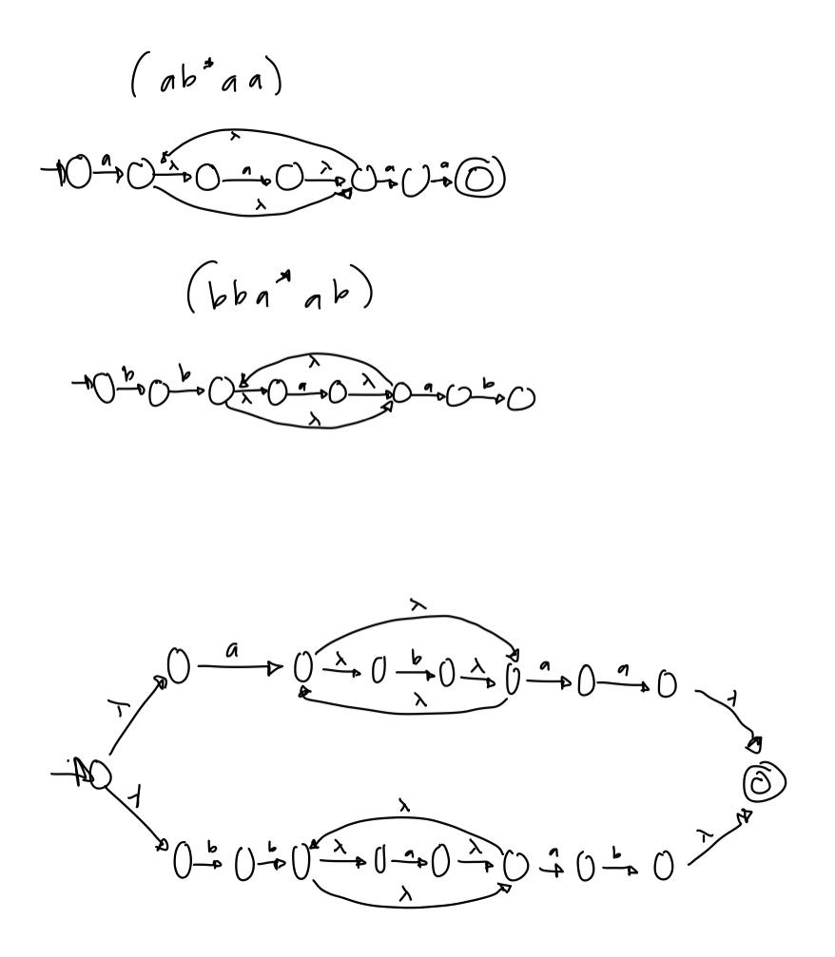

Q4. [20] Construct a ***minimal DFA*** that accepts the following language

1. [10] L(*ab*(*a*+*ab*)*(*a*+*aa*))

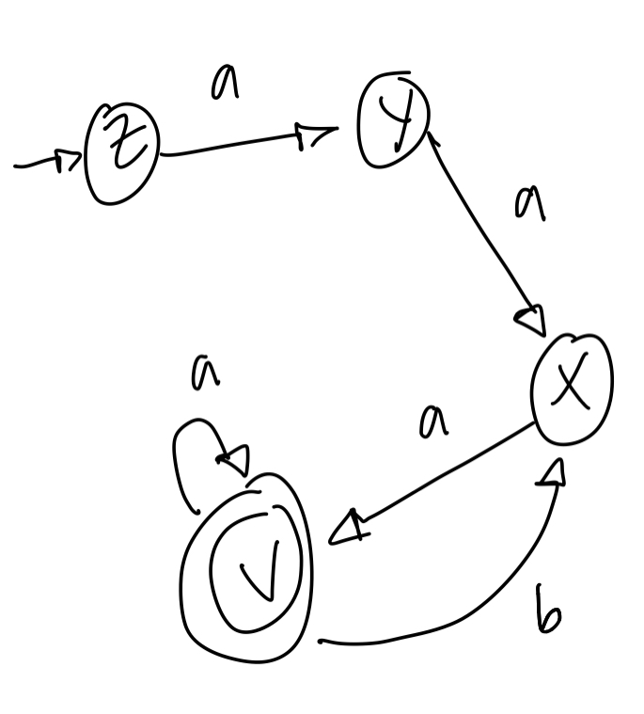

1. [10] L((*aa*\*)\**b*)*)

Hint: Start with constructing an NFA (by Theorem 3.1), convert it to DFA, then get the minimal DFA by mark & reduce procedures.

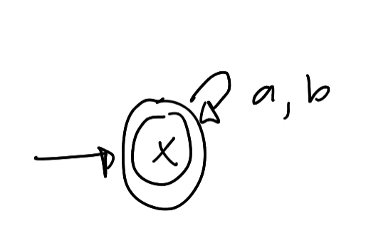

Q5. [20] Find ***regular expressions*** for the languages accepted by the following automaton.

1. [10]

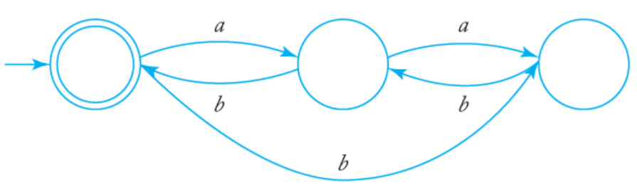

i. q0 = q1 b + q2 b + e (e = epsilon & q0 = initial state)ii. q1 = q0 a + z3 b

iii. q2 = q1 a

Substituting eqn. (iii) in (i) and (ii)

ii. q1= q0 a + q1 ab => q1 = q0 a(ab)* (from Arden's Theorem)

i. q0 = q1 b + q1 ab + e

Now, substituting equation (ii) into (i), we get

i. q0 = e + q0 a (ab)* b + q0 a (ab)* ab

=> q0 = e + q0 (a (ab)* (b + ab))

=> q0 = e (a (ab)* (b + ab))

=> q0 = a (ab)* (b + ab)

Thus, q0 **= a (ab)* (b + ab)**

1. [10]

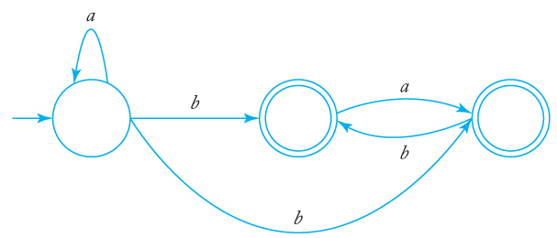

i. q0 = q0 b + e (q0 = starting point )

ii. q1 = q0 b + q2 b

iii. q2 = q0 b + q1 a

Solving equation i) using Arden's Theorem we get,

i. q0 = e (b)* => q0 = (b)*

Substituting value of q0 in equation (ii) and (iii), we get:

ii. q1 = (b)* b + q2 b

iii. q2 = (b)* b + q1 a

Substituting equation (ii) in (iii), we get,

iii. q2 = (b)* b + ( (b)* b + q2 b ) a

=> q2 = (b)*b + (b)* ba + z3 ba=> q2 = ((b)*b + (b)* ba) (ba)* (using Arden's Theorem)

q1 = (b)* b + (((b)*b + (b)* ba) (ba)*) b

Q6. [10] Construct a ***DFA*** that accepts the language generated by the *grammar*

S ® *ab*S | B, A ® *a*B | *bb,* B ® *ba*A.

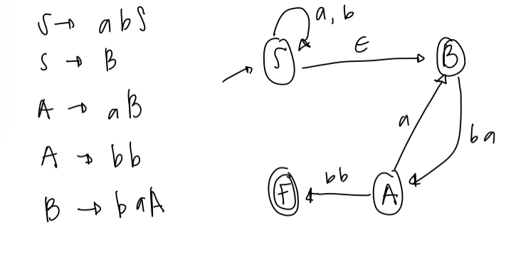

Q7. [20] Find a ***regular grammar*** that generates the language on S={a, b}

1. [10] *L*(*aa*\*(*ab*+*a*)*)

S -> aA

A -> Aa|B

B -> abB|aB\(lambda)

aA, aaA, aaaA, aaaabB, aaaababB, aaaababaB, aaaababa

1. [10] the language consisting of all strings with no more than two *a*’s.

b*a{0,1} b*a{0,1} b*

babab

aa

aba

bbb