CSci 435: Formal Languages and Automata

Instructor: Dr. M. E. Kim Name: Elena Corpus

Home Assignment 5: 100 points + 15 points (optional)

In any (N/D)PDA, assume that a start stack symbol z is already in the stack; so, you don’t have to insert z into the stack at the beginning of transition.

Q1. [20] For a given language L = { *w* | *na*(*w*) + *nb*(*w*) = *nc*(*w*) } where S = G = {*a*, *b, c*}

1. [10] Construct a PDA M that accepts L with S = G = {*a*, *b, c*}

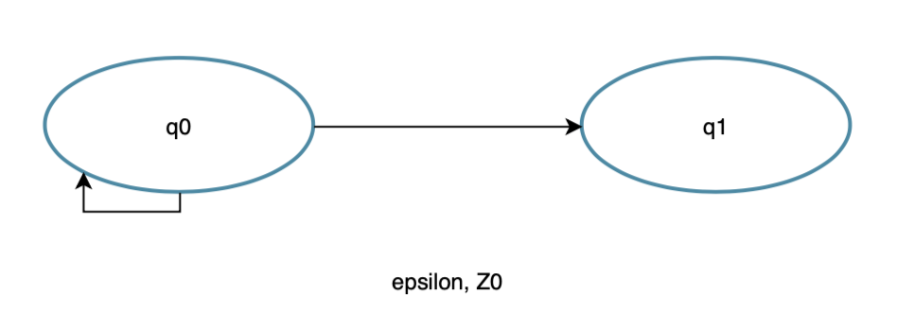

1. [10] Show the sequence of instantaneous descriptions for the acceptance of *acacbcbc* by M in 1).

*A = push to stack*

*C = delete A*

*A = push to stack*

*C = delete A*

*B = push to stack*

*C = delete B*

*B = push to stack*

*C = delete b*

*Epsilon to Z0*

1. [10, optional] Give a CFG G that generates L, L(G) = L.

Anbmcn+m

S -> AC

A-> aAc | lambda

C -> cCb | lambda

Q2. [20] Construct an NPDA for the following languages.

1. [10] L1 = {*bba*\**bab*\* }

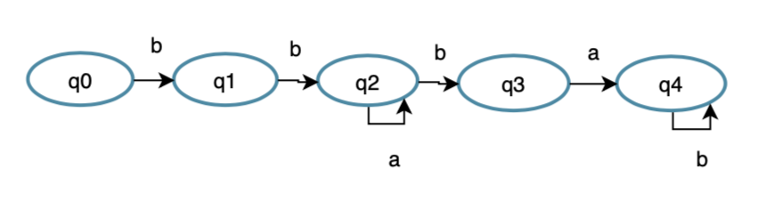

1. [10] L2 = {*bbb\*aba* }

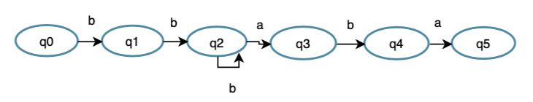

1. [5, optional] L4 = L2 – L1.

L2 - (L1 ∩ L2)

But {L1 ∩ L2} = {bbaba}

So L2 – L1 = L2 - {bbaba}

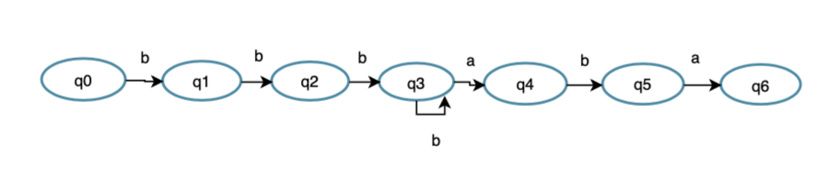

Q3. [10] Give the language that is accepted by the NPDA M in a formal expression (including a regular expression) where M = ({*q0, q1, q2*}, {*a, b*}, {*a, b*, z}, d, *q0*, z, { *q0* , *q1*, *q2*}), with transitions

¨ d(*q0*, *a*, z) = {(*q1*, *a*), (*q2*, l)},

¨ d(*q1*, *b*, *a*) = {(*q1*, *b*)},

¨ d(*q1*, *b*, *b*) = {(*q1*, *b*)},

¨ d(*q1*, *a*, *b*) = {(*q2*, l)},

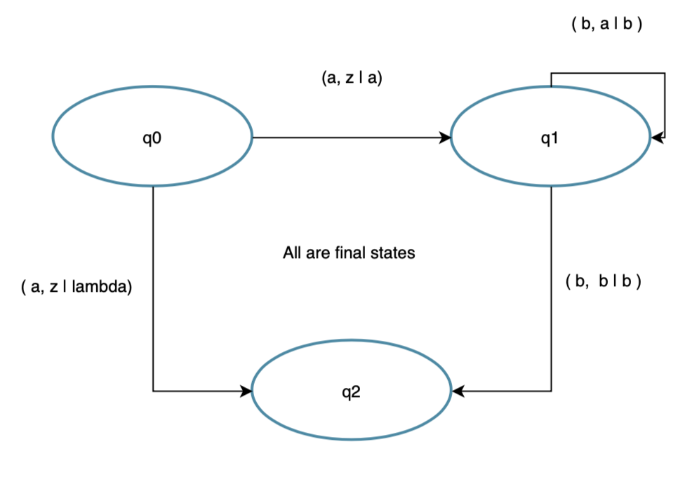

So, q0 will have 2 transitions

Q1 will consume any number of B’s

Q2 is the state in which it accepts endings with an “a”

Regular Expression: a+abma

Q4. [20] (A) Construct a NPDA that accepts the language defined by the given grammar and (B) give the language in a formal expression (including a regular expression).

1. S ® *ab*S*b* | l.
2. S ® AA | *a*, A ® SA | *ab*.

Hint: Convert the grammar into Greibach Normal Form, then apply Thm. 7.1.

Q5. [20] Find a (minimal) Context-Free Grammar that generates the language accepted by the NPDA M where M = ({*q0, q1*}, {*a, b*}, {*A*, z}, d, *q0*, z, {*q1*}), with the transitions

¨ d(*q0*, *a*, z) = {(*q0*, *Az*)},

¨ d(*q0*, *b*, *A*) = {(*q0*, *AA*)},

¨ d(*q0*, *a*, *A*) = (*q1*, l).

Simplify the production rules by eliminating the useless variables and productions.

δ(q0, a, z) = {(q0, Az)},

δ(q0, b, A) = {(q0, AA)},

δ(q0, a, A) = {(q1, λ)},

δ(q1, λ, A) = {(q1, λ)},

δ(q1, λ, z) = {(q2, λ)}.

Last three transition =

(q0Aq1) → a,

(q1Aq1) → λ,

(q1zq2) → λ.

From the first two transitions =

(q0zq0) → a(q0Aq0)(q0zq0)|a(q0Aq1)(q1zq0)|a(q0Aq2)(q2zq0),

(q0zq1) → a(q0Aq0)(q0zq1)|a(q0Aq1)(q1zq1)|a(q0Aq2)(q2zq1),

(q0zq2) → a(q0Aq0)(q0zq2)|a(q0Aq1)(q1zq2)|a(q0Aq2)(q2zq2),

(q0Aq0) → a(q0Aq0)(q0Aq0)|a(q0Aq1)(q1Aq0)|a(q0Aq2)(q2Aq0),

(q0Aq1) → a(q0Aq0)(q0Aq1)|a(q0Aq1)(q1Aq1)|a(q0Aq2)(q2Aq1),

(q0Aq2) → a(q0Aq0)(q0Aq2)|a(q0Aq1)(q1Aq2)|a(q0Aq2)(q2Aq2).

Removing the useless variables:

(q1zq0), (q1zq1), (q1zq2),(q2zq0), (q2zq1), (q2zq2), (q1Aq0), (q1Aq1), (q1Aq2), (q2Aq0), (q2Aq1), and (q2Aq2).

Thus equaling:   
(q0Aq1) → a,

(q1Aq1) → λ,

(q1zq2) → λ,

(q0zq0) → a(q0Aq0)(q0zq0),

(q0zq1) → a(q0Aq0)(q0zq1),

(q0zq2) → a(q0Aq0)(q0zq2),

(q0Aq0) → a(q0Aq0)(q0Aq0),

(q0Aq1) → a(q0Aq0)(q0Aq1),

(q0Aq2) → a(q0Aq0)(q0Aq2),

Having the start variable as (q0zq2)

Q6. [10] Construct a Deterministic-PDA that accepts L= { *anbm* | 0 £ *m* < *n* } to show L is a Deterministic-CFL.

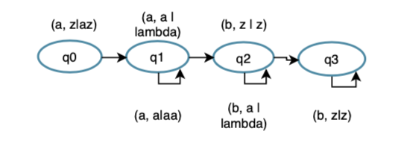

d(*q0*, *a*, z) = {(*q0*, a*z*)},

d(*q1*, a, a) = {(*q1*, aa)},

d(*q1*, b, a) = (*q2*, l).

d(*q2*, b, a) = {(*q0*, l)},

d(*q2*, *b*, z) = {(*q3*, z)},

d(*q3*, b, z) = (*q3*, z).