Final  
4 qveqseli broadcastebiturt  
10.0.0.0-10.63.255.255/10  
10.64.0.0-10.127.255.255/10  
10.128.0.0-10.191.255.255/10  
10.192.0.0-10.255.255.255/10  
  
**Step 1:hostnamebi sheucvale routerebs uewveli mere shegawuxebs tu ar izav**  
Config terminal  
Hostname “rac ginda”  
  
**Step 2:** [**10.0.0.0/8**](http://10.0.0.0/8) **4 qveqselad davyot da chamovwerot)**  
  
- Subnet 1: [10.0.0.0/10](http://10.0.0.0/10) (VLAN 50 - IT)  
- Subnet 2:[10.64.0.0/10](http://10.64.0.0/10) (VLAN 60 - HR)  
- Subnet 3:[10.128.0.0/10](http://10.128.0.0/10) (VLAN 70 - Sales)  
- Subnet 4:[10.192.0.0/10](http://10.192.0.0/10) (VLAN 80 - LAW)  
  
**Step 3: VLANebi davakonfigurirot switchebz**e  
  
S1,s2,s5 ze shevqnat vlan 50 da vlan 60(vlan 50 s IT davarqvat da vlan 60s HR)  
  
1. Switches S1, S2, and S5(samives cli-shi vwert shemdeg commandebs):  
  
Switch(config)# vlan 50  
Switch(config-vlan)# name IT  
Switch(config-vlan)# exit  
  
Switch(config)# vlan 60  
Switch(config-vlan)# name HR  
Switch(config-vlan)# exit  
  
  
2:Switches S3, S4, and S6:  
S3,s4, da s6 ze shevqmnat vlan 70 da vlan 80(vlan 70 s Sales varqmevt da vlan 80 s LAW)samives cli-ahi vwert:  
  
Switch(config)# vlan 70  
Switch(config-vlan)# name Sales  
Switch(config-vlan)# exit  
  
Switch(config)# vlan 80  
Switch(config-vlan)# name LAW  
Switch(config-vlan)# exit  
  
  
**Step 4:**s1 da s2 switchის fa0/1 და fa 0/2 პორტები გავაწევრიანოთ შესაბამისად vlan 50 da vlan 60 shi და გადავიყვანოთ access რეჟიმში.ასევე s3 da s4 სვიჩის fa0/1 da fa 0/2 პორტები გავაწევრიანოთ შესაბამისად vlan 70 da vlan 80 shi და გადავიყვანოთ access რეჟიმში.  
+აქვე ბარემ სვიჩების შესაბამისი პორტები trunk რეჟიმში გდავიყვანოთ  
  
1. Switch S1:  
  
Switch(config)# interface fa0/1  
Switch(config-if)# switchport mode access  
Switch(config-if)# switchport access vlan 50  
Switch(config-if)# exit  
  
Switch(config)# interface fa0/2  
Switch(config-if)# switchport mode access  
Switch(config-if)# switchport access vlan 60  
Switch(config-if)# exit  
  
Switch(config)# interface gig0/1  
Switch(config-if)# switchport mode trunk  
  
(Anu aq daakvirdi zeda switchs am shemtxvevashi S5 s riti uertdeba da interface gig0/1 magis mixedvit wer)  
  
  
2. Switch S2:  
(Same shit rac s1shi  
Prosta am trunkis dros interface gig0/2unda)  
  
Switch(config)# interface fa0/1  
Switch(config-if)# switchport mode access  
Switch(config-if)# switchport access vlan 50  
Switch(config-if)# exit  
  
Switch(config)# interface fa0/2  
Switch(config-if)# switchport mode access  
Switch(config-if)# switchport access vlan 60  
Switch(config-if)# exit  
  
Switch(config)# interface gig0/2  
Switch(config-if)# switchport mode trunk  
  
  
3. Switch S3:  
  
Switch(config)# interface fa0/1  
Switch(config-if)# switchport mode access  
Switch(config-if)# switchport access vlan 70  
Switch(config-if)# exit  
  
Switch(config)# interface fa0/2  
Switch(config-if)# switchport mode access  
Switch(config-if)# switchport access vlan 80  
Switch(config-if)# exit  
  
Switch(config)# interface gig0/2  
Switch(config-if)# switchport mode trunk  
  
4. Switch S4:  
(Aqac same shit rac s3 shi prosta trunki interface gig0/1)  
  
  
Switch(config)# interface fa0/1  
Switch(config-if)# switchport mode access  
Switch(config-if)# switchport access vlan 70  
Switch(config-if)# exit  
  
Switch(config)# interface fa0/2  
Switch(config-if)# switchport mode access  
Switch(config-if)# switchport access vlan 80  
Switch(config-if)# exit  
  
Switch(config)# interface gig0/1  
Switch(config-if)# switchport mode trunk  
  
  
  
  
**Step 5: trunk portebi s5 da s6zec**  
  
Orive switchshi amas wer:  
  
Switch(config)# interface gig0/1  
Switch(config-if)# switchport mode trunk  
Switch(config-if)# exit  
  
Switch(config)# interface gig0/2  
Switch(config-if)# switchport mode trunk  
Switch(config-if)# exit  
  
Switch(config)# interface fa0/24  
Switch(config-if)# switchport mode trunk  
Switch(config-if)# exit  
  
  
  
  
  
  
**Step 6: shevqmnat subinterfacebi routerebshi da gavuwerot qveqselshi pirveli gamoyenebadi ip misamarti**  
1. Router 1:  
  
Router(config)# interface gig0/0.50  
Router(config-subif)# encapsulation dot1Q 50  
Router(config-subif)# ip address 10.0.0.1 255.192.0.0  
Router(config-subif)# exit  
  
Router(config)# interface gig0/0.60  
Router(config-subif)# encapsulation dot1Q 60  
Router(config-subif)# ip address 10.64.0.1 255.192.0.0  
Router(config-subif)# exit  
  
  
Gavaaqtiurot gig0/0  
Router(config)# interface gig0/0  
Router(config-if)# no shutdown  
Da exit  
  
  
2. Router 2:  
  
Router(config)# interface gig0/0.70  
Router(config-subif)# encapsulation dot1Q 70  
Router(config-subif)# ip address 10.128.0.1 255.192.0.0  
Router(config-subif)# exit  
  
Router(config)# interface gig0/0.80  
Router(config-subif)# encapsulation dot1Q 80  
Router(config-subif)# ip address 10.192.0.1 255.192.0.0  
Router(config-subif)# exit  
  
Gavaaqtiurot gig0/0  
Router(config)# interface gig0/0  
Router(config-if)# no shutdown  
Da exit  
  
  
**Step 7:routerebze serial interface misamartwbi gavwerot**  
  
Router1:  
Router(config)# interface serial 0/0/0  
Router(config-if)# ip address 192.168.20.1 255.255.255.0  
Router(config-if)# no shutdown  
Router(config-if)# exit  
  
  
Router2:  
Router(config)# interface serial 0/0/0  
Router(config-if)# ip address 192.168.20.2 255.255.255.0  
Router(config-if)# no shutdown  
Router(config-if)# exit  
  
  
**Step 8:routerebs ertmanetis misamartebi vaswavlot**  
  
Router1:  
Router(config)# ip route 0.0.0.0 0.0.0.0 192.168.20.2  
Router(config)# exit  
  
  
Router2:  
Router(config)# ip route 10.0.0.0 255.192.0.0 192.168.20.1  
Router(config)# ip route 10.64.0.0 255.192.0.0 192.168.20.1  
Router(config)# exit  
  
  
**Step 9:router 2 shi gig0/0 s ip adresi gavuwerot**(dhcp servers ro shevqmnit mag ips gamoviyenebt rogorc ip helper address)  
Btw ar aqvs mnishvneloba ras gauwer rac gagiswordeba  
  
Router2:  
Router(config)# interface gig0/0  
Router(config-if)# ip address 192.168.3.1 255.255.255.0  
Router(config)# exit  
  
  
  
**Step 10: shevqmnat dhcp pool router 2 ze**  
  
router2:  
Router(config)# ip dhcp pool VLAN50  
Router(dhcp-config)# network 10.0.0.0 255.192.0.0  
Router(dhcp-config)# default-router 10.0.0.1  
Router(dhcp-config)# exit  
  
Router(config)# ip dhcp pool VLAN60  
Router(dhcp-config)# network 10.64.0.0 255.192.0.0  
Router(dhcp-config)# default-router 10.64.0.1  
Router(dhcp-config)# exit  
  
Router(config)# ip dhcp pool VLAN70  
Router(dhcp-config)# network 10.128.0.0 255.192.0.0  
Router(dhcp-config)# default-router 10.128.0.1  
Router(dhcp-config)# exit  
  
Router(config)# ip dhcp pool VLAN80  
Router(dhcp-config)# network 10.192.0.0 255.192.0.0  
Router(dhcp-config)# default-router 10.192.0.1  
Router(dhcp-config)# exit  
  
  
  
**Step 11:subinterfacebze gavwerot ip helper address wegan ro shevqmeni(**ro ip addresebu daurigos pc ebs)  
  
Router1:  
Router(config)# interface gig0/0.50  
Router(config-subif)# ip helper-address 192.168.3.1  
Router(config-subif)# exit  
Router(config)# interface gig0/0.60  
Router(config-subif)# ip helper-address 192.168.3.1  
Router(config-subif)# exit  
  
  
  
Router2:  
Router(config)# interface gig0/0.70  
Router(config-subif)# ip helper-address 192.168.3.1  
Router(config-subif)# exit  
Router(config)# interface gig0/0.80  
Router(config-subif)# ip helper-address 192.168.3.1  
Router(config-subif)# exit  
  
  
  
**Step 12: SSH wvdoma orive routerze**(hostname tu ar gaq shecvlili ar izavs amito unda sheucvalo uew)  
Username:admin  
Password:cisco  
  
  
Oriveze :  
Router(config)# ip domain-name [cisco.com](http://cisco.com/)Router(config)# username admin password cisco  
Router(config)# crypto key generate rsa  
How many bits in the modules [512]: 1024  
  
  
Router(config)# line vty 0 15  
Router(config-line)# login local  
Router(config-line)# transport input ssh  
Router(config-line)# exit  
  
  
  
  
**Step 13:routerebs console portebze gavuwerot paroli:class**  
**da barem davshifrot (service password encryptit)**  
**Daaa momxmareblis privilegirebul rejimze gavwerot paroli cisco**  
  
  
Orive routerze:  
Router(config)# line con 0  
Router(config-line)# password class  
Router(config-line)# login  
Router(config-line)# exit  
Router(config)# enable secret cisco  
Router(config)# service password-encryption

**Step 14:dns serverze shevqmnat** [**cisco.com**](http://cisco.com/) **chanaweri shesabamisi ip misamartit**  
  
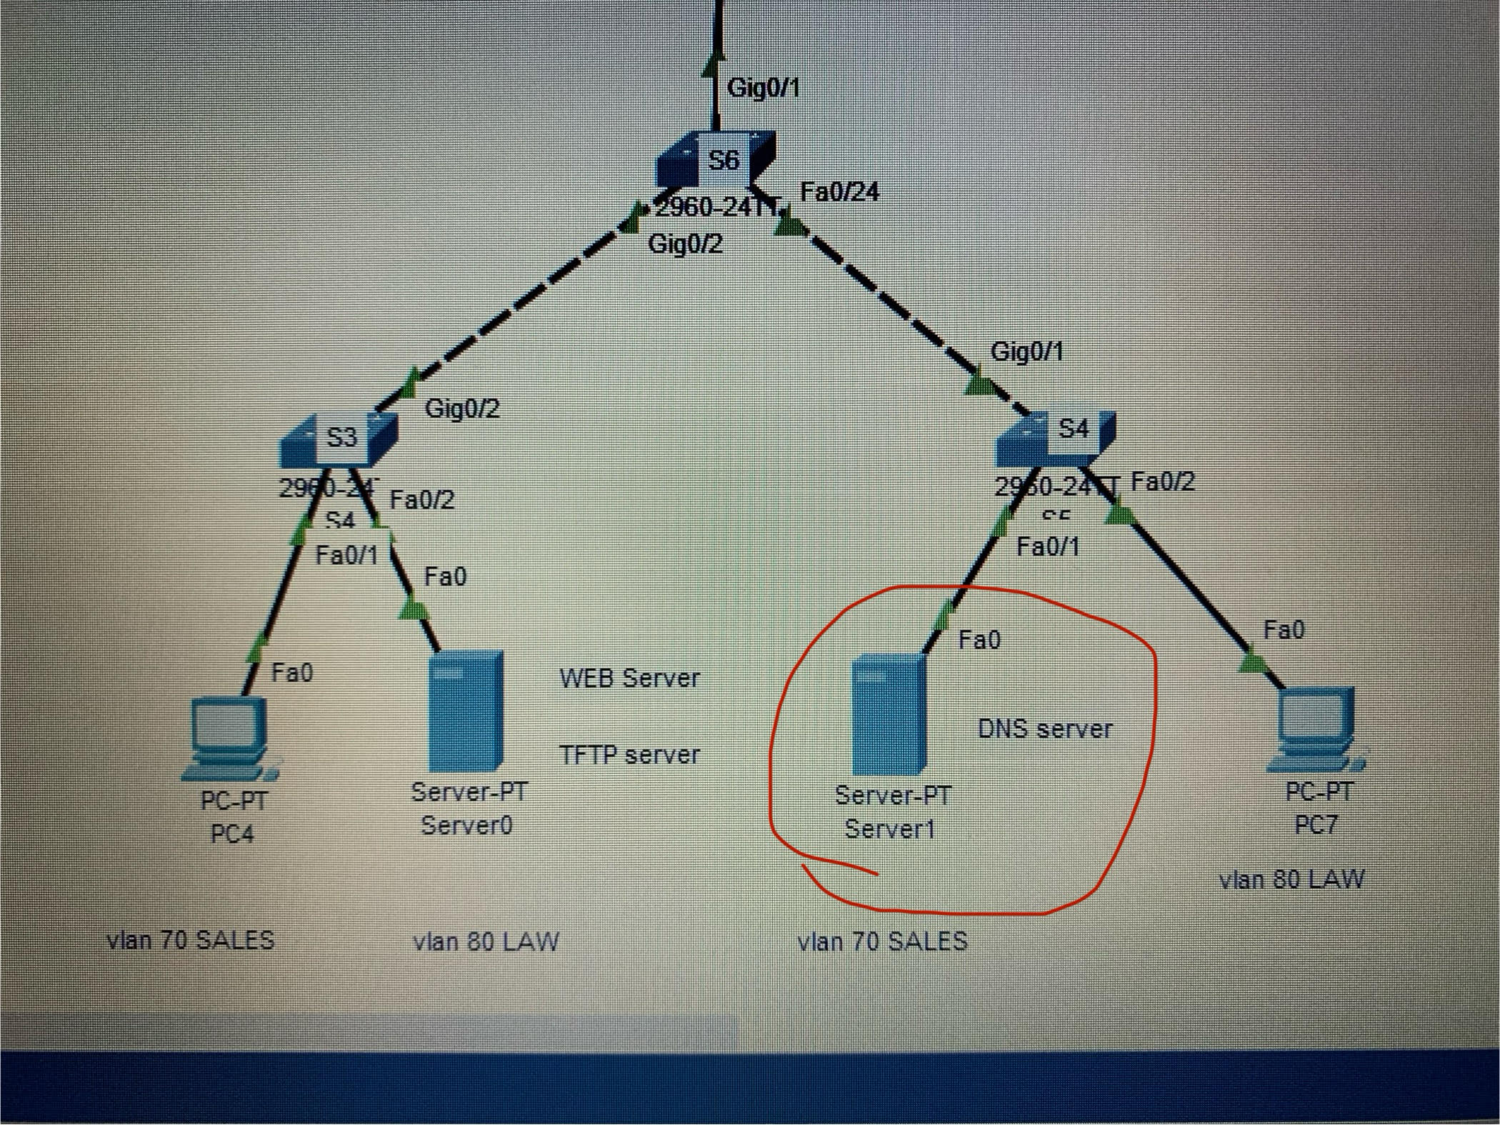  
Aq dns serverze chvenit unda gavwerot ip  
Desktop->ip configuration->staticshi vwert:  
  
Ipv4address:10.128.0.4(mtavaria lan 70 iyos anu 10.128. uew da danarxhenshi mgoni rasac ginda chawer idk zustad)  
Subnet:255.192.0.0  
Default gateway:10.128.0.1  
  
  
Meore serverze(fotoshi dns is marcxniv)  
Ipv4:10.192.0.3(imito ro vlan 80 ia)  
Subnet mask:255.192.0.0  
Def gateway:10.192.0.1  
  
  
Exla shevqmnat dns serveri:  
  
Shevdivart dns servserze(fotoshi racaa moxazuli)mere services,mere dns da vawert “on”-s.  
Name-shi:[cisco.com](http://cisco.com/)Address:10.192.0.3(meore serveris misamarti anu)  
Mere vawer add-s da mere save.(rac daamate magas daawire jer da save)  
Desktop->ip config-shi dns servsershi chavwerot marcxena serveris ip anu 10.192.0.3  
  
  
Marcxena serverze services->dnsshic gavaaqtiurot dns anu “on”ze davayenot mandac  
  
  
**Step 15:dhcp poolebshi unda gavwerot dns serveri ro pc ebs daurigdet dns serveris misamarti**  
  
Router 2:  
  
Router(config)# ip dhcp pool VLAN50  
Router(dhcp-config)# dns-server 10.128.0.4  
Router(dhcp-config)# exit  
  
Router(config)# ip dhcp pool VLAN60  
Router(dhcp-config)# dns-server 10.128.0.4  
Router(dhcp-config)# exit  
  
Router(config)# ip dhcp pool VLAN70  
Router(dhcp-config)# dns-server 10.128.0.4  
Router(dhcp-config)# exit  
  
Router(config)# ip dhcp pool VLAN80  
Router(dhcp-config)# dns-server 10.128.0.4  
Router(dhcp-config)# exit  
  
**Pcebisis desktop—>>ip config dhcp ze daayene** ro ip misamartebi da dns serveri achamo,es uew qeni dagwirdeba pcs ip  
(da web browsershu cisco.comze unda shediodes)  
  
  
**Step 16:pc3 ze shevzgudot wvdoma**  
  
Router1:  
Router(config)# access-list 100 deny tcp host 10.64.0.3(anu pc3 is ips wer aq)host 10.192.0.3 eq www  
Router(config)# access-list 100 permit ip any any  
  
Router(config)# interface gig0/0.60  
Router(config-if)# ip access-group 100 in  
Router(config-if)# exit  
  
  
(sheamowme Pc3 veghar unda shediodes cisco.comze web browseridan,sxvebidan ki)  
  
  
  
**Step 17:tftpze atvirtva**  
Orive routerze:  
Router# copy running-config tftp  
Address or name of remote host []?:10.192.0.3  
Destination filename (enters daawire an tu ginda sxva saxeli dawere)