From Mathematical Reasoning to Algorithmic Judgment
Tracing a Missing Bridge in AI Literacy Research with the OpenAIRE Graph
OpenAIRE AI Hackathon 2026 - Theme A: Explore & Narrate
Eleni Nolka | Harokopio University of Athens
CC BY 4.0

1. Question and rationale
Research question. What research connections - and gaps - link mathematical and model-based reasoning with AI literacy, particularly in relation to interpretation, uncertainty, evaluation and judgment?
AI-literacy frameworks increasingly ask learners to critically evaluate AI. That requirement is important but underspecified when an AI output is uncertain, probabilistic or potentially wrong. The project therefore used the OpenAIRE Graph to test whether AI-literacy research is already connected to two adjacent traditions: empirical research on when humans appropriately rely on or override AI advice, and mathematical/statistical traditions for reasoning about uncertainty.

2. What was done
Five adaptive investigations were conducted through the Alien Intelligence MCP connector. The sequence was not designed to confirm a predefined gap. Each stage responded to the evidence produced by the preceding stage, and the final stage explicitly attempted to falsify the emerging interpretation.
- Investigation 1 mapped the AI-literacy field and its anchor frameworks.
- Investigation 2 tested reasoning, interpretation, critical evaluation, judgment, uncertainty and probabilistic reasoning separately, distinguishing explicit terminology from inferred relevance.
- Investigation 3 traced mathematical, statistical, probabilistic and model-based reasoning and looked for stable author, citation, project or venue clusters.
- Investigation 4 moved into adjacent HCI, psychology, clinical and public-administration research to locate established constructs that operationalise human judgment about AI outputs.
- Investigation 5 performed a final falsification test across alternative bridge vocabularies, citation networks and overlap patterns.
The OpenAIRE workflow used research-product search, bibliometric details, influence classes, research trends, author profiles, citation networks, research relationships and project searches. Long AND queries sometimes collapsed, while broad queries sometimes produced false abundance. These cases were retained as methodological evidence and mitigated through shorter reformulations and inspection of representative records.
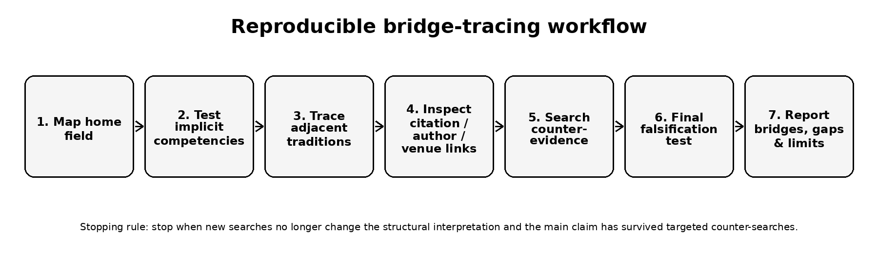
Figure 1. Reproducible bridge-tracing workflow used in the case study.

3. Main insight
The exploration revealed a structural gap between three relevant research traditions rather than the simple absence of reasoning from AI literacy:
- T1 - AI literacy frameworks: Critical evaluation, competencies and model understanding are already part of the field's conceptual architecture.
- T2 - Human-AI judgment and reliance: HCI and psychology contain established empirical constructs such as trust calibration, appropriate reliance, automation bias, algorithm aversion, adherence and override.
- T3 - Mathematical/statistical reasoning: Mathematics and statistics education contain traditions for probability, uncertainty, quantitative reasoning and model-based reasoning.
Within the OpenAIRE-indexed evidence examined, these traditions remained weakly connected by citation, authorship, venue and shared constructs. The final falsification investigation did not identify a paper integrating all three traditions. Partial bridges existed - including recent work combining AI literacy with algorithm aversion or AI dependence - but they did not yet constitute a mature cross-disciplinary research community, and the quantitative reasoning tradition remained largely absent from those bridge papers.
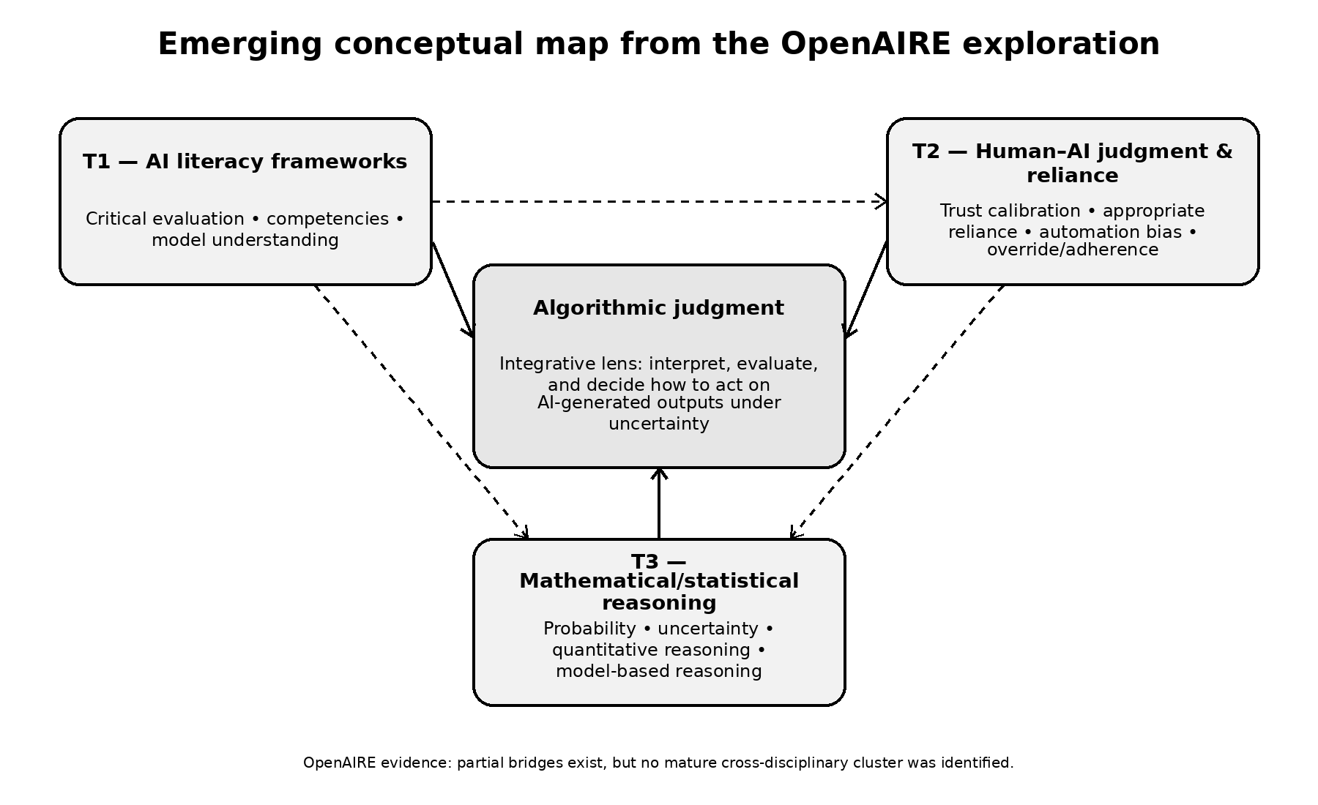
Figure 2. Three weakly connected traditions and the algorithmic-judgment integrative lens.

4. Algorithmic judgment as an integrative lens
The project does not claim that “algorithmic judgment” is an established construct. The OpenAIRE exploration instead showed that its substantive ingredients are distributed across different vocabularies. In this case study, algorithmic judgment is therefore used as an integrative lens for the capacity to interpret, evaluate and decide how to act on AI-generated outputs, particularly under conditions of uncertainty.
This synthesis connects three operations that the mapped literatures currently treat separately: (1) understanding and interpreting models/outputs; (2) reasoning about uncertainty, confidence and error; and (3) calibrating reliance by accepting, revising, rejecting or qualifying AI advice.

5. What others can reuse
The main reusable contribution is the Bridge-Tracing Protocol. It can be applied to any emerging interdisciplinary construct where a “gap” may actually reflect disciplinary vocabulary fragmentation.
- Map the home field neutrally.
- Identify implicit or underspecified competencies.
- Trace adjacent traditions where those competencies are operationalised.
- Inspect citation, author, venue, project and conceptual links.
- Classify candidate bridges as genuine integration or incidental co-occurrence.
- Search explicitly for counter-evidence.
- Run a final falsification test.
- Report integration, partial bridges, fragmentation and limitations separately.

6. Limitations and responsible interpretation
This is an exploratory case study, not a systematic review or exhaustive bibliometric study. OpenAIRE AND-logic can cause query collapse or false abundance. ScholeXplorer/citation coverage is partial, some behavioral-science literature appeared underindexed, and citation data for very recent publications are immature. AI-mediated synthesis can also introduce bibliographic metadata inconsistencies, so key references were checked separately before inclusion in the public case study.
Accordingly, the strongest defensible claim is: the fragmentation hypothesis was supported within the OpenAIRE-indexed evidence examined. The project does not claim universal proof that no bridge literature exists.

7. Selected references
- Long, D., & Magerko, B. (2020). What is AI Literacy? Competencies and Design Considerations. CHI 2020. https://doi.org/10.1145/3313831.3376727
- Ng, D. T. K., Leung, J. K. L., Chu, S. K. W., & Qiao, M. S. (2021). Conceptualizing AI literacy: An exploratory review. Computers and Education: Artificial Intelligence, 2, 100041. https://doi.org/10.1016/j.caeai.2021.100041
- Chiu, T. K. F., Ahmad, Z., Ismailov, M., & Sanusi, I. T. (2024). What are artificial intelligence literacy and competency? A comprehensive framework to support them. Computers and Education Open, 6, 100171. https://doi.org/10.1016/j.caeo.2024.100171
- Zhang, Y., Liao, Q. V., & Bellamy, R. K. E. (2020). Effect of Confidence and Explanation on Accuracy and Trust Calibration in AI-Assisted Decision Making. FAccT 2020. https://doi.org/10.1145/3351095.3372852
- Laupichler, M. C., Knoth, N., Schleiss, J., & Raupach, T. (2025). Algorithm aversion revisited: The role of AI literacy and attitudes towards AI in shaping perceptions of AI-generated texts. British Journal of Educational Technology. https://doi.org/10.1111/bjet.70035
- Tian, J., & Zhang, R. (2025). Learners' AI dependence and critical thinking: The psychological mechanism of fatigue and the social buffering role of AI literacy. Acta Psychologica, 260, 105725. https://doi.org/10.1016/j.actpsy.2025.105725

8. AI-use and licence statement
Alien Intelligence MCP connector/agent: primary AI-mediated interface to the OpenAIRE Graph. ChatGPT (OpenAI): prompt design, methodological structuring, confirmation-bias checks, evidence comparison and drafting/editing. Claims in this case study were grounded in the retained Alien/OpenAIRE investigation outputs.
Original written materials and figures in this case study are licensed CC BY 4.0. Third-party bibliographic metadata remain subject to their original source terms.

