# An g(old) era of clothing 1990s

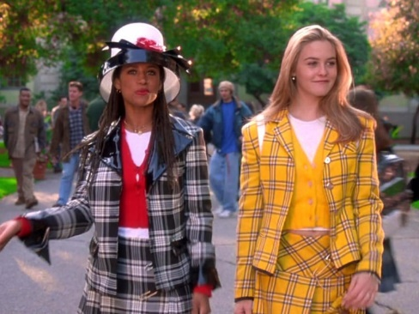From clueless to pulp fiction 90s fashion has impacted the world of clothes and appearances. Men and women from early ages acknowledge the importance of those who have set the beginning for a new era of clothing.  
  
For instance, Cher in the movie of clueless is the perfect example that is being followed dearly by teenage girls as well as the male characters of the movie followed by teenage boys. The stylistic and gorgeous outfits chosen for Cher and her fellow actors have made a mark in the history of fashion. The girly type of using complex matches and different colors makes girls want to try themselves the magic of fashion in the 90s. As we see in the picture the protagonist and her friend use bright colors and complex designs matched perfectly with one another.

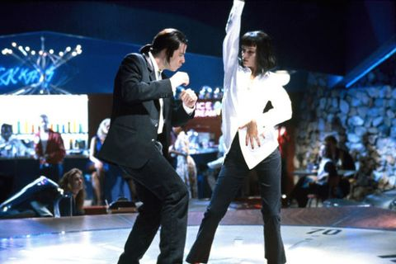  
Mia Wallace in the movie Pulp fiction has an elegant and basic style that looks stunning with the right choice of jewelry and shoes. The classic white low neckline shirt and loose black pants paired with jewels and low heels have a timeless value. Women, today, copy her style and outfits due to their elegance. Moreover the men of the film wearing classic suits show the important of being decently dressed at all times. Also Mia’s short cut dark hairstyle has influenced many women to cut their hair and try out something new and stylish. Today more and more women experience their inner “MIA WALLACE” by following her basic but elegant fashion advice.

Without a doubt fashion would not have evolved to what it is today if it wasn’t for the tremendous impact fashion in the 90s had to fashion in 2019.

1. <https://www.insider.com/clueless-movie-cast-then-and-now-photos-2018-7>
2. <https://www.elle.com/culture/movies-tv/news/a14985/mia-wallaces-fashion-in-pulp-fiction/>

## FASHION TRENDS THAT CAME BACK

* Checked skirt suits

<https://www.theguardian.com/film/2014/mar/07/clueless-classic-teen-movie-iggy-azalea#img-1>

* Logo bags

<https://akns-images.eonline.com/eol_images/Entire_Site/2018222/rs_634x1024-180322192328-634.gigi-hadid-fendi.ct.032218.jpg?fit=inside|900:650&output-quality=90>

* Slip dresses (which will forever be popular)

<https://cdn.cliqueinc.com/cache/posts/189905/5-times-the-90s-slip-dress-made-fashion-history-1733649-1460683265.750x0c.jpg?interlace=true&quality=70>

* Animal print dresses (either mid-length or long)

<https://i2.wp.com/www.theladylikeleopard.com/wp-content/uploads/2018/05/90s-Leopard-Print-Naomi-Campbell.jpg?w=1753&ssl=1>

* Blush pink dresses and suits

<https://i.dailymail.co.uk/i/pix/2015/12/04/15/002B71D500000190-3346212-image-a-53_1449244725418.jpg>

* Branded sportswear (whether it is champion or adidas it is still adopted by both men and women as a comfortable stylistic outfit)

<https://static.vibe.com/files/2012/11/vibe-vixen-destinys-child-tommy-hilfiger-500x400.jpg>

* Hippy style (mini sunglasses and sneakers paired with a messy hair look and a unique outift is all you need to show your inner hippster)

<https://cdn.cliqueinc.com/cache/posts/234799/90s-fashion-234799-1533742879455-image.1200x0c.jpg?interlace=true&quality=70>

* Tiny bags

<https://ksassets.timeincuk.net/wp/uploads/sites/46/2019/03/micro-bags-1220x686.jpg>

* Bucket hats (started with liam Gallagher in the 90s and came back with Justin Beiber)

<https://cdn.cliqueinc.com/posts/234799/90s-fashion-234799-1504787147639-image.800x0uc.jpg>