Multi-Parametric Deep Phenotyping: Fusing 2021 WHO Molecular Grading with Perfusion-Based Vascular Signatures for Glioblastoma Survival Forecasting
Neel Madhav Padhi, Aryan Bharadwaj
$$Dt : 22-03-26$$
1. Dataset and Overview
This project explores a multi-parametric survival prediction pipeline for glioblastoma using MRI, vascular features, and clinical data.
We use the UPenn-GBM dataset. For this $prototype$, a subset of 10 randomly selected patients is used to validate the full pipeline.
1.1 Data Modalities Used in our project:-
- T1Gd MRI (contrast-enhanced structural imaging)
- Tumor segmentation masks
- DSC perfusion imaging (rCBV)
- Clinical survival data
Each MRI volume has dimensions: 155×240×240
1.2 Dataset Structure
NIfTI-files/
├── images_structural
├── images_structural_unstripped
├── images_DTI
├── images_DSC
├── images_segm
├── automated_segm
1.3 Tumor Subregions
Using segmentation masks, tumor is divided into(seg=1,2,4):
- Enhancing Tumor (ET)
- Necrotic Core (NCR)
- Edema (ED)
These regions are used for region-wise feature extraction.

2. Pipeline Overview
The best tumor slice was $93$ out of 155.

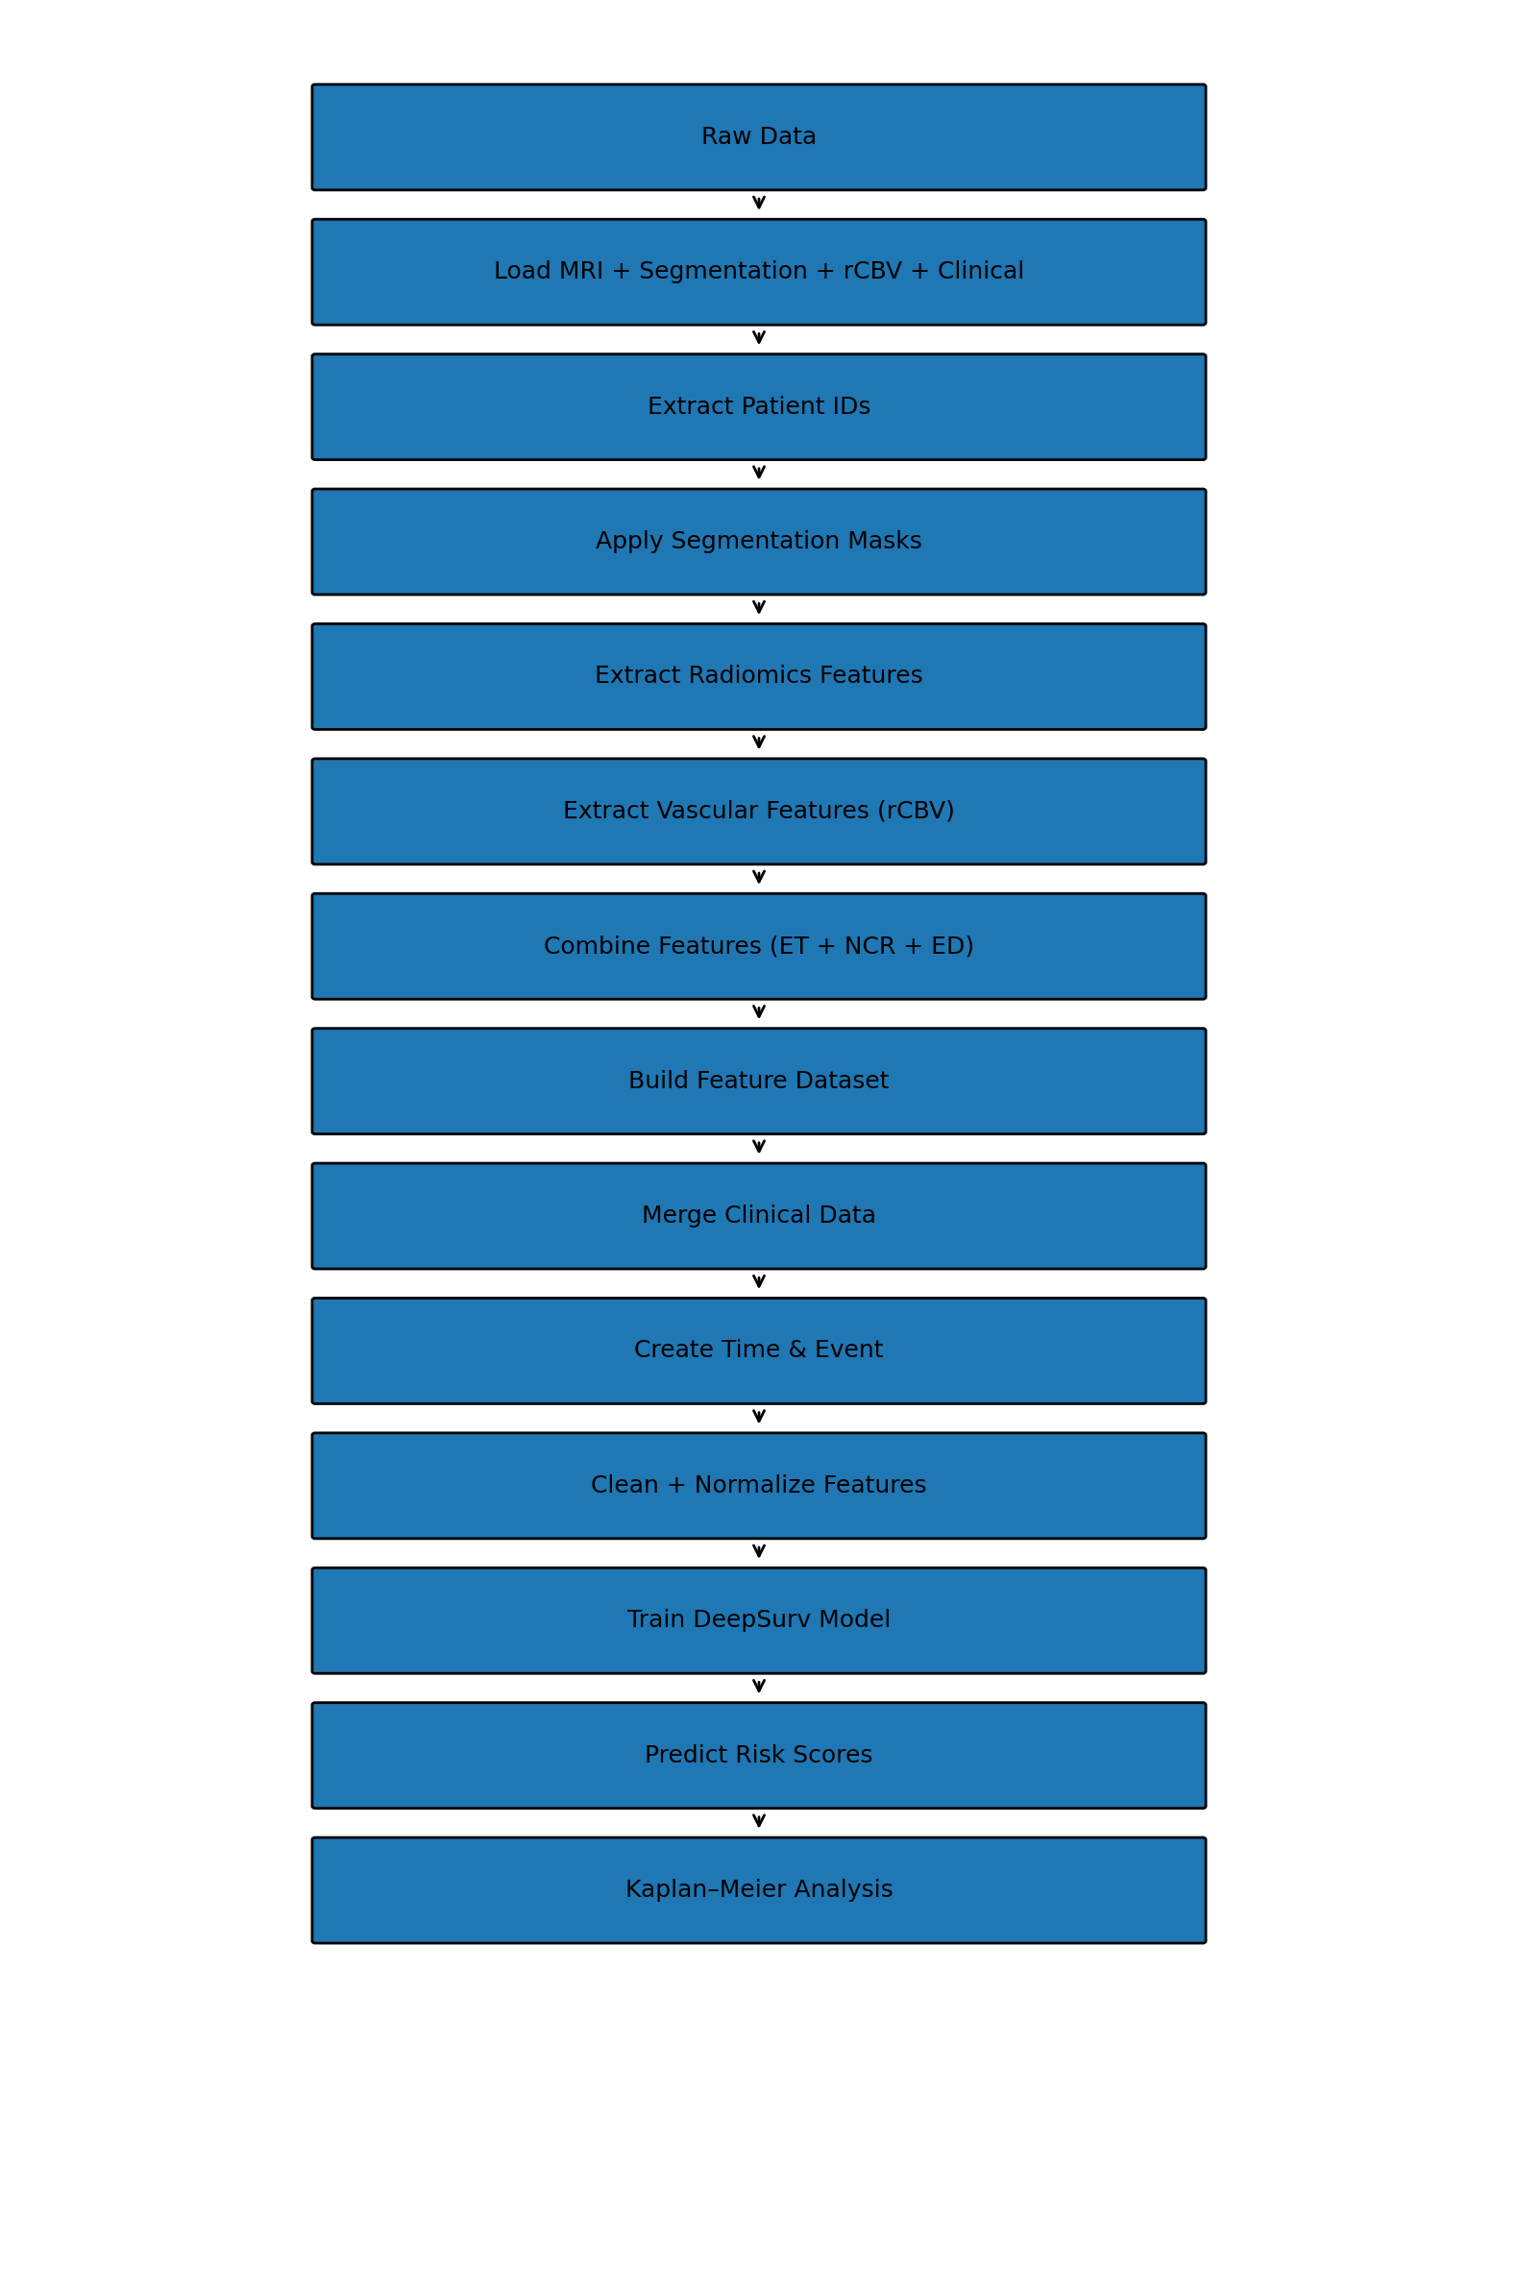

3. Feature Engineering
3.1 Radiomic Features
Radiomic features capture statistical and texture properties from MRI:
$$f_{\left\{rad\right\}}= \{ mean, variance, entropy,skewness,…\}$$
These are extracted separately for ET, NCR, and ED regions using segmentation masks.
3.2 Vascular Features (Perfusion Imaging)
Perfusion imaging provides relative cerebral blood volume (rCBV), which reflects tumor vascularity.
$$rCBV = \frac{\left\{{\left\{CBV\right\}}_{\left\{\left\{tumor\right\}\right\}}\right\}}{\left\{{\left\{CBV\right\}}_{\left\{\left\{normal\right\}\right\}}\right\}}$$
Extracted features include:
- Mean rCBV
- Maximum rCBV
- Variance
These features are critical as they capture tumor aggressiveness.
3.3 Feature Combination
Final feature vector:
$$X=[f_{rad}^{ET},f_{rad}^{NCR},f_{rad}^{ED}​,f_{vascular}​,f_{clinical}​​]$$
3.4 Feature Normalization
All features are normalized before training:$$x' = \frac{x - μ}{σ}$$
4. Survival Model
The model used is a DeepSurv-based neural network, which estimates patient-specific risk scores.
4.1 Neural Network Architecture

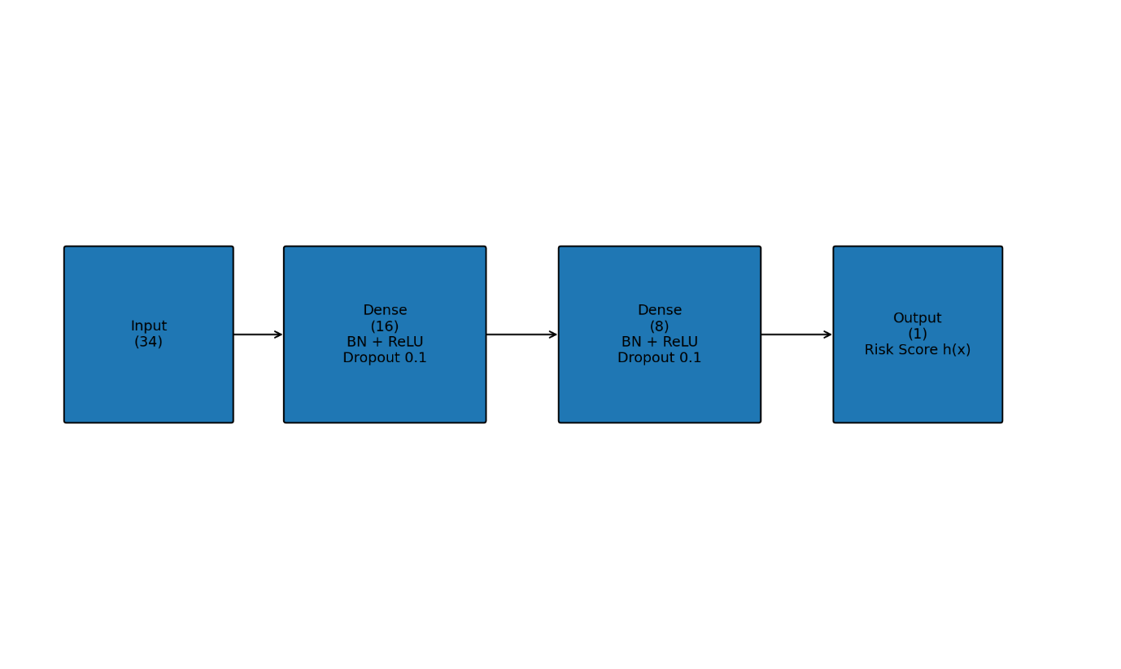

4.2 Model Output
The model outputs a single scalar risk score : $h\left(x\right)$
This represents the relative risk of death for a patient.
4.3 Loss Function (Cox Partial Likelihood)
$$L=-\sum_{i:E_{i}=1}{\left(f\left(x_{i}\right)-\log{\sum_{j∈R_{i}}{e^{f\left(x_{j}\right)}}}\right)}$$
Where:
- $(E_{i}):$ event indicator (death or censored)
- $(R_{i}):$ risk set
4.4 Optimization
- Optimizer: Adam
- Learning rate: 0.01
- Epochs: 100
- Batch size: 4
Gradients are computed using automatic differentiation , enabling efficient backpropagation through the network.
5. Training and Prediction
5.1 Training Process
$$Features (X) + Survival Data → Neural Network → Risk Score → Loss → Backpropagation$$
The model learns $relative ordering of risk$ rather than exact survival time.
5.2 Risk Prediction
For each patient:
$$RiskScore=h\left(x\right)$$
Higher values indicate higher risk.
6. Risk Stratification and Survival Analysis
6.1 Risk Grouping
Patients are divided into two groups based on median risk: $high risk and low risk$
6.2 Kaplan–Meier Estimation
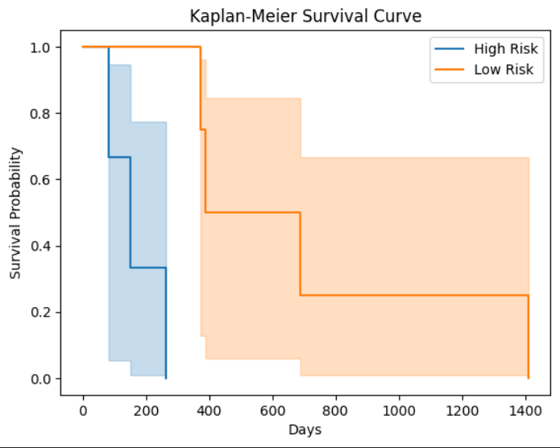Survival function:
$$S\left(t\right)=P\left(T>t\right)$$
Kaplan–Meier estimator:
$$\hat{S}\left(t\right)=\prod_{t_{i}≤t}{\left(1-\frac{d_{i}}{n_{i}}\right)}$$
Where:
- $\left(d_{i}\right)$: number of events
- $\left(n_{i}\right)$: number at risk
6.3 Observations
- Clear separation between high-risk and low-risk groups
- Model successfully captures survival differences
- Vascular features contribute to improved stratification
7. Future Work
We have currently made a prototype, and the following improvements are planned by the $next week$:
- Use the full UPenn dataset
- Incorporate additional perfusion features (PH, PSR)
- Use DTI features (FA, MD, RD, AD)
- Implement transformer-based survival models
- Compare with baseline models (Cox, RSF, DeepSurv variants)
- Validate on additional datasets (e.g., BraTS)
- Perform feature importance and explainability analysis

