**HW 7: Flask**

**Objectives**

* Be able to install Flask and use Flask to create basic web applications
* Be able to use templates to integrate python and HTML code to create dynamic web pages

**Supporting Materials**

Starter code:

* Accept invite at: <https://classroom.github.com/a/rIU3wdPU>

Lectures:

* [+Lecture 23: Getting Started with Flask](https://paper.dropbox.com/doc/X6lFMJOYNM3ODXZyPWQkK)
* [+Lecture 24: Templates with Flask](https://paper.dropbox.com/doc/nusfVpLy85NrUDDZCR1DL)

Other

* New York Times API
* <https://developer.nytimes.com/>

**Main Assignment**

For this assignment, you will be creating a basic Flask application, that greets a user and tells them the top technology news stories for that day.

**Part 1 - Setting Up Flask**

1. Accept invite at: <https://classroom.github.com/a/rIU3wdPU>
2. Clone and create local repo
3. Check you have a starter code file called “top_headlines.py” within your repo directory
4. Create a python file called “secrets.py” for API Key within your repo directory
5. Create a directory called “templates” within your repo directory

After part 1, you should have 3 files within the local repo directory: (1) “top_headlines.py”, (2) “secrets.py” and “README.md”, and 1 directory called “templates”.

**Part 2 - Adding Content**

For both components in part 2, you can use as many or as f functions as you would like.

1. **Default Home Page**

If the user goes to the default homepage ([http://localhost:5000](http://127.0.0.1:5000)), your output should look like the following (use <h1> tag to make the font larger):

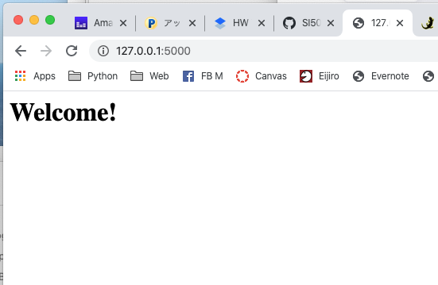

1. **Get Users Name**

Create a template called “name.html” under the directory “templates” with the following content:

* **<h1>Hello, {{name}}!</h1>**

In your “top_headlines.py” file, utilize the template to incorporate an individual's name. For example, <http://localhost:5000/name/Buffy> should return the following:

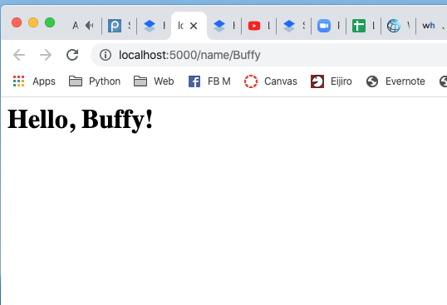

1. **Query New York Times API**

In your “top_headlines.py” file, write code to retrieve the top 5 articles from the New York Times from the **technology** section. Make sure to include your API key in a file called “secrets.py”.

You need to obtain an API key for **Top Stories API** on New York Times. The link to get the API key and the documentation can be found at <https://developer.nytimes.com/>.

After issuing the API key, the screen should be the following:

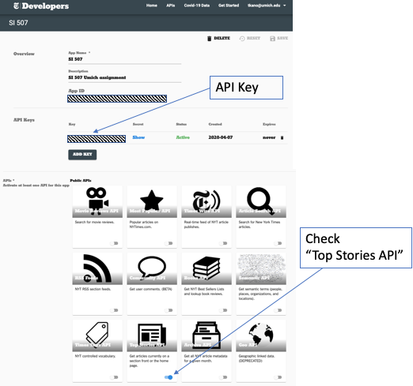

“secrets.py” will contain a variable named **api_key.**

Format the top 5 articles with the corresponding titles as an ordered list.

Remember: Do NOT share your API key on Github. (use “.gitignore”)

For example, if you were to run “top_headlines.py” on April 8th and go to the URL  <http://localhost:5000/headlines/Buffy>, your final output of part 2 should look like this:

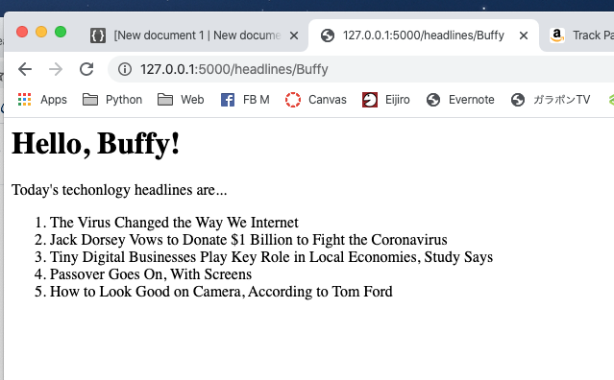

The text displayed should have different header tags (i.e. <h1>, <h2>). Experiment with the different header tags, until your webpage looks like the example above.

**What to Submit**

1. Push up all your code and files that you made to the Github Classroom. Make sure your files are organized as described above. Do NOT submit your “secrets.py” file.
2. Submit a GitHub URL on Canvas.

**Rubric**

|  |  |  |  |
| --- | --- | --- | --- |
| Req | Description | Category | Point Value |
| 1 | Part 2: When we run the “top_headlines.py”, Flask environment becomes active.   i.e. Terminal should show something like below.   Running on http://127.0.0.1:5000/ (Press CTRL+C to quit) | Behaviour | 10 |
| 2 | Part 2-1: [http://localhost:5000](http://127.0.0.1:5000) doesn’t show error. | Behaviour | 10 |
| 3 | Part 2-1: [http://localhost:5000](http://127.0.0.1:5000) shows the text “Welcome!”.  (See the sample output 1.) | Behaviour | 10 |
| 4 | Part 2-2: <http://localhost:5000/name/Buffy> doesn’t show error. | Behaviour | 10 |
| 5 | Part 2-2: <http://localhost:5000/name/Buffy> shows the text “Hello Buffy!”  (See the sample output 2.) | Behaviour | 10 |
| 6 | Part 2-2: When we replace “Buffy” in the URL with another name (e.g., “Biff”), the output changes correctly. | Behaviour | 10 |
| 7 | Part 2-3: <http://localhost:5000/headlines/Buffy> doesn’t show error. | Behaviour | 10 |
| 8 | Part 2-3: <http://localhost:5000/headlines/Buffy> shows five lines of headlines. | Behaviour | 10 |
| 9 | Part 2-3: <http://localhost:5000/headlines/Buffy> shows NYT headlines of “Technology” category. | Behaviour | 10 |
| 10 | Part 2-3: <http://localhost:5000/headlines/Buffy> shows with a correct font tag. (See the sample output 3.) | Behaviour | 10 |
|  | **Total** |  | 100 |

**Extra Credit 1 - Add links to your headlines**

Change your program so that the user can see the headlines with links to the actual story on NYT. This functionality should be accessible at the route /links/<name>. For example if a user goes to <http://localhost:5000/links/Buffy> they should see:

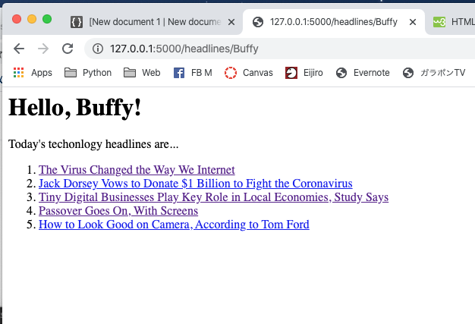

(and the links work).

**Rubrics**

|  |  |  |  |
| --- | --- | --- | --- |
| Req | Description | Category | Point Value |
| 11 | <http://localhost:5000/links/Buffy> shows five headlines with links.  (See the sample output 4.) | Behaviour | 1 |
| 12 | Each Link correctly opens the page. (The grader will try at least one of the links.) | Behaviour | 1 |
|  | **Total** |  | 2 |

**Extra Credit 2 - Add thumbnails and make a table**

Change your program so that the user can see the headlines with links and thumbnails as a table. If you’re unfamiliar with HTML tables you can learn how they work via this [HTML Tables tutorial](https://www.w3schools.com/html/html_tables.asp). This functionality should be accessible at the route /images/<name>. For example if a user goes to <http://localhost:5000/images/Buffy> they should see:

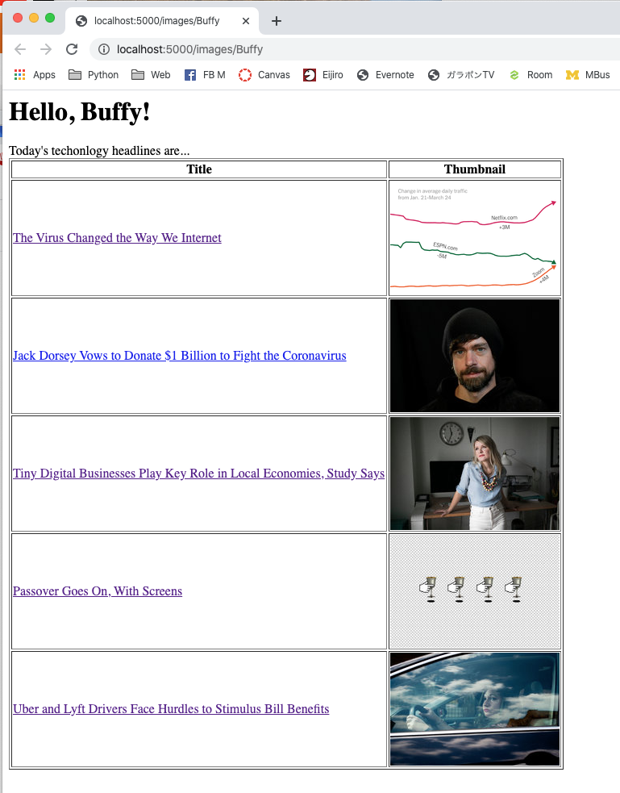

**Rubrics**

|  |  |  |  |
| --- | --- | --- | --- |
| Req | Description | Category | Point Value |
| 13 | <http://localhost:5000/images/Buffy> shows five headlines with thumbnails.  (See the sample output 5.) | Behaviour | 1 |
| 14 | <http://localhost:5000/images/Buffy> shows information using a table. | Behaviour | 1 |
|  | **Total** |  | 2 |