

EduCode – AI Programming Task Generator
System Design Documentation

Project members: Eleonora Stankovska, Mila Nastoska, Neja Kašman
Maribor 2026

Table of Contents
1 Introduction 3
2 Project Goals 4
3 Use Case Diagram (DPU) 4
4 Entity Relationship Diagram (ERD) 5
5 Architecture Design 6
6 System Mockups 7
6.1 Generate task 7
6.2 Templates 8
6.3 Validation 9
6.4 Export 10
6.5 History 10

Introduction

EduCode is an AI-powered web application designed to assist teachers and programming instructors with automatic generation of programming exercises. The system enables generation of tasks, solutions, and test cases based on selected programming language, concept, and difficulty level. This document presents the initial system design, architecture, database structure, and interface mockups of the application.

Project Goals

- Simplify preparation of programming exercises
- Reduce time required for creating assignments
- Support multiple programming languages
- Automatically generate test cases and solutions
- Enable export to educational platforms
- Provide AI-assisted validation of generated content

Use Case Diagram (DPU)

The Use Case Diagram illustrates the interactions between the professor/assistant user and the EduCode system. It shows the main functionalities such as task generation, template management, validation, exporting, and reviewing task history.
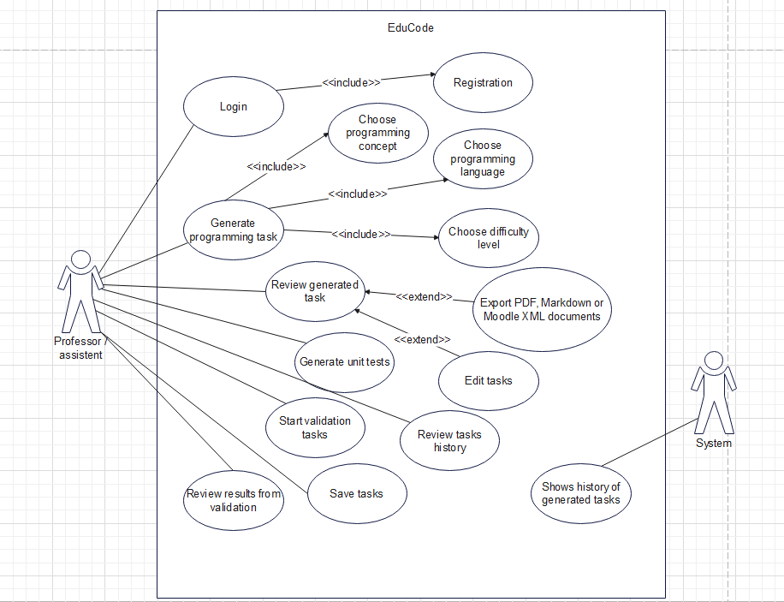

Entity Relationship Diagram (ERD)

The ERD defines the database structure of the application. It includes entities such as User, Task, Template, TestCase, Solution, Language, and ValidationResult, along with their relationships and foreign keys.
The database is designed using relational principles and foreign key constraints to ensure data consistency and scalability.

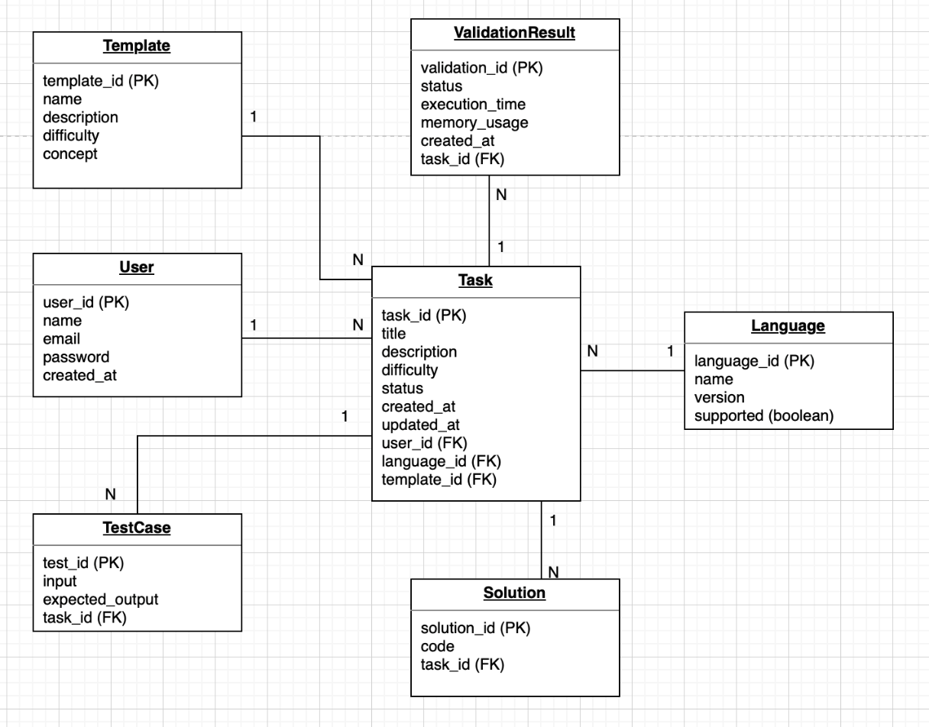

Architecture Design

The architecture diagram presents the communication flow between the frontend, backend, database, OpenAI API, Docker sandbox, PDF generator, and Moodle XML generator. The system uses FastAPI for backend services and React for the frontend interface.
Docker containers are used for simplified deployment and environment consistency.
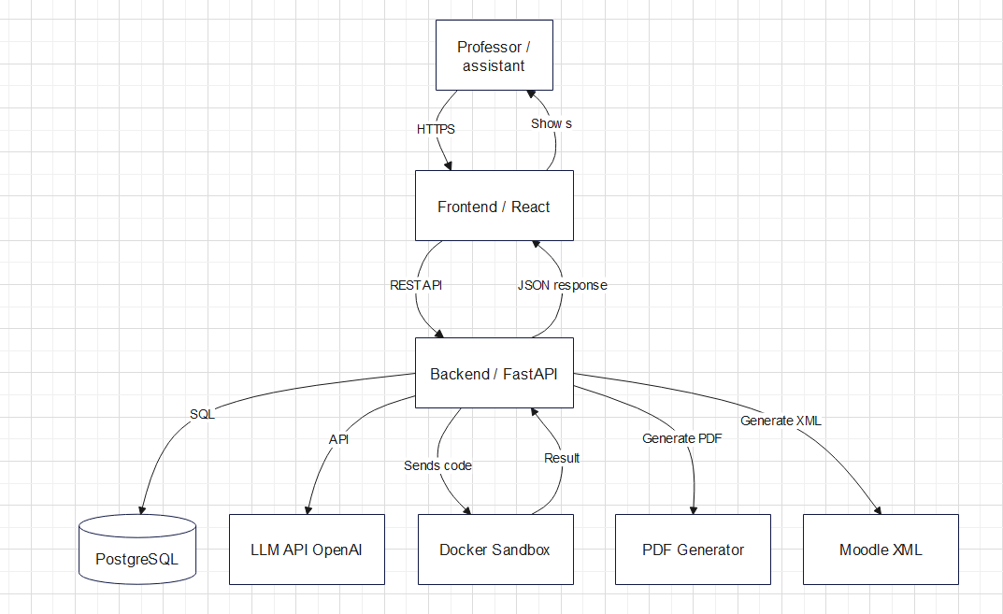

System Mockups
The mockups were designed to visualize the expected user workflow and interface organization before full implementation.
The following mockups present the user interface design of the EduCode AI Task Generator application. They demonstrate the main pages and workflows available to users.

Generate task
Generate Task page where users select programming language, concept, difficulty level, and templates.
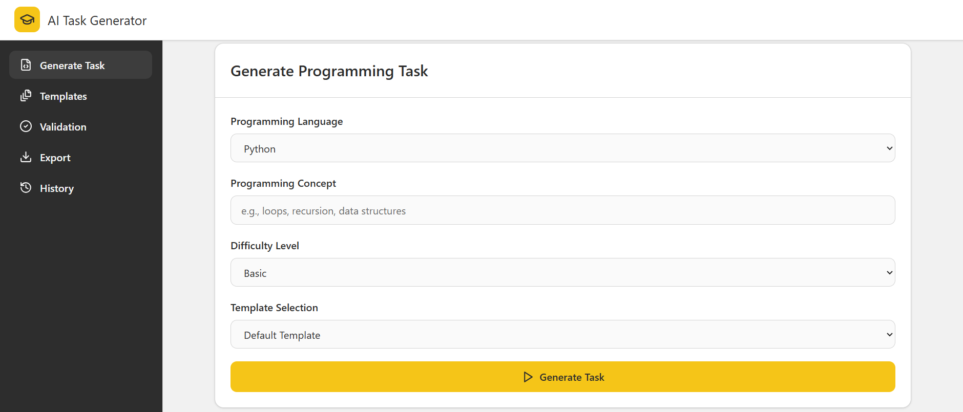
Generated result view displaying task descriptions, reference solutions, and unit tests.
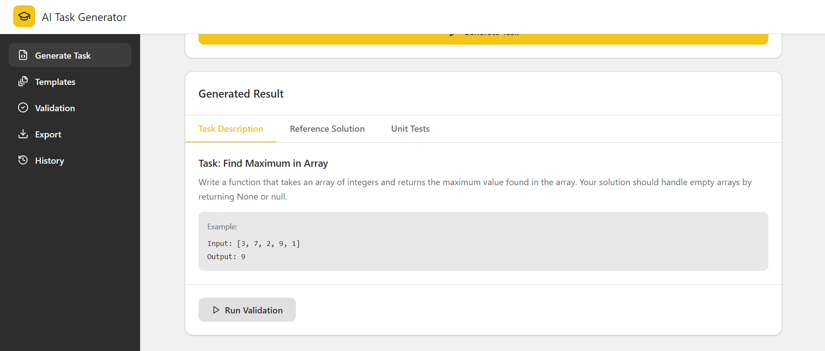

Templates
Template editor interface used to create and customize reusable task templates.

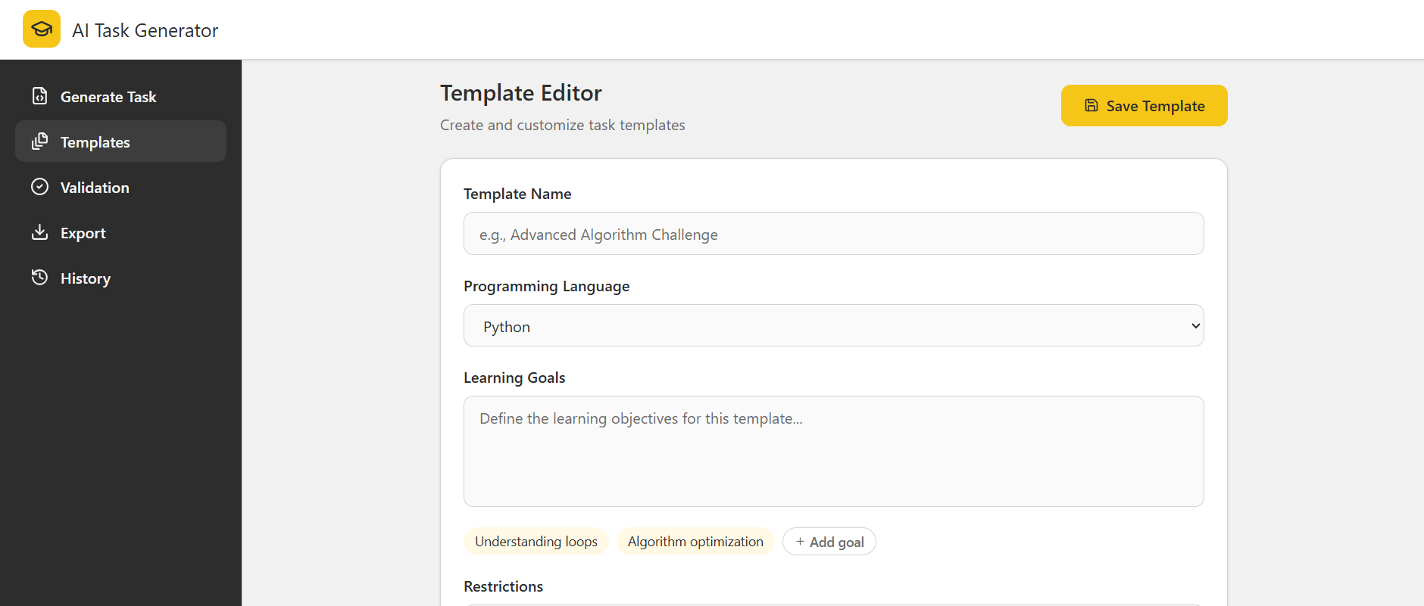

Template editor with restrictions and predefined code structure templates.

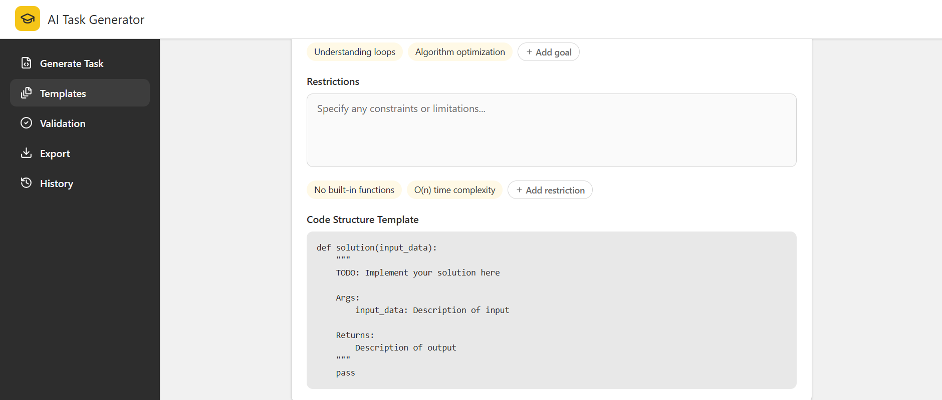

Existing templates overview showing available templates and generated task statistics.
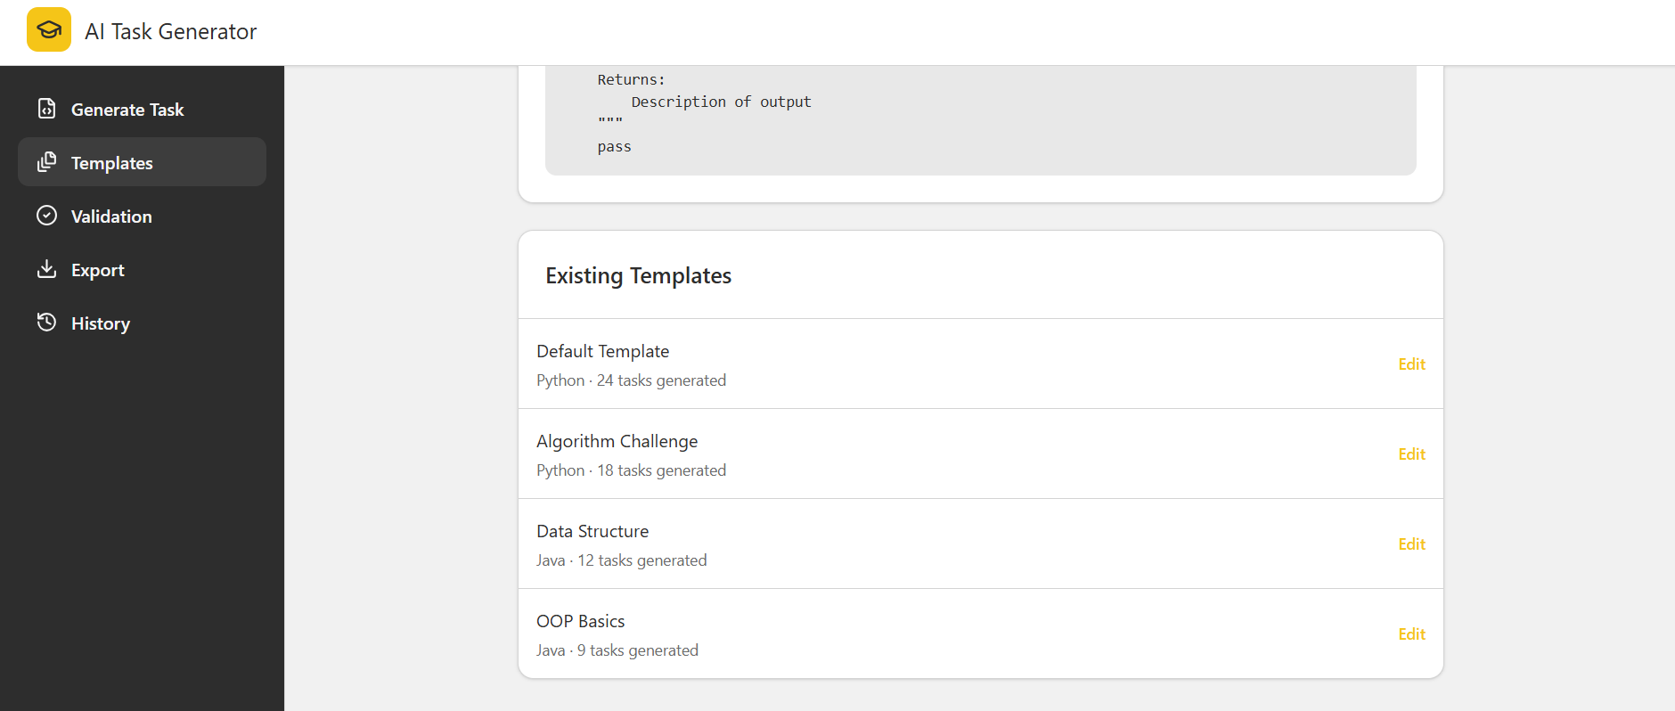

Validation
Validation dashboard displaying validation results, execution times, and task statuses.

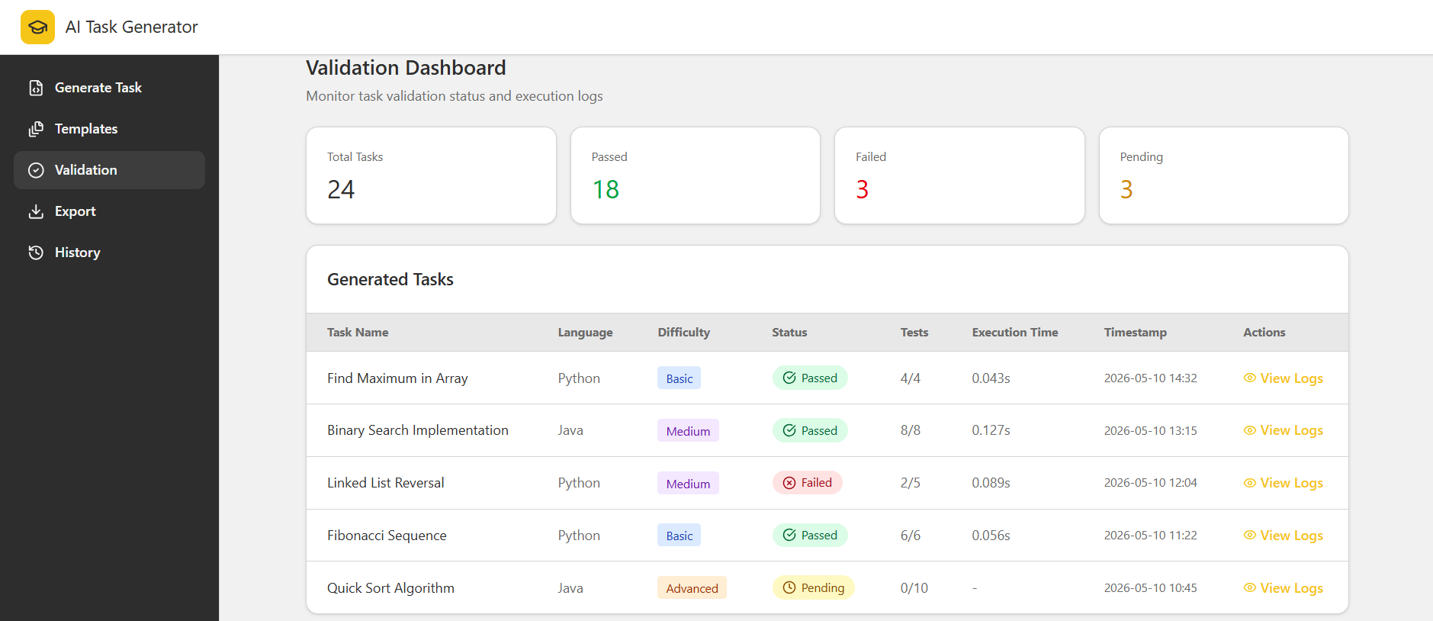

Export
Export section prepared for exporting generated tasks into PDF or Moodle XML formats.

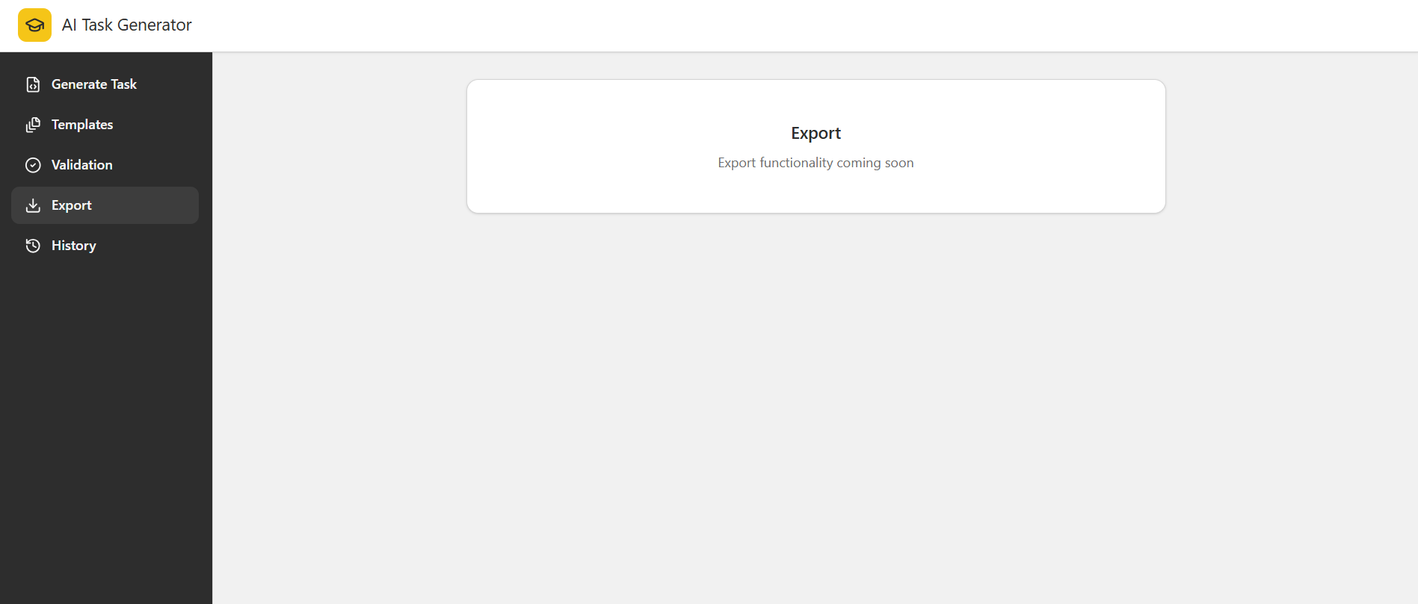

History
History page displaying previously generated tasks and user activity.

