EduCode – System Design Documentation

This document presents the core design and interface components of the EduCode AI Task Generator system. It includes the Use Case Diagram (DPU), Entity Relationship Diagram (ERD), Architecture Design, and system mockups.
- Use Case Diagram (DPU)
The Use Case Diagram illustrates the interactions between the professor/assistant user and the EduCode system. It shows the main functionalities such as task generation, template management, validation, exporting, and reviewing task history.
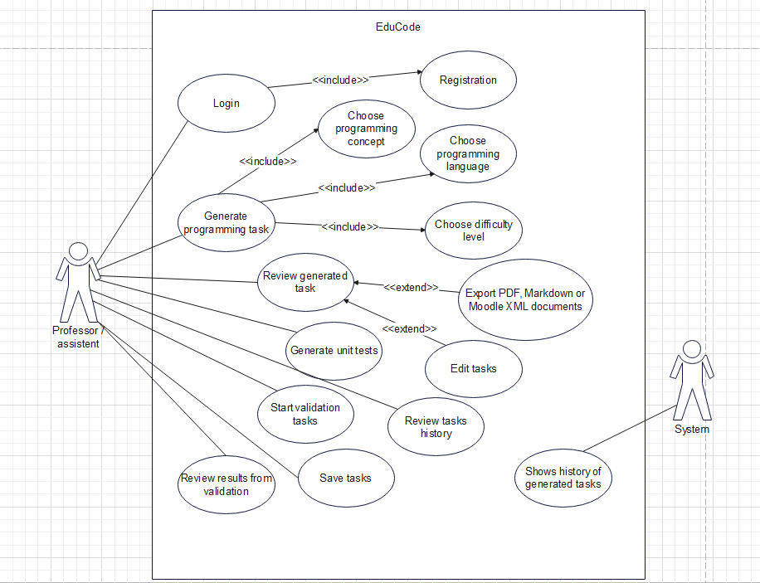

- Entity Relationship Diagram (ERD)
The ERD defines the database structure of the application. It includes entities such as User, Task, Template, TestCase, Solution, Language, and ValidationResult, along with their relationships and foreign keys.
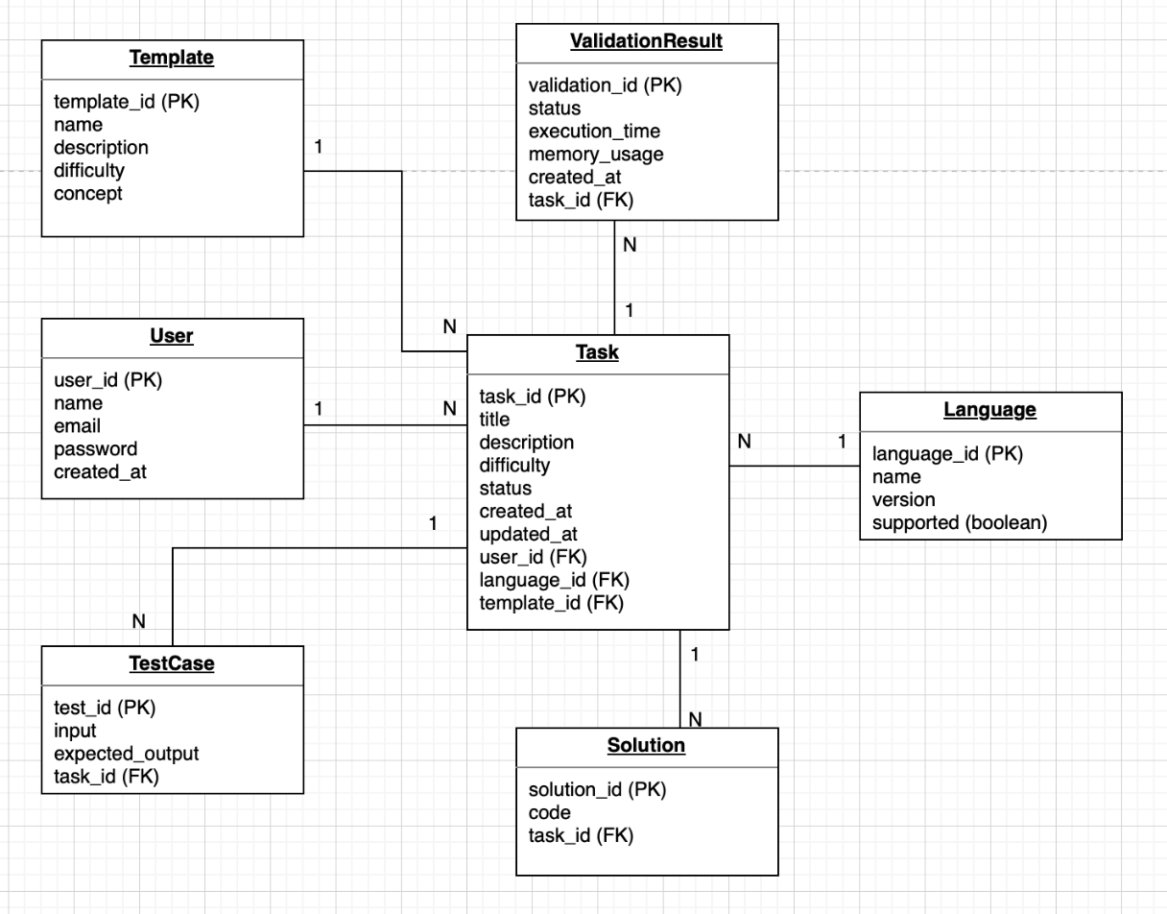

- Architecture Design
The architecture diagram presents the communication flow between the frontend, backend, database, OpenAI API, Docker sandbox, PDF generator, and Moodle XML generator. The system uses FastAPI for backend services and React for the frontend interface.
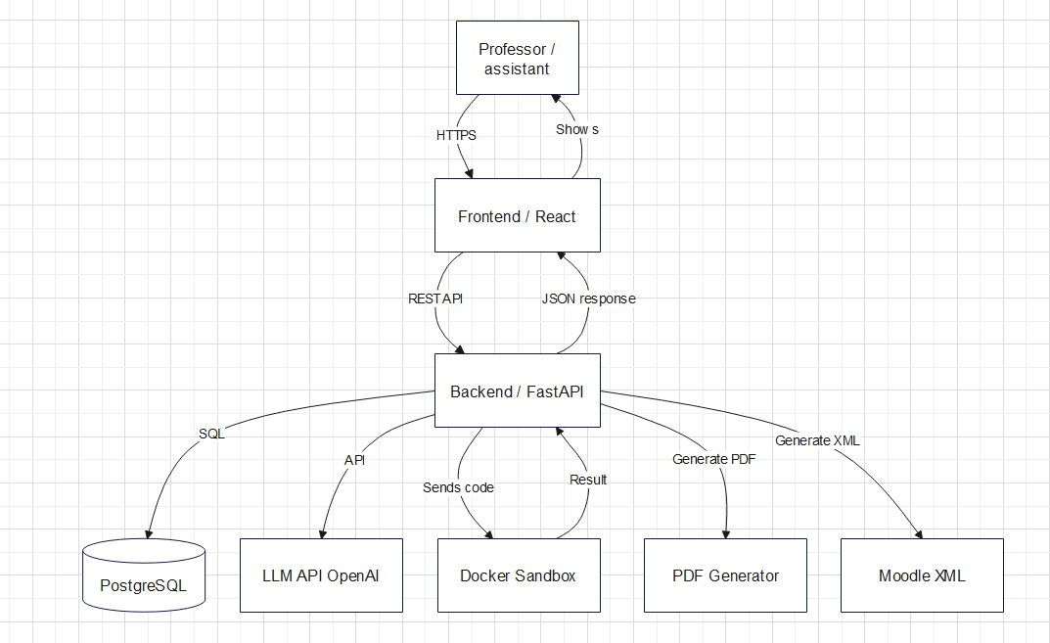

- System Mockups
The following mockups present the user interface design of the EduCode AI Task Generator application. They demonstrate the main pages and workflows available to users.

  - Mockup
Generate Task page where users select programming language, concept, difficulty level, and templates.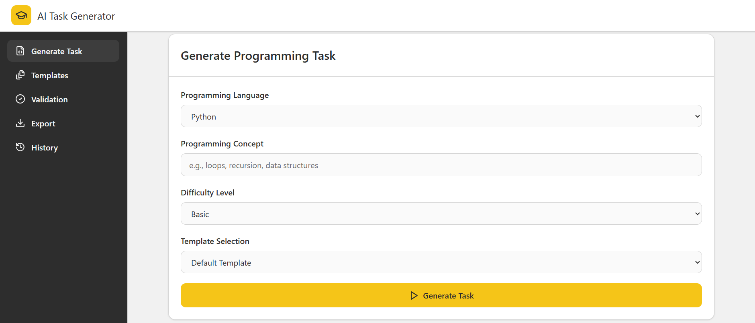
  - Mockup
Generated result view displaying task descriptions, reference solutions, and unit tests.
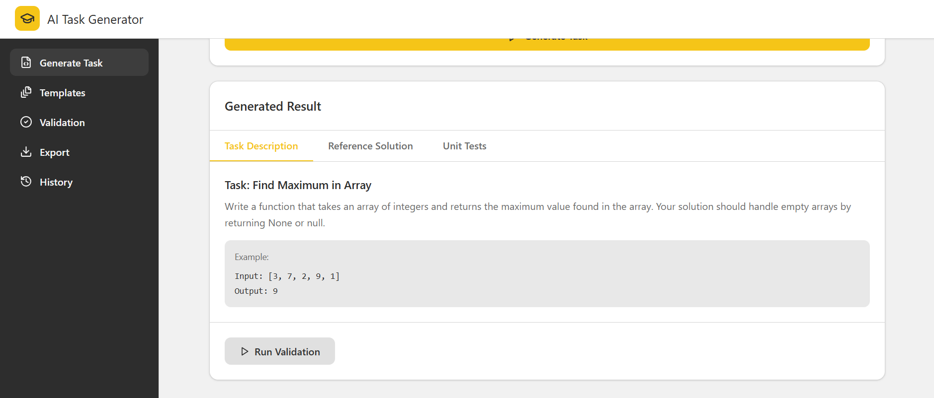
  - Mockup
Template editor interface used to create and customize reusable task templates.
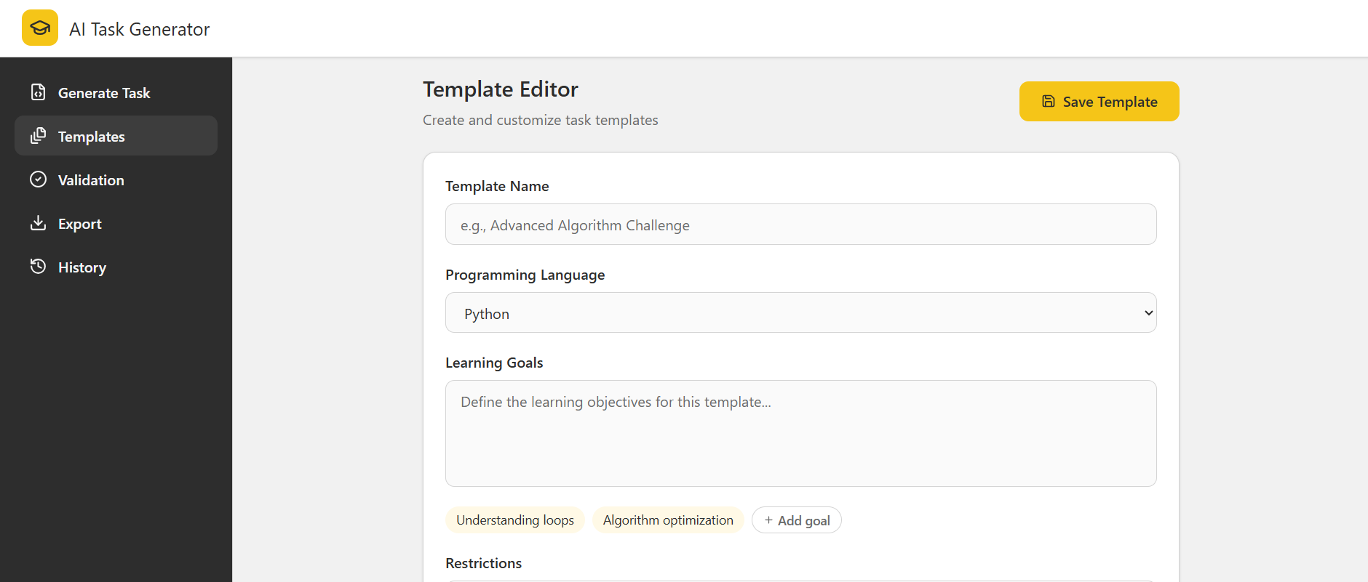
  - Mockup
Template editor with restrictions and predefined code structure templates.
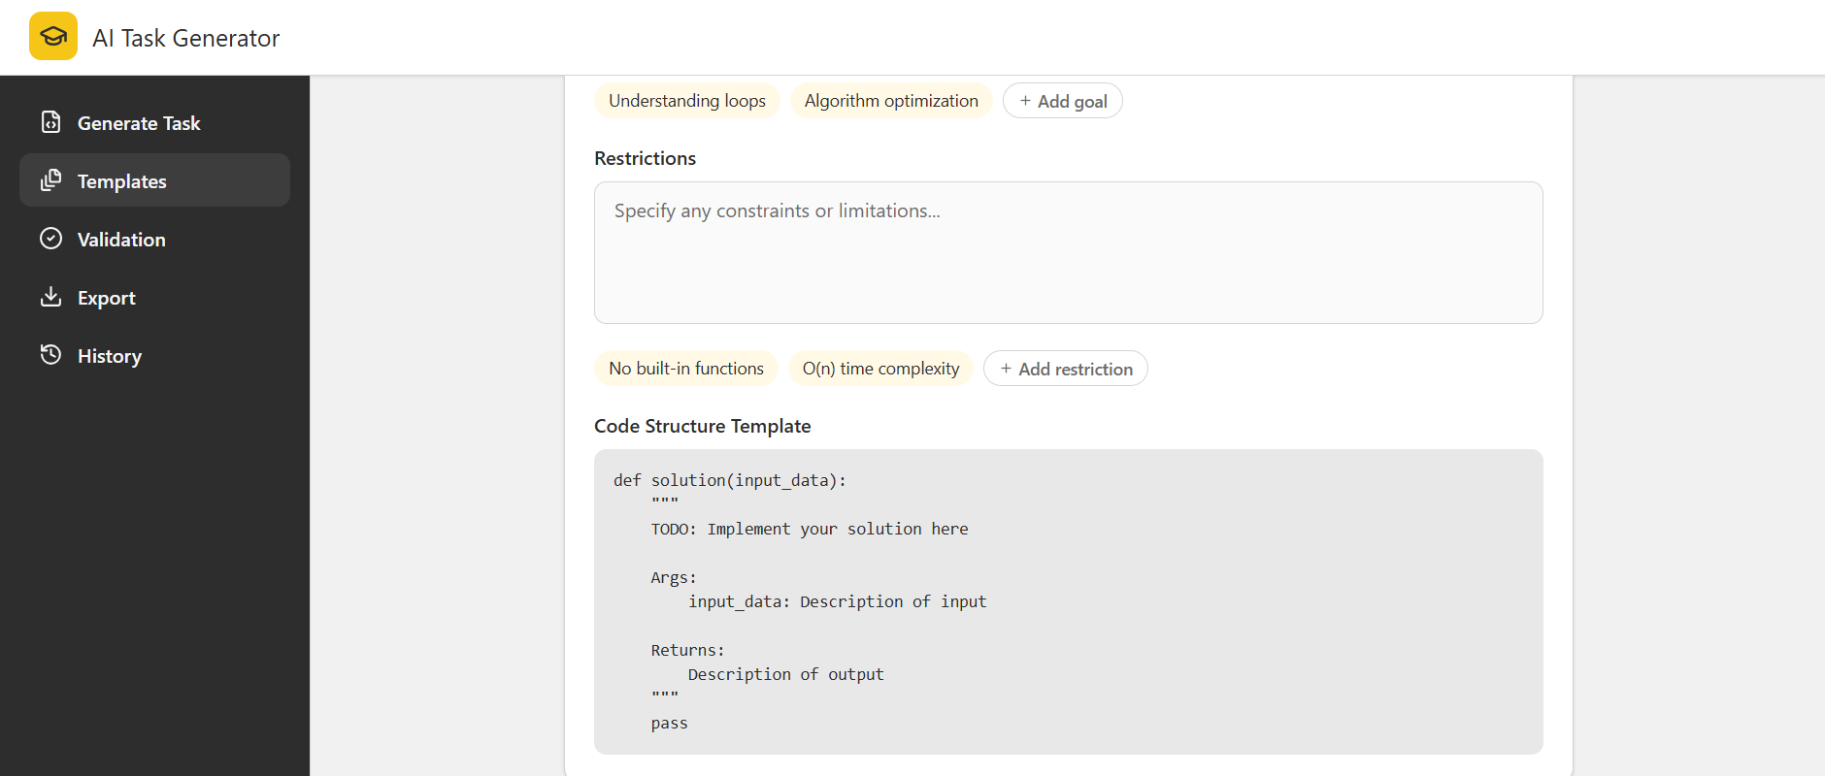

  - Mockup
Existing templates overview showing available templates and generated task statistics.
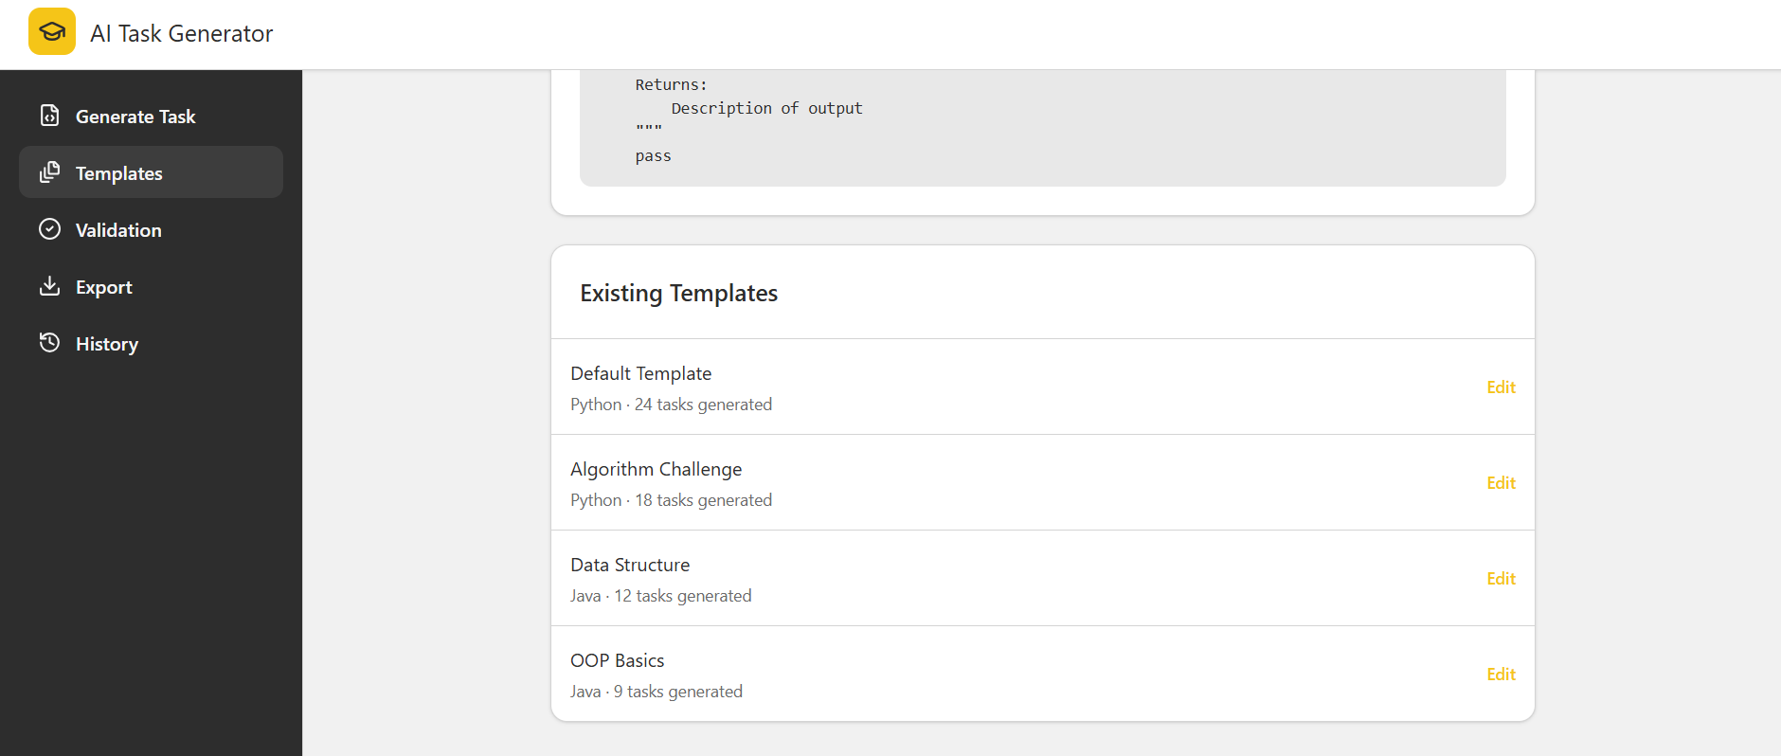
  - Mockup
Validation dashboard displaying validation results, execution times, and task statuses.
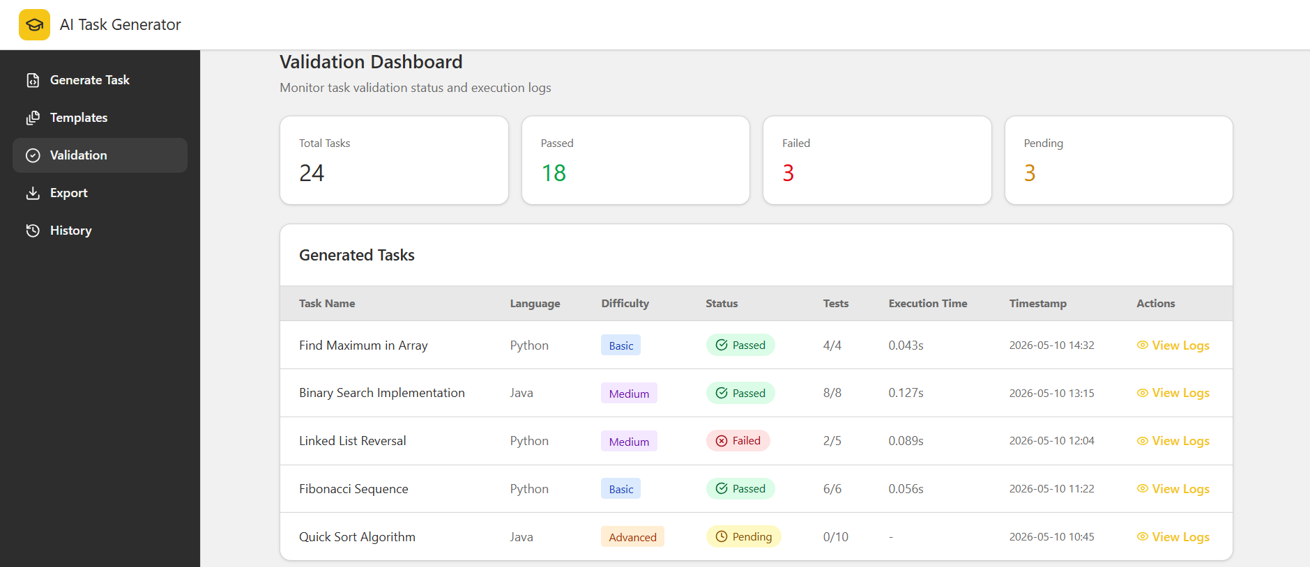

  - Mockup
Export section prepared for exporting generated tasks into PDF or Moodle XML formats.
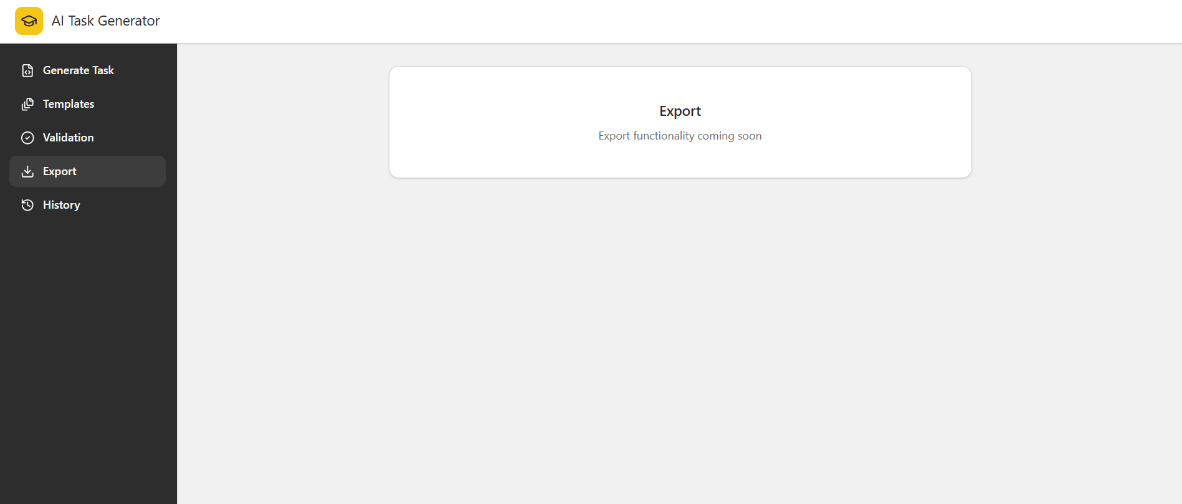
  - Mockup
History page displaying previously generated tasks and user activity.
