**Ambari HDP Cluster Creation**

Student Exercise Manual

Contents

Exercise A: Team Work: Setting up Ambari-server 3

## Exercise A: Team Work: Setting up Ambari-server

**Overview**

**In this exercise, we are going to set-up Ambari. This allows us to manage the Hortonworks cluster**

**Time: 20-30 Minutes**

**Step 1: Install Ambari on Ubuntu 16**

1. **Log in to your machine as root and check the OS version. This command, linux standard base, gives information about the distribution we are using:**

***lsb_release -a***

1. **Download the Ambari repository file to running following commands. We will use apt-get package management. The apt-key process ensures that we are getting the package from the correct, trusted source**

***wget -O /etc/apt/sources.list.d/ambari.list*** [*http://public-repo-1.hortonworks.com/ambari/ubuntu16/2.x/updates/2.6.1.5/ambari.list*](http://public-repo-1.hortonworks.com/ambari/ubuntu16/2.x/updates/2.6.1.5/ambari.list)

***apt-key adv --recv-keys --keyserver keyserver.ubuntu.com B9733A7A07513CAD***

***apt-get update***

1. **Install Ambari server**

***apt-get install -y ambari-server***

1. **Set Up the Ambari Server and run the following command on the Ambari server host to start the setup process**

***ambari-server setup***

**Respond to the setup prompt:**

* 1. **Customize user account for Ambari-server daemon: No**
  2. **Select a JDK version to download: Enter 1**
  3. **Do you accept the Oracle Binary Code License Agreement: Yes**
  4. **Enable Ambari Server to download and install GPL Licensed LZO packages: Yes**
  5. **Enter advanced database configuration: No**

1. **Start the Ambari Server**

**ambari-server start**

1. **To check status of ambari server**

**ambari-server status**

**Step 2: Log In to Ambari server:**

1. **Point your web browser to**

http://<your.ambari.server>:8080

**Example : http://ec2-54-210-207-122.compute-1.amazonaws.com:8080**

**The default user name: admin**

**The default user password: admin**

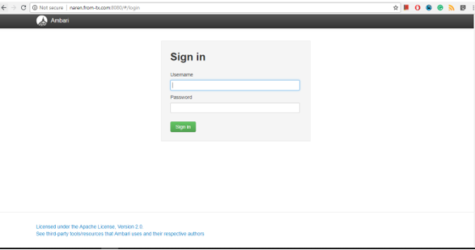

**Step 3: Create a Ambari cluster:**

**In Ambari Welcome page, choose Launch Install Wizard**

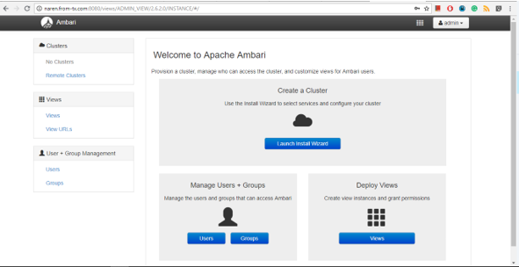

**Step 4: Enter name for you cluster and Enter Next button**

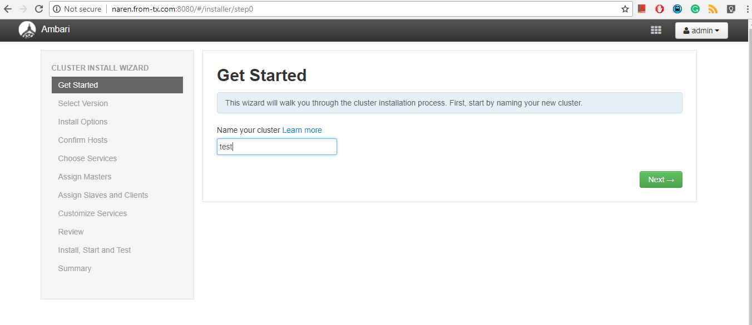

**Step 5: Choosing version**

**Select: HDP 2.6.5.0**

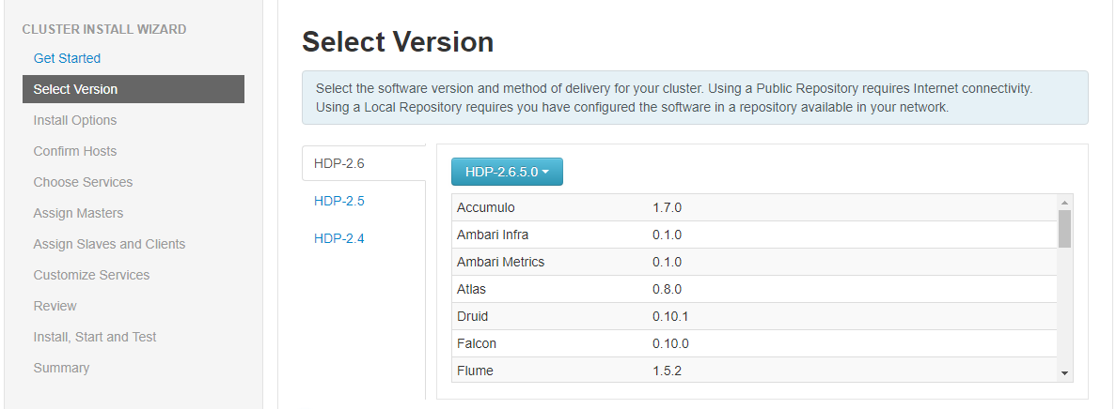

**Step 6: Select Version: HDP 2.6.3.0**

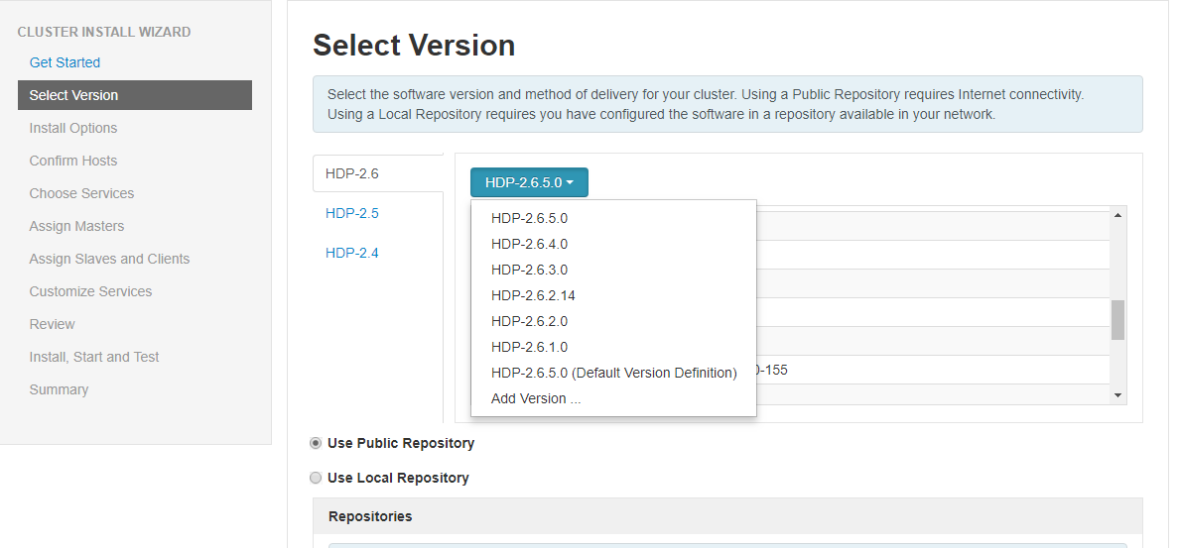

**Step 7: Select a repository**

**Chose: Use Public Repository and click Next button**

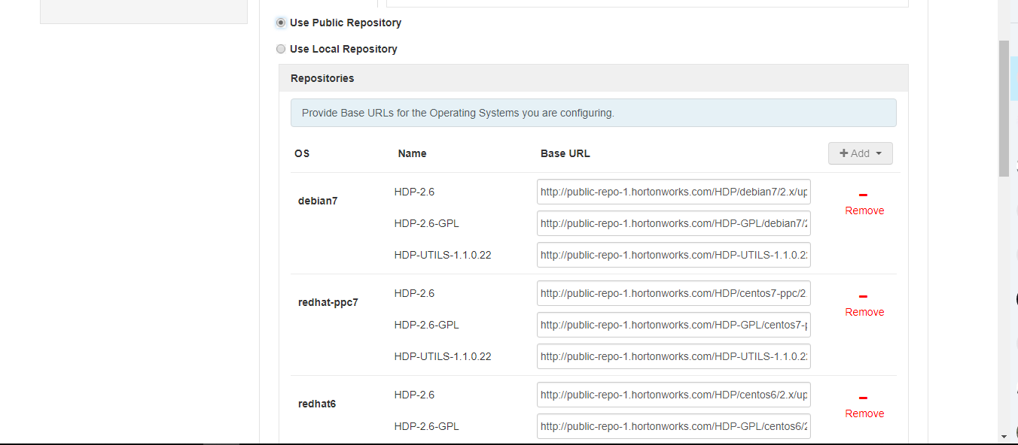

**Step 8: Install Option**

**Target Hosts enter your host name.**

**Note**

**If you are using AWS-EC2 Instance, use the internal Private DNS host names.**

**Example: ip-172-16-0-12.ec2.internal**

**Provide your SSH Private Key and use the Choose File button**

**Choose file: Private Key file**

**SSH user Account: ubuntu**

**SSH port: 22**

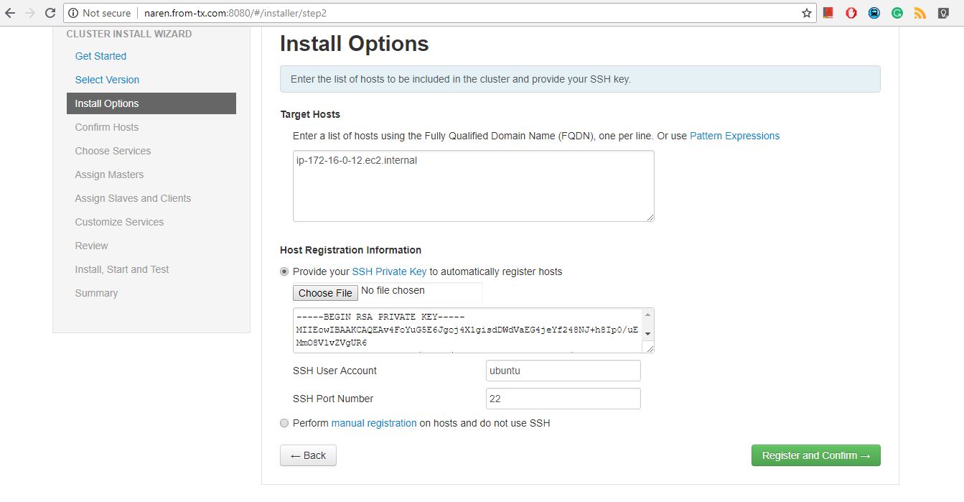

**Step 9: Confirm Hosts will register the Host to Ambari server. Once register the Enter next button**

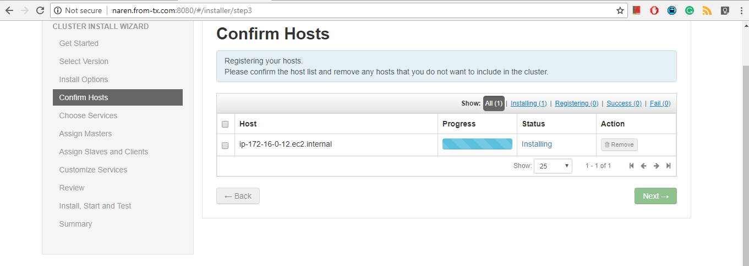

**Step 10: If you are facing some warning issue. First resolve and move further.**

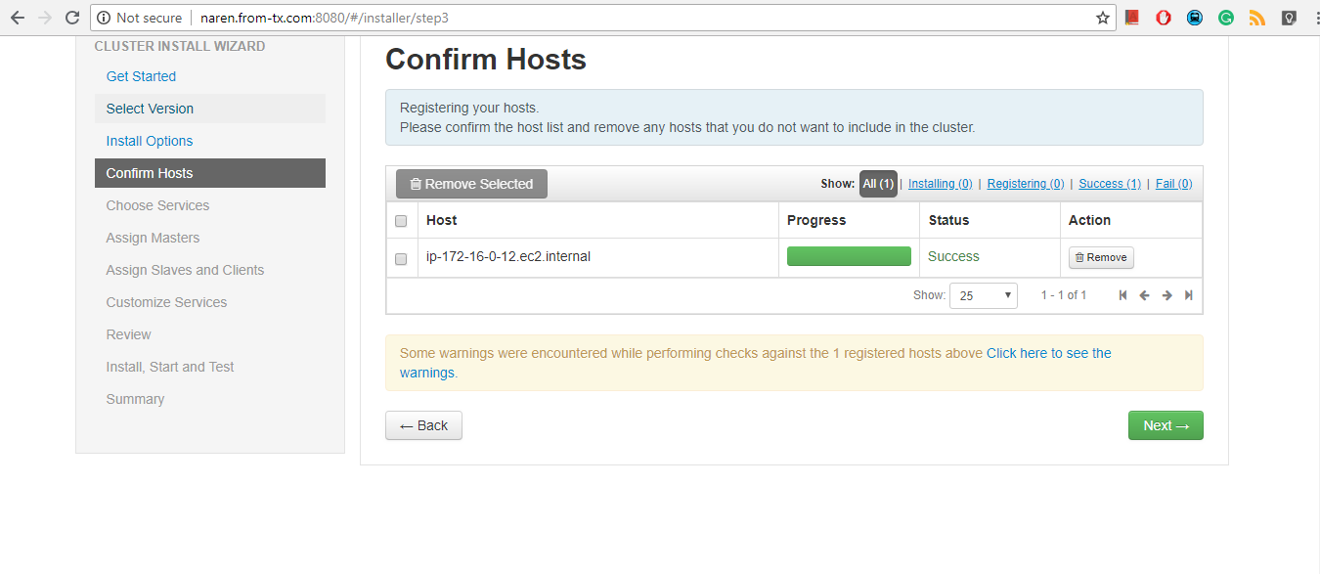

**The warning is the NTP is not running. To resolve this, install and start the NTP services.**

***apt-get -y install ntp***

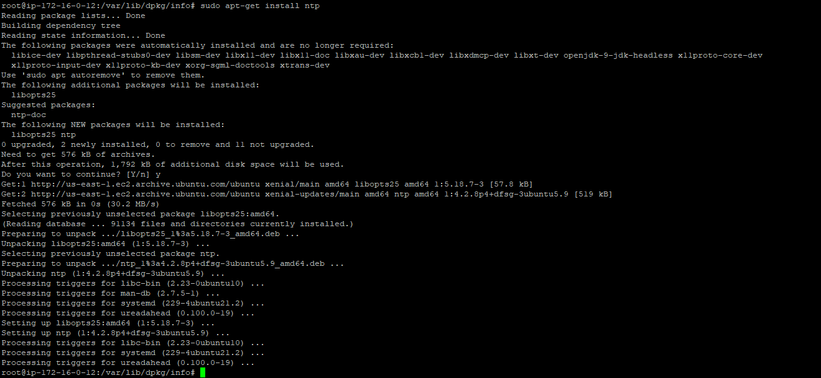

**Disable the transparent_hugepage**

***echo never > /sys/kernel/mm/transparent_hugepage/enabled***



**Then back to Ambari, Click Rerun checks.**

**Step 11: Choose Services**

**HDFS, YARN+MapReduce2, Tez, Zookeeper and Ambari-Metrics will automatically be chosen as mandatory services. Then press Next button.**

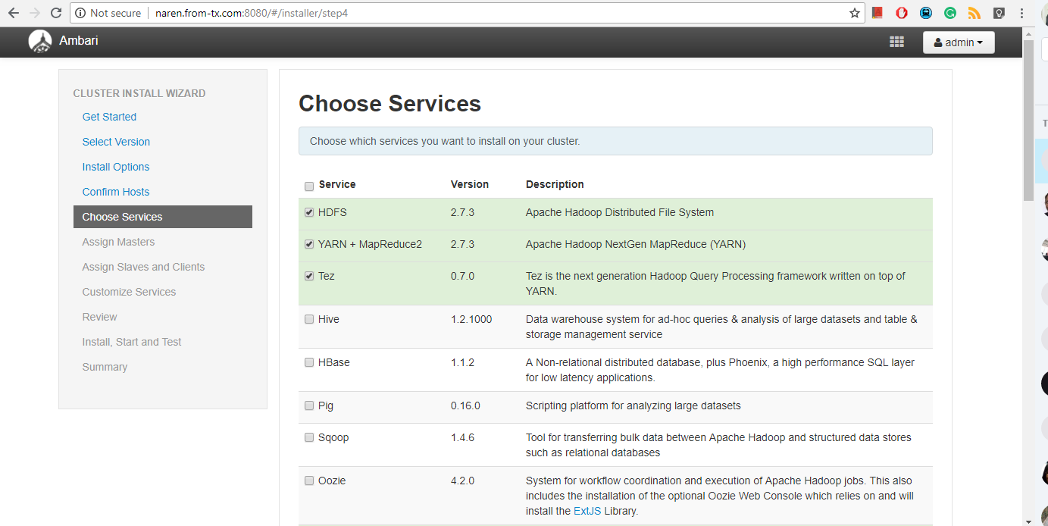

**Step 12: Assign Master**

**Here we have only one node so we are installing everything on the same host. Click Next.**

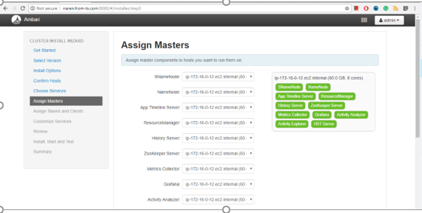

**Step 13: Assign Slave and Clients**

**Select DataNode, NodeManager, NFSGateway and Client then Press Next.**

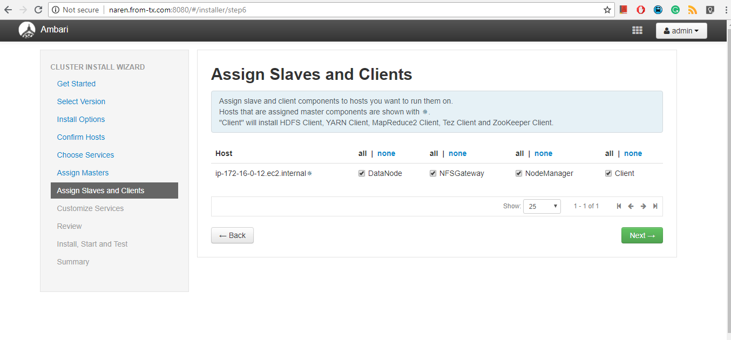

**Step 14: Customize Services**

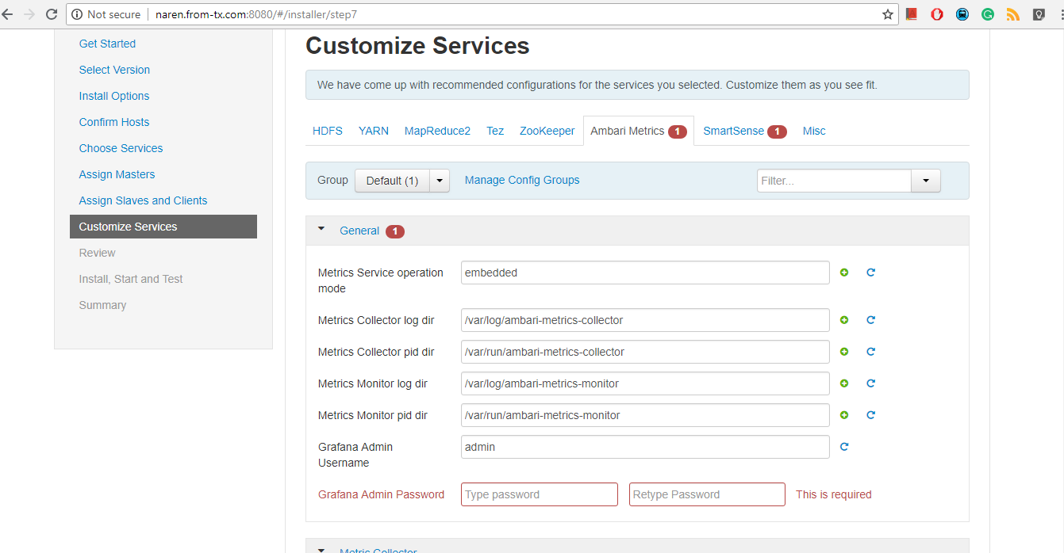

**In configuration you will face some error. Go to the relevant configuration file and fix the issue.**

**Here we see an issue in Ambari Metric Configuration and Smart Sense Configuration.**

**Click the Ambari Metrics configuration**

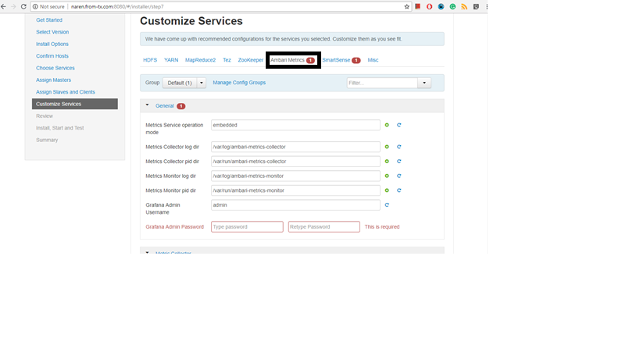

**Enter the Grafana Admin Password: admin**

**Enter the Confirm admin password: admin**



**Click the Smart Sense Configuration**

**Enter the Activity Explorer Admin Password: admin**

**Enter the Confirm admin password: admin**

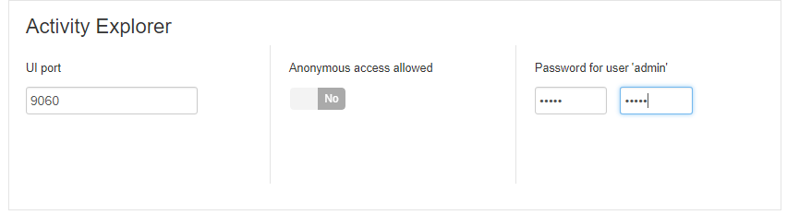

**Step 15: These other warnings can be ignored, Click Proceed anyway.**

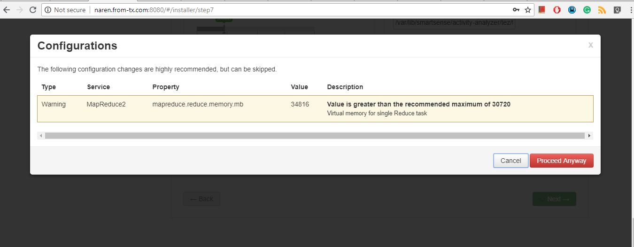

**Step 16: Review Your configuration and click Deploy**

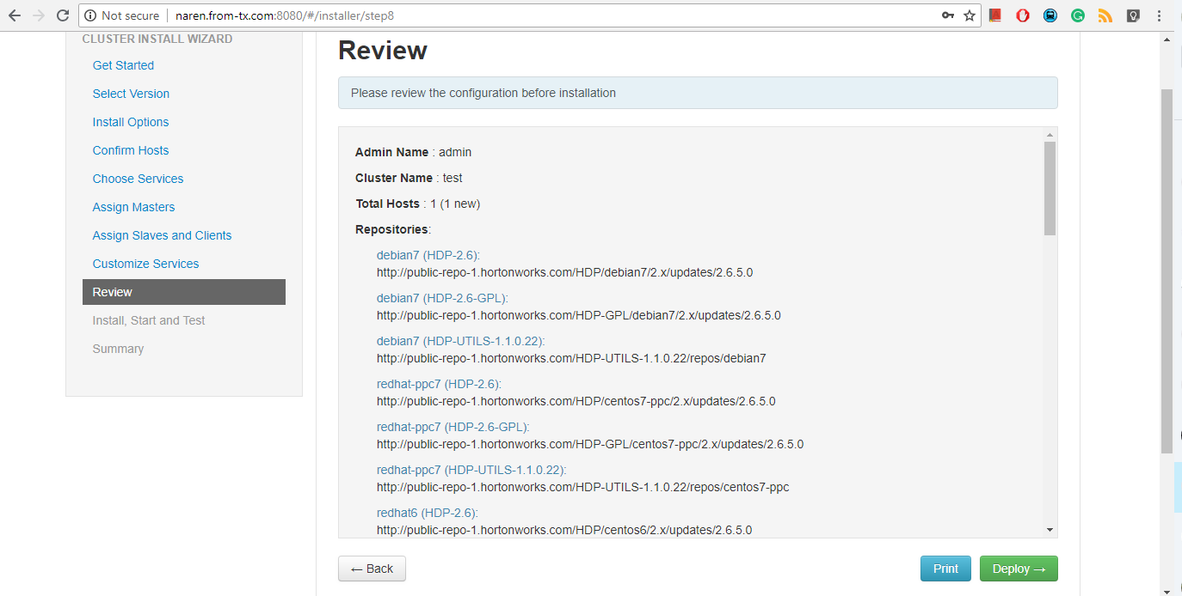

**Step 17: Install and Test**

**You will enter the Install and Test Web page. When you see the message “Successfully installed and started the services”, click Next.**

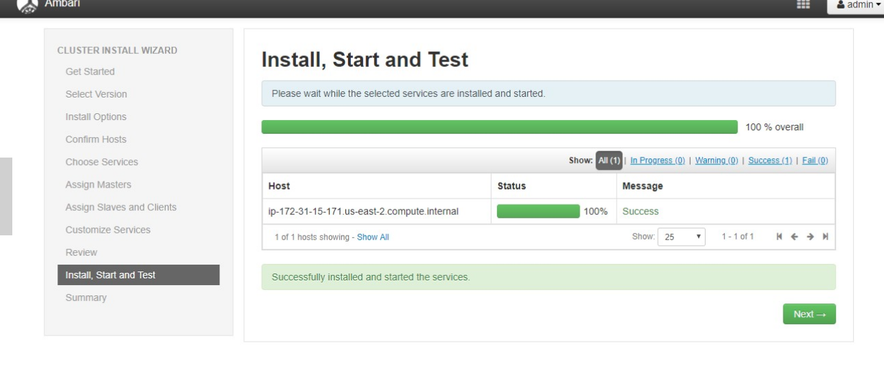

**Step 18: Complete**

**The Summary page provides you a summary list of the accomplished tasks. Click Complete. Ambari Web opens in your web browser.**

