TMAS Traffic Volume Data Recompilation and Rearrangement Tool

# **Tool’s Objective**

The U.S. Traffic Volume Data, released through the FHWA Office of Highway Policy Information website at <https://www.fhwa.dot.gov/policyinformation/tables/tmasdata/>, is in its original database format as it is collected through the FHWA Travel Monitoring Analysis System (TMAS).

In its original data format, a day’s 24-hour volumes make one record (one row). Due to historical traffic monitoring development versions, some year/month data files use fixed column width format, and other year/month data are pipe (|) separated. This version issue often requires special effort and attention from data users.

To improve data user experiences, a Python tool is developed to assist users in converting the original Traffic Volume Data through this weblink into alternative formats. Specifically, this tool offers the following functions:

1. Use a single zipped data file as an input and produces the converted data files in another zipped file.
2. Convert the input zip file to a consistent CSV format (comma separated) with a column header and zip it.
3. Convert volume records from daily format (one row per day and 24 columns for each hour of day) to hourly format (one column for the hour of day and one for the hourly volume with 24 rows).

# **Background**

The U.S. Traffic Volume Data in TMAS is collected in a standard format set forth by the Traffic Monitoring Guide (TMG) by all State highway agencies. The data is in a fixed column width format as described below. The FHWA Office of Highway Policy Information releases this data via the office website.

The TMG (2001) specified fixed width volume data format as listed below

**Field Columns Length Description**

1 1 1 Record Type

2 2-3 2 FIPS State Code

3 4-5 2 Functional Classification

4 6-11 6 Station Identification

5 12 1 Direction of Travel

6 13 1 Lane of Travel

7 14-15 2 Year of Data

8 16-17 2 Month of Data

9 18-19 2 Day of Data

10 20 1 Day of Week

11 21-25 5 Traffic Volume Counted, 00:01 - 01:00

12 26-30 5 Traffic Volume Counted, 01:01 - 02:00

13 31-35 5 Traffic Volume Counted, 02:01 - 03:00

14 36-40 5 Traffic Volume Counted, 03:01 - 04:00

15 41-45 5 Traffic Volume Counted, 04:01 - 05:00

16 46-50 5 Traffic Volume Counted, 05:01 - 06:00

17 51-55 5 Traffic Volume Counted, 06:01 - 07:00

18 56-60 5 Traffic Volume Counted, 07:01 - 08:00

19 61-65 5 Traffic Volume Counted, 08:01 - 09:00

20 66-70 5 Traffic Volume Counted, 09:01 - 10:00

21 71-75 5 Traffic Volume Counted, 10:01 - 11:00

22 76-80 5 Traffic Volume Counted, 11:01 - 12:00

23 81-85 5 Traffic Volume Counted, 12:01 - 13:00

24 86-90 5 Traffic Volume Counted, 13:01 - 14:00

25 91-95 5 Traffic Volume Counted, 14:01 - 15:00

26 96-100 5 Traffic Volume Counted, 15:01 - 16:00

27 101-105 5 Traffic Volume Counted, 16:01 - 17:00

28 106-110 5 Traffic Volume Counted, 17:01 - 18:00

29 111-115 5 Traffic Volume Counted, 18:01 - 19:00

30 116-120 5 Traffic Volume Counted, 19:01 - 20:00

31 121-125 5 Traffic Volume Counted, 20:01 - 21:00

32 126-130 5 Traffic Volume Counted, 21:01 - 22:00

33 131-135 5 Traffic Volume Counted, 22:01 - 23:00

34 136-140 5 Traffic Volume Counted, 23:01 - 24:00

35 141 1 Restrictions

The following shows an example of a volume data file that is used in TMAS and released on the FHWA Office of Highway Policy Information website. In this format, each data field has its unique column with fixed width. The hourly count data for each of the 24 hours in a day takes 24 columns.



The following shows another example of a volume data file that is used in the released website. In this format, fields are separated by the pipe symbol (|), and each column takes the same width as what TMG specified.



# **The Tool’s Function**

The tool asks for a zipped volume file (downloaded from the FHWA Office of Highway Policy Information website ([https://www.fhwa.dot.gov/policyinformation/tables/tmasdata/](https://www.fhwa.dot.gov/policyinformation/tables/tmasdata/))). The tool then converts it to different formats with a daily record or hourly record forms.

Once all files in the zipped file are processed, the tool will zip all produced files in one zipped file.

1. When (*convert a day record into 24 hour records*) 24 hourly record form is chosen, the new file will be arranged as follows:
2. Column header – the produced result files always have a column head attached as Record_Type, State_Code, F_System, Station_Id, Travel_Dir, Travel_Lane, Year_Record, Month_Record, Day_Record, Day_of_Week, **Hour_Record, Hour_Volume,** Restrictions

The **Hour_Record** and **Hour_Volume** columnsare new and created from the original input file.

1. Converted records – the converted file has created two new columns: **Hour_Record** indicating which hour of the day the record is of and **Hour_Volume**. In the following example, 14,00017 tells that the hour volume of hour 14:01-15:00 (2021/12/1) is 00017. Note that the Year_Record has only two digits without the century included.

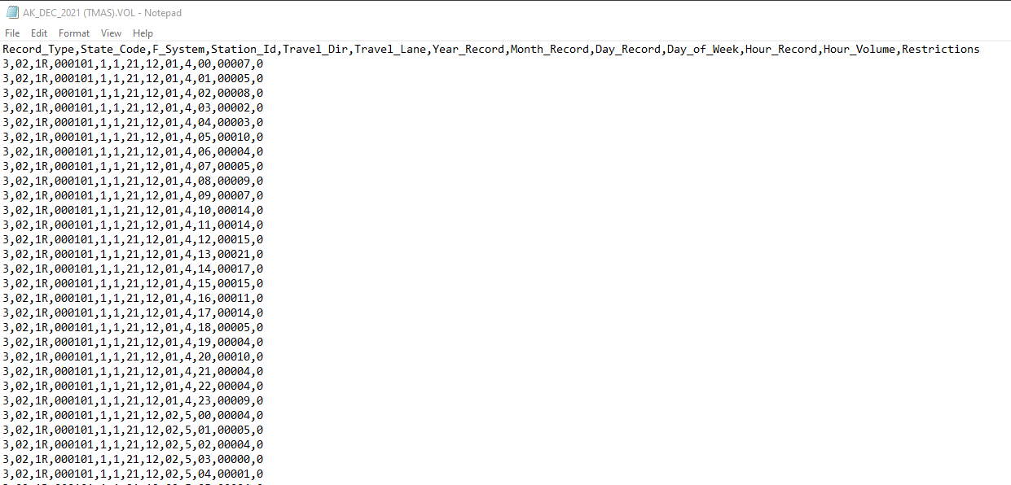

1. When the daily record form is chosen, the file will be arranged as the original file sequence except that each variable (column) is separated by the comma symbol (,) as illustrated below.
2. Column Header

Record_Type,State_Code,F_System,Station_Id,Travel_Dir,Travel_Lane,Year_Record,Month_Record,Day_Record,Day_of_Week, Hour_00, Hour_01, Hour_03, Hour_04, Hour_05, Hour_06, Hour_07, Hour_08,Hour_09, Hour_10, Hour_11, Hour_12,Hour_13, Hour_14, Hour_15, Hour_16, Hour_17, Hour_18, Hour_19, Hour_20, Hour_21, Hour_22, Hour23, Restrictions

1. Example - The following shows an example.

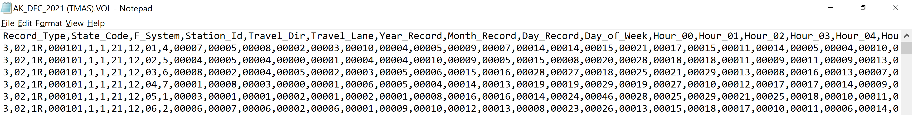

1. Zipped file – all converted files are zipped together as one file. The following example shows zipped results.

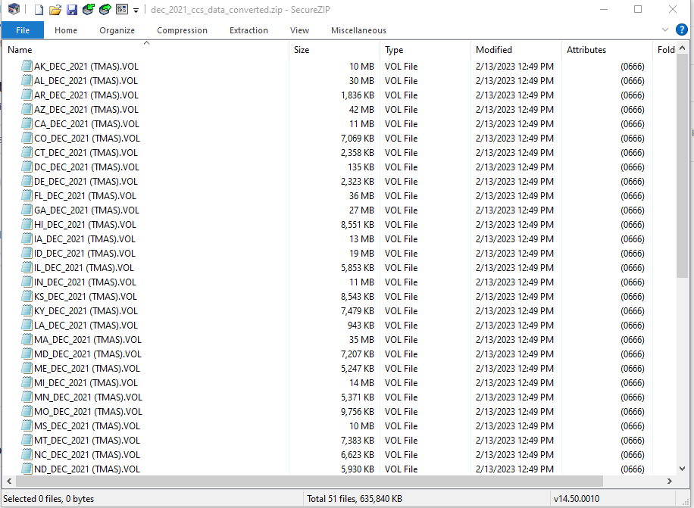

# **How to Use the Tool**

1. Setup Python environment in your local PC (You do not need Administrative Privilege)

The tool is developed by using Python. To run it, you need to setup the Python environment first. Please follow the steps below to setup the Python environment in your computer. If you have already done so, or your Python environment is pre-established, please skip this, and go to step 2.

* 1. Download Python 3.9.13 64 bit edition at <https://www.python.org/downloads/release/python-3913/>. The filename should be python-3.9.13-amd64.exe. Note: the latest version of Python is 3.11, and this tool is compatible with it. You are free to download and use the latest version if you do not have any other Python tool depending on version 3.9.
  2. Install Python by clicking python-3.9.13-amd64.exe. When running, use **Customize Installation** and **match the options shown in the diagrams below** **(pay special attention to matching various options)** to install it. This enables a free installation without the need for Administrator privilege and is free to uninstall later

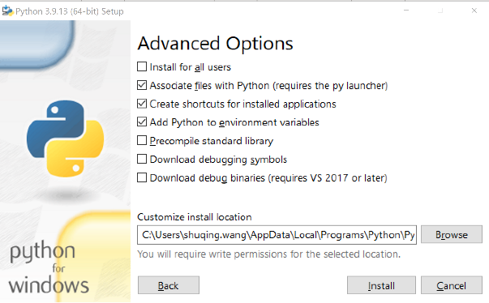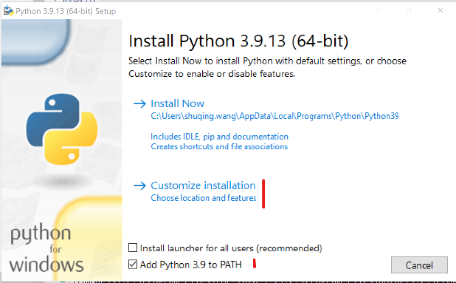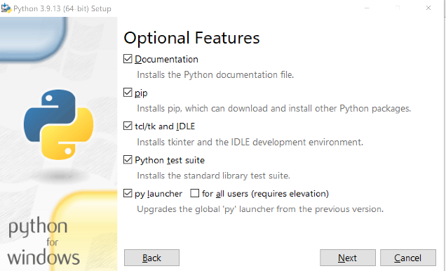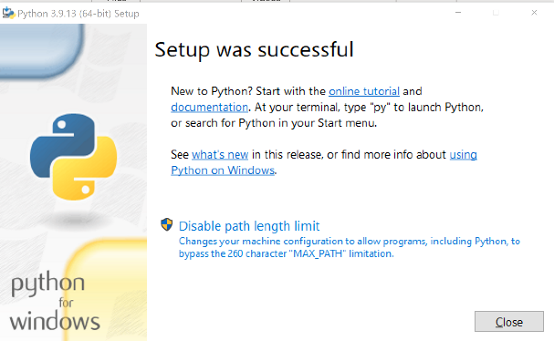

* 1. Verify the Python installation. Once the **Setup was successful** message box is popped up, which indicates the installation succeeded, click Close. However, we need to verify it.

Please following the steps below to verify the installation.

Click Windows Start menu and enter **cmd** and press enter. This will open a Command window as shown on the right below.

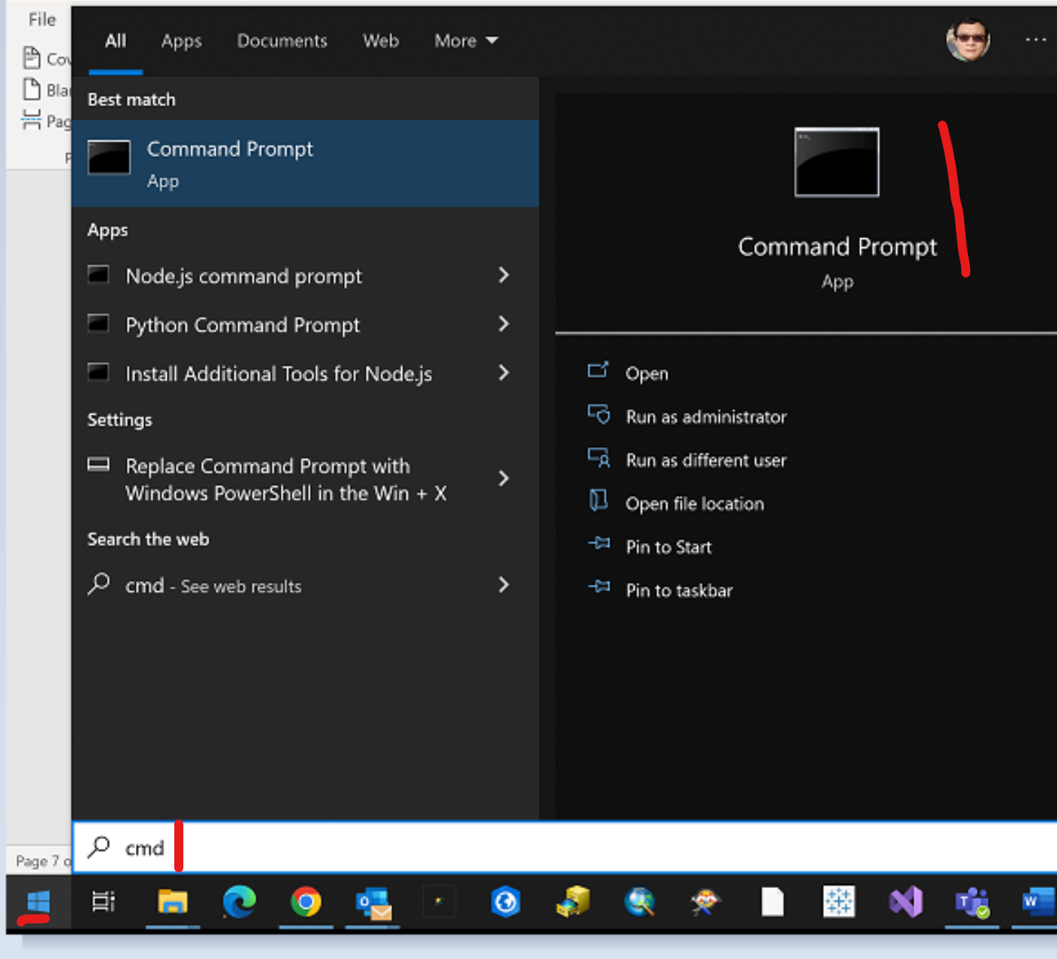

Enter **python -V** in the command line. If it prints out Python 3.9.13, it means the installation succeeded, and you are ready to run your own Python code.

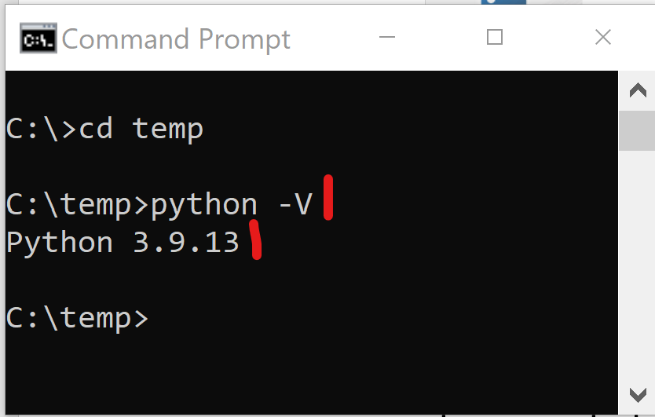

* 1. Install Pandas module. Pandas is a powerful and widely used data processing module. It provides Databrick like functionalities to process huge data, plus machine learning with different algorithms. This tool is developed by using Pandas for Python. You need to install it to your Python environment if you have not yet done so.

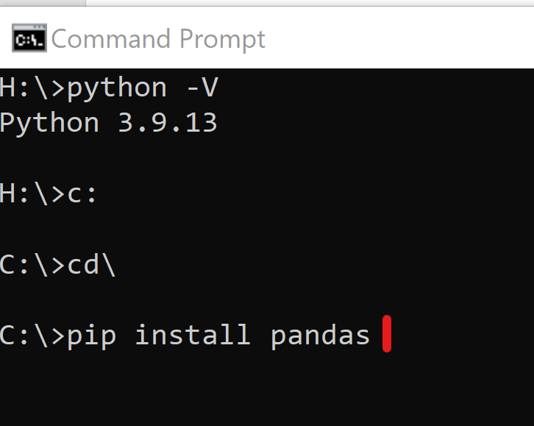

Open a CMD window as mentioned above and Use **pip install pandas** to install pandas.

1. Create a folder called “**up**” or (any other named folder) as in the example **c:\temp\up** in your local machine and download the tool **rvd.py** .
2. Download the desired Zipped traffic volume data file from

<https://www.fhwa.dot.gov/policyinformation/tables/tmasdata/> by specifying year and month to your computer storage drive/folder. The following screen shot shows the website. You can download the volume data of a month by clicking the month title under a year.

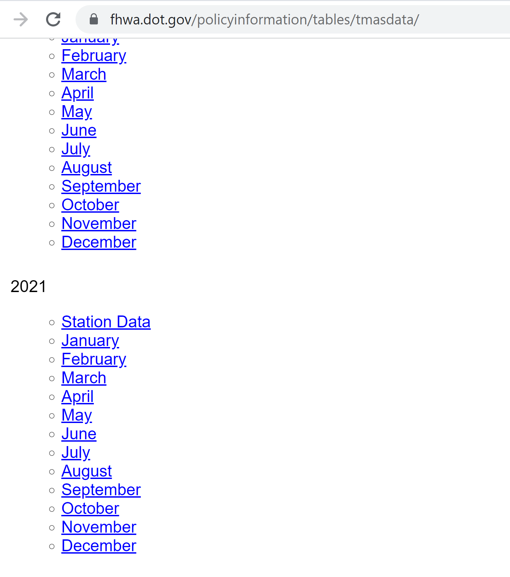

1. Run the following command in your folder

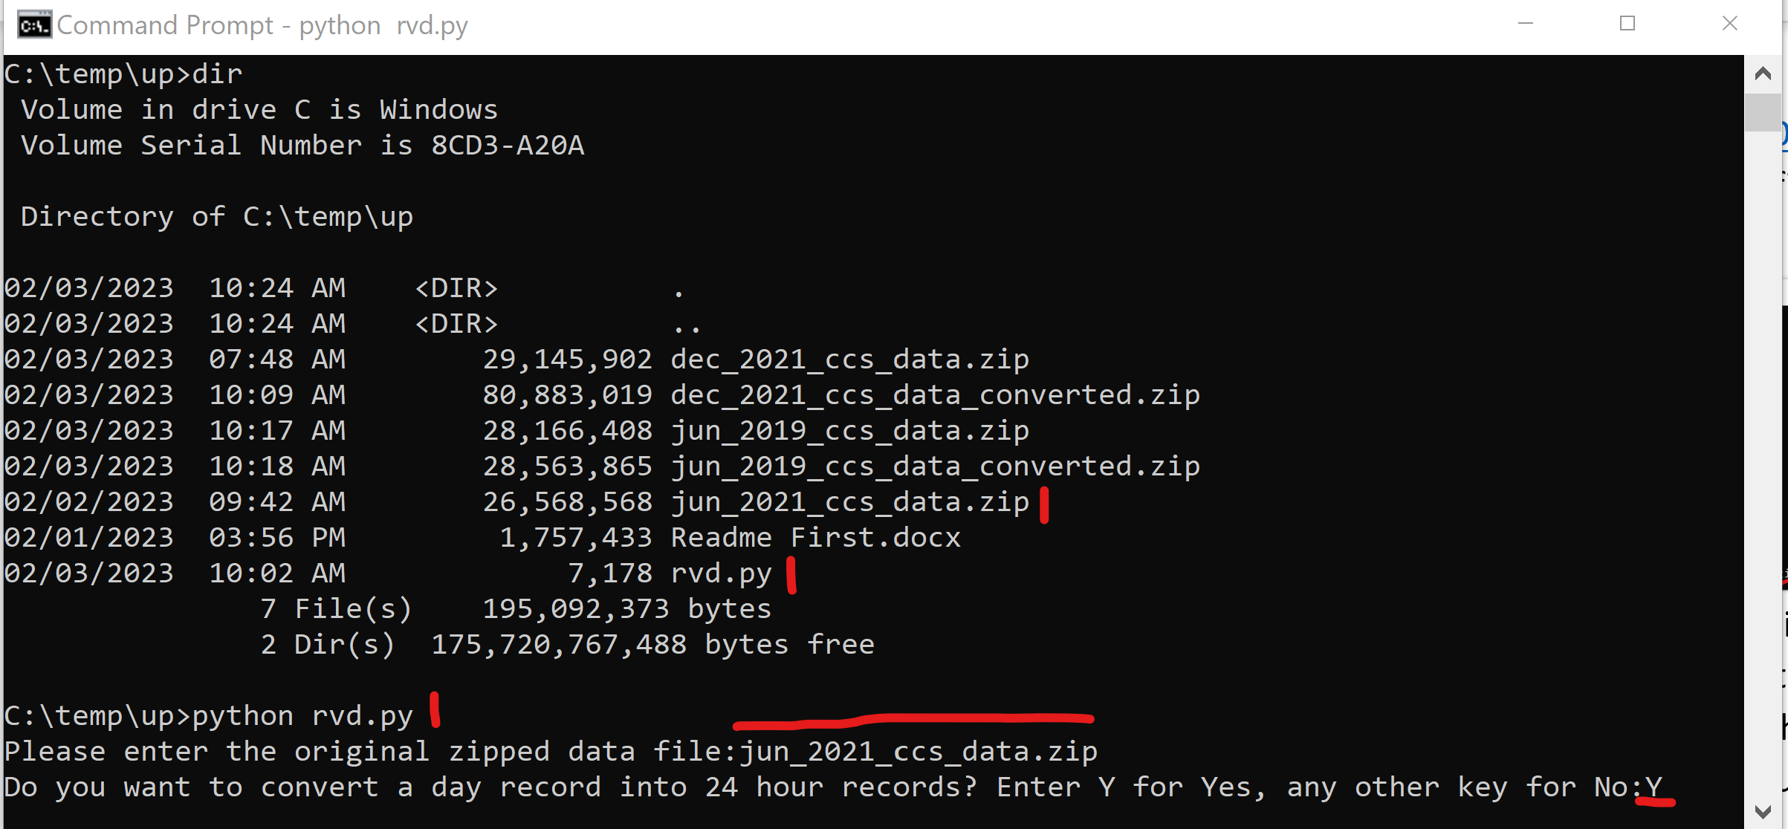

1. Enter the input Zip file name as shown above (note: if the zip file is not the in the same folder, you must enter the full path name). Then enter Y to convert daily record into hourly record. The following message will be prompted, listing your input zip file, brief information about each data file in the zip file such as if it has headers, whether is delimited by |, and the original/after unpivoted number of records. As a quick check, the total number of records after unpivoted is always 24 times of original records. In the following output examples, Header=True/False tells if a file has a header or not, and Pipe=True/False tells if a file is | separated or not.

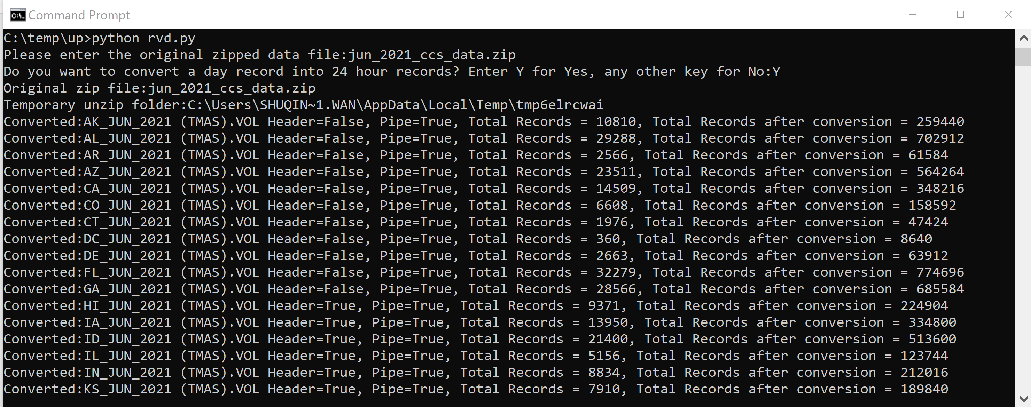

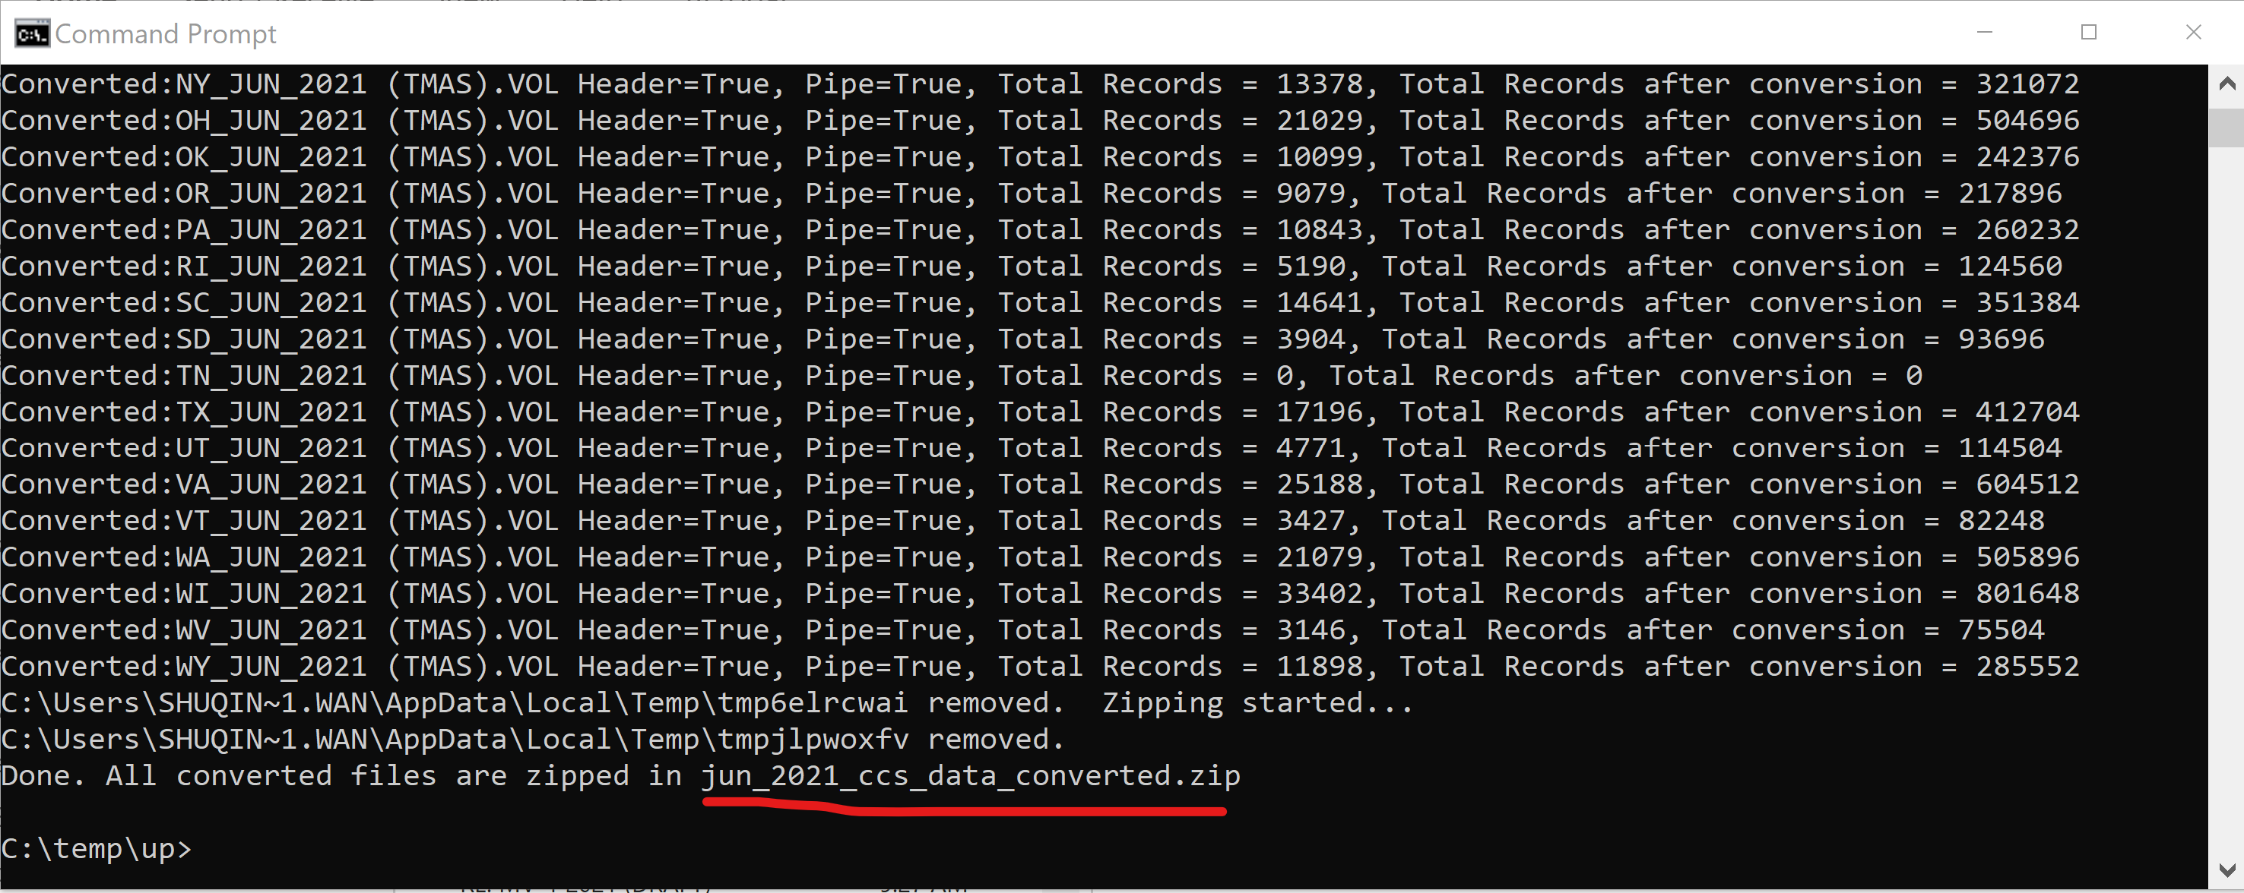

1. Get the final product and run for another month. All each individual state data file within the original zip file will be processed and rezipped together as a new zip file named the same as the original but with a suffix of **_converted**. The following shows an example. If you have another month file needs to process, repeat steps from 3.

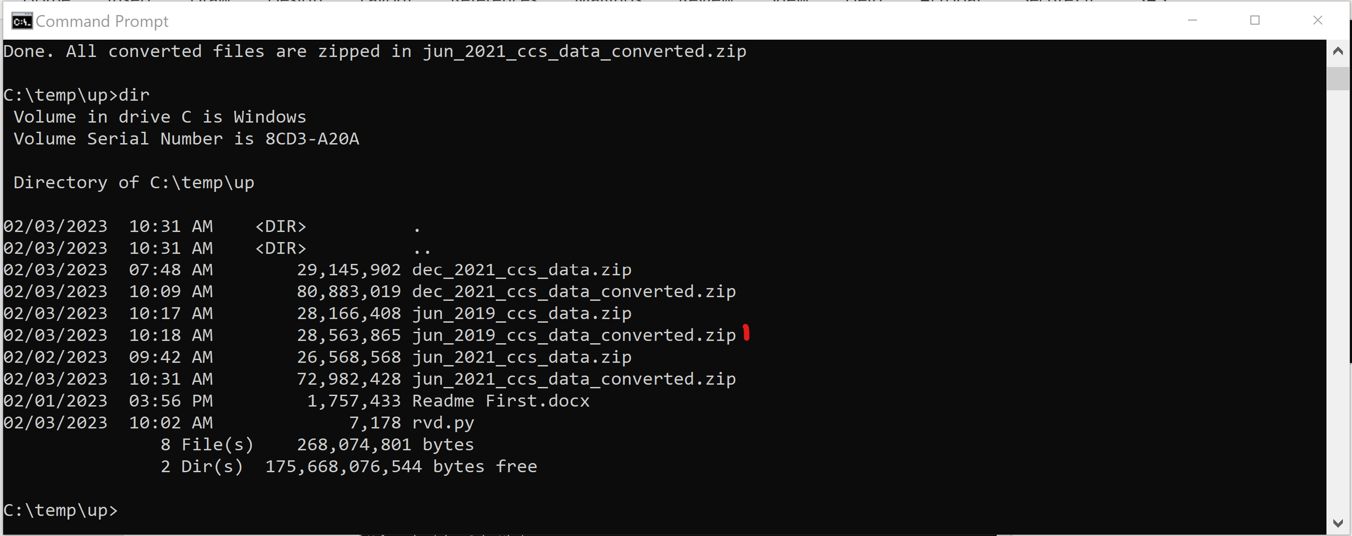

Now you are done and in possession of the volume data in a new format.

1. If you would like to keep using daily record instead of breaking on day volume counts into 24 hourly records, but only want to unify the column header and delimitation. You can run the tool the same way as stated in step 3, but only to enter **N** to the second question as shown below. Note that the total records number is the same in this case. The last screenshot shows an example of a converted file.

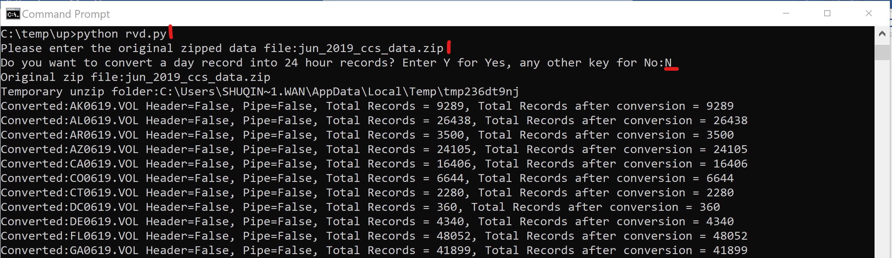

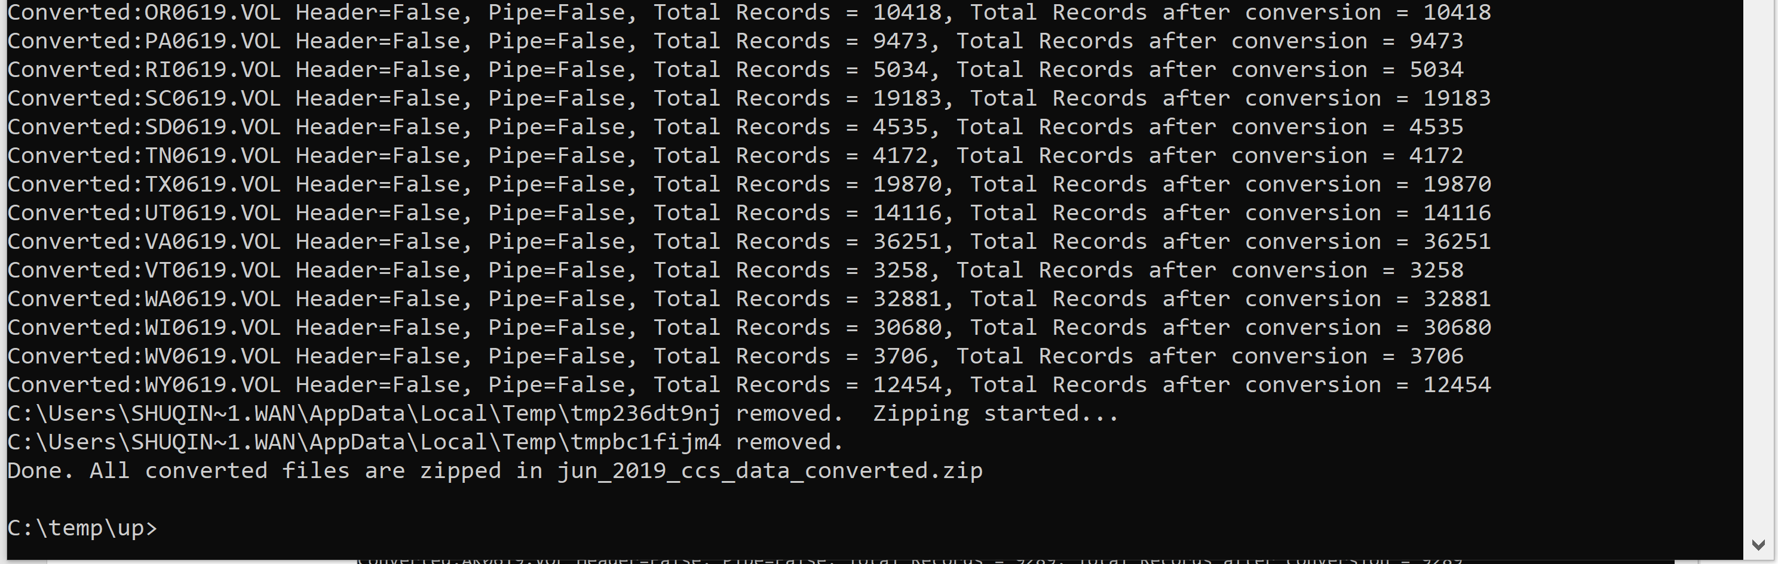

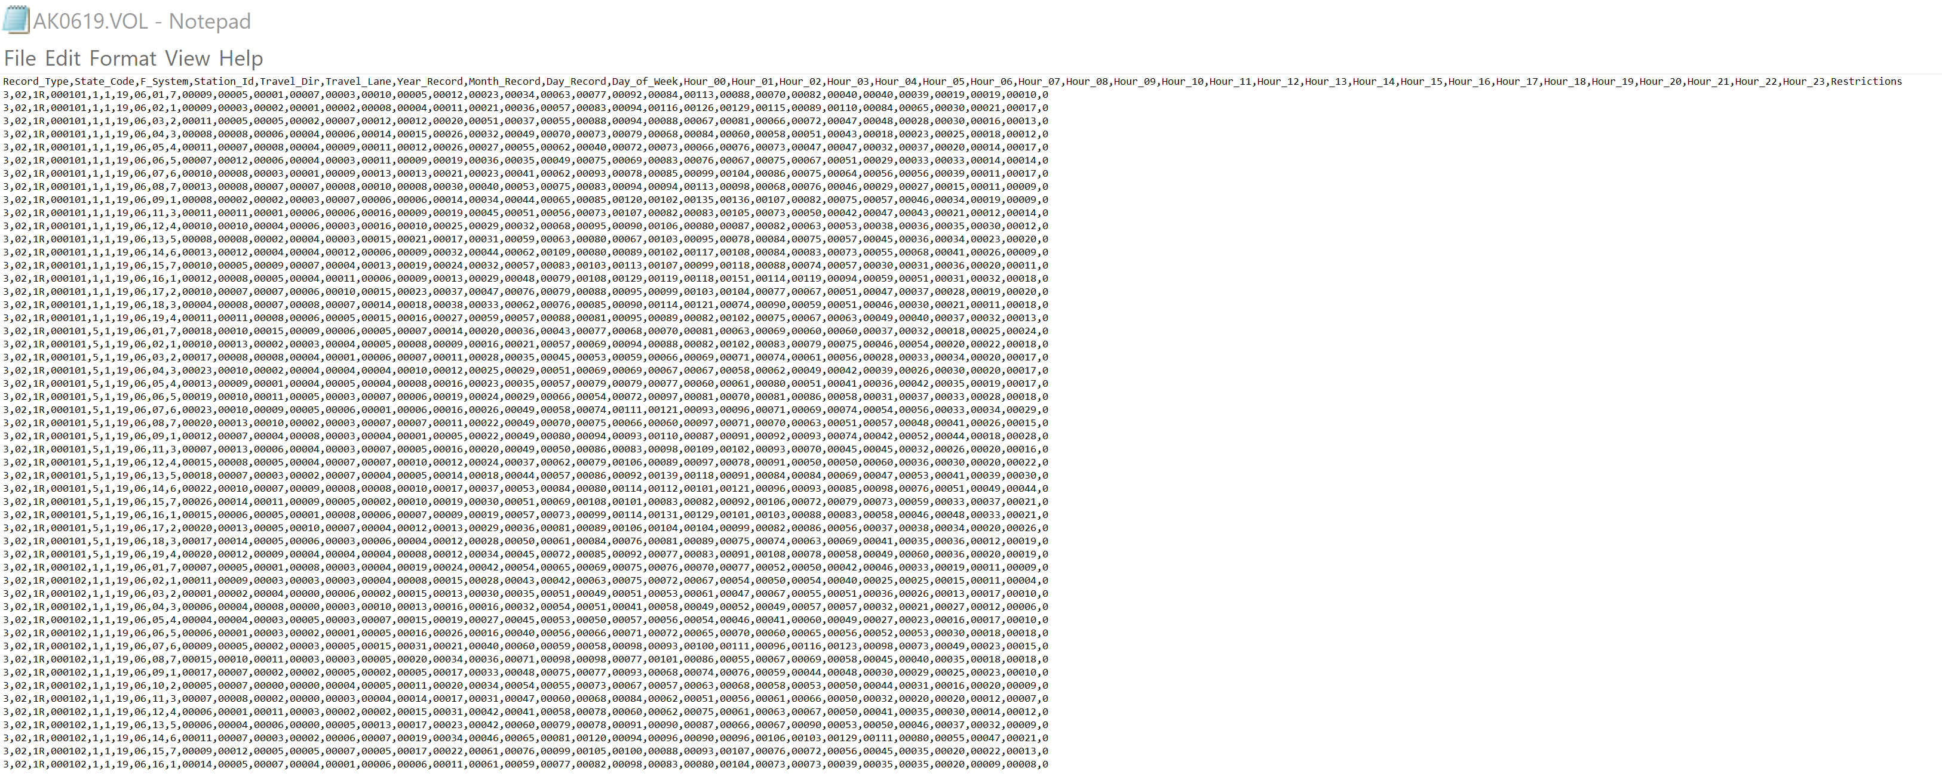

_End_