人脸检测服务facedetect镜像部署步骤

1.制作V1.0.2 +日志版本
# docker stop face_cpuserver ; docker rm face_cpuserver
# /home/wk/examples_python151/FaceDetect-serverimage-cpu
# vim server2image.dockerfile 关闭自启动
本地测试
# docker build -f server2image.dockerfile -t facedetect-server2image-cpu-bay:1.0.2 ./ ; docker run -it --name face_cpuserver -v /home:/home -p 8053:8053 facedetect-server2image-cpu-bay:1.0.2 bash
# /home/wk/examples_python151/FaceDetect-serverimage-cpu/demo
边修改边调试server
# vim server-detectFace.py 修改代码，添加logger日志config等
日志代码具有定时清理功能
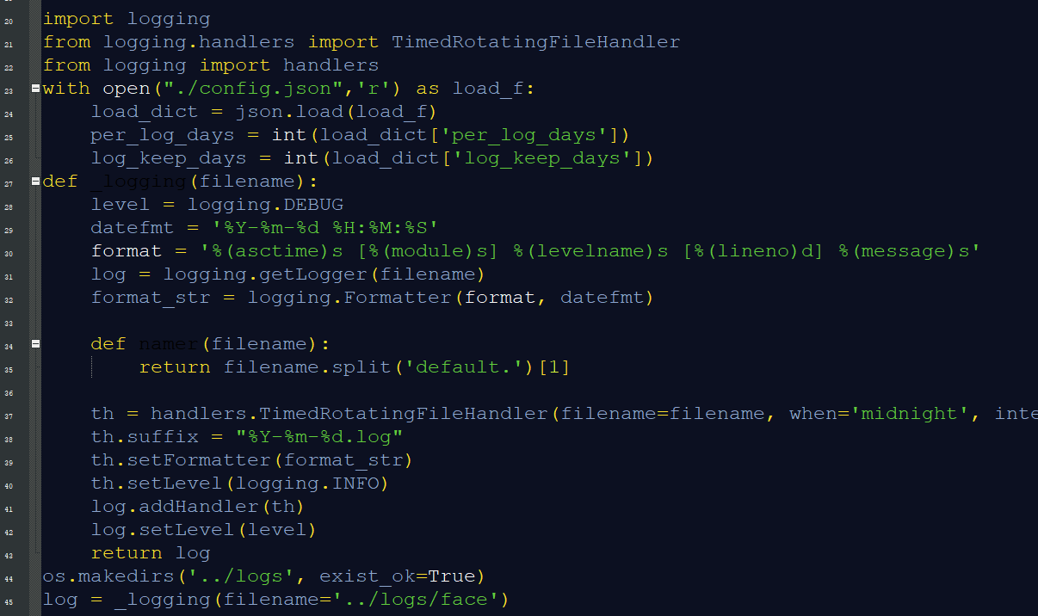
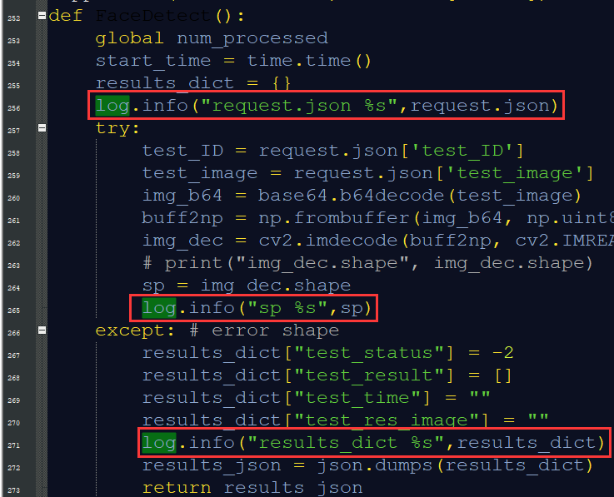
# python3 server-detectFace.py
# cat logs/face
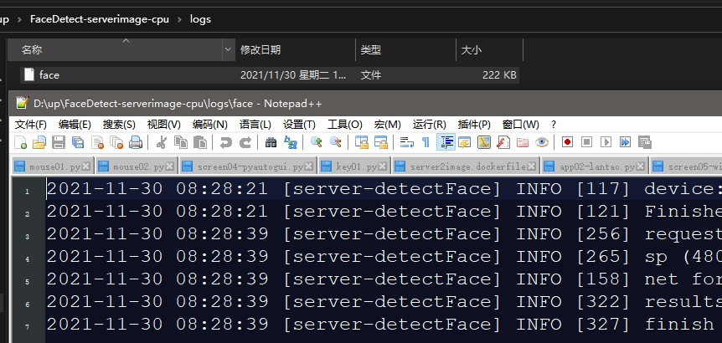
用thread_main转发服务进行Client测试
docker exec -it sfz_cuda /bin/bash
# cd /home/wk/soft/miniconda3/bin ; . ./activate ; conda activate testtest
/home/wk/examples_python151/bay-dockerserver-test/
# nohup python thread_main_bay.py >log 2>&1 &
# ps -aux | grep thre
# python client.py

# vim server2image.dockerfile 恢复自启动

一条龙服务（镜像制作+打标签+上传）
# docker build -f server2image.dockerfile -t facedetect-server2image-cpu-bay:1.0.2 ./ ; docker tag facedetect-server2image-cpu-bay:1.0.2 img.ai.ebiot.net/seeraishow/facedetect-server2image-cpu-bay:1.0.2 ; docker push img.ai.ebiot.net/seeraishow/facedetect-server2image-cpu-bay:1.0.2

2.制作V1.0.3 +编译版本 1130成功
1.验证server源码能否在torch执行
使用已有fire镜像进行调试
# docker stop fire_cpuserver ; docker rm fire_cpuserver
# docker run -d --name fire_cpuserver -v /home:/home -p 8021:8021 img.ai.ebiot.net/seeraishow/fireyolov5-server2image-cpu-bay:1.0.2
# docker exec -it fire_cpuserver /bin/bash
# cd /home/wk/examples_python151/FaceDetect-serverimage-cpu/demo/
# python3 server-detectFace.py
# python3 client-detectFace.py OK
2.生成可执行文件
# docker exec -it sfz_cuda /bin/bash
# cd /home/wk/soft/miniconda3/bin ; . ./activate ; conda activate testtest
# cd /home/wk/examples_python151/FaceDetect-serverimage-cpu/demo/
安装编译所需要的库
# pip install pyinstaller pyinstaller-4.7 pyinstaller-hooks-contrib-2021.3
# pip install tinyaes tinyaes-1.0.2
# pip install easydict
# pyinstaller -F server
# pyinstaller -F client
# pyinstaller --key eB_Ai$X3cH% -F server
# pyinstaller --key eB_Ai$X3cH% -F client
编译后的结果+拷贝原图片和模型文件到指定目录下
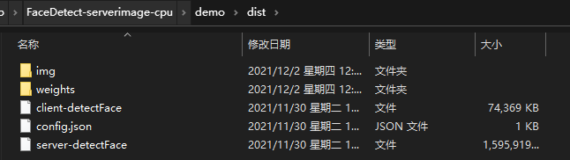
在容器sfz_cuda虚拟环境testtest下运行服务端[dist]# ./server-
在容器sfz_cuda虚拟环境testtest下运行客户端[dist]# ./client-
在宿主机下制作新镜像
# vim serverbuild2image.dockerfile 带自启动
COPY demo/dist /opt/demo
WORKDIR /opt/demo
RUN chmod +x /opt/demo -R
EXPOSE 8053
# 配置启动命令
ENTRYPOINT ./server-detectFace >log 2>&1
去除安装库
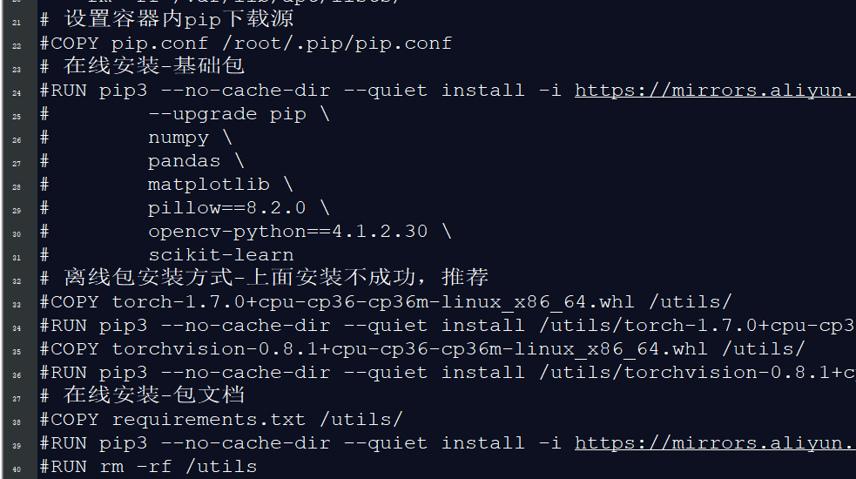
一体化操作 制作+打标签+上传：
# docker build -f serverbuild2image.dockerfile -t face-server2image-cpu-bay:1.0.3 ./ ; docker tag face-server2image-cpu-bay:1.0.3 img.ai.ebiot.net/seeraishow/face-server2image-cpu-bay:1.0.3 ; docker login img.ai.ebiot.net ; docker push img.ai.ebiot.net/seeraishow/face-server2image-cpu-bay:1.0.3
下载测试新镜像
docker stop face_cpuserver && docker rm face_cpuserver
docker run -d --name face_cpuserver -p 8053:8053 img.ai.ebiot.net/seeraishow/face-server2image-cpu-bay:1.0.3
docker exec -it face_cpuserver /bin/bash # ./client- OK
镜像导出
docker pull img.ai.ebiot.net/seeraishow/face-server2image-cpu-bay:1.0.3 && docker save img.ai.ebiot.net/seeraishow/face-server2image-cpu-bay:1.0.3 > face_cpuserver.tar

3.制作V1.0.3 +编译版本 未成功x
# cd /home/wk/examples_python151/FaceDetect-serverimage-cpu/
# vim server2image.dockerfile 关闭自启动
# docker build -f server2image.dockerfile -t face-server2image-cpu-bay:1.0.3 ./ ; docker run -it --name face_cpuserver -v /home:/home -p 8053:8053 face-server2image-cpu-bay:1.0.3 bash
# /home/wk/examples_python151/FaceDetect-serverimage-cpu/demo
边修改边调试server
# python3 server-detectFace.py
# cat logs/face
边修改边调试Client
docker exec -it face_cpuserver /bin/bash
# /home/wk/examples_python151/FaceDetect-serverimage-cpu/demo
# python client.py
服务器生成可执行文件
# pip install pyinstaller pyinstaller-4.7 pyinstaller-hooks-contrib-2021.3
# pip install tinyaes tinyaes-1.0.2
# pyinstaller -F server
# pyinstaller -F client
# pyinstaller --key eB_Ai$X3cH% -F server-detectFace.py
# pyinstaller --key eB_Ai$X3cH% -F client.py

问题：
OSError: could not get source code
[417] Failed to execute script 'server-detectFace' due to unhandled exception!
原因为：torch torchvision版本与pythoninstaller版本不匹配。
https://blog.csdn.net/qq_41754409/article/details/115679755?utm_medium=distribute.wap_relevant.none-task-blog-2~default~baidujs_title~default-5.wap_blog_relevant_default&spm=1001.2101.3001.4242.4

opencv图像处理服务镜像部署步骤
制作V1.0.3 +编译版本：1202 OK
验证原代码可以运行
# docker exec -it sfz_cuda /bin/bash
# cd /home/wk/soft/miniconda3/bin ; . ./activate ; conda activate testtest
/home/wk/examples_python151/opencv_image/demo# python server-opencv.py
/home/wk/examples_python151/opencv_image/demo# python client-opencv.py
# pyinstaller --key eB_Ai$X3cH% -F server-opencv.py
# pyinstaller --key eB_Ai$X3cH% -F client-opencv.py
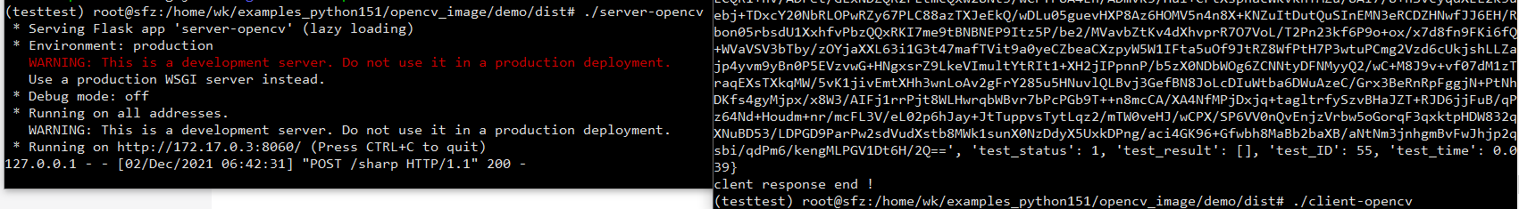
在宿主机下制作新镜像
# vim serverbuild2image.dockerfile 带自启动
一体化操作 制作+打标签+上传：
# docker build -f serverbuild2image.dockerfile -t opencv-server2image-bay:1.0.3 ./ ; docker tag opencv-server2image-bay:1.0.3 img.ai.ebiot.net/seeraishow/opencv-server2image-bay:1.0.3 ; docker push img.ai.ebiot.net/seeraishow/opencv-server2image-bay:1.0.3
下载测试新镜像
docker stop opencv_server && docker rm opencv_server
docker run -d --name opencv_server -p 8060:8060 img.ai.ebiot.net/seeraishow/opencv-server2image-bay:1.0.3
docker exec -it opencv_server /bin/bash # ./client- OK
镜像导出
docker pull img.ai.ebiot.net/seeraishow/opencv-server2image-bay:1.0.3 && docker save img.ai.ebiot.net/seeraishow/opencv-server2image-bay:1.0.3 > opencv_server.tar

