AI Site Build Protocol
Problem Briefing & Process Overview
Date: March 26, 2026 Prepared by: Lindsay Ogden Organization: Elevate Digital

Overview
We are adopting an AI-driven site build process where Feature Docs and Brand Guidelines feed into Cursor, which generates AI Context Docs — effectively the "tickets" from which the site is built. Cursor can also generate Design Docs (schemas, taxonomies, page structures, etc.) derived from those Context Docs, giving designers and architects the artifacts they need to evaluate and revise site fundamentals.

Key Terms

Feature Documentation
Human-authored documents describing the intended functionality, scope, and requirements of the site. Created and maintained in Confluence.

Brand Guidelines
Visual and tonal direction provided by the client or by Elevate's design team.

AI Context Docs
Generated by Cursor from Feature Docs and Brand Guidelines. These function as the implementation "tickets" in the AI-driven flow — the ground truth Cursor uses to build and rebuild the site.

Design Docs
Human-legible artifacts (schema matrices, taxonomies, visual plans, etc.) generated by Cursor on request from the AI Context Docs. These replace the traditional design/architecture phase outputs and are used by the team to review, understand, and revise the site design.

Workflow Comparison

Conventional Site Build Flow
- Generate Feature Docs & Brand Guidelines
- Designers & architects produce Visual Design, Technical Design, Site Architecture, and SEO plans
- BAs create tickets
- Devs build
- Designers & architects review and revise
- Devs build again
- Launch, Profit!

AI-Driven Site Build Flow
- Human — Generate Feature Docs & Brand Guidelines
- AI — Generate AI Context Docs ("tickets")
- AI — Build site prototype / draft
- Human — Review site; revise design through prompting with AI
- Human — Request Design Docs derived from AI Context Docs
- Human — Revise Design Docs
- AI — Consume revised Design Docs and codebase; regenerate AI Context Docs
- Repeat from Step 3

Key shift: In the conventional flow, design artifacts come before tickets. In the AI-driven flow, they come after — derived from the tickets themselves. The team reviews and revises rather than creates from scratch.

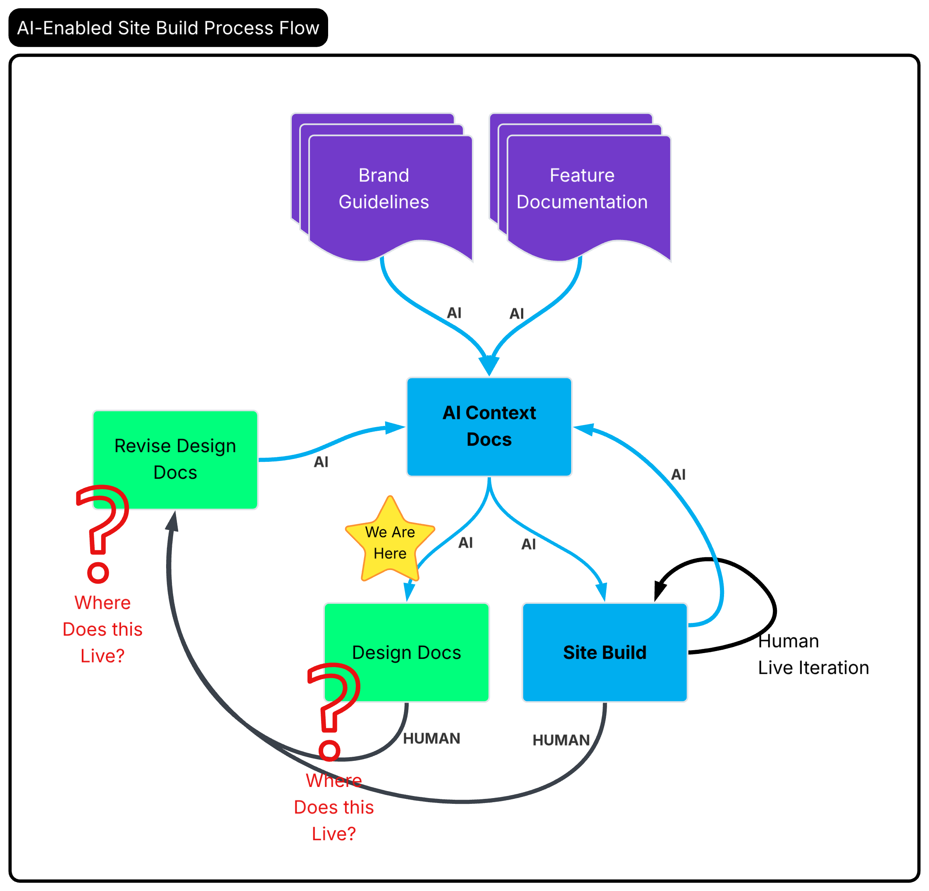

The Problem
We are currently blocked on the collaboration and version control layer for Design Docs. The team needs a Cursor-readable document store where Design Docs can be collaboratively revised and iterated. All currently available options are either technically restricted or operationally impractical:

- Cursor cannot connect to Confluence — blocked by security policy
- Google Docs and Google Drive integration are also not currently approved — blocked by security policy
- Working directly in Git is not viable for the current team's skillset

We are blocked on the collaboration/versioning layer for Design Docs.

What We Need to Resolve
We need one of the following to move forward:

- Option A — An approved integration between Cursor and an existing document store (Confluence or Google Drive), enabling the team to collaboratively author and revise Design Docs that Cursor can read and act on.
- Option B — An alternative storage and collaboration layer that satisfies security policy while remaining accessible to Cursor and usable by a non-Git team.

This briefing was prepared to align the team and surface a decision for the appropriate stakeholders.

