SUPPORT
PLAN
Prepared for
{CLIENT NAME}
{DATE OF MEETING}
Presented to: {CLIENT CONTACT}
Presented by: {SALES REP}

ELEVATED MSP

Our Core Values
INTRODUCTION
We Care More!
At Elevated MSP, we lead with care—because we believe IT should be personal, proactive, and built around your success. We take the time to understand your business, not just your systems.
Our services—Technology Consulting, IT Management, Cybersecurity & Compliance, and Business Continuity & Disaster Recovery—are delivered with a focus on building trust, reducing stress, and giving you confidence in every decision.
When you work with Elevated, you're not just supported – you're cared for.
EPIC Family
EXCELLENCE: Taking no shortcuts
PASSION: Loving what we do
INTEGRITY: Doing the right thing
COMMITMENT: Honoring what we say
FAMILY: Caring about our team and yours

ELEVATED MSP
WHY CHOOSE US
Elevated MSP was founded on integrity, innovation, and a people-first approach.
Originating from Aquarius Computers in 1996, we've grown through the evolution of Gibraltar Technologies, the launch of Momentum ECM, and the acquisition of Netrepid.
Formed in 2021, Elevated now supports over 200 clients with proactive IT support, vCIO consulting, and cybersecurity – including our enhanced firewall services with our NetProtect product.
Our TAM & vCIO model helps to ensure IT isn't just supported—it's strategically aligned for your success!
1996  Originated | 10  Minutes  Avg Response Time | 214  Thrilled Clients | 39  States we are supporting



ELEVATED MSP
Our Superpower!
Elevated's Superpower: Proactive Intelligence
Unlike typical IT providers, we don't just fix problems—we help to prevent them.
Our in-depth Best Practices Report is a strategic deep dive into your technology environment, covering infrastructure, security, compliance, and business continuity.
By aligning your systems with Elevated's standards, you gain:
- Peace of mind knowing risks are addressed before they impact your business
- A clear path forward with actionable recommendations
- A future-proof IT strategy built to scale with your goals
This proactive approach empowers your business to operate with confidence, agility, and resilience.
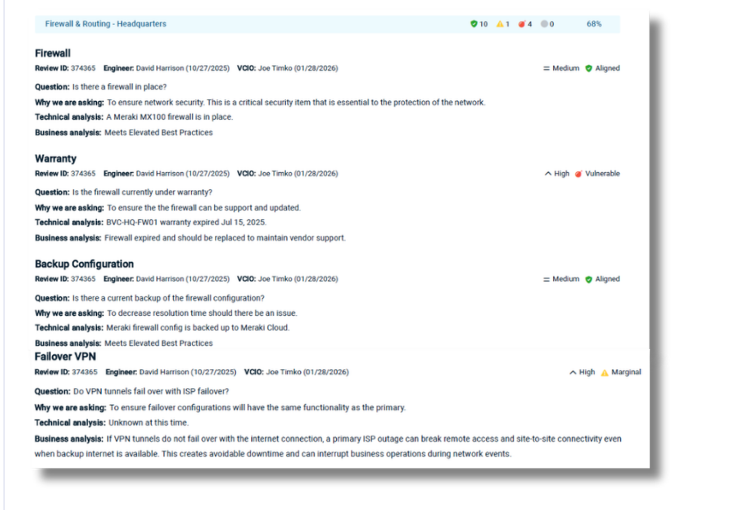

ELEVATED MSP
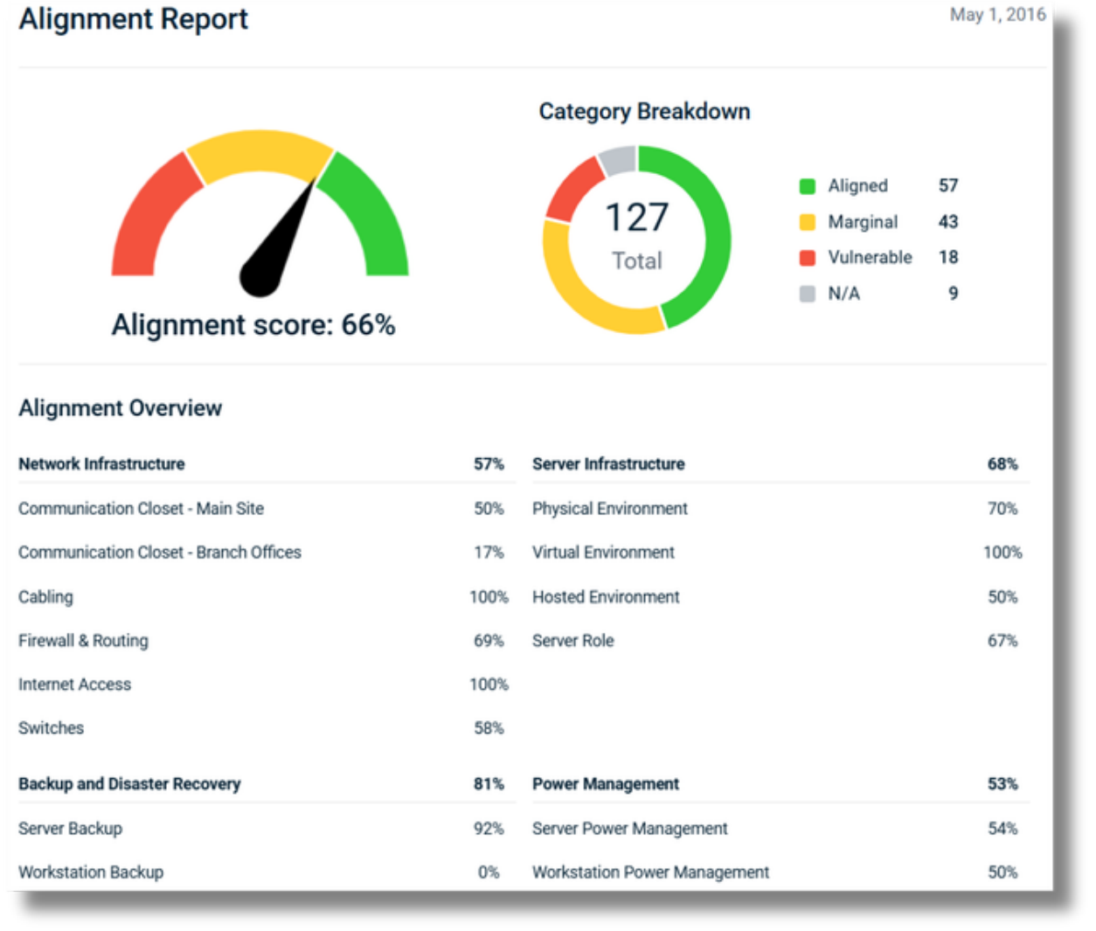
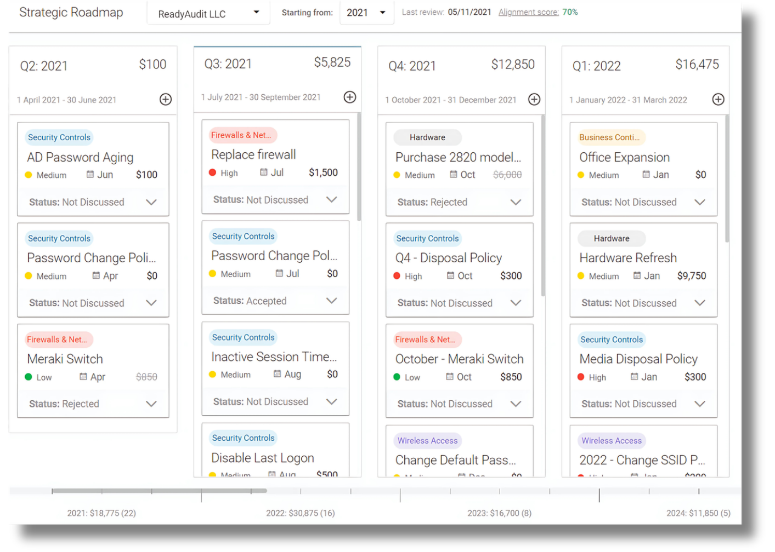

ELEVATED MSP
ABOUT US
Executive Team
  Tom Hogue  CEO/Owner |   Joe Timko  COO

Administrative Team
  Rachelle Hogue  Chief Happiness Officer |   Jodi Weirauch  Account Manager |   Rachel Roades  Business Manager

Sarah Fink
Marketing Coordinator

ELEVATED MSP
ABOUT US
Service Delivery Team
  Darrian Hogue  Service Desk Manager |   Jeremy Gray  Service Desk Engineer |   Eric Greaney  Service Desk Engineer |   Tim Bogert  Service Desk Engineer
  Creg Johnson  Service Desk Administrator |   Chris Miller  Field Engineer |   Andrew Myers  Centralized Services Engineer |   Matthew Pompey  Network Administrator
  Chris Jones  vCIO |   Marcanthony Alvarado  Project Engineer |   David Harrison  Technical Alignment Manager

ELEVATED MSP
Peace of Mind
Elevated offers a fresh way of approaching IT support and maintenance.
The following table provides a comparison of the features and costs included in the Peace of Mind (POM) plan.
PEACE OF MIND - FEATURES | CO-MANAGED | REMOTE | STANDARD | ENTERPRISE
FACILITY/OFFICE SUPPORT AND PRODUCTIVITY
***Maintenance TAM Visits | Quarterly | Yearly | Monthly | Monthly
Project Management | ✔ | ✔ | ✔ | ✔
Knowledge base/Inventory/Warranty tracking | ✔ | ✔ | ✔ | ✔
**Elevated Managed Wi-Fi  -Quantity To Be Determined | X | X | X | ✔
SECURITY AND DATA PROTECTION
Remote Monitoring / Management | ✔ | ✔ | ✔ | ✔
EDR (Endpoint Detection and Response)  Antivirus / Antimalware / Managed SOC | ✔ | ✔ | ✔ | ✔
End User Device &  Infrastructure Drive Encryption | ✔ | ✔ | ✔ | ✔
Multi-Factor Authentication  *Must have Windows Domain | ✔ | ✔ | ✔ | ✔
Vulnerability Scanning &  Quarterly Penetration Testing | ✔ | ✔ | ✔ | ✔
Security Policy Review | ✔ | ✔ | ✔ | ✔
**Elevated Managed Switch  -Quantity To Be Determined | X | X | X | ✔
**Elevated Managed Firewall  -Quantity To Be Determined | X | X | X | ✔
END USER SUPPORT AND PRODUCTIVITY
Patch Management and Security Updates  for End User Devices | ✔ | ✔ | ✔ | ✔
Remote support | **Point-of-  Contact | *Unlimited | *Unlimited | Unlimited
Email Spam filtering, Identity Protection  Secure Messaging, and Email Archiving  *Must be on Office 365 for email | ✔ | ✔ | ✔ | ✔
Cloud Detection and Response for SaaS  *Microsoft 365 and Google Workspace | ✔ | ✔ | ✔ | ✔
**Elevated Managed Desktop  -Quantity To Be Determined  Win11Pro/i7/16GB/500GBSSD | X | X | X | ✔

ELEVATED MSP
Peace of Mind
PEACE OF MIND - FEATURES | CO-MANAGED | REMOTE | STANDARD | ENTERPRISE
BACKUP, DISASTER RECOVERY, and BUSINESS CONTINUITY
Datto SaaS Backups  *Microsoft 365 and Google Workspace | ✔ | ✔ | ✔ | ✔
Datto Server Image Backups  with local appliance | X | X | ✔ | ✔
Backups replicated to SOC2  Tier 3 Datto data center | X | X | ✔ | ✔
COMPLIANCE AND REPORTING
Monthly Health Report  Device Health and Patching | ✔ | ✔ | ✔ | ✔
Cybersecurity Training & DarkWeb Monitoring | ✔ | ✔ | ✔ | ✔
Best Practices Report | ✔ | ✔ | ✔ | ✔
Backup reporting | X | X | ✔ | ✔
TECHNOLOGY CONSULTING
Best Practices Review | ✔ | ✔ | ✔ | ✔
***vCIO Consultation | Onsite – 2 Per Year  Remote – 2 Per Year | Remote – 4  Per Year | Onsite – 4 Per Year | Onsite – 4 Per Year

ELEVATED MSP | Support Plan
PEACE OF MIND | CO-MANAGED | REMOTE | STANDARD | ENTERPRISE
Pricing is based on User count over the previous month and will be reflected in monthly invoicing  # of Users {NUMBER OF USERS}  Project/T&M billable rate as quoted | {PER USER PRICE COMANGE} | {PER USER PRICE REMOTE} | {PER USER PRICE STANDARD} | {PER USER PRICE ENTERPRISE}
Monthly Peace of Mind Total | {MRR PRICE COMANGE} | {MRR PRICE REMOTE} | {MRR PRICE STANDARD} | {MRR PRICE COMANGE}
Elevated Enterprise Hardware as a Service | N/A | N/A | N/A | {ORR – HAAS}
Setup Fees equal to one-month rate | {MONTHLY TOTAL COMANGE} | {MONTHLY TOTAL REMOTE} | {MONTHLY TOTAL STANDARD} | {MONTHLY TOTAL ENTERPRICE}
Contract Length | 1 Year | 1 Year | 3 Years | 5 Years
Initial Plan selection

TIME AND MATERIALS
On-site and/or Remote Network and Project Support as needed.
No software, system monitoring, backups, or reporting included.
The current rate of $185 per hour
On-Site: ½ hour minimum service call charge; billed in ¼ hour increments thereafter
Remote Network Support: ¼ hour minimum service call charge; billed in ¼ hour increments thereafter
Travel time is invoiced at ½ standard hourly T&M rate; travel fees for out-of-state clients passed along via invoice monthly
Month to Month support plan

ELEVATED MSP | Support Plan
THIS SUPPORT PLAN IS SUBJECT TO THE TERMS AND CONDITIONS OF THE MASTER SERVICE AGREEMENT CURRENTLY IN EFFECT.
SUPPORT TERMS
*PROVIDER STANDARD BUSINESS HOURS ARE MONDAY THROUGH FRIDAY 7:00 AM – 7:00 PM EST.
24X7 EMERGENCY SUPPORT FOR ENTERPRISE PLANS INCLUDED.
ASSUMES THE CLIENT MAINTAINS CURRENT AND VALID 3RD PARTY VENDOR HARDWARE AND SOFTWARE SUPPORT PLANS.
**ELEVATED MANAGED HARDWARE (INCLUDING WI-FI, FIREWALL, DESKTOP/LAPTOP, OR SWITCH) IS PURCHASED, WARRANTIED, AND OWNED BY ELEVATED MSP. FINAL DEVICE QUANTITIES WILL BE DETERMINED APPROXIMATELY NINETY (90) DAYS FOLLOWING ONBOARDING, BASED ON THE CLIENT’S OPERATIONAL NEEDS AND ENVIRONMENT ASSESSMENT. UPON SUPPORT PLAN TERMINATION OR EXPIRATION, A BUYOUT OPTION WILL BE OFFERED BY THE PROVIDER TO THE CLIENT FOR THE INSTALLED HARDWARE.
***OVER TIME, AS THE CLIENT REACHES ALIGNMENT WITH ELEVATED BEST PRACTICES, THE FREQUENCY OF VCIO/TAM VISITS MAY BE REDUCED.
COMPENSATION
IN CONSIDERATION OF THE SERVICES TO BE PERFORMED BY PROVIDER, CLIENT AGREES TO PAY PROVIDER IN THE MANNER, AND AT THE RATES SET FORTH IN THIS SUPPORT PLAN. STANDARD PAYMENT TERMS ARE NET 15 DAYS, AND MONTHLY INVOICES ARE SENT FOR THE UPCOMING MONTH, PRIOR TO SERVICE DELIVERY.
LATE PAYMENTS WILL INCUR FINANCE CHARGES OF 1.5% OF THE UNPAID MONTHLY CHARGES EVERY 30 DAYS. BEYOND 90 DAYS COLLECTION PROCEDURES WILL BEGIN AND SERVICES WILL BE INTERRUPTED.
CREDIT CARD PAYMENTS INCUR AN ADDITIONAL 4% PROCESSING FEE. PRICING MAY INCREASE BY UP TO 10% ANNUALLY AS A RESULT OF SOFTWARE AND SUPPORT COSTS. PAYMENTS ARE PREFERRED VIA ACH.
AUTHORIZATION
THE SIGNER OF THIS SUPPORT PLAN, IN ADDITION TO REPRESENTING THAT HIS/HER SIGNATURE LEGALLY BINDS THE CLIENT AND THAT ALL ACTIONS HAVE BEEN TAKEN BY THE CLIENT TO DULY GRANT THIS AUTHORITY, DOES, BY HIS/HER EXECUTION, PERSONALLY AND INDIVIDUALLY UNDERTAKE AND ASSUME THE FULL PERFORMANCE HEREOF INCLUDING PAYMENT OF AMOUNTS DUE HEREUNDER.
SUPPORT PLAN APPROVAL
Client: {CLIENT NAME}  Signature: _________________________  (Print) Name: {CLIENT CONTACT}  Title: {CLIENT TITLE}  Date: _________________________  Address: {CLIENT ADDRESS} | Provider: Elevated MSP, LLC  Signature: _________________________  (Print) Name: Thomas Hogue  Title: CEO/Owner  Date: _________________________  Address: 27 Miller Street  Lemoyne, PA 17043

ELEVATED MSP
Timeline
Onboarding with Care. Strategy with Purpose.
Elevated leads you through a 5-phase journey built on trust and results—starting with thoughtful onboarding, implementing best practices, and aligning IT to your business goals.
We deliver more than just support—we deliver care and strategy that drive lasting success.
PHASE 01  SETTING THE STAGE | We start with a quick onboarding call to:  - Review your service plan & agreements  - Set up billing & portal access  - Discuss any open issues  - Schedule your onsite onboarding
PHASE 02  ONBOARDING | During your onboarding visit, we:  - Deploy Elevated tools & controls  - Configure reporting & conduct a best practices audit  - Organize cabling and workspace  - Document your environment  - Provide go-live support (with mousepads!)
PHASE 03  BEST PRACTICES | After go-live, we:  - Apply service plan fixes for vulnerable systems  - Conduct a follow-up best practices audit  - Roll out Security Awareness Training & MFA
PHASE 04  vCIO | We don't stop at go-live.  - Share initial and post-go-live Best Practices Reports  - Review your Strategic IT Roadmap  - Walk through monthly reporting insights  - Plan ahead for key projects and improvements
PHASE 05  PROJECTS | Executing the Strategic Roadmap  We turn strategy into action by implementing key projects aligned with your roadmap—driving continuous improvement and long-term success.

