Welcome to the OCR Test Document
This document is designed to evaluate the performance of an Optical Character Recognition (OCR) system. It includes various formatting elements to test how well different styles and structures are recognized.

Text Styles
- Bold text should stand out.
- Italic text can be useful for emphasis.
- Underlined text might not always be rendered.
- Mixed bold and italic styles test nested formatting.

Sample Table
Item | Quantity | Price
Apples | 4 | $2.00
Bananas | 6 | $1.50
Oranges | 3 | $3.00

Image with embedded text


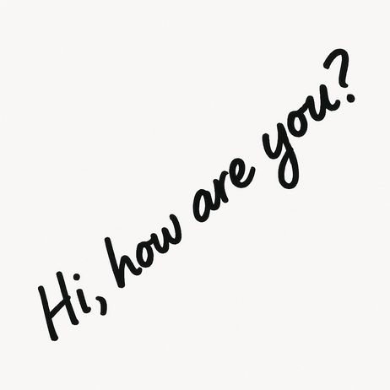
Multilingual Greetings
Below is a list of the word "Hello!" in various languages:
- English: Hello!
- French: Bonjour !
- German: Hallo!
- Greek: Γειά σου!
- Arabic: مرحبا!
- Hebrew: שלום!
- Japanese: こんにちは！
- Chinese: 你好！

