Group Members:

Yulong Chen

Paul Diaz

Brandon Trinh

Branden Andersen

Team Yoda Group Report

# Class Diagrams

## Model View Controller Pattern

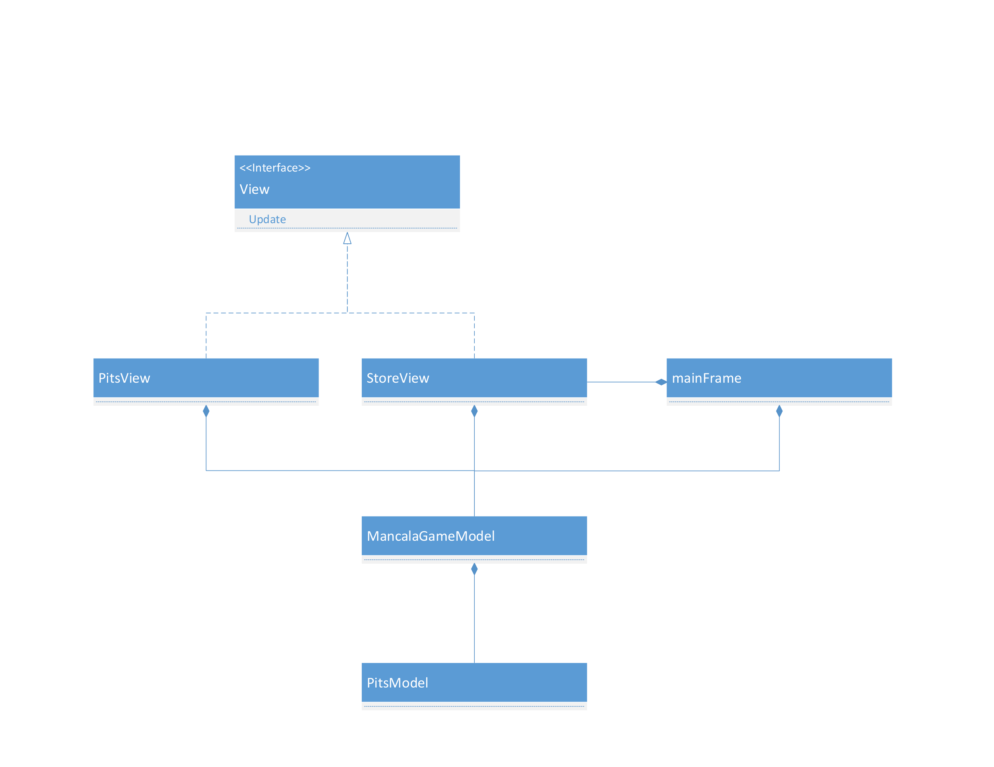

## Strategy Pattern

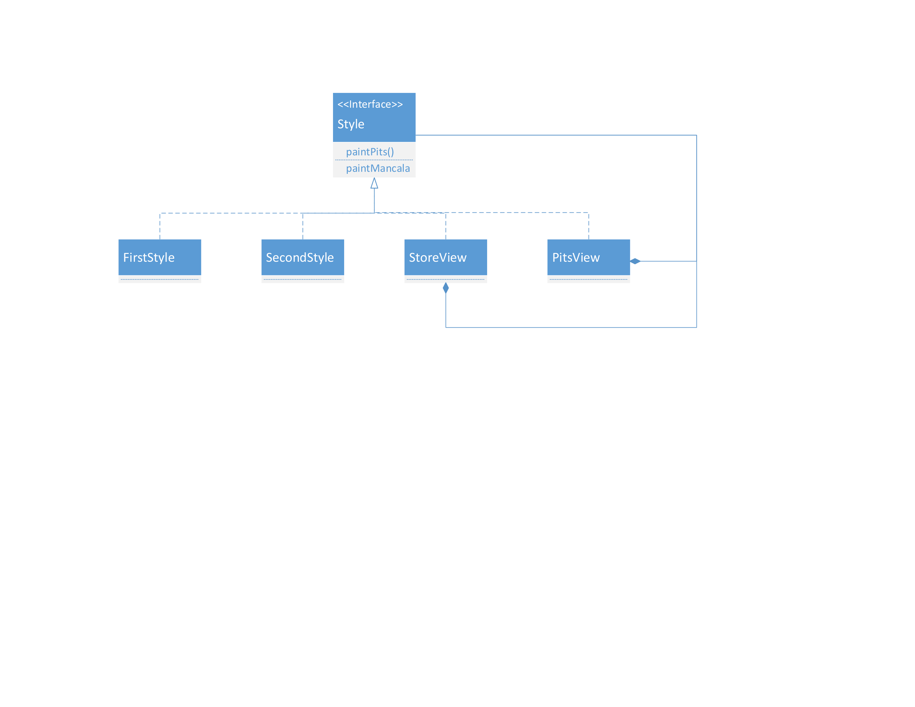

# Use Cases

## start game use cases

|  |  |  |
| --- | --- | --- |
| Steps | User’s Action | System’s Response |
| 1 |  | System promote a window to ask user to pick number of stones per pit, the maximum number is 4 |
| 2 | User enter a number |  |
| 3 |  | System create a new window that contains a broad that has numbers of stone user picked. |
| 5 |  | In the top right corner, system indicates which player’s turn it is, the initial will be Player 1 |
| 6 | Player 1 can make movement |  |

## Game play use cases

|  |  |  |
| --- | --- | --- |
| Steps | User’s Action | System’s Response |
| 1 | Player click in one of his pit |  |
| 2 |  | System will move the stones from the chosen pit to the other pits according to the game rule. |
| 3 |  | In the right bottom corner, system will allow player to click undo button, which it will undo the movement player 1 just made. |
| 4 |  | System will check if the win condition has been reached, if so, the game stop and pop up a window to show who is the winner and how many stones each player finally get. if not, the right top corner will change to next player’s turn. |
| 5 | Repeat 1-4 |  |

# Sequence Diagrams

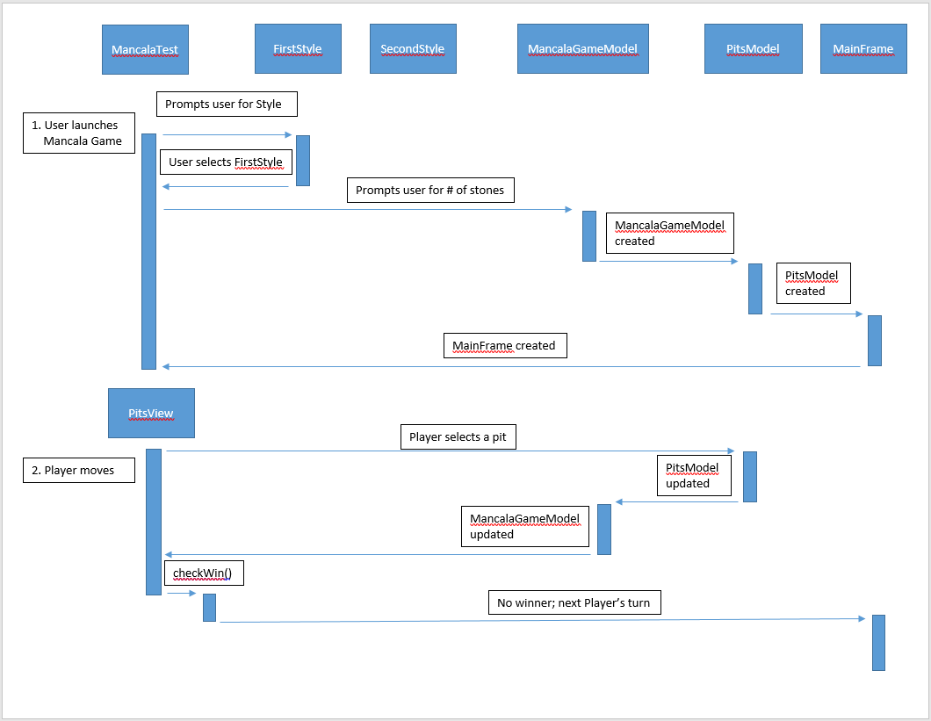

Sequence Diagrams (cont.)

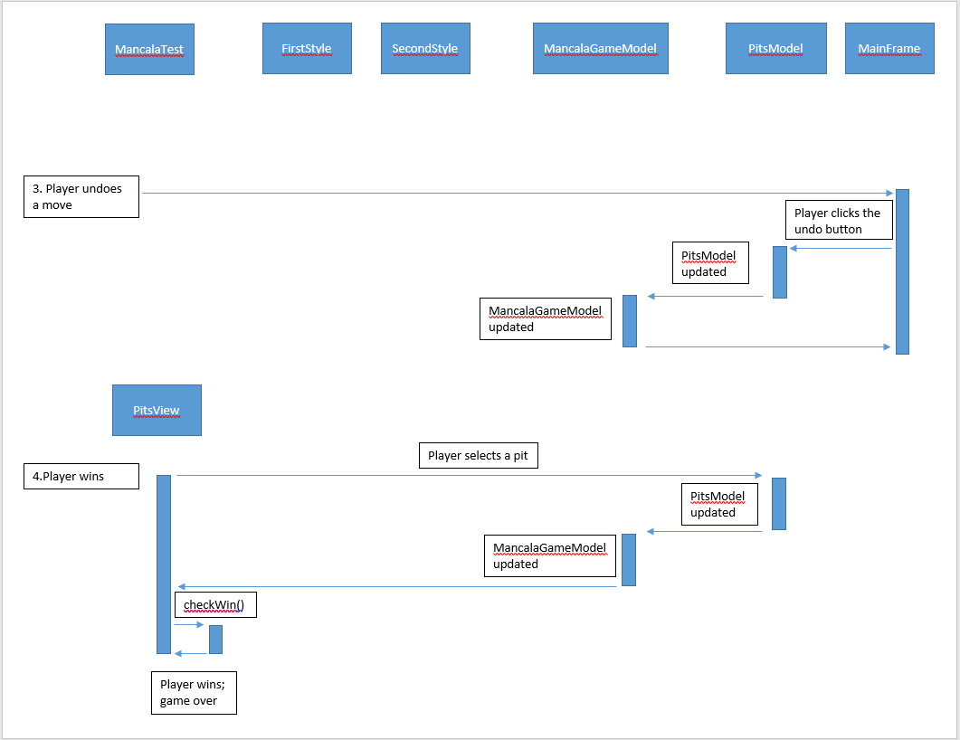

1. Which materials/key concepts from this course did you apply on the project?  
We applied the observer pattern in our project. We used MVC. We have a model to store the pits data and a model to store the mancala board data. Our view is the mancala board with all the components on one main frame. Our controllers include the undo button, the quit button, and the action listeners on the pits.

We also applied the strategy pattern. We created an interface Style that acts as the interface for our strategy pattern. The Style interface is implemented by FirstStyle, SecondStyle, and PitsView. FirstStyle and SecondStyle are concrete classes for our strategy pattern. PitsView is the context that uses our strategy pattern.  
  
2. Which topics did you have to learn through self-study in order to complete the project?

In this project, other than the GUI materials we learned in the lecture, and used in the past projects, we had to research, learn more about GUI swing and awt library in order to complete the program. For example, we used JDialog class, specifically JDialog.setDefaultLookAndFeelDecorated(true), different versions of JOptionPane.showInputDialog(). Also, we had to work with different GUI Layouts in a more complex manner..