Software Requirements Specification (SRS)
Project Name: Rangefinder
Version: 1.3
Date: 2026-03-13
Author(s): Jan Frančák, Jaroslav Vaněček, Jakub Šoma, Tomáš Elexa, Lola Rodríguez

Introduction

1.1 Purpose

This document specifies the requirements for the Rangefinder, a Raspberry PI based range-finding tool with a mobile phone app user interface. Its users are able to see the real time measurements of distance together with a chart to easily see any outliers.

1.2 Document conventions

- Requirement IDs: FREQ-x for functional requirements; NFREQ-x for nonfunctional requirements; SCN-x for scenarios.
- Time is stated in seconds; availability in %; data sizes in MB/GB
- RF – shortcut for Rangefinder – mobile application
- RPi – shortcut for Raspberry Pi
- SeS - shortcut for SensorStation, RPi with connected sensors
- BT - shortcut for Bluetooth

1.3 Intended Audience and Reading Suggestions

- Product owner / client: read Sections 1–3 for scope, users, and scenarios; skim 4 and 6 for priorities.
- Developers / architects: read Sections 2, 4–8; start with 7 for architecture constraints
- Testers / QA: read Sections 3, 4, 6 for traceability and acceptance criteria.
- Operations / security: read Sections 2.4–2.7 and 6.2–6.4

1.4 Product Scope

The Rangefinder provides a real time measurement of distance from the sensors mounted on the Raspberry Pi, that are transmitted by Bluetooth to a mobile phone app. Once the user pairs his app to the gadget, he will be able to see measurements of each sensor, the chart showing the measurements in a time period and a debug window of the Bluetooth connection. This version (1.3) focuses on the foundation of a more complex rangefinder, allowing easy further development.

1.5 References

Raspberry Pi: https://www.raspberrypi.com

2. Overall Description

2.1 Product Perspective
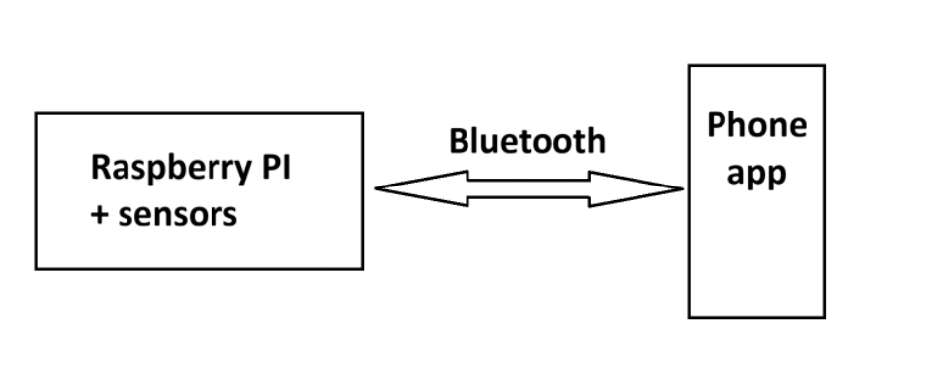
Figure 2.1 - Rangefinder context diagram

Rangefinder is a new product based on the Raspberry PI helping with commercial-use distance measurement. Together with the Raspberry PI chassis is an in-house built phone application that shows all measured data. The context diagram shows a simplified look at the workings of the system.

2.2 Product Features/Functions

Real-time measurements of each sensor
- Chart showing measurements over a set period of time
- Debug window for Bluetooth connection
- True/False obstacle checker

2.3 User Classes and Characteristics

Not applicable

2.4 Operating Environment
- Raspberry Pi Zero 2W – Raspbian Lite
- Android operating system

2.5 Design and Implementation Constraints
- Inexperience with Bluetooth integration

2.6 User Documentation
- PDF user manual
- PDF troubleshooting guide
- Release notes per version

2.7 Assumptions and Dependencies
- Stable Bluetooth connection

3. System scenarios (Use cases)

3.1 Use-case diagram
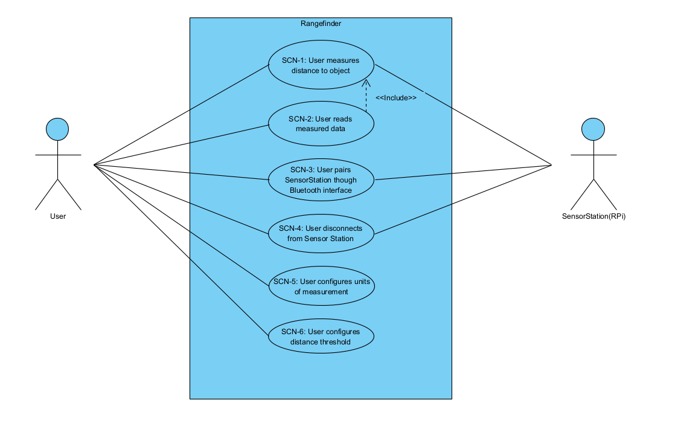

3.2 Scenarios

3.2.1 SCN-1: User measures distance to an object
FREQ reference | FREQ-7, FREQ-6, FREQ-5
NFREQ reference | NFREQ-3, NFREQ-1
Short Description: | User uses the SeS to measure a distance from the sensors to a certain object
Actors | User, SeS
Precondition: | SeS is on, Bluetooth is active, SeS connected to RF app

Basic flow: User measures distance to an object
Step | User action |  | System response
1 | Places an object in front of the ultrasonic/ToF sensor |  | The object is detected by the sensors
2 | - |  | SeS measures the distance and sends it through Bluetooth interface
3 | - |  | Mobile app receives data from SeS
Post-condition: |  | SeS keeps sending new data as long as it is not turned off

Alternative flows
A1 – Object is out of bounds
- Trigger: Object is either too close or too far from the sensor
- System response: SeS sends either 0 or max value respectively
- Result: The measurement it inaccurate
A2 – Bluetooth connection is lost
- Trigger: The Bluetooth connection is unexpectedly lost
- System response: RF app alerts the user
- Result: User has to reconnect his BT connection

3.2.2 SCN-2: User reads measured data
FREQ reference | FREQ-2, FREQ-3, FREQ-4
NFREQ reference | NFREQ-4, NFREQ-3
Short Description: | User uses the Rangefinder app to read the data currently being sent by the sensors
Actors | User
Precondition: | SeS connected and actively transmitting

Basic flow: User reads measured data
Step | User action |  | System response
1 | SCN-1 |  | SCN-1
2 | - |  | RF app handles data processing and displays measurements in Simple or Advanced section of mobile app
3 | Opens “Advanced” menu |  | “Advanced” menu gets opened
4 | Views data |  | -
Post-condition: |  | SeS keeps sending new data as long as it is not turned off

Alternative flows
A1 – Corrupted data
- Trigger: RF app receives a malformed payload
- System response: App catches the parsing exception and ignores the bad packet
- Result: App waits for the next packet without crashing

3.2.3 SCN-3: User pairs Rangefinder through Bluetooth interface
FREQ reference | FREQ-1
NFREQ reference | NFREQ-3
Short Description: | User uses the mobile app’s Bluetooth interface to pair the app to SeS
Actor | User, SeS
Precondition: | SeS is on and broadcasting, phone has BT and location services enabled

Basic flow: User reads measured data
Step | User action |  | System response
1 | Selects the Setting option |  | Settings option is opened
2 | Turns scanning on by clicking on “Scan devices” |  | App starts scanning for pairable devices
3 | - |  | App displays found BT devices
4 | Selects SeS and taps “Pair” |  | App pairs with the SeS
Post-condition: |  | SeS and the app are successfully paired, and the app starts receiving data

Alternative flows
A1 – Malfunctioning SeS
- Trigger: SeS not working properly
- System response: SeS does not appear in the BT search
- Result: User cannot pair the app with SeS
A2 – Connection timeout
- Trigger: RF app fails to connect
- System response: App displays an error message
- Result: User is prompted to try again

3.2.4 SCN-4: User disconnects from Sensor Station
FREQ reference | FREQ-8
NFREQ reference | -
Short Description: | User terminates the connection to the SeS to save battery and stop the data stream
Actor | User, SeS
Precondition: | RF app is currently connected to the SeS

Basic flow: User disconnects from Sensor Station
Step | User action |  | System response
1 | Selects the Setting option |  | Settings option is opened
2 | Taps “Disconnect” button |  | App explicitly unsubscribes from the BLE characteristic and closes the BT connection
3 | - |  | App displays last known values in the menus with a “Disconnected” tag
4 | - |  | SeS detects the disconnection and goes back to broadcasting its BLE signal for future pairing
Post-condition: |  | SeS waits for another pairing

Alternative flows
A1 – Hard exit
- Trigger: User forcefully kills the app
- System response: Mobile OS automatically severs the BLE connection
- Result: SeS detects the severing and goes back to broadcasting safely

3.2.5 SCN-5: User configures units of measurement
FREQ reference | FREQ-9, FREQ-2, FREQ-3
NFREQ reference | -
Short Description: | User changes the display units from meters to centimetres and inputs a new distance threshold
Actor | User
Precondition: | RF app is currently running

Basic flow: User configures units of measurement
Step | User action |  | System response
1 | Selects the Setting option |  | Settings option is opened
2 | Toggles the preferred units of measurement |  | App switches the displayed measurements to the chosen units
Post-condition: |  | RF app is on operating on new units of measurement

3.2.6 SCN-6: User configures distance threshold
FREQ reference | FREQ-10, FREQ-2, FREQ-3
NFREQ reference | -
Short Description: | User changes the distance threshold to a new distance
Actor | User
Precondition: | RF app is currently running

Basic flow: User configures distance threshold
Step | User action |  | System response
1 | Selects the Setting option |  | Settings option is opened
2 | Inputs a new number into the distance threshold window |  | App switches the distance threshold to a new distance
Post-condition: |  | RF app is on operating on new units of measurement

Alterative flows
A1 – Invalid threshold input
- Trigger: User inputs a negative number, text or a value out of sensor’s physical bounds.
- System response: App informs the user of the invalid value and reverts to last known valid setting
- Result: The threshold is ready to be changed again

4. Functional Requirements

4.1 FREQ-1 - Connecting to the SeS
Description: The phone app shall allow the user to connect to the SeS using Bluetooth
Priority: High
Acceptance criteria: Given the Bluetooth is working correctly on both devices, the user is able to connect to the SeS and starts to receive data

4.2 FREQ-2 - Displaying data
Description: The phone app shall allow the user to see data from each of the sensors, including the True/False obstacle detector.
Priority: High
Acceptance criteria: Given the user is connected to the SeS, they can clearly see data from each sensor in the “Advanced” menu of the app and min/max value in the “Simple” menu of the app.

4.3 FREQ-3 - Displaying the chart
Description: The phone app shall allow the user to see data from all the sensors on the chart.
Priority: Medium
Acceptance criteria: Given the user is connected to the SeS, they can see the chart in the “Advanced” menu of the app and they can distinguish each sensor by their assigned colour.

4.4 FREQ-4 - Displaying the Debug window
Description: The phone app shall allow the user to see the Debug window.
Priority: Medium
Acceptance criteria: Given the user is connected to the SeS, they can see the debug window on the bottom of the “Advanced” menu, where the entire Bluetooth connection between the devices is continuously displayed.

4.5 FREQ-5 – Sending data
Description: The SeS shall send its data once a Bluetooth connection is correctly set up
Priority: High
Acceptance criteria: The data is being correctly transmitted through the Bluetooth connection.

4.6 FREQ-6 – Receiving data
Description: The Rangefinder app shall correctly receive data, that are being sent through the Bluetooth connection
Priority: High
Acceptance criteria: The data from the SeS are received and are able to be used

4.7 FREQ-7 – Detecting and measuring distances of objects
Description: The sensors shall correctly measure distances of objects and send their data throughout the SeS, so they are then able to be transmitted through Bluetooth
Priority: High
Acceptance criteria: The measured distances from the sensors are being passed to the SeS

4.8 FREQ-8 – Disconnecting from SeS
Description: The app shall allow the user to disconnect from the SeS
Priority: Medium
Acceptance criteria: The app is successfully disconnected from the SeS

4.9 FREQ-9 – Configuring units of measurement
Description: The app shall allow the user to configure measurement units between m-dm-cm-mm
Priority: low
Acceptance criteria: The data are correctly recalculated and displayed

4.10 FREQ-10 – Configuring distance threshold
Description: The app shall allow the user to configure distance threshold in currently chosen units of measurement
Priority: low
Acceptance criteria: If the object is closer or equals the threshold, a warning is displayed in the app

5. External Interface Requirements

5.1 User Interfaces (UI design / User Interaction Flow)
- UI should include: Advanced menu, Simple menu, Settings menu, Corresponding button for each
- Advanced menu should include:
  - A chart displaying data of each sensor in a set time period
  - Current measurement of each sensor in a separate box
  - Debug window of Bluetooth connection
  - Scrollbar to reach the debug window
- Simple menu should include:
  - Minimum distance currently measured by a sensor
  - Maximum distance currently measured by a sensor
  - Current data from the obstacle sensor

5.2 Hardware Interfaces
- I²C, GPIO pin reading
- Raspberry Zero 2W
- WaveShare Laser sensor
- Ultrasound sensor HC-SR04
- Time-of-flight sensor VL53LDK
5.3 Software Interfaces (API Interfaces)
- Go Bluetooth – BLE
- Bluetooth LE plugin for Xamarin & MAUI

5.4 Communications Interfaces
- Bluetooth with AES encryption

6. Other Nonfunctional Requirements

6.1 Performance Requirements
Not applicable

6.2 Safety Requirements
Not applicable

6.3 Security Requirements
The data transfer between SeS and RF app should be encrypted. For this purpose AES encryption will be used. The data on SeS will be encrypted by Secret Key, transmitted safely and then decrypted by the RF app.
6.4 Software Quality Attributes
- NFREQ-1 (Correctness): The system shall measure within a meter accuracy.
- NFREQ-2 (Maintainability): Codebase shall include automated tests covering at least 60% of backend logic and 40% of frontend components.
- NFREQ-3 (Portability): The application shall work with any modern android phone.
- NFREQ-4 (Usability): The application shall display all measured distances within at maximum half a second.

7. System Design & Architecture

7.1 High-Level Architecture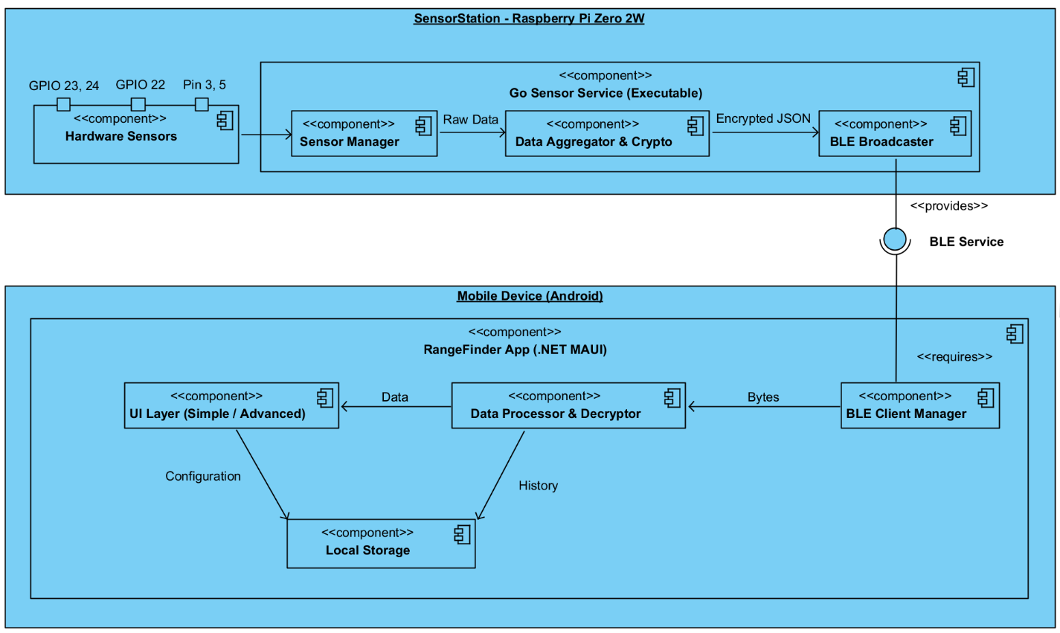

7.2 Technology Stack
- Phone App: .NET MAUI
- Hardware:
  - Main unit: Raspberry Pi Zero 2W
    - ARM64 architecture, 512 MB RAM, integrated BT chip
  - Operating system: Linux (Raspberry Pi OS, 64-bit)
  - Programming language: Go (Golang)
  - Architecture of runtime: Goroutines + Mutex – safe and effective asynchronous parallel processing
  - Key libraries:
    - go-rpio/v4 : low-level GPIO control
    - go-i2c & go-vl5310x : communication with ToF sensor through HW registry
    - go-logger : for log control (I2C console spamming)
  - Communication and safety:
    - Bluetooth Low Energy (BLE) – GATT server using system BlueZ
    - E2E encryption: AES-256 in GCM mode
      - PSK Pre-Shared-Key key management through environment variables
  - Data structure: JSON

7.3 Data Flow
Data is collected from a single sensor -> Data is transferred by Bluetooth to the mobile device application -> Data is parsed and displayed in the application.

8. Other Requirements
None.

