**Steps**: 102200

**Started:** 2017-02-28 14:45:00 Loss = 5.05

**Finished**

2017-03-01 13:48:09.

548501: step 102200, loss = 0.04 (140.5 examples/sec; 0.911 sec/batch)

Total loss

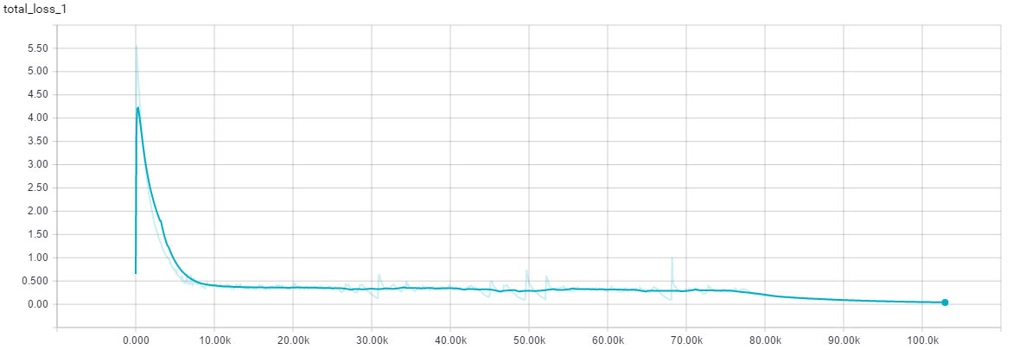

Learning Rate

