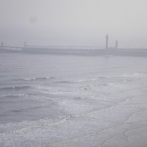

|  |  |  |  |
| --- | --- | --- | --- |
| **0a5d539762** | **0a5d539762** | **0a5d539762** | **0a5d539762** |



|  |  |  |  |
| --- | --- | --- | --- |
| **0a5d539762** | **0a5d539762** | **0a5d539762** | **0a5d539762** |



|  |  |  |  |
| --- | --- | --- | --- |
| **0a5d539762** | **0a5d539762** | **0a5d539762** | **0a5d539762** |



|  |  |  |  |
| --- | --- | --- | --- |
| **0a5d539762** | **0a5d539762** | **0a5d539762** | **0a5d539762** |



|  |  |  |  |
| --- | --- | --- | --- |
| **0a5d539762** | **0a5d539762** | **0a5d539762** | **0a5d539762** |