Requirements Specification for Property Listings Management Business Process

1. General description of business process
- A general description of the business process and a description of the performance metrics generated by this process, possible current analytical problems.
The property listings management process is as follows: Firstly, real estate agents meet with potential clients to view their properties, assess their condition, features, advantages, and disadvantages. During that meeting, they discuss the listing price, commission rate, and marketing strategy before deciding to partner with the property owner. After signing an agreement with the owner, the agency’s photographers take pictures of the apartment. The marketing team then handles advertising the property by creating an appealing description and posting the listing on our website alongside other popular real estate platforms. As part of the ongoing process, apartment information is regularly updated, ensuring the details remain accurate and relevant. The listing order on the webpage is adjusted based on key factors such as price and demand, allowing customers to view the most interesting and attractive offers. Potential buyers can schedule property viewings, where the real estate agent shows them the apartment and answers their questions. Interested customers can negotiate prices, and once the agreement is reached, the agent signs the purchase contract with the new homeowner. At the last step, the previous owner receives the payment, the company gets its commission, and the new landlord receives the key to the apartment.
The agency has two primary goals for this process: reducing the average time on market for listed apartments by 15% compared to the previous year and increasing the number of potential buyers per apartment by 5% compared to the previous month by improving advertisement strategies, enhancing listing details, and ensuring that the most attractive offers are featured prominently to draw more interest.

- Typical questions

Which areas attract the most buyers?
Which apartment sizes attract the most buyers?
In which season do we receive the most property listing offers from owners?
In which district do apartments sell the fastest?
What was the total profit of last year?
In which districts do apartments receive the most listing views and inquiries?
Which areas have the highest demand, leading to faster sales?
How do the average listing prices of apartments of the same size compare across different cities?
Which apartment sizes generate the most interest and attract the highest number of inquiries?
Who are the top-performing real estate agents in each city? (Measured by the number of successful listings or shortest time on market)
How do listing-related profits compare across different cities?
How does the number of newly listed apartments this month compare to the previous month?
In which season do we receive the most new property listings from owners?
In which district do apartments get listed and sold the fastest?
What was the total revenue generated from apartment listings last year?

- Data

All listings data is extracted from the PropertyMaster system. The property system stores detailed information about the apartments, which includes their location, size, condition, owner, buyer, as well as responsible agents.

2. Data sources structures
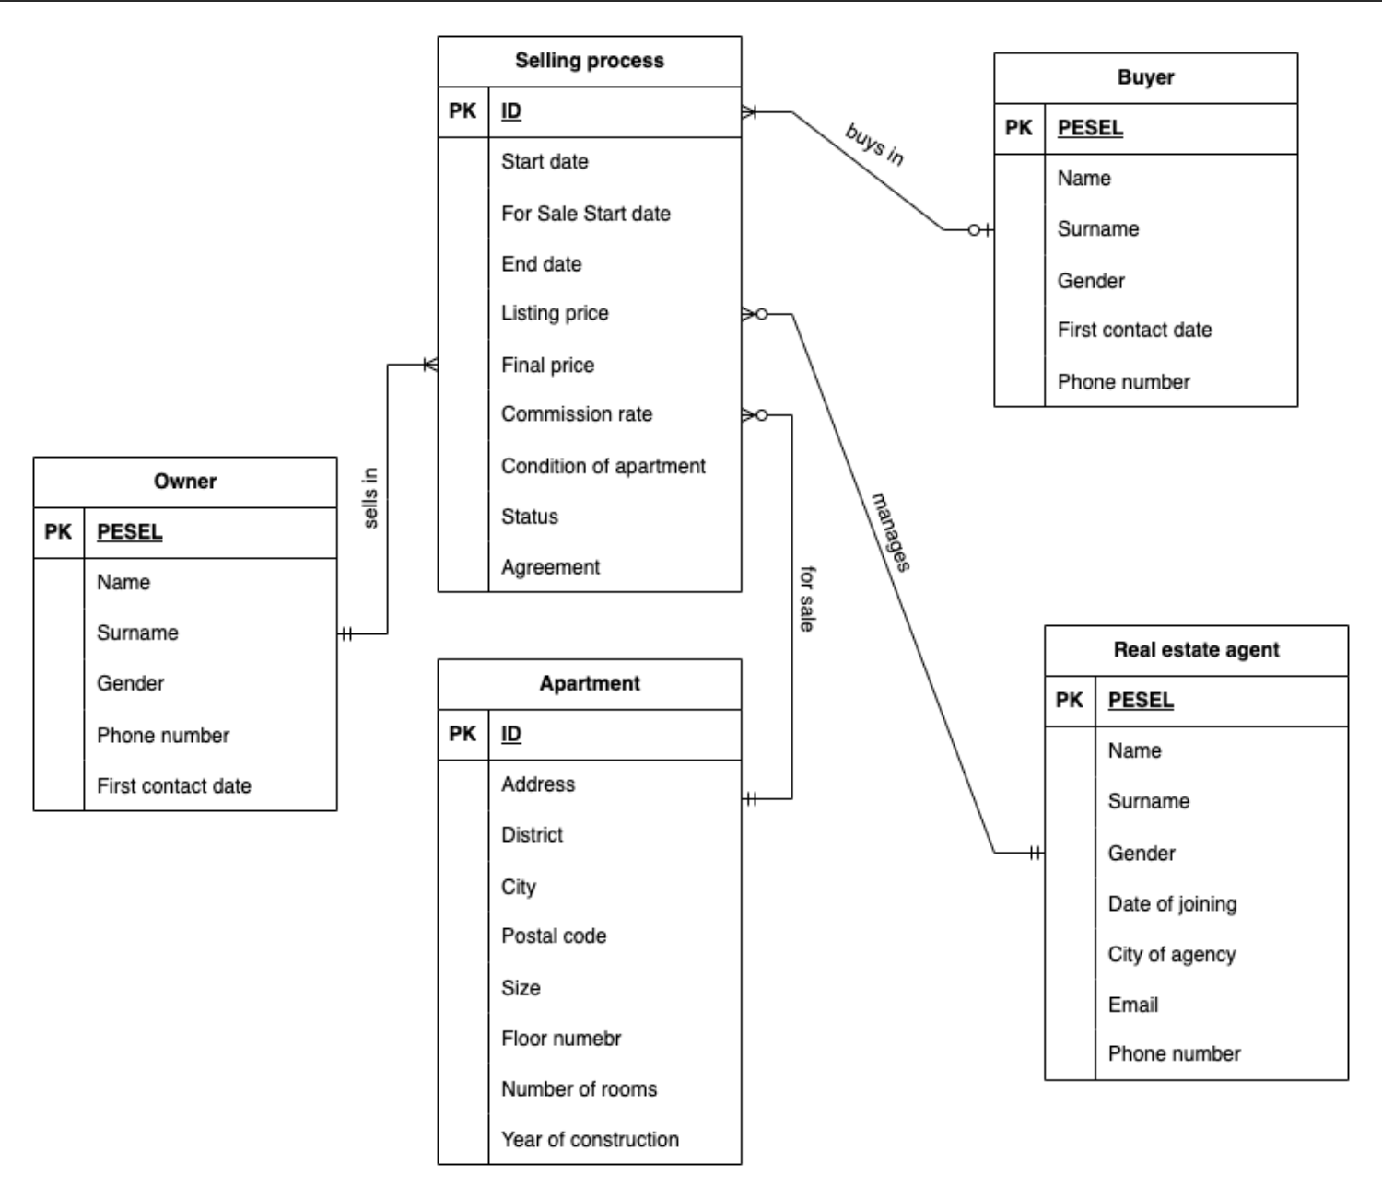

PropertyMaster

Table Name | Attribute | Attribute Type | Description
Apartment | A single property that the agency is helping to sell, recognized by a surrogate key
Apartment | ID | Numeric | PK, auto generated starting from 1 with increment 1
Apartment | Address | String characters - 70 | The street name and number with apartment number, where the property is located, BK
Apartment | District | String characters - 30 | The district of the city in which the apartment is located
Apartment | City | String characters - 30 | Name of the city where the apartment is located - also the location of the branch of our agency that the apartment is assigned to
Apartment | Postal code | String characters - 6 | Postal code of the address of the apartment
Apartment | Size | Numeric | The area of the property, defined in m²
Apartment | Floor number | Numeric | On which floor is the apartment located
Apartment | Number of rooms | Numeric | How many rooms (bedrooms, living rooms etc.) does the property have
Apartment | Year of construction | Date | The date when the construction of the apartment was finished - when it was ready to be sold originally
Owner | The landlord of the apartment, client who wants the agency to help them in selling their property, recognized by PESEL number
Owner | PESEL | String characters - 11 | PK, the PESEL number of the owner, BK
Owner | Name | String characters - 20 | First name of the landlord
Owner | Surname | String characters - 20 | Last name of the owner
Owner | Gender | String characters - 6 | Sex of the landlord. Allowed values: Male, Female, Other
Owner | Phone number | String characters - 15 | Contact to the owner, telephone number of the landlord
Owner | First contact date | Date | The exact date when the owner showed an interest in working with the agency
Buyer | The person who makes the payment and becomes the new owner of the property, recognized by the PESEL number
Buyer | PESEL | String characters - 11 | PK, the PESEL number of the buyer, BK
Buyer | Name | String characters - 20 | First name of the buyer
Buyer | Surname | String characters - 20 | Last name of the new owner
Buyer | Gender | String characters - 6 | Sex of the buyer. Allowed values: Male, Female, Other.
Buyer | Phone number | String characters - 15 | Contact information of the buyer, telephone number
Buyer | First contact date | Date | The date when the buyer first contacted our agency to view one of the listed properties.
Real estate agent | Employee responsible for meeting with clients, assessing the apartments to be sold and conducting property viewings with potential clients, recognized by their PESEL number
Real estate agent | PESEL | String characters - 11 | PK, the PESEL number of the real estate agent, BK
Real estate agent | Name | String characters - 20 | First name of the agent
Real estate agent | Surname | String characters - 20 | Last name of the employee
Real estate agent | Gender | String characters - 6 | Sex of the real estate agent. Allowed values: Male, Female, Other
Real estate agent | Date of joining | Date | The exact date the person became an employee of the agency
Real estate agent | City of agency | String characters - 30 | The branch that the agent is assigned to, place of work
Real estate agent | Email | String characters - 50 | Business email address of the employee, contact information
Real estate agent | Phone number | String characters - 15 | Contact information of the agent, telephone number
Selling process | The process of selling one apartment, recognized by a surrogate key
Selling process | ID | Numeric | PK, auto generated starting from 1 with increment 1
Selling process | Start date | Date | The date when the owner reaches out to the agency to sell an apartment, start of the whole selling process, part of BK
Selling process | For Sale Start date | Date | The exact date when the apartment is put on the market
Selling process | End date | Date | The date when the buyer makes the payment and the apartment is sold or when we are no longer selling that apartment - status : Cancelled
Selling process | Listing price | Numeric | The original price agreed between the owner and the agent, in kPLN
Selling process | Final price | Numeric | The price at which the apartment is bought after the negotiations, in kPLN
Selling process | Commission rate | Numeric | The percentage of the final price that will be earned by the agency, agreed between the owner and the agent
Selling process | Condition of apartment | String characters - 10 | In what state is the apartment (verified by the real estate agent). Allowed values: very poor, poor, acceptable, good, very good.
Selling process | Status | String characters - 11 | In what stage of selling is the apartment. Allowed values: Pre-Sale (signed agreement/waiting to sign with the owner, in preparation to put it on sale), For sale (it is being advertised), Under offer (there is a potential buyer, offer is being discussed, waiting for purchase contract to be signed), Sold (purchase contract is signed, all the payments are made, we have a buyer), Cancelled (the process of selling has started, but we can’t sell the apartment anymore, for example the owner withdrawn from the contract)
Selling process | Agreement | String characters - 7 | If the owner signed an agreement to partner with the agency. Allowed values: Deal, No Deal.
Selling process | Apartment_Address | String characters - 70 | FK, the address (unique) of the apartment that is sold through this process. Implementation of n to one relationship between Selling process and Apartment. (for sale), part of BK
Selling process | Owner_PESEL | String characters - 11 | FK, the owner of the apartment sold in this process. Implementation of n to one relationship between Selling process and Owner, part of BK (sells in)
Selling process | Buyer_PESEL | String characters - 11 | FK, the buyer of the apartment sold in this process. Implementation of n to one relationship between Selling Process and Buyer. (buys in)
Selling process | Real_Estate_Agent_PESEL | String characters - 11 | FK, the agent assigned to this process. Implementation of n to one relationship between Selling process and Real Estate Agent. (manages)

EXCEL/CSV

Sheet 1 (Information about the agency’s branch offices, each line describes an office, line 1 is the header row)
Column A - Identification number of the agency’s branch office (numeric, 0 decimal precision),
Column B - City (text, which corresponds to the city attribute of the apartment entity in the PropertyMaster system, because we only have one branch office in each city, so naturally the city where the apartments located is the city of our branch office),
Column C - Address (text),
Column D - Postal code (text),
Column E - Number of agents (integer), extracted from the PropertyMaster system, in the case of change the column is updated.
Column F - Number of apartments (integer), extracted from the PropertyMaster system, in the case of change the column is updated.
Sheet 2 (Information about interested buyers per apartment, each row describes one potential buyer for a specific apartment, line 1 is the header row)
Column A - Name (text),
Column B - Surname (text),
Column C - Phone number (text),
Column D - City (text),
Column E - Interested apartment (address of the apartment, which is the business key for the apartment entity, extracted from the PropertyMaster system),
Column F - Owner of the apartment (identified by PESEL, so we can integrate this data with what we have in the PropertyMaster system)
Column G - Start date of selling process (The date when the owner reaches out to the agency to sell an apartment, start of the whole selling process, part of BK)
Column H - Status (viewing, negotiating price, contract signing, payment, withdrawn)
Column I - Buyer first contact date (date in format year - month - day, e.g. 2013-12-09).

3. Scenarios of analytical problems
Why do some apartments have faster apartment sales than others?
- Are there any common characteristics shared by the top 100 fast-selling apartments for the agency?
- Compare the average listing period for apartments in various districts in each city.
- Do apartments sell faster if the ratio of final price and listing price is close to 1 compared to those which have high fluctuations in prices?
- What is the average sales speed based on the number of interested buyers per apartment?
- Compare the average sales speed based on the number of real estate agents in each branch office.
- What is the average sales speed based on the number of competing listings?
- Does high-quality advertisement speed up the selling process?

How do certain characteristics of apartments affect the number of interested buyers?
- Are there any districts of the branches that have no interested buyers?
- Compare the number of potential buyers based on the apartment size category.
- Is there a monthly increase in the number of potential buyers depending on the number of rooms in a property?
- What are the top 5 districts in each branch that attract the most buyers?
- What is the average number of potential buyers per each price range in each branch?

4. Data needed for analytical problems
Analytical problem: Why do some apartments have faster apartment sales than others?
- Are there any common characteristics shared by the top 100 fast-selling apartments for the agency?
- Ranking of fast-selling apartments - calculate based on PropertyMaster, table Selling process, column For Sale Start date, End date and rank the results in descending order
- Apartment characteristics: filter from PropertyMaster, table Apartment, column size, floor number, number of rooms, year of construction, condition
- Compare the average listing period for apartments in various districts in each city.
- Listing period - PropertyMaster, table Selling process, column For Sale Start date, End date
- Apartment location - PropertyMaster, table Apartment, column district, city
- Do apartments sell faster if the ratio of final price and listing price is close to 1 compared to those which have high fluctuations in prices?
- Price change - calculate the ratio based on PropertyMaster, table Selling process, column listing price, final price
- Selling speed - PropertyMaster, table Selling process, column For Sale Start date, End date
- What is the average sales speed based on the number of interested buyers per apartment?
- Selling speed - PropertyMaster, table Selling process, column For Sale Start date, End date
- Number of interested buyers - Excel/csv Sheet 2 Column E (count the occurrence of each unique value in this column, the interested apartment in this column is represented by the apartment address, which is the business key for the apartment entity in the PropertyMaster system)
- Compare the average sales speed based on the number of real estate agents in each branch office.
- Selling speed - PropertyMaster, table Selling process, column For Sale Start date, End date, calculate the selling speed by subtracting start date from end date, the result should be an integer, as in number of days; then take the average value for all apartments in each branch office (city), and the result may be a float
- Number of agents - Excel/csv Sheet 1 Column E which provides the number of agents in each branch office/city, and this city value corresponds to the city attribute for apartments in the PropertyMaster system.
- What is the average sales speed based on the number of competing listings? (requires additional data but no process change)
- Selling speed - PropertyMaster, table Selling process, column For Sale Start date, End date
- Number of competing listings - there’s no such information available in both data sources. Below are proposals for acquiring such information:
  - Integrate external real estate market data sources that track the number of active listings per district at a given time.
  - Scrape public real estate websites to estimate competing listings in different areas.
  - Establish a partnership with local real estate databases to gain access to aggregated district-level market data.
- Does high-quality advertisement speed up the selling process? (requires additional data and process change)
- Selling speed - PropertyMaster, table Selling process, column For Sale Start date, End date
- Quality of advertisement - no such information
- Since advertisement quality is not currently tracked, we propose implementing a standardized rating system for listing quality.
- Introduce structured advertisement criteria, including:
  - Number of high-quality images
  - Length and detail of the description
  - Use of premium advertising features (highlighted listing, virtual tour, video, etc.)
- Modify the business process to require agents or marketing staff to assign a quality score to each listing upon publication.
- Store this quality rating in a new database field linked to each apartment listing.
Analytical problem: How do certain characteristics of apartments affect the number of interested buyers?
1. Are there any districts of the branches that have no interested buyers?
- Districts - PropertyMaster, table Apartment, Column District
- Branch - Excel/csv file, Sheet 1, Column A - Branch office number and Column B - City and finding a match from PropertyMaster, table Apartment, Column City
- Number of attracted buyers - We count it from the Excel/csv file, Sheet 2, column E - Interested apartment, count the number for each apartment and then add that number to the district that apartment is located in
2. Compare the number of potential buyers based on the apartment size category.
- Number of potential buyers - We count it from the Excel/csv file, Sheet 2, column E - Interested apartment, count the number for each apartment and then add that number to the size category that property is in
- Apartment size category - We define the categories of apartment size as follows : studio: 10-30 m², small: 30-50 m², medium: 50-80 m², large: 80-120 m², very large: 120+ m². Data taken from PropertyMaster, table Apartment, column Size.
3. Is there a monthly increase in the number of potential buyers depending on the number of rooms in a property?
- Monthly number of potential buyers - Excel/csv file, Sheet 2, Column F - Status should be equal to either viewing, negotiating price, contract signing or the first contact date should be in the analyzed month
- Number of rooms in a property - PropertyMaster, table Apartment, Column Number of rooms
4. What are the top 5 districts in each branch that attract the most buyers?
- Districts - PropertyMaster, table Apartment, Column District
- Branch - Excel/csv file, Sheet 1, Column A - Branch office number and Column B - City and finding a match from PropertyMaster, table Apartment, Column City
- Number of attracted buyers - We count it from the Excel/csv file, Sheet 2, column E - Interested apartment, count the number for each apartment and then add that number to the district that apartment is located in
5. What is the average number of potential buyers per each price range in each branch?
- Price range - price is categorized as follows: low-cost: bottom 20% of the market prices, mid-range: 20-60% of the market prices, high-end: top 5-20% of the market prices, Luxury : top 5% of the market prices, PropertyMaster, table Selling Process, Column FinalPrice and Column Apartment_ID
- Number of potential buyers - We count it from the Excel/csv file, Sheet 2, column E - Interested apartment, count the number for each apartment and then add that number to the price range that apartment is in
- Branch - Excel/csv file, Sheet 1, Column A - Branch office number and Column B - City and finding a match from PropertyMaster, table Apartment, Column City

