Vertical Drilling Frame Assembly

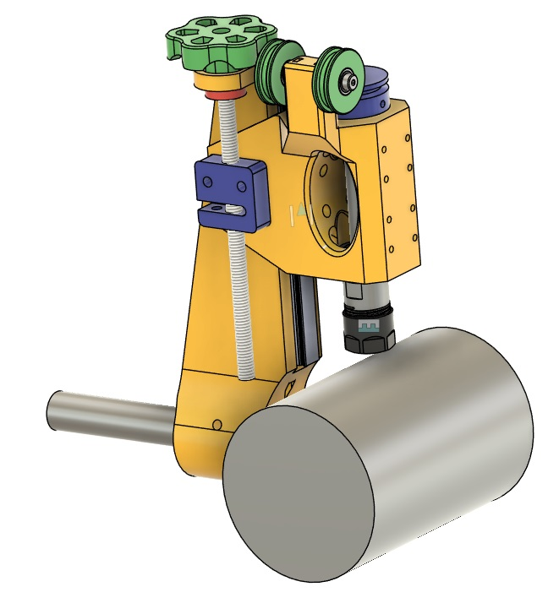

Parts List:
ER Chuck Housing
QTY | Hardware
1 | MGN12 rail. 150mm long
2 | MGNC carriage
4 | M3x8mm SHCS
2 | M3x12mm SHCS
1 | C12-ER16-100L
2 | M5x10mm Shoulder Bolt with M4 threads (6mm long)
2 | M5x0.2 Bearing Shim
2 | M5 Washer 1mm thick
2 | M4 Square Nut
2 | 8-32x0.1875" Set Screw
2 | M5 Square Nut
2 | MR6201_ZZ Bearing
4 | MR695_ZZ Bearing
Main Arm
3 | M5x5mm Set Screw
3 | M5 Square Nut
1 | 0.75"x5" Steel Shaft
1 | 250-104 Boring Bar Tool Holder
2 | M3 Square Nut
Leadscrew
1 | TR8 Leadscrew 2mm pitch, 2mm lead
1 | Anti-Backlash Nut to fit
2 | M5x20 SHCS
5 | 8-32x0.1875" Set Screw
 | 3D printed parts
1 | ER Chuck Housing
2 | Idler Pulley
2 | Idler Spacer (5x7x1.5mm)
1 | Drive Pulley
1 | Leadscrew Knob
1 | Leadscrew Lock
1 | Main Arm

Main Arm:
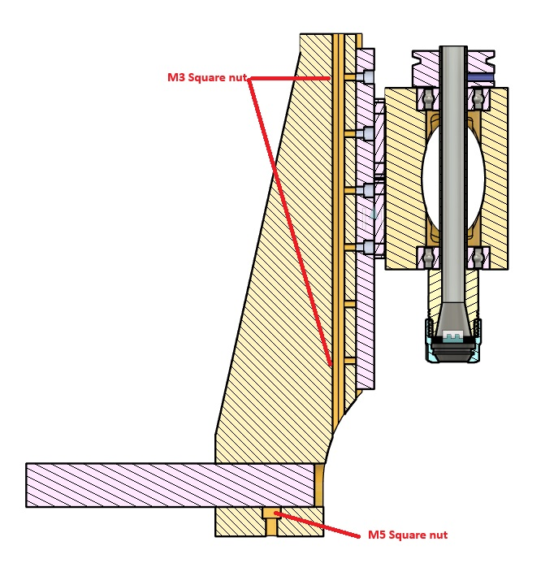
M3 tap 6 of the 8 holes to attach linear slide to arm. Drill the two end holes with 1/8th inch or 3.5mm drill. Insert the two M3 square nuts. Note: M3 nuts can be used on all of the holes, but may be difficult to install.
Attach the ¾” shaft to the arm using the M5 square nuts and set screws. Note: M5 SHCS may be used instead of the set screws.
Attach the linear rail to the arm.

Spindle Housing:
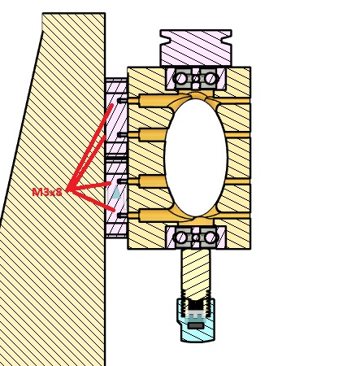

Press the MR6201_ZZ bearings into the housing.
Fasten the housing to the linear rail carriages using M3x8 SHCS.
Install the ER16 chuck.
Install the drive pulley using two 8-32 set screws.

Idler Pulleys:
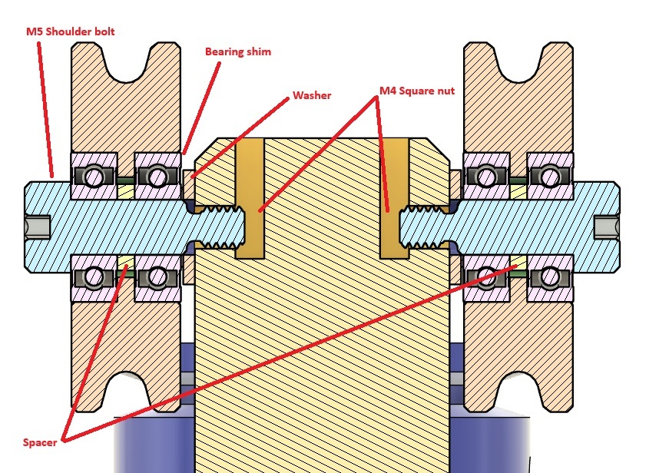

Press the M4 square nuts into the top of the housing.
Press the MR695_ZZ bearings into the idler pulleys making sure the spacer is installed. Insert the M5 shoulder bolt, add the bearing shim and the washer, then attach the idler pulley to the housing.

Leadscrew
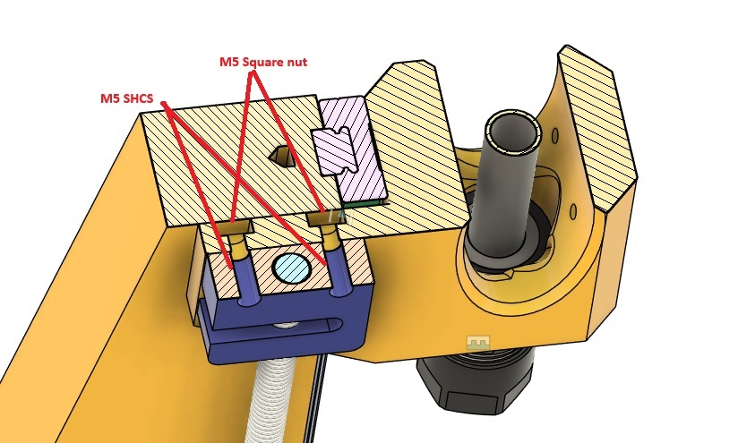

Install M5 square nuts in the housing. Attach the anti-backlash nut using M5 screws.
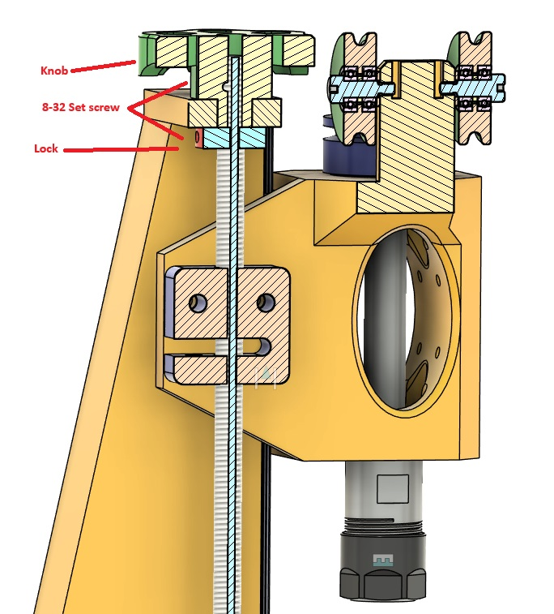

Tap the knob and the lock for 8-32 set screws.
Attach the knob, lock, and leadscrew.

3D Print
VerticalDrillFrame.3mf is optimized for a Bambu X1C printer.
Print Settings:
- 8 Walls
- 40% Infill, Cubic pattern
- Main Arm has a 100% infill modifier in the center
- Support: Tree Slim

