Improving Sim City

Brigham Young University - Idaho

Larson Caldwell, Sam Graham, Haru McClellan

**Introduction:** As an instructor of several climate change courses, Brother Sargeant has created a simulation for students where they are able to model power plants. This simulation is wonderful for instructing these students, however the user experience is intimidating, and needs improvement. This project’s aim is to make the end-user’s encounter with climate change more friendly, fun, and novel.

**Program Definition:** The current implementation has three main features:

1. Allow students to access and modify their country’s parameters and save those changes to an online file. (Through the instructor physically typing things in)
2. Allows the course instructor to add and modify parameters as needed. (Instructor has control of the document)
3. Enable different groups to exchange resources with each other in a classroom environment. (This is done using a paper system)

Brother Sargeant currently uses a large excel program to do the number cruching for this simulation. This program is used to model climates (socioeconomic conditions). It has been found to scare students unfamiliar with Excel, and has grown quite large and unwieldy. This program is intended for students in that class, as a way of replacing this Excel file.

**Design Overview:** The design is based off of the current Excel file. Its function is very similar except it is much more user friendly. The application will pull data from online resources. This will enable Brother Sargeant (and others) to update the various parameters of the simulation. Currently this will be saved to files on Google Drive and used in the simulation during each stage of the simulation.

The project is visually held mainly in a single window. This shows the current round. There are several options for the various types of plants. User’s can select to remove or add to the plants as desired. Additionally, a window can be called up to enter in information regarding tradable commodities..

**How the current version works:** On the Excel spreadsheet that Brother Sargeant has created, the users compete in teams. The teams manage a fleet of power plants which are used to produce energy.

The groups must fulfill three requirements:

1. Supply their city’s energy demands
2. Maintain at least a 45% approval
3. Not exceed their budget.

These goals are met in a series of seven rounds, numbered zero to six. In each round players must make decisions for the resources they receive. Resources are traded among the groups in the class, and these resources modify various aspects of energy production and emissions output.

In addition to these requirements, the groups compete with each other to:

1. Minimize emissions
2. Maximize security
3. Maximize profit in order to get the best ranking.

There are four primary factors influencing the long term goals:

1. Nuclear plants,
2. Renewable plants,
3. Fossil fuel plants, and
4. Oil.

Each has trade-offs. For instance, Nuclear has low emissions, and low security.

This is done through several different methods.

First, the user can create and destroy power plants. Each type of plant has different statistics on how much it impacts approval, energy supply, emissions, profit and security, as well as how much it costs per unit.

Another way to progress in the game is to use action points, technologies, emission credits and market shares to boost power plant statistics and both long and short term goals directly. It should also be noted that there is a fourth energy source: oil. While the player is unable to affect oil directly by creation or destruction of plants, he may alter its statistics through use of technologies and action points.

The end goal of the game is to get the highest profit, security, and lowest emissions. The team with the best score out of these three classes will be declared the winner.

**Design for this Program:** This program provides the same functionality of the old version, with better interaction with the user. Due to the steep learning curve associated with the Excel spreadsheet program, many users have problems with this assignment. One of the principal goals is to emulate the current version’s logic and data, but to have a new face for this program.

This will be done by a JavaFX application. It will include a window for viewing any given round. This data will be gathered from the internet as a comma separated values file, which can be edited by an instructor. Once this has been downloaded, the student group will be able to add their information for that round. The program executes based on input and forms a file which is then sent to the instructor. The rankings are then found from these input files, and the next round commences until completion.

The code will flow in the following manner according to this UML document. (See (Appendix A for a more detailed UML, See Appendix B for mockups of the GUI)

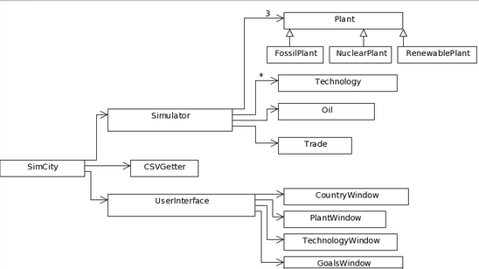

**Appendix A: More Detailed UML**

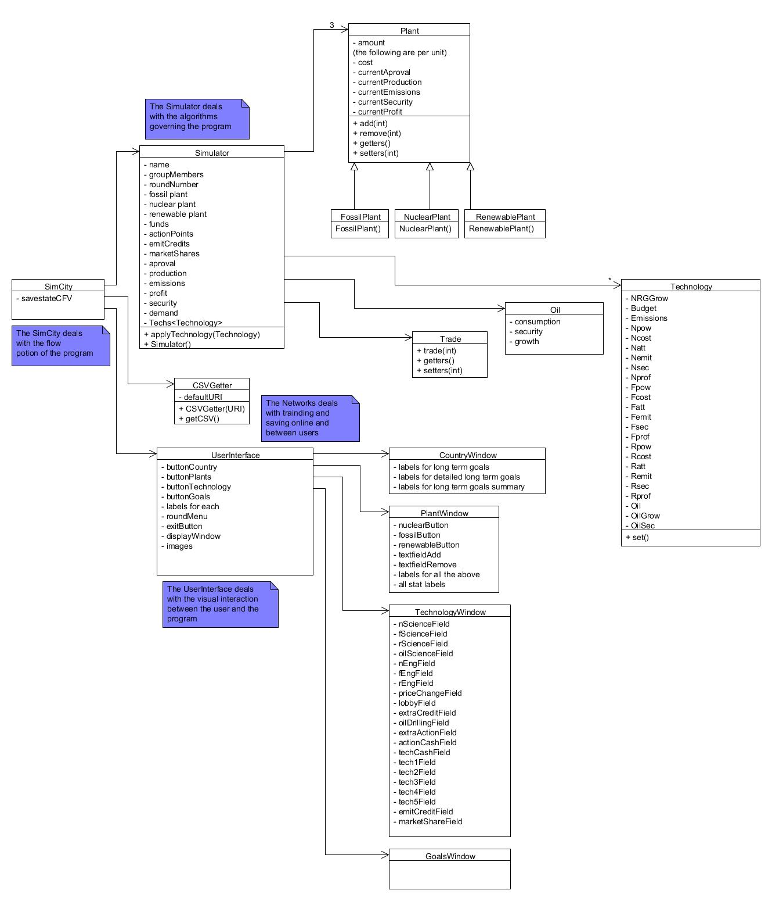

**Appendix B: GUI Mockups**

