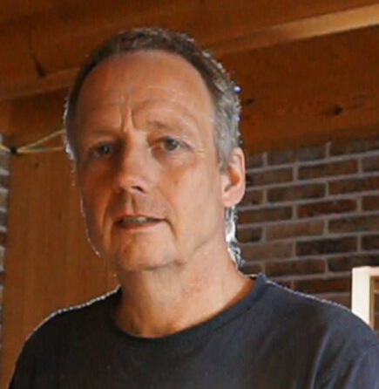

|  |
| --- |
| **Peter Mostert** |

|  |  |
| --- | --- |
|  | Phone  +31 6 100<redacted> |
|  | Email  <redacted> |
|  | [http://www.linkedin.com/in/peter-mostert-24a7486/](http://www.linkedin.com/in/) |
|  | Home  <redacted>, Netherlands |

|  |  |
| --- | --- |
| **Certificates** |  |
| * AWS Certified SysOps Administrator – Associate * AWS Certified DevOps Professional |  |
| **Languages** |  |
| * Dutch * Englisch |  |
| **Hobbies** |  |
| * Keeping our little farmhouse under control |  |

|  |  |  |
| --- | --- | --- |
|  | | **Profile** |
|  |  | I am an experienced infrastructure engineer with a demonstrated history of working in Cloud, computer network- and security related areas for several companies.  With many years of experience across various expertises, I am able to quickly gain a comprehensive understanding for a particular project and handle appropriately. |
|  | | **Hard Skills** |
|  |  | * Programming: python, bash, c * Cloud: AWS (certified) and Azure (devops) * Operating Systems: i5os, Linux, AIX, hp-ux * IaC: CloudFormation, Terraform, Ansible * CI/CD: Jenkins, CircleCI, CodePipeline |
|  | | **Work Experience** |
|  |  | **Digital Engineer – TechNative**  2023 - current  Building and configuring an observability system within a customers microservice environment.  Toolset:   * EKS * Grafana Cloud Components (LGTM) * ArgoCD * Terraform Cloud.   **Senior Cloud Solution Engineer – Cognizant**  2017 - 2023  Supporting several Cognizant customers running applications in the AWS-cloud. Providing day to day operations in order to keep the Cloud environments up and running.  Things that come into scope:  1. Linux  3. SAP, Hybris, Sterling  4. Cloudformation, Terraform  5. AWX, Ansible, Puppet  6. Docker, ECS, EKS  8. Cloudwatch, Datadog, New Relic, SignalFx, Checkmk  All of the above come with different levels of proficiency.  **Senior Solution Engineer – elft.nl (self owned, dormant)**  2013 - current  As a freelancer I support customers in designing and implementing their ICT-Strategy. This one-stop-shop approach requires extended knowledge of ADDS, WAN, Firewalls, Switches, Routers, Anti-malware, Backup, corporate WIFI, VPN, virtualisation and storage solutions.  **System Engineer – Unit4 Group**  2010 - 2013  The Unit4 takeover required to reverse the activities executed within GIT. I returned to base to get the Consist activities disentangled from the IBS infra, bring them home and integrate them within the Unit4 infra as a next step.  **Technical Consultant – Pink Roccade**  2009 - 2010  In the capacity of technical consultant explored various SAP landscapes and resolved a number of infrastructure issues.  **System Engineer – IBS AB**  2003 - 2009  Responsible for the IBS Global Network. Our group successfully consolidated resources from the different country organizations to a limited number of datacenters and provided a stable infrastructure in between. IBM Lpars and vmWare ESX vitualisation were further utilized to effectively consolidate the workflows.  **System Programmer at Consist B.V.** 1994 - 2003  Started at Consist as a system programmer for one of their software solutions for AS/400 (FMS). Played a leading role when the need multi-platform solutions of their product-line became apparent. After the one-source migration engine concept to Unix had been  realized I became part of the IBM SF-framework team. The idea was to design a new product-line based on Java and SF which would be multi-platform by design.  **System Engineer at ENIAC B.V.** 1989 - 1994  As a member of the group "research en techniek" I had the mission to implement and integrate the newly announced IBM AS/400 internally as well as with customers. This included performance analysis and error detection and forwarding improvement  suggestions to the development teams.  **Prior experience**  past – 1989  Did research on the non-destructive analysis of nuclear fuel pallet degradation.  Programmed PLCs to be implemented in new plant sections. Became involved in connecting Mainframe systems that were used for administrative automation within the same plant. |
|  | | **Training and Education** |
|  |  | **Electronics – HTS Alkmaar**  1983 - 1988  Studied Electronics graduated in Computer Technology.  **AWS Certified DevOps Professional**  2022 - 2022  Upgraded my AWS associate certification to the professional level. |
|  |  |  |