**AWS**

**Create database by terraform:**

**First create directory and create terraform files (main.tf – variables.tf)**

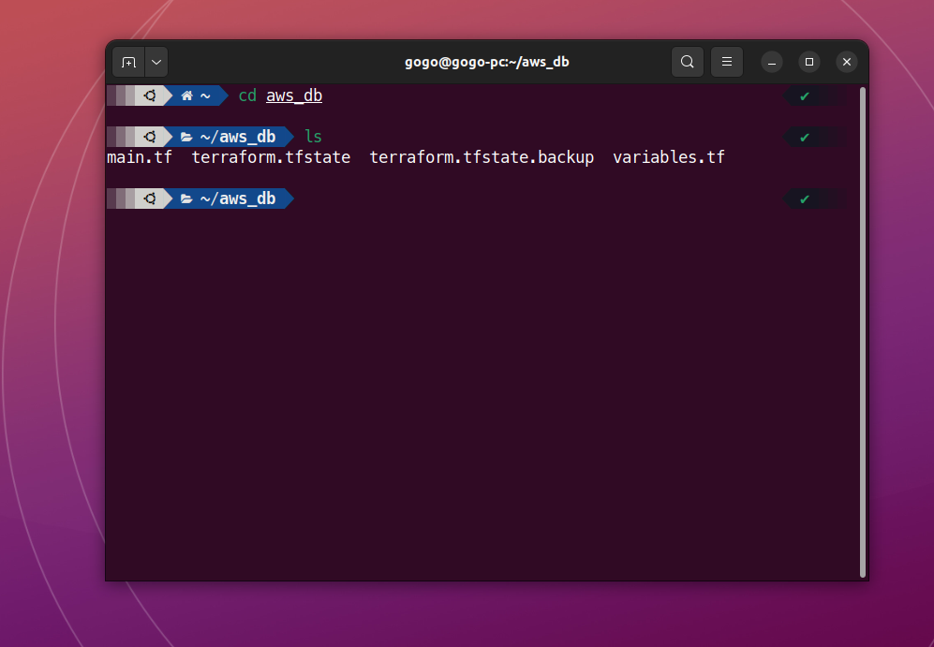

**2- connect the aws account in terraform by access key and select region**

**3- create resources in main file and mapping for variables file**

**4- now install plugins and providers by (terraform init )**

**5- Second Create resources by (terraform plan)**

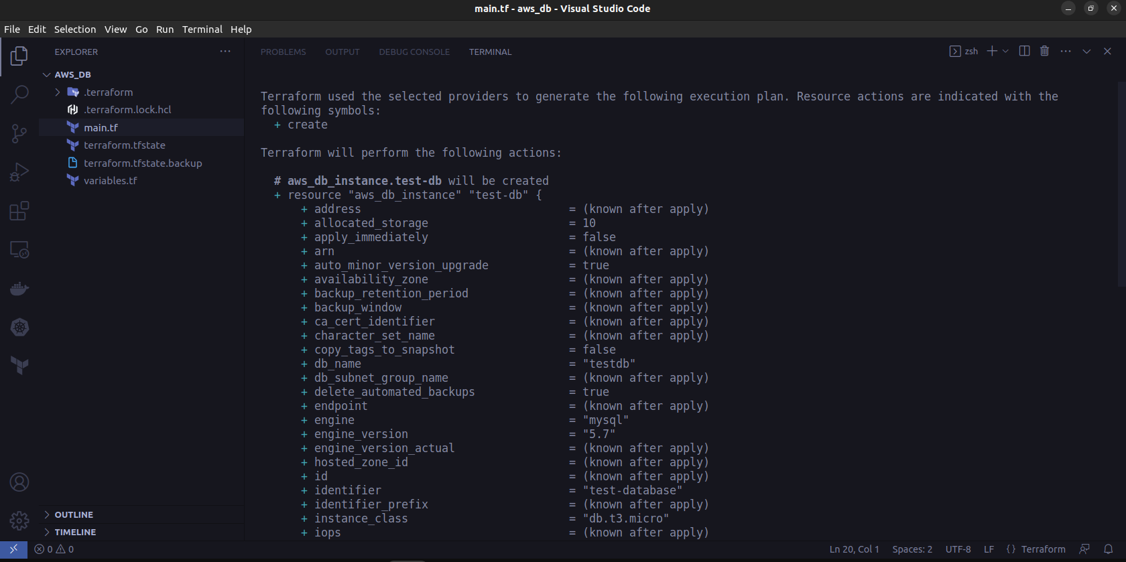

**6- now apply the changes by (terraform apply) and confirm this by (yes)**

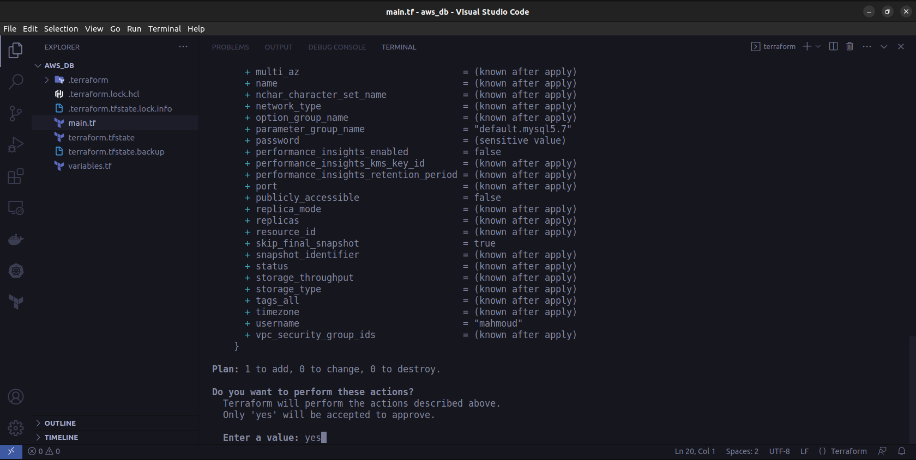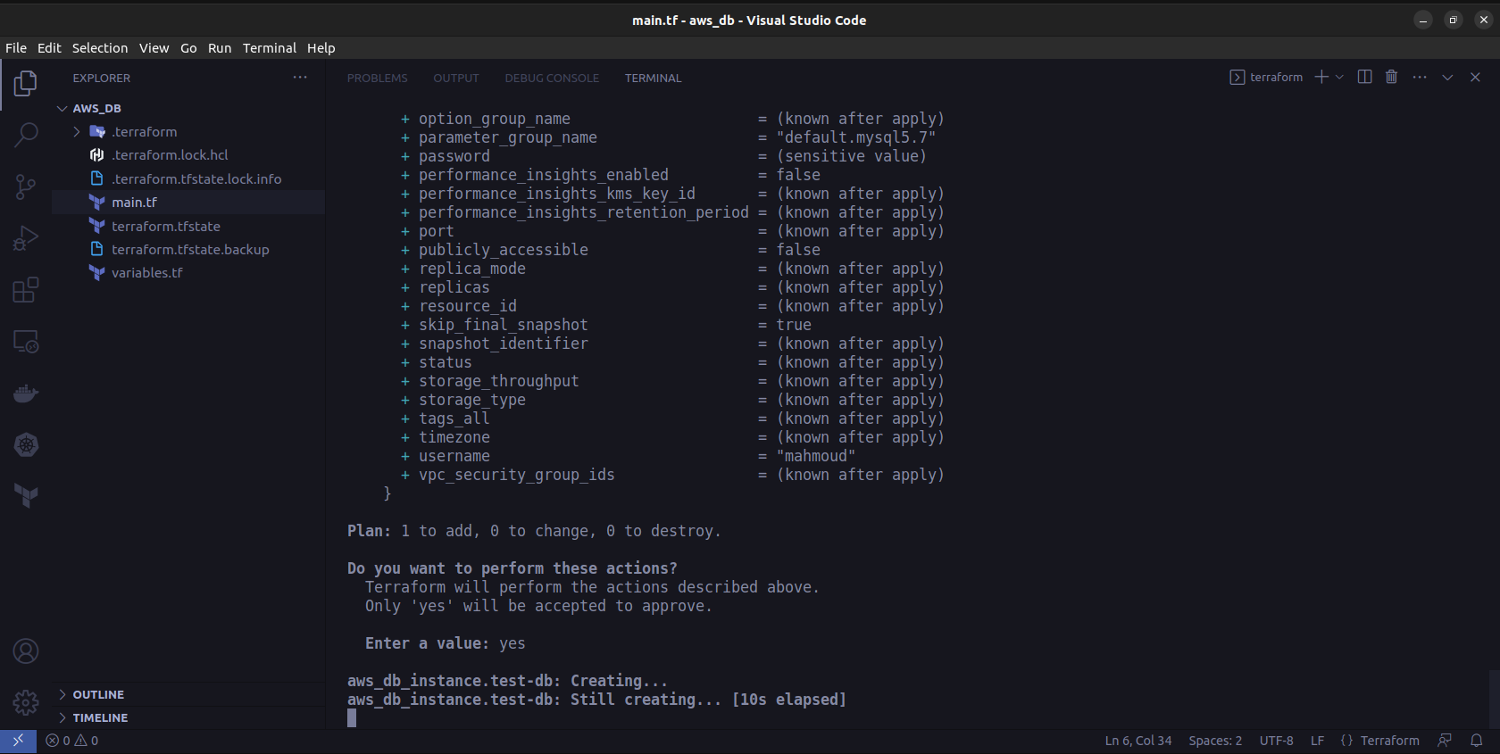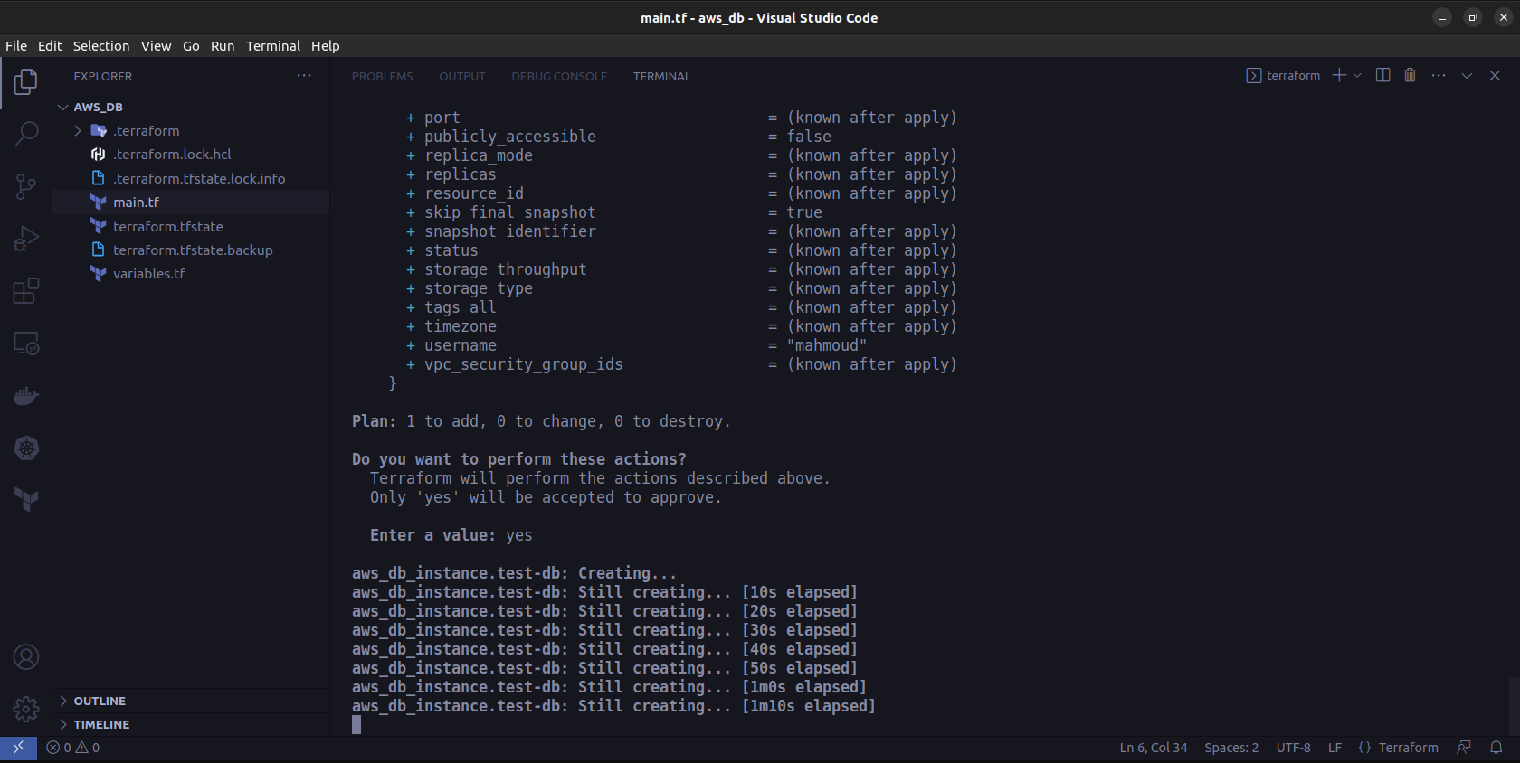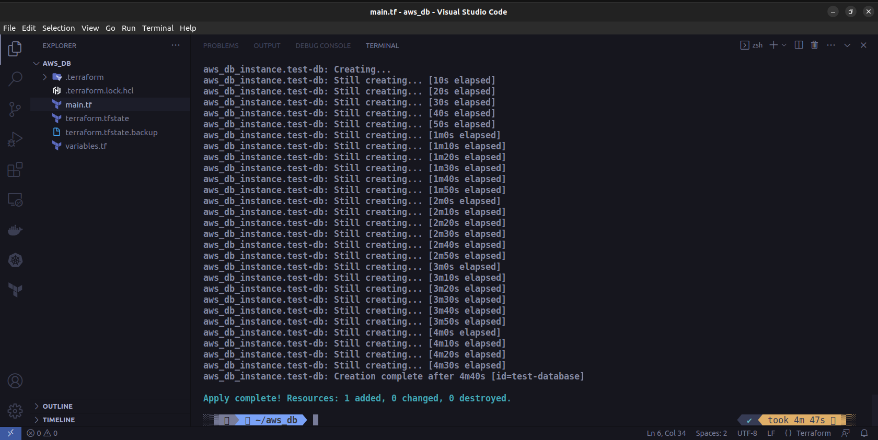

**7- the instance created in AWS cloud**

**8- Edit the congiurations and Networking**

**9- finally if you want destroy the instance use (terraform destroy)**



