**Sonarqube**

**1-Install SonarQube and sonar server for code quality.**

**We have 2 steps for install SonarQube**

* **Install by apt package.**
* **Install by image and run container from image in port (9000)**

**First pull image in docker _registry:**

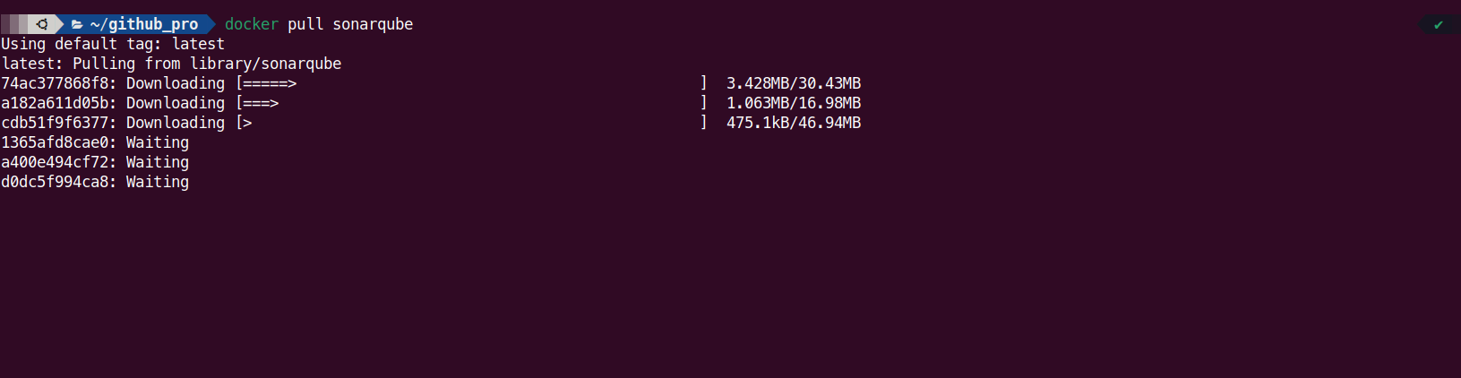

**2- Run container from image**

**3- Create new password and choose to create new projects**



